Dear Editor,

We would like to thank you for the editorial comments. We also thank the reviewers for the quality of their work which helped us to improve the manuscript.
We took into account all the editorial comments. We provide below a point-by-point reply to the reviewer's comments. As requested, additional experiments were performed to answer some specific questions.
A revised version of the manuscript is also provided. The modifications made in the text appears in blue. The script for the video is highlighted in yellow.

Best wishes,

On behalf all the authors,

Paul Verhoeven

Editorial comments:
Changes to be made by the Author(s):
1. Please take this opportunity to thoroughly proofread the manuscript to ensure that there are no spelling or grammar issues. Please define all abbreviations at first use.

Response: We have double-checked all abbreviation add we added the definition of PBS and MOI. The manuscript has been carefully proofread.

2. Please provide an email address for each author.

Josselin Rigaill: josselin.rigaill@chu-st-etienne.fr
Estelle Audoux: estelle-audoux@orange.fr
Killian Rodriguez: k.rodriguez@univ-st-etienne.fr
Aurélien Peyron: peyron.aurelien@gmail.com
Philippe Berthelot: philippe.berthelot@univ-st-etienne.fr
Jérôme Josse: jerome.josse@univ-lyon1.fr
Frédéric Laurent: frederic.laurent@univ-lyon1.fr
Robin Caire: caire.robin@gmail.com
Paul O. Verhoeven: paul.verhoeven@univ-st-etienne.fr
In the introduction, please mention the advantages over alternative techniques with applicable references to previous studies. In particular, please discuss (briefly) the lysostaphin protection assay so that you can then present your improvement. Please also consider including a description of the context of the technique in the wider body of literature.

Response: As suggested, a paragraph was added in the introduction.
3. Please ensure that all text in the protocol section is written in the imperative tense as if telling someone how to do the technique (e.g., “Do this,” “Ensure that,” etc.). The actions should be described in the imperative tense in complete sentences wherever possible. Avoid usage of phrases such as “could be,” “should be,” and “would be” throughout the Protocol. Any text that cannot be written in the imperative tense may be added as a “Note.” However, notes should be concise and used sparingly. Please include all safety procedures and use of hoods, etc.

Response: OK. Done.

4. Please format the manuscript as: paragraph Indentation: 0 for both left and right and special: none, Line spacings: single. Please include a single line space between each step, substep and note in the protocol section. Please use Calibri 12 points and one-inch margins on all the side. Please include a one line space between each protocol step and then highlight up to 3 pages of protocol text for inclusion in the protocol section of the video.

Response: OK. Done.

5. Don’t include multiple notes between steps.

Response: OK. Done.

6. Please note that your protocol will be used to generate the script for the video and must contain everything that you would like shown in the video. Please ensure you answer the “how” question, i.e., how is the step performed? Alternatively, add references to published material specifying how to perform the protocol action. There should be enough detail in each step to supplement the actions seen in the video so that viewers can easily replicate the protocol.

Response: OK. Details have been added throughout the protocol. Paragraph 3.1 to 3.4 included will be used to generate the script of the video.

7. 3.1.2 and 3.2.3: Please mention what MOI was used in this paper. It will also help in filming.

Response: OK. A MOI of 1 was chosen.

8. After including a one line space between each protocol step, highlight up to 3 pages of protocol text for inclusion in the protocol section of the video. This will clarify what needs to be filmed. Please do not highlight notes.

Response: OK. Paragraph 3.1 to 3.4 included are highlighted.

9. Please remove the embedded figure(s) from the manuscript. All figures should be uploaded separately to your Editorial Manager account. The legends should appear only in the Figure and Table Legends section after the Representative Results.

Response: OK. Done.

10. Please sort the Materials Table alphabetically by the name of the material.

Response: OK. Done.

____________________________________
Reviewers' comments:
Reviewer #1:
Manuscript Summary:
This manuscript by Rigaill et al. describes an improved protocol to quantify S. aureus internalization within non-phagocytic cells and the intracellular efficiency of antimicrobial compounds. The key finding resides in the usage of lysostaphin, resulting in the elimination of the washing steps. This provides a crucial improvement of the protocol since heavily infected cells easily detach from their support when washed. This protocol will be of great interest for the microbiology and cell biology community since it will be readily applicable to a large number of bacterial pathogens and cell types.
Major Concerns:
none
Minor Concerns:
a few typos and grammatical errors.
Response: OK. We have carefully corrected the manuscript.
Reviewer #2:
Manuscript Summary:
The manuscript by Rigaill et. al. entitled "Improved lysostaphin protection assay to study Staphylococcus aureus internalization and intracellular efficacy of antimicrobial compounds" describes the existing protocol Enzyme protection assay (EPA), and an improvement in published EPA in Infection and immunity (IAI, 2019) (doi: 10.1128/IAI.00119-19, reference 12 of the manuscript). This comprehensive IAI paper raised the longstanding drawbacks associated with gentamicin protection assay (GPA), and advocated the use of lysostaphin in Enzyme protection assay (EPA) for the precise enumeration of intracellular Staphylococcus. During GPA, the gentamicin entered inside the host cells, and kills the intracellular bacteria, while IAI paper conclusively proved that lysostaphin (EPA) does not enter the host cells; therefore, EPA could precisely determine the intracellular bacteria. Rigaill et al. rename the same protocol as lysostaphin protection assay (LPA), and improved lysostaphin protection assay (ILPA) which will be somewhat confusing for the readers to follow. I, therefore, suggest the authors to keep the same name Enzyme protection assay (EPA), and add their precise improvement to the IAI method published as EPA. The improvement to add of Proteinase K to deactivate the lysostaphin is a welcome step suggested in this manuscript. In addition, Rigaill et. al. also determined the efficacy of 3 different antibiotics to kill the intracellular bacteria. The protocol needs to provide several specific details and the background of the w steps before publication. Please see the minor/major comments below:
Major/minor Concerns:
1. In title of the paper, the lysostaphin protection assay (LPA) or improved lysostaphin protection assay (ILPA) should be renamed as improved enzyme protection assay (iEPA) for the readers to easily follow the one additional improvement (deactivation of lysostaphin using proteinase K instead of EDTA or 1,10-phenanthroline, Fig S12 of Kim et al. 2019, IAI) in the existing EPA published in IAI (doi: 10.1128/IAI.00119-19, reference 12 of the manuscript). Therefore, please replace the LPA or ILPA to iEPA throughout the manuscript.

Response: We agree with this comment. Corrections were done.
2. In abstract, line no. 31 "NPPCs are grown in multi-well plate until confluence" What was the level of confluency because the level of confluency of mammalian cells changes the property of the cells as the high-cell density/confluency leads to contact inhibition of proliferation (CIP), a fundamental property whereby normal cells cease proliferation and cell division when they occupy all the space allocated to them upon reaching confluence (https://doi.org/10.1038/2131102a0). Does the cell confluency was maintained through in all the experiments? If not, please specify the level of confluency maintained for specific experiments.

Response: Thank you for this comment. We have specified the level of confluency in the protocol.
3. In abstract the line number 31-32, please specify the Staphylococcus culture media instead of "culture broth"

Response: We agree with this comment. The sentence was modified.

4. The last paragraph of introduction needs to be improved in context to methods applied so far to enumerate the intracellular bacteria. Proctor et. al. (1982) used the lysostaphin for the first time to kill the surface bound bacteria. However, the GPA was used for the more than 4 decades until the comprehensive study of the drawback of the GPA was demonstrated for Staphylococcus aureus, and the benefits of EPA employing lysostaphin was elucidated by Kim et al. 2019 (IAI). Therefore, explaining the GPA, and its drawback is necessary for the wide adaptability of the EPA in the field of infectious disease. Thus, the introduction should address these points such as why the most used gentamicin protection assay (GPA) needs to be changed to enzyme protection assay (EPA)? What are the advantages of EPA? What is that precise improvement in this manuscript under review brought to the existing EPA/LPA method to clearly identify the importance of improved enzyme protection assay (iEPA).
Response: As recommended, a paragraph was added in the introduction. LPA/ILPA was replaced throughout the manuscript.

5. In Protocol, section 1, "why only T75 flask not the culture plate?" "what was the level of cell confluency? Please replace the "trypsin cells" with "Trypsinzed cells" "please replace 300g with 300 ×g" "please replace the 1.105 with 1.0×105" and again in 1.7 mention the level of cell confluency

Response: Thank you for these comments.
Sentence about the T-75 was modified (see 1.2).
Few steps were added to the protocol to clarify.
Level of confluency was added (see 1.12)
All other comments have been taken in account.

6. In protocol section 2, why the S. aureus needs to be grown in DMEM but not in bacterial media? Please provide the rationale regarding this. The FBS itself hampers the growth, biofilm and adhesion properties of the S. aureus (10.1016/j.micpath.2010.07.005), why is the FBS required for the staphylococcal growth? Please justify.

Response: Thank for this comment.
We usually use cell culture media to keep culture conditions stable before and during the infection. We performed additional experiments (see results point 21) and we read carefully the recommended article above (10.1016/j.micpath.2010.07.005). It seems that 10% FBS does not inhibit bacterial growth but have an impact in the biofilm formation.
In our experience, we believe that there is no more reason to use a culture broth than a cell culture media. Moreover, there are probably some advantage to try to mimic conditions that could be encounter by S. aureus in vivo, which are probably far from those in a culture broth.
A sentence was added at the end of the note after step 2.5 to give the readers the opportunity to adapt their culture conditions.

7. In section 3.1.1, please define the infection media here with or without FBS.

Response: The composition of the complete infection media was defined at step 2.1.

8. In section 3.2.1, only microscopic observation is not enough, the cell suspension should be seeded in microtitre plate, wherein at least 2 to 3 wells should be a dedicated for the host cell counting to determine the MOI for 100% mammalian cells infection.

Response: Thank you for this comment. A new paragraph was added to specifically describe the cell count procedure (see new 3.1 step).
Before the infection step, we use low magnification microscopy only to verify the cell health and expected growth in every well of the plate.
9. In 3.2.2, "Eliminate the cell medium on 24-well plate" should be rephrased as "Eliminate the spent cell medium on 24-well plate"
Response: We agree with this comment. The sentence was modified (see 3.3.2).

10. In section 3.2.3, Right MOI? Please explain and define the MOI for the 100% host cells to get infected.

Response: Thank you for this comment. The preparation of the bacterial suspension was modified to clarify the protocol (See step 3.2). As suggested by the editor, we used a MOI of 1 in the protocol. In our hands, MOI of 1 is enough to study S. aureus internalisation and intracellular survival with a cytotoxicity below to 5%. Even with a MOI of 100, it is almost impossible to get 100% infected cells in our models of epithelial cell (i.e. A549 or HaCaT cells) without inducing a strong cytotoxicity which lead to under evaluate the S. aureus intracellular load.
11. In section 3.2.3, Why is the infection time two 2h? any specific reason? 2 h is too long for infection, because significant number of host cells will start floating due to death, of course, the rate of bacterial internalization as well as their death depends on the type of cells used. Please explain and give the rationale for 2h of infection time.

Response: In our setup, we did not observe a high cytotoxicity by using 2 hours of inoculation but we agree that the cytotoxicity can vary widely according to MOI, strains and cell types. We used 2 hours of incubation with bacteria to minimize the bias due to the delay of handling and pipetting steps between wells. In our hands, it could take up to 15-20 min to inoculate the whole 24 well plate with different strains and conditions.
A sentence was added to note after step 3.3.4 to consider this comment.

12. In section 3.3, ILPA, this is unnecessary and inconsistent acronym (LPA, ILPA for the same method)? As suggested earlier, use iEPA consistently throughout the manuscript.

Response: We agree with this comment. Corrections were done.
13. Line no. 136 and 137 seem unnecessary.

Response: OK. These lines were deleted.
14. Please write the right protocol for the lysostaphin preparation and its long-term storage with glycerol.

Response: Thank you for this comment. Protocol of lysostaphin preparation was added to the manuscript (see 3.4.2 and 3.4.3). According to manufacturer’s recommendations, stock solution in acetate buffer pH 4.6 can be stored at -20°C up to 6 months. We store stock solution at -80°C to avoid freeze/thaw cycles in -20°C freezer. This information was added to step 3.4.2.
Ambicin is lyophilized recombinant lysostaphin. Freezing at -80°C is recommended for long term storage of the lyophilized form. This information was added in the material table.
15. One-hour incubation is too long with lysostaphin as the over incubation may allow the entry of lysostaphin in to dead cells during infection. 10-15 min incubation is enough to kill the extracellular S. aureus. Please determine the killing-kinetics of lysostaphin in your protocol and provide the data.

Response: Thank you for this comment. We agree we the fact that lysostaphin can enter into dead cells. However, we believe that the situation is very complex. First, in one hand, S. aureus can be rapidly relapsed by dead cells and then be destroyed by lysostaphin. In the other hand, we also experienced that S. aureus can survive to lysostaphin within cell debris. Thus, the time of incubation is not the only parameter that can impact the lysostaphin activity.
As requested, we performed killing-kinetics of lysostaphin (see result below):
After 30 minutes of incubation, the initial bacterial load (3,12 x10⁵ UFC/ml) decrease by 99.5% and continue to decrease by 99.9% after 60 minutes of incubation, which plaid for an incubation time of 60 minutes. It is important to note that these results were obtained by inactivating the lysostaphin with PK just prior to plate the bacterial suspension on agar plate (open circles). As shown on agar plate, we evidenced that lysostaphin continues to kill S. aureus onto agar plate which leads to overestimate the lysostaphin efficacy (close circles). The dashed zone highlights the area where the lysostaphin keep is activity onto agar.
Moreover, it was demonstrated by kim et al. in 2019 (doi: 10.1128/IAI.00119-19) that “lysostaphin could not be detected inside the host cells” after 30 minutes of incubation in RAW264.7 macrophages. We believe that is unlikely that lysostaphin can enter NPPCs (which have a lower micropinocytosis than macrophages) within 1 hour. Thus, we decided to keep an incubation period of 1 hour for lysostaphin.

S. aureus load according to the incubation period with lysostaphin. Lysostaphine was inactivated with proteinase K (PK) (open circles) or not (close circles).

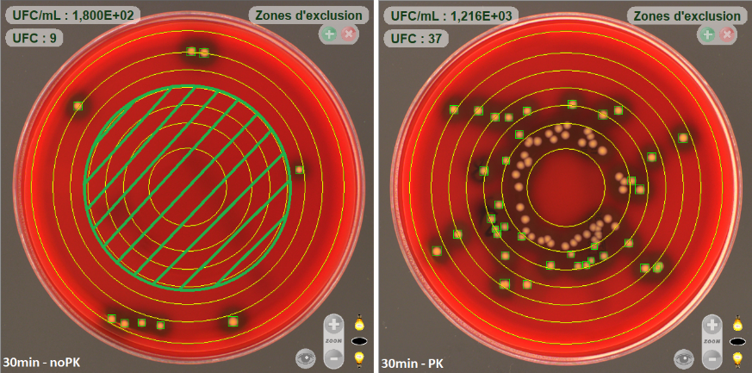
Spiral plating without lysostaphin inactivation (left) and with lysostaphin inactivation (right).

16. 2% Triton X-100 for the osmotic burst of mammalian cells are too high? Please cite an appropriate paper.

Response: We agree with this comment. We are sorry for the confusion. In fact, the final concentration of Triton X-100 is 0.25% for both protocol:
- For iEPA, the lysis buffer is at 4X concentrated and a 250 µl-volume is added into the well containing 750 µl of media (final concentration 0.25%)
- For EPA, 1 ml of the lysis buffer at 1X concentration is added to the empty well
The preparation of 4X and 1X lysis buffer was clarified in the two parts of the protocol (see 3.4.1 for iEPA and 3.5.1 for EPA)

17. In 3.4, please replace the LPA with iEPA.

Response: OK. Done.

18. In NOTE (line no.182-185), please replace the 3.5.5 with right section as there is no 3.5.5?

Response: Thank you. We made the correction.

19. In discussion, line no 225, "the internalization rate" should be replaced with "internalized bacteria" as there is no time-dependent kinetic study to determine the rate.

Response: We agree with this comment. The word “rate” was no longer used in the manuscript.

20. In discussion, "Bacterial suspension should be use rapidly and clumps could be dissociated with the help of an ultrasound bath. Alternatively, the inoculum can be prepared in advance and stored at +4°C for 24 hours or frozen at -20°C for several months but the impact on the metabolism of the bacteria must be taken into consideration." Clumping can be resolved by the hard vertexing or by repeated passing the bacteria through syringe, or by ultrasonic wave. However, the alternative method suggested is irrelevant pathophysiological conditions, and thus, should be removed from the manuscript.

Response: OK. The sentence was deleted.

21. In discussion, line no. 246-247, where is data showing phenol red is bacteriostatic? Author should also check and provide the growth inhibitory effect FBS on Staphylococcus aureus.

Response: As requested, we carried out additional experiments. As mentioned in response to point 6, the addition of 10% FBS do not reduce the growth of S. aureus SF8300 strain.
We have noticed in the past that bacteria grow more slowly in the presence of phenol red using RPMI1640 culture medium. Phenol red seems to have little or no effect on S. aureus growth with DMEM.
The sentence in the discussion was modified (see lines 364-365).

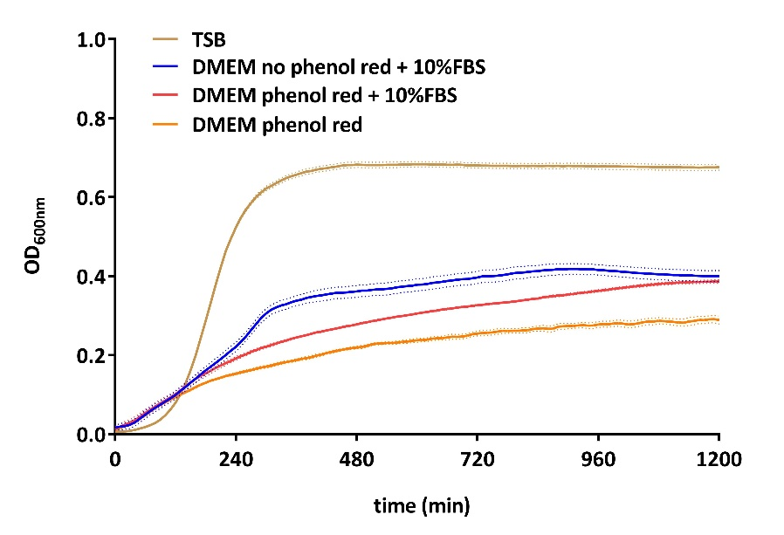
Growth curves of S. aureus SF8300 (Tecan Infinite M200).

22. In discussion, line no. 255-256, please be careful in using "internalized bacteria" and "internalization rate" interchangeably, as there is no kinetics study of the rate of internalization. Therefore, please use the term "internalized bacteria" than that of "internalization rate".

Response: As mentioned above, the word “rate” was no longer used in the manuscript (see lines 346 and 374). A sentence was deleted (see line 372).

23. In discussion, line no. 263-264, Kim et. al 2019 used EDTA or 1,10-phenanthroline, Fig S12 of Kim et al. 2019, IAI). Please correct.
Response: Thank you. The sentence was corrected as proposed (see line 379).
Reviewer #3:
Manuscript Summary:
The authors described a modificiation of lysostaphin protection assay to improve the study of interanlization and intracellular efficacy of antimcirobial compounds. The manuscript is well written and easy to follow. Also the protocol is very clear. However, I have only few questions/comments (see minor concerns)
Minor Concerns:
The authors described the preparation of bacteria in DMEM high glucose withoud phenol red, a bacteriostatic medium. Is it possible the bacterial growth is affected because the microbes are under stress? Can this point affect the expression of adhesins necessary for interanlization?

Response: In our hands, we did not observe a difference of internalization level of S. aureus into HaCaT cells according to the media used for growing bacteria.

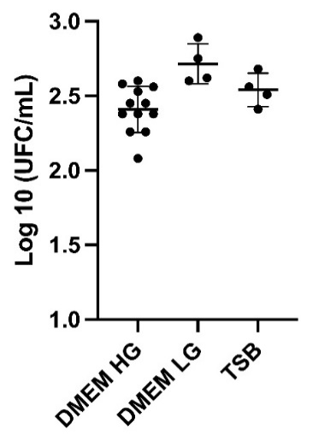

Intracellular S. aureus loads into HaCaT cells at 3 hours post infection according to the culture media used for bacteria (HG: high glucose; LG: low glucose; TSB: Tryptic soy broth).

Why is not possible to culture the bacteria in a growth media and resuspend in DMEM directly before infection?

Response: Theoretically, It is quite possible to grow S. aureus in TSB, centrifuge bacteria and resuspend them in DMEM for example. However, in our hand, washing bacteria induces a significant variability between experiment probably because it generates clumps that not always easy to fully dissociate. Thus, we are unwilling to recommend washing bacteria.
A sentence was added in the discussion (see lines 360-361).

Why the points 3.36 and 3.4.5 are different?

Response: We are sorry for the confusion. As mentioned in response to reviewer #2, the final concentration of Triton X-100 is 0.25% for both protocol:
- For iEPA, the lysis buffer is at 4X concentrated and a 250 µl-volume is added into the well containing 750 µl of media (final concentration 0.25%)
- For EPA, 1 ml of the lysis buffer at 1X concentration is added to the empty well
The preparation of 4X and 1X lysis buffer was clarified in both protocol (see 3.4.1 for iEPA and 3.5.1 for EPA)

Are you sure that the long incubation with lysostaphin do not alter the host cells?

Response: Thank you for this interesting comment. To our best knowledge, there is no data in the literature about the effect lysostaphin on mammalian cells. We cannot exclude that lysostaphin could modify (at least slightly) the host cell response. However, in our experience, lysostaphin is not cytotoxic for A549 and HaCaT cells.

The authors claim that this modified protocol improve the intranlization of bacteria. However, the fig. 1a does not show significant differences.

Response: Yes. We decided to show results demonstrating that the EPA and iEPA give similar result when cell health is good. As mentioned in the results section, iEPA is more reliable when cell are heavily infected. The sentence was modified to clarify what we said (see lines 324-325).

Why the antibiotic treatment was done with other strains and cells?

Response: The journal ask to provide representative results. We work on different research projects using different strains and cell lines in the lab. To be honest, we have used results that are available in our research group.

