Dear Dr. Bajaj,
Thank you for reviewing our manuscript “Quantifying Levels of Dopaminergic Neuron Morphological Alteration and Degeneration in Caenorhabditis elegans” and providing the opportunity to submit our revisions. We have reviewed the careful feedback we received and done our best to address all the points brought up by the three reviewers and the editorial and production team. Please find new details, clarifications, and edits in our revised submission, highlighted with the “track changes” feature. Please also look below for responses to specific comments from each reviewer. In addition to addressing these comments and concerns, we also took this time to ensure the manuscript is well proofread and follows all JoVE formatting requirements. We very much appreciate the time spent by you and all our reviewers to ensure that our manuscript is in the best possible shape. We look forward to hearing back from you regarding our submission and are more than happy to address any further questions and comments you may have.
Respectfully,
Shefali Bijwadia, Katherine Morton, and Joel Meyer

Editorial and production comments:
Thank you for providing this feedback. We appreciate the attention to detail and the notes to ensure our manuscript is well received and fits the goals of your journal and its audience. We note below how we have responded to each of your comments.
Changes to be made by the Author(s) regarding the manuscript:
1. Please take this opportunity to thoroughly proofread the manuscript to ensure that there are no spelling or grammar issues. Manuscript has been thoroughly proofread by all authors.
2. Please make the title concise: Quantifying Levels of Dopaminergic Neuron Morphological 2 Alteration and Degeneration in Caenorhabditis elegans. Our title has been shortened as suggested.
3. Please ensure that the long Abstract is within 150-300-word limit and clearly states the goal of the protocol. We have reviewed the abstract to ensure it is within word limit and contains the rationale, relevance, and goal of the protocol.
4. JoVE cannot publish manuscripts containing commercial language. Please remove all commercial language from your manuscript and use generic terms instead. All commercial products should be sufficiently referenced in the Table of Materials and Reagents.
For example: Keyence BZ-X710 All-in-One Fluorescence Microscope, Keyence image file, Blinder, etc. We have removed all cases of commercial language from the manuscript. Specific commercial products we used are referenced in the table of materials.
5. Please ensure that all text in the protocol section is written in the imperative tense as if telling someone how to do the technique (e.g., “Do this,” “Ensure that,” etc.). The actions should be described in the imperative tense in complete sentences wherever possible. Avoid usage of phrases such as “could be,” “should be,” and “would be” throughout the Protocol. Any text that cannot be written in the imperative tense may be added as a “Note.” The protocol section has been amended to ensure formatting and phrasing follows JoVE requirements. Any text not written in imperative mood has been revised or moved to a “note”.
6. Please add more details to your protocol steps. Please ensure you answer the “how” question, i.e., how is the step performed? This can be done by including mechanical actions, knob turns, button clicks in the software, etc. We have added key details to improve clarity in the protocol section. In particular, we have added specific actionable instructions such as “pipette or pick,” “tap,” and “click.”
7. The Protocol should be made up almost entirely of discrete steps without large paragraphs of text between sections. We have reviewed the protocol section to ensure conciseness. Additionally, we have moved alternative protocol options, previously embedded within different steps of the protocol, into their own protocol step (step 8: Consider Alternate Protocol Options). This was intended to reduce instances of longer text throughout the key steps of the protocol.
8. Please ensure that individual steps of the protocol should only contain 2-3 actions sentences per step. All protocol steps have been reviewed to confirm they are no more than 2-3 sentences.
9. Only one note can follow one step. In the JoVE Protocol format, “Notes” should be concise and used sparingly. They should only be used to provide extraneous details, optional steps, or recommendations that are not critical to a step. Any text that provides details about how to perform a particular step should either be included in the step itself or added as a sub-step. Notes have been checked to ensure they contain appropriate information and are each individually placed after one step.
10. Please ensure the Representative Results are described in the context of the technique you have described, e.g., how do these results show the technique, suggestions about how to analyze the outcome, etc. The paragraph text should refer to all of the figures. Data from both successful and sub-optimal experiments can be included. We have reviewed the Representative Results to ensure they are described with the presented protocol in mind. Please note that the first paragraph in this section describes the methods of the experiment used to generate the representative results, as the nature of our protocol has to do with the data collection and analysis rather than the experimental details themselves. A note has been added to mention Figure 1 so that the text refers to all figures.
11. Please obtain explicit copyright permission to reuse any figures from a previous publication. Explicit permission can be expressed in the form of a letter from the editor or a link to the editorial policy that allows re-prints. Please upload this information as a .doc or .docx file to your Editorial Manager account. The Figure must be cited appropriately in the Figure Legend, i.e. “This figure has been modified from [citation].” The data presented in this manuscript is currently unpublished thus does not require copyright permission.
12. As we are a methods journal, please ensure that the Discussion explicitly cover the following in detail in 3-6 paragraphs with citations:
Please find these details in the paragraphs of the discussion section listed below:
a) Critical steps within the protocol Paragraph 3 (discussion of statistical analysis)
b) Any modifications and troubleshooting of the technique Paragraph 3 (presents two alternate options for analysis, along with caveats and suggestions)
c) Any limitations of the technique Paragraph 4
d) The significance with respect to existing methods Paragraphs 1 and 2
e) Any future applications of the technique Paragraph 5
Changes to be made by the Author(s) regarding the video:
1. Please increase the homogeneity between the video and the written manuscript. Ideally, all figures in the video would appear in the written manuscript and vice versa. The video and the written manuscript should be reflections of each other.
2. Furthermore, please revise the narration to be more homogenous with the written manuscript. Ideally, the narration is a word for word reading of the written protocol.
The protocol section of the video has been rearranged and re-recorded so that the narration reads word for word the written protocol, with minor deviations where needed to ensure clarity.
3. Introduction/Conclusion: Instead of having slides it will be nice to show this section as a person being interviewed on the camera or include some video shots. We have added video shots to both the introduction and conclusion section of the video.
4. Please do not show/narrate commercial terms in the video, VWR, Keyence, Blinder, etc. These narrations have been removed from the video. Any images containing commercial terms have been cropped or edited so as not to show the commercial terms. Please note that Blinder is non-commercial (though in the manuscript text and video narration we write/say “blinding software” to emphasize that any such software may be used).
5. 2:54: If possible, show worm images/ video shots for different scores. An additional worm image has been added at 2:30.
6. The representative results section should only show what are results obtained from the protocol being shown in the video. Any other details associated with the protocol should be in the protocol section. 5:03 this part needs to be moved to the protocol instead. Also instead of just showing the chemical please include a video shot of how it is used in the protocol. We have shortened this section to minimize the details of the rotenone exposure protocol, since these methods are relevant only to the particular experiment done to generate the representative results, and not to the protocol presented in the manuscript/video. We have chosen not to include these details in the protocol section to avoid confusion; any experiment using an appropriate strain can be performed and processed/analyzed according to our protocol. This is conveyed in the Introduction and Discussion.
7. Video Editing Content:
• Please downconvert the video maximum resolution for JoVE videos is 1920x1080 for 16:9 or 1440x1080 for 4:3. Videos larger than 1920x1080 is not acceptable. Video has been down-converted to 1440x1080 resolution.
• 00:05 - 00:49 Consider adding some video clips or image to pair with what is being explained in the narration. it will be easier to understand. Video clips have been added.
• 00:48 - 03:24 Consider adding some video clips or multiple image to pair with what is being explained in the narration. it will be easier to understand. This section’s narration has been re-recorded in order to better reflect the manuscript, and video clips have been paired accordingly.
• 05:37 - 06:19 Consider adding some video clips or multiple image to pair with what is being explained in the narration. it will be easier to understand. Video clips have been added.
8. Audio Editing and Pacing:
• Audio are quite low. Please boost the audio level & ensure audio level peaks average around -9 dB. Audio levels throughout the video have been increased to 9 dB.
Reviewers' comments:
Reviewer #1:
Manuscript Summary:
Bijwadia et al, provide a detailed protocol describing a scoring system for anterior dopaminergic neurons in C. elegans. I agree that this is an important contribution and fully support publication.
I have several points that can be improved, the most important one me urging the authors to better describe (highlighting key features by arrows) and extending the corresponding figure legend degenerating neurons in their example Figures. Ideally, the video should be extended the narrator describing all example pictures. The second major comment relates to safe handling of compounds used for inducing neurodegeneration.

Dear reviewer #1,
Thank you for taking the time to review our submission. We have carefully reviewed your notes and made every effort to address all concerns and consider all recommendations. We appreciate your support for publication and are committed to using your thoughtful review to make this submission a successful contribution to the scientific community. Please find our specific responses to your point per point comments below.
Here my point per point comments:
IMPORTANT: I think the authors should comment on (and or provide a reference to) the safe handling (and inactivation) of the drugs used for inducing dopaminergic loss especially on 1-methyl-4-phenyl-1,2,3,6-tetrahydropyridine (MPTP) which passes the blood brain barrier and causes neurodegeneration. I think that this is one of the most dangerous drugs, that requires excessive safety procedures, and accidents handling MPTP occurred in the past. To my best knowledge 6-hydroxydopamine (6-OHDA) is much less critical it not passing through the blood brain barrier. Rotenone? (I assume no major safety concerns). It is important to ensure that ill equipped and unexperienced labs are not encouraged to use MPTP.
Thank you for recognizing the importance of working safely with toxic compounds and mentioning how we can better express this in our manuscript. We have added a general safety statement in the representative results section, where we describe our use of rotenone, a mitochondrial toxin. However, we kept this statement general, because researchers are testing more and more chemicals for their capacity for dopaminergic neurodegeneration. It is impossible to provide handling instructions for all that might be tested.
Please note that in most lab us use BY200 [vtIs1 (dat-1p::GFP, rol-6)] which largely does not show a roller phenotype (this phenotype having a very low penetrance). Please comment on this to avoid confusion.
It is out of the scope of this review, but I think that there is a case for generating a genome edited version of this reporter.
Please specifically mention that BY273 carries an alpha synuclein fusion, and that it thus should not be used for compound scoring!
Please mention that BY200 and BY273 (and other strains mentioned) are available at the GCG strain collection.
Thank you for sharing your thoughts and concerns pertaining to the mentions of specific strains in this manuscript. We agree that a genome edited strain would be useful. A mention of the low penetrance of the roller phenotype in BY200s has been added to the introduction section. We have also noted that scoring BY273 should not be done without validation, given that this strain carries an alpha synuclein protein (as a side note, we believe it may be interesting to test how a-syn expression might combine with chemical exposure in a gene x environment interaction; however, this is indeed beyond the scope of this manuscript). Please find the source of the BY200 strain, used for our experiments, listed in the List of Materials. To our surprise, it does not appear to currently be available from the CGC; therefore, we have offered to make it available upon request. We have noted that many strains are available from the CGC, or upon request from specific laboratories.
At the end of the introduction section please add 1-5 lines describing a picture of normal and degenerating anterior dopaminergic neurons and refer to the first figure where this is shown. This way reading the methods section will become much easier.
Line 124-135 (and within the extended intro section (point above) please refer to your first Figure.
Details of typical normal and degenerated ADE neurons have been added to the end of the third paragraph in the introduction, with a reference to Figure 1.
Line 152 Scoring from the left to right when the nose is at the top of the image is recommended to ensure
indicate left right and 'nose in the first picture'.
We have added a left- and right-side label into the corresponding section of the video (2:36) to ensure clarity.
Line 200 Eggs hatched in complete K200 medium33,39 with 0.25% dimethyl sulfoxide (DMSO), and worms remained in liquid until mid-L4 larval stage, at which point they were removed from chemical exposure, and prepared, imaged, and scored according to the protocol steps above.
Can you improve the above sentence to better indicate to the non C. elegans expert reader that exposure was done for ~2 days from L1 stage larvae onwards. Do I assume correctly that ref 33 and 30 fully describe the K200 medium needed to grow and culture worms in liquid medium.
This sentence has been edited to contain a note that the exposure was done for approximately 48 hours. You are correct in your interpretation of reference 33 and 30.
Figure 1, panel 2 please change arrow such that it points to a 'blob'.
Figure 1, in the figure legend please indicate in all cases what the arrows point at. In panel 4 are all 4 dendrites still around? Panel 5 please comment as to why dendrites are scored as present.sc
Thank you for these notes. We have clarified in the figure legend that the arrows in Figure 1 point at one dendrite at the score value labelled in each panel. We do not point at specific blebs with the arrows because we consider the entire dendrite in our scoring system. In panel 4, all four dendrites are still present, but show clear damage. In panel 5, the dendrite indicated by the arrow is scored as present because 25-75% of the dendrite remains visible. Please note that line this dendrite can still be traced confidently (it presents as a dotted line due to the blebbing).
I strongly encourage to describe all the example Figures in the video. In many cases I was not sure if I agree on the score. Thus, extending the video to describe all sample pictures is important, I think.
Video: 3 image with only three dendrites scored. It appears to me that one neuron contains blobs.
We have rearranged the video narration so that the narration explaining the score categories plays as the viewer sees Figure 1. This change is intended to help the viewer associate the score value requirements with example images in real time and provide ample time to consider the image. In the first two walk-through example images, only 3 dendrites are scored because the images contained one un-scorable dendrite (which we explicitly state in the narration). These images were chosen specifically because we felt it valuable to show examples of overlapping dendrites and limitations of z-stack captures. Please note that criteria for un-scorable dendrites are included in the protocol and mentioned in the video during the walk-through scoring.
Supp Figure 1) TS_01 All neurons are scored as 2, can you show the up to 5 blobs for each neuron by arrows?
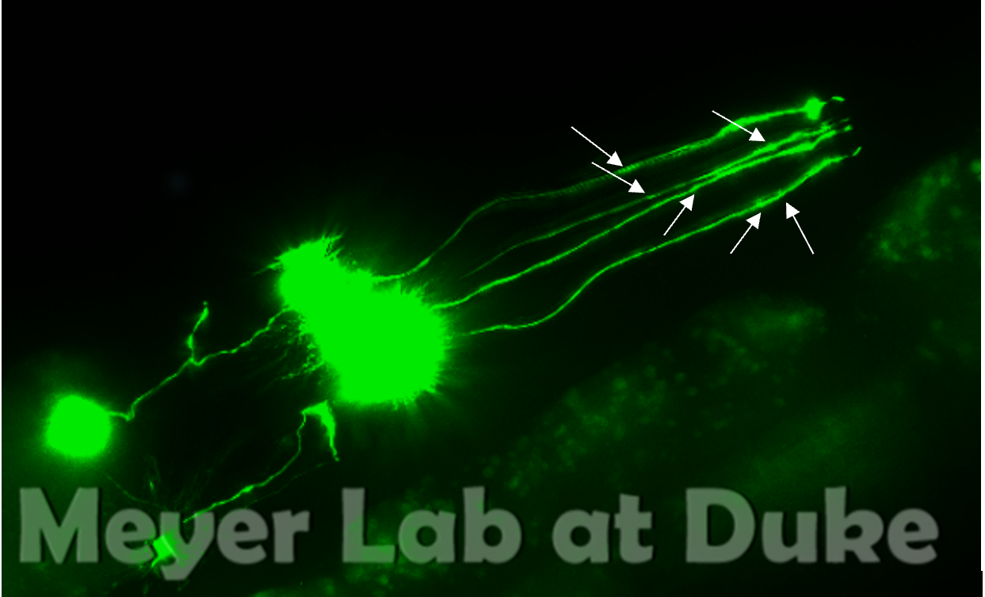
Please start with TS_21 as a wild type reference without any degeneration. In TS_21 is this picture underexpose compared to other pictures? (eg TS_16, 09, 13 etc)
Moved TS_21 to first slot, renamed TS_00, renamed TS_22 to TS_21 to keep numbering cohesive. The exposure on this image may be slightly lower, or the worm may have lower GFP expression. We chose deliberately to include worms with varying appearances to show how we score them despite the variability in image appearance.
TS_22, it appears that the worm moved during image acquisition. Remove?.
It is not uncommon for the projection of the z-stack to have high background depending on the projection method; it is also possible the position of the two less visible dendrites was not optimal for imaging. However, as the full length of the dendrite remains visible and trackable we still include the image in our analysis.
TS_02) why is D2 scored as 4? I do not see blobs. For D3 which is scored as 5, it appears that the part of the posterior section of the dendrite is out of focus (as opposed to be absent or broken)
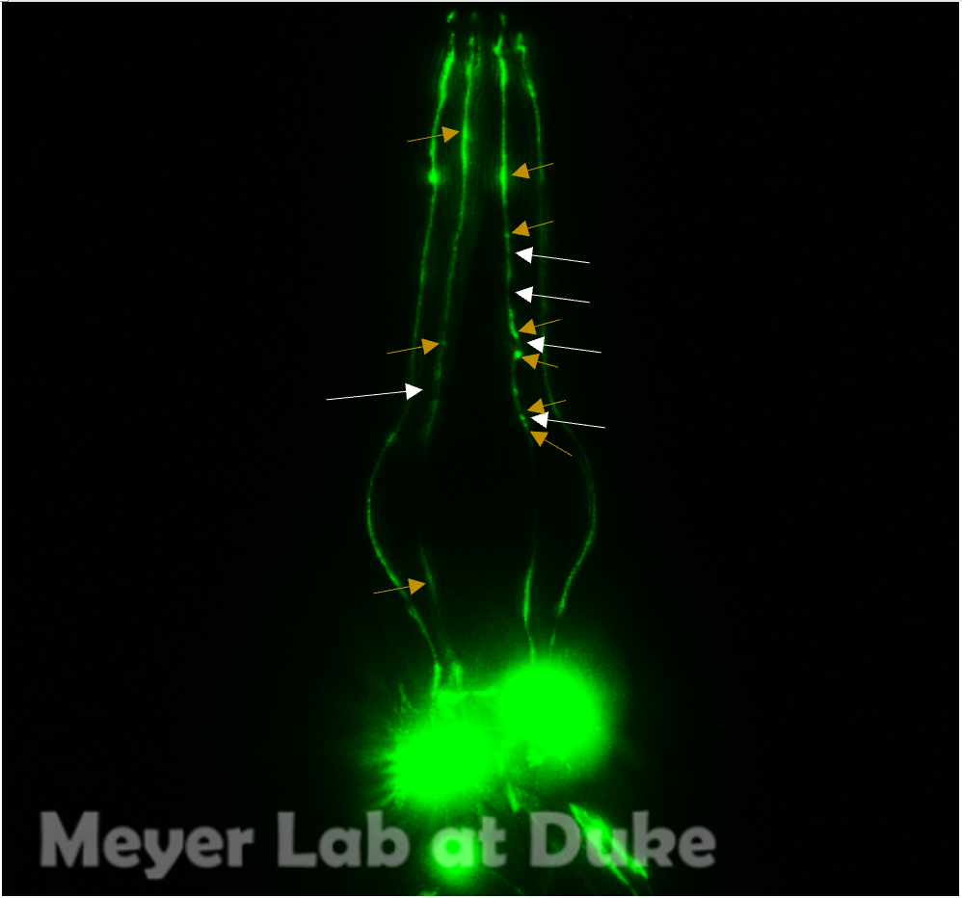
The white arrows indicate breaks, the orange arrows indicate blebs. As D2 has a break, it is scored a 4 as the break is more severe damage than blebs. D3 has multiple breaks, causing it to be scored a 5.
TS_03) As for TS_01 is it not really clear what a blob is.
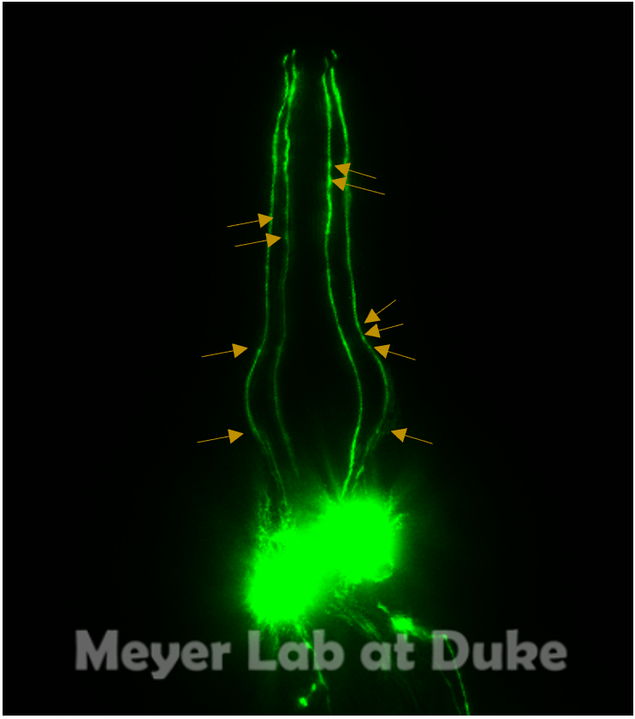
The orange arrows indicate blebs.
TS_08) It is not clear why one dendrite scores 5 the other 6. To me the both look equally degenerated (score both as 5 or both as 6)
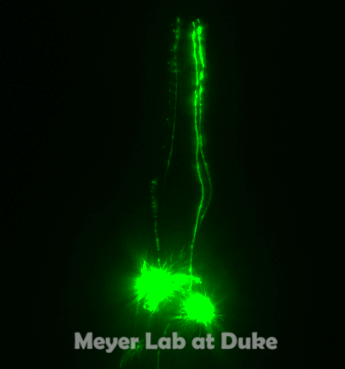
Thank you for pointing this out. We have reviewed and re-scored this image. The first two dendrites have been both scored as a 5, due to breakage removing 25-75% of the dendrite in each case.
TS_11) Where are the blobs.
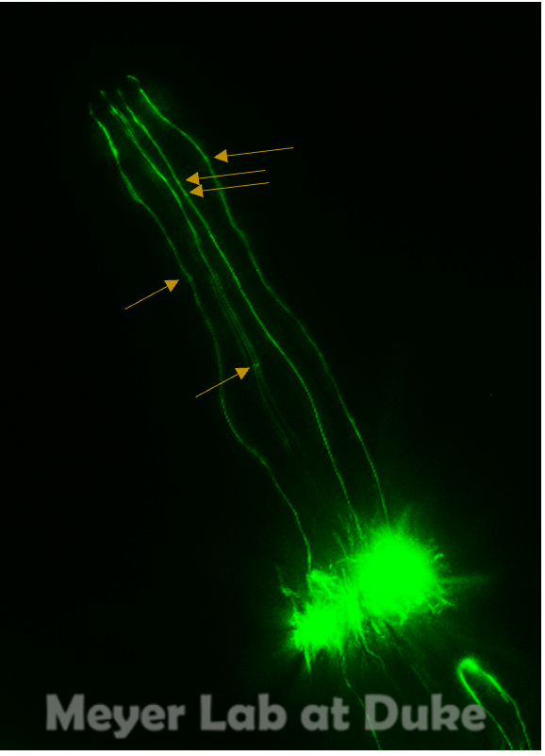
Blebs are indicated by the orange arrows.

Reviewer #2:
Manuscript Summary:
In this manuscript, authors developed a universal scoring system in order to assess morphological changes and degeneration in C. elegans' cephalic neuron dendrites. The described protocol represents a very useful tool to improve laboratory consistency and reproducibility when attemting to measure degeneration of dopaminergic neurons in this specific animal model. The method is well described and standarized so that other researchers can reproduce it thoroughly. Moreover, I find the training set of images and table very useful in order to achieve more consistent results over time.
Minor Concerns:
I recommend the authors including additional experiments analyzing at least one transgenic C. elegans model of PD expressing the protein alpha-synuclein in dopaminergic neurons (i.e. BY273 or UA44 strains). Neurodegeneration of cephalic neurons in these strains occurs concomitantly with age due to aggregation of alpha synuclein specifically in these neurons, so it would add more value to the protocol if they could show reproducible results with these models as well. Also, more detail of the statistic treatment of data, adding analysis examples in their protocol would be very valuable as well.
Dear reviewer #2,
Thank you for your thoughtful feedback and for highlighting areas of our submission that can be clarified and improved. We agree that transgenic strains of PD expressing alpha-synuclein may produce interesting and important data, however our scoring protocol has not been validated with, and is not intended to account for, all PD C. elegans models. We focus instead on scoring itself rather than on specific models. To ensure this point is clearly conveyed in the manuscript, we have added clarification in the third paragraph of the introduction and in the second paragraph of the discussion section. Thank you for noting that more detail may be helpful for statistical treatment. We have added additional details into protocol step 6, on statistical analysis.
Reviewer #3:
Manuscript Summary:
Bijwadia et al. present a detailed protocol for the detailed quantification of morphological changes and neurodegeneration in the dopamine neurons of hermaphroditic C. elegans. The authors provided an in-depth overview on the background of research surrounding dopamine neuron morphology and neurodegeneration of C. elegans and its role in C. elegans PD. To address some of the shortcomings that current dopamine neuron degeneration scoring methods have, the authors proposed a 7-point scoring method. The work provides a robust write-up for replicating the scoring consistently, with a set of reference images for calibration.
Minor Concerns:
* Having a criterion for each stage does help address some level of ambiguity (especially across different scorers), but there can still be some inconsistency during the image process and that can result in different interpretations, especially between stages 2-4. A good example is in the differences between images shown in figure 1 and in the Training set images. Should there be a directive set so that worms can be imaged consistently? For example, overexpose the soma, and make sure the processes fall within a certain GFP intensity range for scoring.
* Somewhat related to the previous point, the blebs in criteria 5-6 (from Figure 1) appear to be a lot more pronounced than ones shown in 2-3. How can we be sure that the blebs in 2-3 are not puncta, or a non-uniform distribution of GFP?
* Having a linear 0-7 score implies that there is a progression from healthy neurons (0) to dysmorphology (1) to blebbing (2-5) to degenerated (6). Can this progression be backed up with current literature?
* In the event where a process presents features from multiple criteria (ex. irregular + blebs), how can this be addressed consistently?

Dear reviewer #3,
We appreciate your manuscript summary and the feedback you provided. We have taken your concerns into account as we have reviewed and revised our submission—please read on for our responses to your specific comments. First, we acknowledge that ideally all worms should be imaged consistently, but that perfect consistency is not possible with a score-based system. We do think that our new system, combined with a training set that all users will practice on, will significantly improve replicability. Unfortunately, because this protocol was designed for a variety of imaging instruments, we cannot provide one directive set due to the variation between instruments. We feel the generalizability of the protocol to labs with different equipment availability is worth the trade-off in being able to prescribe instructions that might permit more nearly perfectly consistent image acquisition. Even so, we aim to maximize consistency in our protocol instructions, notably in protocol step 2. We have added a sentence (2.1.1: Be mindful of exposure and aperture settings; avoid overexposure of dendrites and keep settings consistent across trials. Make the dendrites as bright as needed for clear visualization; this typically results in overexposure of the soma.) in order to accomplish this goal. Please also see protocol step 4.2.2 to address concerns regarding false blebs and other notes to avoid mis-scoring dendrites. Second, we agree that the 0-7 score implies a progression from healthy to degenerated. While we use criteria (blebs, breaks) that have been used in previous literature as a sign of dopaminergic neuron damage, we agree that unfortunately, the progressive scale has not yet been validated in current literature. We note this as a most important area of research for future directions at the conclusion of the discussion section. We also note that while the scale presents as linear, the data is non-parametric, and provide discussion on how to best analyze the data with all these limitations in mind. Finally, thank you for pointing out the ambiguity surrounding scoring dendrites with multiple features, such as irregular + blebs. We have added instructions for this type of scenario in protocol step 4.2.1: If multiple criterion are met within a single dendrite (i.e. kinks and blebs), assign the highest applicable score.

