To July 2, 2021
Vidhya Iyer, Ph.D.
Review Editor,
JoVE,

&

Prof. Abigail Lytton-Jean, (Editor)
Journal of Visualized Experiments,
Koch Institute for Integrative Cancer Research at MIT.

Subject: Response Requested: JoVE Submission JoVE62832R1 - [EMID:4ea92d7f424240bb] on dated June 25, 2021

Dear Dr.Vidhya Iyer, Ph.D.,

At the outset, we would like to thank you for giving us an opportunity to resubmit the revised manuscript in your journal. Additionally, we would like to thank the Review Editor (Vidhya Iyer, Ph.D. Review Editor) for the constructive suggestions, comments and for changing the formatting of our manuscript. By addressing these comments, we feel the quality and impact of our manuscript have significantly improved. According to the Editor’s suggestions, 10 figures are shifted to supplemental figures and 7 main figures are there. Additionally, we have modified the title of the manuscript. Please find enclosed our revised manuscript entitled, “A User-friendly, High-throughput, and Fully Automated Data Acquisition Software for Single Particle Cryo-electron Microscopy” which we are submitting for review as a video article in the Methods Collection on cryo-EM in your prestigious journal “Journal of Visualized Experiments”.
Two figure files “main figures” and “supplemental figures” are attached with this manuscript. We have addressed all the comments of the Editor’s and highlighted all the answers in the manuscript using the reply button of the Editor’s comments. Additionally, some sentences, which are not required or modified are “strikethrough” but did not delete it from the manuscript. If we delete the sentence, the Editor’s comments and Author’s answer willalso deleted. Therefore, these lines
are only “strikethrough”, not deleted from the text. Track changes are on to visualize the changes are made during this revision. Also, we highlighted the Protocol (including headings and spacing) that identifies the essential steps {starting from Protocols Number 3 (3.1.) to Protocol number 6 (6.12)} of the protocol for the video.
All authors reviewed the manuscript, and Structure Final File Checklist and agreed to the submission of the revised manuscript. We hope the manuscript will be acceptable for publication. Please feel free to contact me if you have any questions.
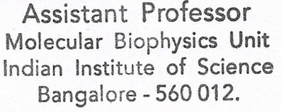
Sincerely,
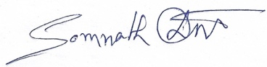
Somnath Dutta (Assistant Professor)
Molecular Biophysics Unit
Indian Institute of Science
Bangalore 560012

