Response to reviewers
Thank you for your insightful feedback. We believe that we have addressed all of the key concerns raised. In the rare case that a concern was not addressed by an amendment to the text, we have provided a brief justification. Any edits to the previous submission have been highlighted in red.
Editorial and production comments:
- Please take this opportunity to proofread the manuscript thoroughly to ensure that there are no spelling or grammar issues.
We have proofread the manuscript thoroughly.
- Please format the manuscript as: paragraph Indentation: 0 for both left and right and special: none, Line spacings: single. Please include a single line space between each step, substep and note in the protocol section. Please use Calibri 12 points.
The manuscript has been re-formatted accordingly.
- Please provide an email address for each author.
Jarrah Dowrick: j.dowrick@auckland.ac.nz
Alex Anderson: elegantgrooves@gmail.com
Ming Cheuk: ming.cheuk@spark64.com
Kenneth Tran: k.tran@auckland.ac.nz
Poul Nielsen: p.nielsen@auckland.ac.nz
June-Chiew Han: j.han@auckland.ac.nz
Andrew Taberner: a.taberner@auckland.ac.nz
- Please rephrase the Short Abstract/Summary to clearly describe the protocol and its applications in complete sentences between 10-50 words: “This protocol presents…”
The Short Abstract/Summary has been re-phrased to “This protocol presents …”.

- Please ensure that all text in the protocol section is written in the imperative tense as if telling someone how to do the technique (e.g., “Do this,” “Ensure that,” etc.). The actions should be described in the imperative tense in complete sentences wherever possible. Avoid usage of phrases such as “could be,” “should be,” and “would be” throughout the Protocol. Any text that cannot be written in the imperative tense may be added as a “Note.”
Text that could not be written in the imperative tense were added as “notes”. We have rephrased or removed all instances of phrases such as “could be”, “should be”, and “would be” throughout the protocol section.
- Please ensure you answer the “how” question, i.e., how is the step performed?
We have restructured the protocol section to ensure that the how question is answered. In some cases, the level of detail was increased to make the steps involved clearer.
- Solution preparation details can be moved to a table and uploaded separately as .xlsx file.
We have removed the solution preparation details from the protocol section and moved them into a file called “Tables_of_solutions.xlsx”.
- There is a 10 page limit for the protocol section including headings and spacings.
The protocol complies with this limit.
- Please ensure the results are described in the context of the presented technique. e.g., how do these results show the technique, suggestions about how to analyze the outcome, etc. The paragraph text should refer to all of the figures. Data from both successful and sub-optimal experiments can be included.
We have included new figures (Figures 1, 3B, and 4), and have largely revised the result texts and figure captions.
- Please ensure all figures are referenced in the order. Please discuss all figures in the Representative Results. However, for figures showing the experimental set-up, please reference them in the Protocol.
We have checked that all figures have been referenced in order. The figures that show the experimental set-up are now referenced in the protocol section.

- Please obtain explicit copyright permission to reuse any figures from a previous publication. Explicit permission can be expressed in the form of a letter from the editor or a link to the editorial policy that allows re-prints. Please upload this information as a .doc or .docx file to your Editorial Manager account. The Figure must be cited appropriately in the Figure Legend, i.e. “This figure has been modified from [citation].”
All figures used within this article are original and generated specifically for it.
- JoVE cannot publish manuscripts containing commercial language. Please remove all commercial language from your manuscript and use generic terms instead. All commercial products should be sufficiently referenced in the Table of Materials and Reagents. For example: Nikon, etc.
We have removed all mentions of commercial language within the main body of the manuscript.
- Each Figure Legend should include a title and a short description of the data presented in the Figure and relevant symbols. The Discussion of the Figures should be placed in the Representative Results. Details of the methodology should not be in the Figure Legends, but rather the Protocol.
The figure legends have been edited to comply with these stylistic guidelines.
- Please sort the materials table in alphabetical order.
The materials table has now been sorted in alphabetical order based on the Name of Material/ Equipment column.

Changes to be made by the Author(s) regarding the video:
- Please increase the homogeneity between the video and the written manuscript. Ideally, all figures in the video would appear in the written manuscript and vice versa. The video and the written manuscript should be reflections of each other.
The figures included in the video have been changed to increase the homogeneity between the video and the written manuscript.

- Furthermore, please revise the narration to be more homogenous with the written manuscript. Ideally, the narration is a word for word reading of the written protocol.
We re-wrote the script and recorded new narration so it is essentially a word for word reading of the written protocol.

- Currently both the text and the video have different order of steps presented in the protocol text. There can be steps in the text that are not presented in the video however.
The order of the steps presented in the video have been adjusted to reflect the order of steps in the text.

- Please ensure that the protocol subheadings are the same both in the text and the video
We have modified the protocol subheadings in the text and the video so that they are aligned.

- Video Editing:
  - Needs an animal ethics card at the end of the introduction section before the protocol
An animal ethics card has been added at the end of the introduction section of the video.
  - Please include a title card at the end of the video as well.
We have included the opening title card at the end of the video as well.
Reviewer 1 comments:
Major Concerns:
No major concerns
Minor Concerns:
Some minor revisions can be made to further improve the quality of the manuscript and the video.
- The force and length-control equipment are custom but they could be briefly detailed in the manuscript.
A brief description of the custom force and length-control equipment has been added to the caption of Figure 3.

- The representative results are for an isometric twitch contraction. If a length ramp is imposed, sarcomere movement is expected to be greater and maybe faster than for the isometric case. Is the device still working for such protocols? In other words, what are the required experimental conditions to keep a good resolution for the calcium and muscle imaging?
The temporal resolution of each imaging system is independent of any length control applied to the muscle. The rate of tissue movement is not an issue for the calcium imaging system. However, there would be limitations with the brightfield imaging if the length ramp had a high velocity. For the post-processing steps, images must have sufficient contrast. Should the applied ramp result in a high material point velocity, motion blur could restrict the possibility to perform image registration. The minimum exposure time of our camera is 3.193 ms at a frame rate of 100 fps. At a velocity of *3.1 mm/s, features would move by 18.48 pixels (~9.90 μm) during a single exposure. To test the impact on the image registration process, we applied motion blur of 19 pixels in length to an image of a diffraction grating (500 lines/mm) and displacing it by 19 pixels. This displacement was detectable without error using the image registration code (image below). While this amount of motion blur would eliminate the possibility of directly measuring sarcomere length using FFTs, previous work from our group¹ has used these displacement measurements to determine the local strain field and found a strong correlation between strain and sarcomere length.

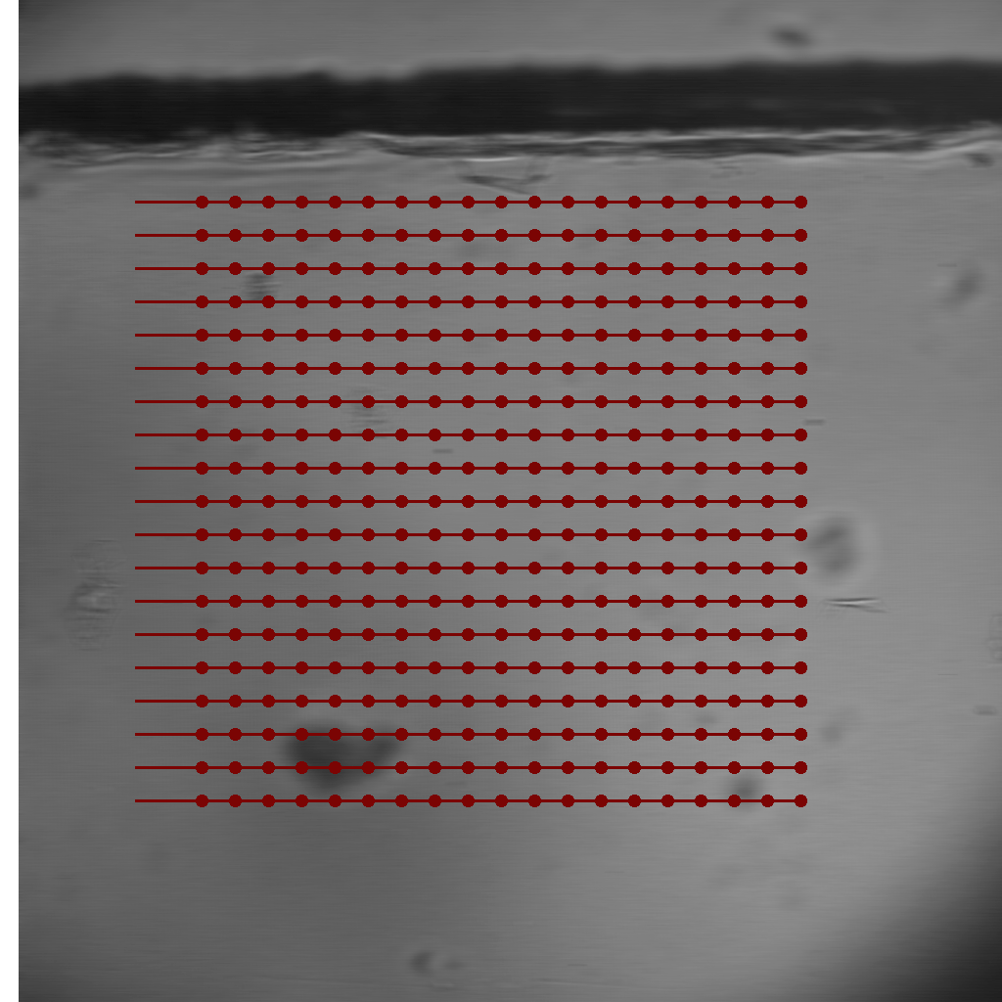
*This velocity was the peak shortening velocity reported in a previous publication².
1. Cheuk, M.L., Lam Po Tang, E.J., HajiRassouliha, A., Han, J.C., Nielsen, P.M.F., Taberner, A.J. A Method for Markerless Tracking of the Strain Distribution of Actively Contracting Cardiac Muscle Preparations. Experimental Mechanics. 61 (1), 95–106, doi: 10.1007/s11340-020-00646-w (2021).
2. Garrett, A.S., Pham, T., Loiselle, D., Han, J.C., Taberner, A. Mechanical loading of isolated cardiac muscle with a real-time computed Windkessel model of the vasculature impedance. Physiological Reports. 7 (17), e14184, doi: 10.14814/phy2.14184 (2019).

- How many sarcomeres (roughly) fit in the window used to image and average the sarcomere length? This information can probably be calculated from the data provided in the manuscript but it would help the reader to directly access this information. This will also quantify the level of heterogeneity the device is able to measure.
For the sarcomere length calculation performed during in the experiment, the user determines the window size. A typical window would be a 100 μm to 150 μm square meaning approximately 43 to 65 sarcomeres fit in the window when close to optimal sarcomere length.
When mapping the distribution of sarcomere lengths in post, a cross-correlation area of 128 pixels by 128 pixels (~67 μm by 67 μm) was used to calculate regional sarcomere length. This area encapsulates approximately 29 sarcomeres when the sample is close to optimal sarcomere length. The user can change this parameter. The step-size (in both x- and y-directions) between the centroid of each cross-correlation window is also under user control. The step-size parameter was set to 50 pixels (~26 μm) for processing these data.
We have added this information to the representative results section.

- Which software/code is used for FFT and exponential/Gaussian fitting? (section 5.1.3)
For the in-experiment setting of muscle length, the code is custom-written LabVIEW (following the algorithm outlined in reference 6). We have added a note to clarify this in what is now Section 4.3.

- For the author video, maybe the portion between 8min21 and 9min can be made clearer, as the galvanometer parameters described (such as X range) are not cited in section 4.6 of the manuscript. Furthermore, it is unclear to me how the position of the centre of the trabeculae is calculated before setting the x and y offset values.
We have now updated the protocol in Step 3.5.4 of the manuscript and provided a method to centre a trabecula in the written submission.

Reviewer 2 comments:
Major Concerns:
- I could not see any description about the data acquisition part (hardware details) in the manuscript. How did they acquire three distinct signals from the combined system? Did they use three separate analog channels? Which data QAQ has used for this? Need a comprehensive detail of these information.
Added a description of the data acquisition system to the paragraph at the start of Section 3 of the protocol. We have also updated the descriptions of the DAQ cards used in the tables of materials for clarity.
- Section 2.2, It is not fully clear how did authors calibrate OCT depth signal in Micrometers? Didn't they used the refractive index of the tissue for the pixel calibration? If yes, what is the value of refractive index chosen, and why? Need a detailed explanation.
The steps involved in calculating the depth resolution have been modified to improve clarity (Section 1.2). Better justification regarding the selection of refractive indices has also been included in Step 1.2.9. The refractive index of the tissue was found in a paper studying the refractive index of muscles from various mammals (reference 12 in the paper).
- Authors need to provide the temporal resolution of the acquisition of each modality and together? What is the frame rate for each modality? Need to provide the temporal and spatial resolution in each case.
Brightfield image: 100 Hz, 0.535 μm/pixel
OCT: B-scan rate 100 Hz, lateral resolution: 10 μm, depth resolution (in air): 2.42 μm, (in myocardium) 1.73 μm
Fluorescence imaging: 200 Hz, PMT integrates the fluorescence associated with a 540 μm by 540 μm window.
These values have been added to the contents of the representative results.
- Authors should provide the schematic and photograph of the combined tri-modal system.
Figures 1 and 2 within the original submission were supposed to function as the schematic of the combined tri-modal system. The new Figure 1 is now a photograph highlighting the combined tri-modal system. We have also added an additional photographic panel to what is now Figure 3 (Figure 2 in the original submission).
- Need to provide the screen shot of the front panel of the image acquisition and control software.
A screenshot of the primary front panels of the custom-made image acquisition and hardware-control code software has been added to the manuscript as the new Figure 4.
- Authors need to show the co-registered image of these three modalities.
The issue with generating a co-registered image of these data is that the OCT generates a 3D mesh, the brightfield microscope a 2D image, and the fluorescence microscope integrates the light intensity within a volume. Co-registration of these three image modalities is not trivial and outside the scope of this manuscript, which is limited to describing a protocol for the simultaneous collection of these data.
Minor Concerns:
- Authors should mention their approach as 'ex vivo' in title as well as in main text (wherever applicable).
Ex vivo has been added to the title and, where applicable, in the main text.

