Nilanjana Saha, Ph.D.
Review Editor
JoVE

San Antonio, July 12, 2021

Dear Dr. Saha:

We hereby submit the second revision of our manuscript (JoVE62785R1), “Quality-controlled sputum analysis by flow cytometry” by Grayson et al., for publishing consideration. We would like to thank the editorial office for their time and effort dedicated to reviewing our manuscript.

We have addressed all the editorial concerns by responding in the comment bubble. There were no questions regarding the figures or tables. Therefore, we left these unchanged.

We have proofread the entire manuscript and found two mistakes that we corrected. These corrections involved lines 255 and 256, where we changed 106 to 10⁶.

We added 1 reference per request (reference # 29).

We confirm that this manuscript has not been published elsewhere, nor is it under consideration for publication at another journal. Thank you for your time and consideration. We look forward to hearing from you.

Sincerely,

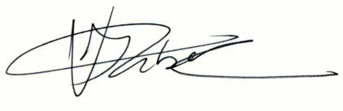

Vivienne I. Rebel, M.D., Ph.D.

