Response to Editor’s and Reviewers’ Comments
We thank the Editor for handling the review process for our submission and allowing us to resubmit a revised copy of the manuscript. We also would like to thank for receiving insightful comments and constructive suggestions concerning this manuscript from the editor and reviewers. We have fully addressed all the review concerns and significantly improved the quality of the manuscript. All revised sentences are printed in BLUE color in the revised version of the manuscript to facilitate the re-review. Below we highlight the point-by-point response (in BLACK) to the all comments.

Editor:
1. Please take this opportunity to thoroughly proofread the manuscript to ensure that there are no spelling or grammar issues.
Response: Thank you for your suggestion. We have proofread the manuscript to correct grammar/language errors carefully throughout the text. Revised sentences are printed in BLUE color in text.

2. Please revise the following lines to avoid previously published work: 77-78, 82-84, 101-108, 124-125, 128-132, 137-138, 141-142, 147-148, 150-152, 191-193,197-199, 205-207, 219-218, 235-237, 262-267, 324-325, 338-339, 353-356.
Response: We have revised these lines carefully to avoid previously published work. They all printed in BLUE color in text. For example, (p. 4, line 85–87, p. 5, line 90–91)

3. Please ensure that abbreviations are defined at first usage.
Response: In revised manuscript any abbreviations exist at first usage have been carefully defined to avoid confusing. For example, (p. 2, line 27–28)
“Further, a pipeline of analyzing Inter-Brain Synchrony (IBS) of oxygenated hemoglobin (Oxy-Hb) signals is presented.”

4.Please revise the text to avoid the use of any personal pronouns (e.g., "we", "you", "our" etc.).
Response: We have thoroughly revised the sentences which use personal pronouns. For example, (p. 2, line 25–28)

5. Please include an ethics statement before the numbered protocol steps, indicating that the protocol follows the guidelines of your institution’s human research ethics committee.
Response: We are sorry about not including the ethics statement in previous manuscript. We have included the ethics statement in this revised manuscript on (p. 5, line 93–96). The manuscript now reads:
“All recruited participants were healthy. Prior to the experiment, participants gave informed consent. Participants were financially compensated for their participation. The study was approved by the University Committee of Human Research Protection (HR-0053-2021), East China Normal University.”

6. Please add more details to your protocol steps. Please ensure you answer the “how” question, i.e., how is the step performed?
Response: Thanks for your suggestion. We have added more details to clarify “how” question.
Step 1.1.1: Please provide details regarding the swimming cap used
“1.1.1. Adopt elastic swimming cap to place optode holder grid. Considering the head sizes of participants are different, two sizes of caps are used. Small caps are prepared for participants with head circumference of 55.4 ± 1.1 cm, and large caps are prepared for participants with head circumference of 57.9 ± 1.2 cm.”

Step 1.2.2: Please specify the laser diodes used
“The absorption of near-infrared light (two wavelengths: 695 and 830 nm) is measured with a sampling rate of 10 Hz.”

Step 2: Please include any participant inclusion/exclusion criteria.
“All participants were healthy and were financially compensated for participation. No participants withdrew from the experiment halfway through.”

Step 2.1.2: Please specify the distance between the chairs
“Seat the participants face-to-face (apart by a table (0.8 m)) to make sure they can see each other directly. Adjust the chair-to-table distance (i.e. nearly 0.3 m) to make participants sit comfortably.”

Step 2.1.6: Please provide details on the procedure of signal calibration. What are the measurement criteria for the sufficient and insufficient signal?
“2.1.6. Perform signal calibration. First, check the quality of signal by clicking on the Auto Gain button. Then, insufficient signal and sufficient signal of a channel is marked in yellow and green in the probe set monitor window, respectively. For channel with insufficient signals, lighted fiber optic probes are used to move the hair under the tip of probe to one side. Additionally, push the probes further into their sockets is also allowed to get sufficient signals. Repeat this process until all the channels are marked in green in the probe set monitor window of the NIRS measurement system, indicating the quality of signals is accessible.”

Step 2.2.4: Please specify the cleaning and the washing procedure
“2.2.4. Clean probes and probe holders with ethanol. Wash caps with mild detergent and let the caps air dry.”

Step 3.1.7: Please elaborate on how the PCA analysis was performed
“The PCA analysis which proposed by Zhang et al., is adopted here. First, decompose the signal. The specific formula of decomposition of fNIRS signal is: $H=UΣV^{T}$ Here, temporal and spatial patterns of fNIRS data are presented in two matrices (i.e. U and V). U is an 2D (sample point × principal component) matrix. V is also an 2D (principal component × principal component) matrix. The column in V indicates one principal component (PC), and the strength of that PC for certain channel is estimated in each entry of the column. The relative importance of each PC is represented by the value of the diagonal matrix Σ. Second, conduct spatial smoothing. Gaussian kernel convolution is employed to remove localized signals and to get the global component, Third, reconstruct the signal. To calculate the global component of the fNIRS data, the smoothed spatial pattern matrix $V^{*}$ is plugged back into the decomposition formula: $H_{Global}=UΣ({V^{*})}^{T}$. Then, localized derived neuronal signal can be obtained by using original data $H$ to subtract $H_{Global}$ : $H_{Neuronal}=H-H_{Global}$.”

7. Line 221: Please remove the reference description
Response: Reference description has been removed in the revised manuscript. The text now reads:
“Compare the averaged cluster-based T values from original pairs with the T values of 1000 permutations. The p values evaluated by this formula³⁴ ”

8. In the software, please ensure that all button clicks and user inputs are provided throughout.
Response: We have double checked the revised manuscript to ensure that all button clicks and user inputs are provided on (p. 8, line 159; p. 8, line 172; p. 9, line 185).

9. Please include a one-line space between individual protocol steps and then highlight up to 3 pages of the Protocol (including headings and spacing) that identifies the essential steps of the protocol for the video, i.e., the steps that should be visualized to tell the most cohesive story of the Protocol. Remember that non-highlighted Protocol steps will remain in the manuscript, and therefore will still be available to the reader.
Response: First, revised manuscript has included a one-line space between individual protocol steps. Second, the essential steps of the protocol for the video have been highlighted with GREY background in the revised manuscript. For example, (p. 5, line 100).

10. Please ensure that the highlighted steps form a cohesive narrative with a logical flow from one highlighted step to the next. Please highlight complete sentences (not parts of sentences). Please ensure that the highlighted part of the step includes at least one action that is written in imperative tense.
Response: The critical steps of the protocol have been highlighted in the revised manuscript with a logical flow. Specifically, the complete sentences have been highlighted, and highlighted action is written in imperative tense. For example, (p. 9, line 182).

11. JoVE cannot publish manuscripts containing commercial language. This includes trademark symbols (™), registered symbols (®), and company names before an instrument or reagent. Please remove all commercial language from your manuscript and use generic terms instead. All commercial products should be sufficiently referenced in the Table of Materials. Please sort the Materials Table alphabetically by the name of the material.
Response: First, all commercial language has been removed from revised manuscript. For example, (p. 9, line 192). Second, all commercial products have been referenced in the Table of Materials, which have been sorted by the name of the material.

12. Please remove the titles and Figure Legends from the uploaded figures. Please include all the Figure / Table Legends together at the end of the Representative Results in the manuscript text.
Response: First, the new version of uploaded figures has been removed the titles and Figure legends. Second, the Figure / Table Legends have been presented at the end of the Representative Results in the manuscript text.

13. Each Figure Legend should include a title and a short description of the data presented in the Figure and relevant symbols. The Discussion of the Figures should be placed in the Representative Results.
Response: First, for each figure legend, the title and the short description of the data have been presented in the Figure and relevant symbols. The discussion of the Figure has been placed in the Representative Results in revised text on (p. 15–16, line 318–337)
“Figure 2 illustrates the fNIRS data analysis pipeline. The fNIRS data analysis is applied on all fNIRS data recorded from each participant and each channel. First, optode density in channel 33 for certain dyad is visualized in Figure 2A. Optode density is recorded in 46 channels (CHs) of each collaborative learning dyad by fNIRS measure system. Second, With the operation clarified in steps 3.1.5 and 3.1.7, viable data are prepared for WTC analysis. Here, the red curve represents the data extracted by the wavelet-based motion artifacts removing method; the blue curve represents the data extracted by both Wavelet-based motion artifacts removing method and PCA. Visualized difference between two curves suggest PCA is efficient in removing non-neural signals (see Figure 2B). Third, WTC matrix is visualized in the Figure 2D. The color map varying from blue to yellow, which represents the value of IBS raged from 0 to 1 (correlations coefficients as a function of time and frequency). Here, 1 denotes the largest coherence between two fNIRS signals, and 0 denotes no coherence is detected. Finally, with the operation stated in steps 3.2.4., the comparison between the observed T value and the distribution of random T value (i.e.1000 times) show significant results (t (38) = 3.31, FDR corrected p < 0.05, Cohen’s d = 1.05) in identified FOI (0.015 Hz-0.021 Hz) (see Figure 2D). Significant coefficients are marked by red rectangle in the plot. Additionally, results show a strong coherence around 1 Hz, which represent cardiac rhythm coherence of dyad. ”

14. As we are a methods journal, please revise the Discussion to explicitly cover the following in detail in 3-6 paragraphs with citations:
a) Critical steps within the protocol
b) Any modifications and troubleshooting of the technique
c) Any limitations of the technique
d) The significance with respect to existing methods
e) Any future applications of the technique
Response: Thank you for your suggestion. We have revised the Discussion carefully to cover the critical points you mentioned above, the revised Discussion as follows:
(p. 19, line 374–380; p. 20, line 386–400; p. 21–23, line 422–465; p. 23–24, line 469–495)

Figure 2: Please mark the different panels of the Figure as A, B, C, etc and provide the description accordingly. Please also provide an X/Y axis description and use SI abbreviations for time: s instead of seconds.
Response: First, we have marked the different panels of the Figure1 as A, B and Figure 2 as A, B, C, D. Second, the corresponding description has also been added in the revised manuscript. Third, X/Y axis description has also been added in the revised manuscript. Finally, in the revised manuscript, SI abbreviations for time (i.e. s instead of seconds) has been used. (p. 17; p. 18)

15. Please spell out journal titles in all the references.
Response: Thanks for your suggestion. We have gone through all the references to ensure all the journal titles have been spelled out. (p. 26–p. 33)
____________________________________

Reviewer #1:
This article described a co-learning task protocol design and associated data analysis pipeline for fNIRS-based hyperscanning study. Hyperscanning is an important topic in fNIRS field and it could be the future direction for this imaging technique. However, this article had quite a few issues that need to be addressed before it can be considered for publication. Also, the English in the article needs to be proofread. Please see my detailed comments below.
Response: We thank the Reviewer for his/her comments on this protocol. The revised text has been proofread. In what follows, we fully address all the comments and suggestions.

1. Line 26, please consider replacing the IBS as inter-brain synchrony.
Response: We have replaced the IBS as inter-brain synchrony. We also ensure that abbreviations are defined at first usage. The text now reads:
“Further, a pipeline of analyzing Inter-Brain Synchrony (IBS) of oxygenated hemoglobin (Oxy-Hb) signals is presented.”

2. Line 74, the phrasing of "IBS of each participant's prefrontal and left temporoparietal regions" is not proper. Since IBS stands for inter-brain synchrony, so it should be an index representing the two brains' association.
Response: We have revised these lines to:
“First, hemodynamic response is recorded simultaneously in each dyads’ prefrontal and left temporoparietal regions during a collaborative learning task.”

3. Line 142, Please specify if there is a quantitative threshold for the statement "Repeat this process until the quality of the signal is accessible."
Response: In this protocol, when all the channels are marked in green in the probe set monitor window of the NIRS measurement system, it represents the signal is sufficient. The specific details can be found in revised text. (p. 8, line 172–179).

4. When validating the localization with the 3D digitization, have the authors considered different head sizes?
Response: Yes, considering the head sizes of participants are different, two sizes of caps are used. The statement can be found in revised text:
“Considering the head sizes of participants are different, two sizes of caps are used. Small caps are prepared for participants with head circumference of 55.4 ± 1.1 cm, and large caps are prepared for participants with head circumference of 57.9 ± 1.2 cm.” (p. 5, line100-103)

5. Please list references that support 5 min is long enough for acquiring sufficient data for functional connectivity analysis.
Response: Functional connectivity analysis was not conducted on 5 min rest phase. Here, rest phase is served as a baseline which prepared to be compare with collaborative learning phase. The whole fNIRS recording process last for 20-25 min. This process includes 5 min rest-state, which serves as baseline, and also includes collaborative learning phase, which lasts for 15-20 min. We did not conduct wavelet transform coherence (WTC) analysis on two part of data separately. For each dyad, the whole data (include rest phase and collaborative learning phase) entered into the WTC analysis. Specifically, we conduct WTC analysis on two fNIRS time serious in each channel of specific collaborative learning dyads, and then for each channel, these data generated a 2-D matrix of the WTC value. In the matrix, each column represents a specific time point; each line represents a specific frequency point (ranged from ∼0.01 Hz in the low-frequency part to 1 Hz in the high-frequency part); Next, the WTC values were time-averaged across the entire resting-state session and collaborative learning session. More details can be checked in revised text (p. 4, line 74–76; p. 13, line 276–278; p. 13, line 285–288)

6. Line 145, how long was the co-learning phase in the protocol.
Response: The whole time contain 5 min rest-state, which serves as baseline, and then each dyad conduct collaborative learning for 15-20 min, so the whole fNIRS recording time lasts 20-25 min.
Specific description can be checked in revised text on (p. 15, line 310–316)

7. Line 166, please consider spelling out SD as standard deviation. In addition, please provide details on how the SD was calculated for each channel/participant/group?
Response: We have spelled out SD as standard deviation. We also ensure that abbreviations are defined at first usage. The details are included in revised manuscript on (p. 10, line 214–218)
“Delete the bad channels. For each participant, average OD value on each channel along full sample points, respectively, and 46 averaged OD values are obtained. Then calculate standard deviation (SD) for each participant. Finally, for each participant, channels with very low or high OD, which exceeded 5 SDs, are marked as unusable and removed from the analysis.”.

8. Were the RS data sharing the same preprocessing and analysis pipeline with the co-learning phase data? If so, was the co-learning phase data also filtered using the "band-pass filter with cut-off frequencies of 0.01-1 Hz"?
Response: Both RS data and co-learning phase data shared the same preprocessing and analysis pipeline. The band-pass filter was applied on collaborative learning phase and rest phase as well. The details are included in revised manuscript on (p. 10, line 204–206)
“Additionally, both fNIRS recording data collected in rest phase and collaborative learning phase share the same preprocessing and analysis operation.”

9. Please state the reason why the deoxy-Hb data was excluded from the analysis.
Response: First, previous research suggested that oxy-Hb is a sensitive indicator of the change in regional cerebral blood flow and has a high signal-to-noise ratio (Hoshi, 2007). Second, previous researches which employed fNIRS hypersacnning in teaching and learning scenario mainly focus on oxy-Hb concentration (Zheng et al., 2018,2020; Pan et al., 2019,2020). As such, we followed previous research to conduct analysis on oxy-Hb data. We have added the statement in revised text on (p. 11, line 224–229).
“In this protocol, all data analysis steps are conducted on Oxy-Hb data, which is considered as an indicator of the change in regional cerebral blood flow with higher signal-to-noise ratio²⁸. Additionally, previous research which employed fNIRS hypersacnning in teaching and learning scenario mainly focus on Oxy-Hb concentration¹¹⁻¹⁴.”

10. The current study used two artifact correction techniques, the Wavelet and PCA. It would be very helpful if the authors could show the effects of the two correction techniques respectively by maybe presenting example curves from a participant/channel?
Response: The example plot has been showed in revised Figure 2B. We also added the statement in revised text on (p. 15, line 322–327)
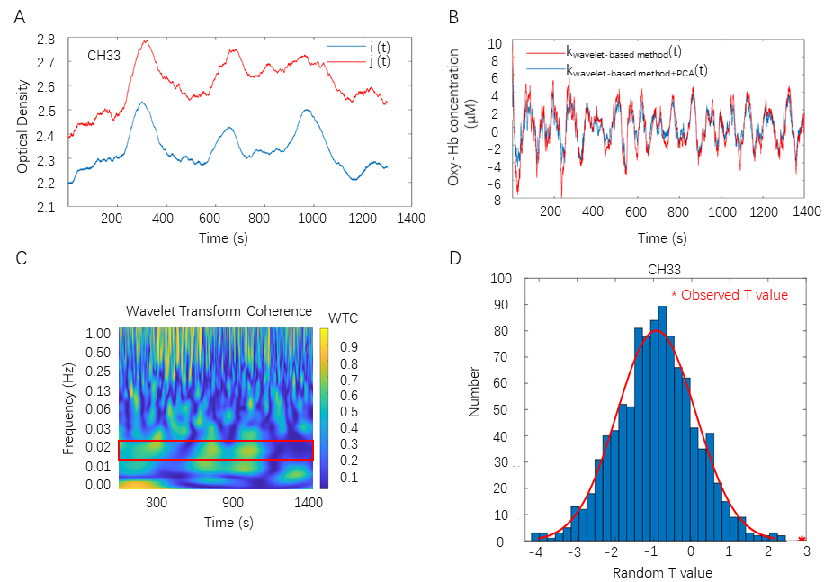Figure 2. Overview of the fNIRS data analysis. (A) Optode density in channel 33 for one exemplary dyad. Optode density is recorded in 46 channels (CHs) of each collaborative learning dyad. i, j, Optode density of two participants of a collaborative learning dyad; t, time. (B) Data preprocess procedure. Wavelet-based motion artifacts removing method and PCA are applied on Oxy-Hb data in sequence. k_{wavelet-based method}, data extracted by the Wavelet-based motion artifacts removing method. k_{wavelet-based method+PCA}, data extracted by both Wavelet-based motion artifacts removing method and PCA. (C) Cluster-based permutation approach. Compare the observed T value with the distribution of random T values in identified FOI (0.015 Hz-0.021 Hz). (D) WTC plot in channel 33 for one exemplary dyad. IBS is estimated by WTC on two clean Oxy-Hb time series.

11. Line 193, the authors stated that "Several toolboxes in Matlab established computation of the WTC", however, only the AST toolbox was mentioned later. Please make sure the statements are accurate.
Response: In this protocol, the toolbox which created by Grinsted was adopted. We have rephrased the statement in revised manuscript:
“Several toolboxes are used to calculate the WTC value. Here we use the toolbox crated by Grinsted and colleagues.³⁰”

12. Line 192, were the WTC matrices calculated from all channel pairs within the two participants?
Response: Yes, the WTC matrices calculated from all channel pairs in each dyad. For two corresponding channels (the same channel in one specific collaborative dyad), one 2-D matrix of the coherence value were generated. In the matrix, each column represents a specific time point; each line represents a specific frequency point (ranged from ∼0.01 Hz in the low-frequency part to 1 Hz in the high-frequency part). (p. 13, line 276–278)
“3.2.3. Calculate the WTC value for two corresponding channels (the same channel in two participants) in numeric computing platform (see Table of Materials). Following the same procedure, 46 WTC matrix are generated from 46 channels.”

13. Section 3.2.4.1, the paired sample t-tests described here are a bit confusing. Please consider rephrasing the paragraph. Specifically, what were the task effects tested here? Also, if I am understanding correctly, a difference in magnitude between the resting state and the co-learning phase is not necessarily a task effect. The authors will need at least a control task to validate this (e.g. two participants doing some other tasks that will not generate a "task effect").
Response: Following previous research, interpersonal interactions as opposed to resting state elicited significantly larger IBS (Cui et al., 2012; Jiang et al., 2012). The significant difference in WTC value between the rest phase and the collaborative learning phase indicate IBS exist during collaborative learning. This paragraph has been carefully revised on (p. 13–14, line 285–288).
“Time-average WTC values in resting phase and collaborative learning phase respectively for each channel combination. Then, conduct paired sample t-tests along the full frequency (frequency range: 0.01–1Hz³²) on these time-averaged WTC values (collaborative learning vs. rest).”

We agree with the reviewer that recruiting a control condition, such as talking condition in which require dyads to talk on certain topic, would be an ideal approach to validate the task effect. We have discussed this concern as a limitation in Discussion on (p. 24, line 489–494).
“Sixth, it is necessary to recruit control condition, such as talking condition which requires dyads to talk on certain topic to exclude confound effects. Meanwhile, to reveal which learning activity in collaborative learning (i.e. knowledge co-construction⁵²) would lead to the IBS. And whether these detected IBS can be used to track the learning performance of collaborative learning dyads are also important.”

14. Moreover, it is interesting to know what frequency is relevant to the co-learning activity.
Response: In this protocol, the frequency band relevant to the collaborative learning activity is ranged from 0.015 Hz to 0.021 Hz. Similar frequency bands (0.017-0.024 Hz) was identified in previous fNIRS hyperscanning research which compared the elaborative feedback and simple feedback in teaching scenario (Zhu et al., 2021). Additionally, the identified frequency band is also overlapping with other frequency band identified by previous studies with communication paradigms (e.g., Jiang et al., 2012; 2015) and teaching paradigms (e.g. Zheng et al., 2018). We have state this results in revised text on (p. 16, line 331–335; p. 16, line 342–344; p. 23, line 459–463).
“Finally, with the operation stated in steps 3.2.4., the comparison between the observed T value and the distribution of random T value (i.e.1000 times) show significant results (t (38) = 3.31, FDR corrected p < 0.05, Cohen’s d = 1.05) in identified FOI (0.015 Hz-0.021 Hz) (see Figure 2C).”

“Taken together, Following the data analysis pipeline, the frequency band (raged from 0.015 Hz to 0.021 Hz) which sensitive to collaborative learning is identified by cluster-based permutation approach.”

“Here, this technique operated efficiently. The collaborative learning related FOI (0.015-0.021 Hz) is identified. and Similar frequency bands has been identified in fNIRS hyperscanning research in teaching scenario¹³ and in verbal communication paradigms⁸.”

15. It is suggested to provide a flow chart for step 3.2.4 to better representing the statistical process.
Response: Thank you for your suggestions, a flow chart (Figure 3) for step 3.2.4 is added as requested.
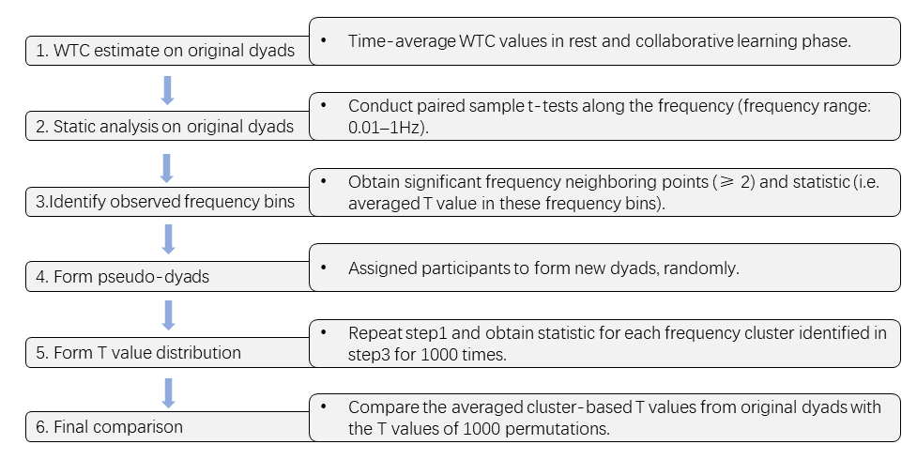
Figure 3. Flowchart of identifying the collaborative learning related FOI.

16. Line 240, the authors stated that they analyzed the data collected from CH 33. How about the data from other channels? Were they analyzed in the same way as to channel 33?
Response: Sorry for inaccurate statement. The data collected from all the channels were entered into the same data analysis pipeline. We have revised those unclear statement on (p. 13, line 276–278).
“3.2.3. Calculate the WTC value for two corresponding channels (the same channel in two participants) in numeric computing platform (see Table of Materials). Following the same procedure, 46 WTC matrix are generated from 46 channels.”

17. In the result section, the authors need to show the relevant tests described in 3.2.4.
Response: We have carefully revised the result section on (p. 16, line 331–335).
“Finally, with the operation stated in steps 3.2.4., the comparison between the observed T value and the distribution of random T value (i.e.1000 times) shows significant results (t (38) = 3.31, FDR corrected p < 0.05, Cohen’s d = 1.05) in identified FOI (0.015 Hz-0.021 Hz) (see Figure 2D).”

18. The sentence in line 261 needs to be rewritten.
Response: We have rewritten the sentence in revised manuscript on (p. 19, line 374–377).
“First, the specific steps of conducting fNIRS hyperscanning experiments in collaborative learning scenario is stated. Second, the data analyze pipeline which assesses the IBS of hemodynamic signals in collaborative learning dyads is also presented.”

19. In the reviewer's opinion, the biggest limitation of fNIRS technique is the detection depth. The authors should discuss how this would limit the hyperscanning experimental design.
Response: We have added this limitation in discussion on (p. 23–24, line 473–480).
“Second, although the fNIRS shows higher tolerance to head motion compared to fMRI, this technique can only detect the brain activity of surface cortex¹⁵. Thus, fNIRS hyperscanning cannot be used in reward-related neural mechanism exploring paradigm, in which amygdala play a crucial role but cannot be detected by fNIRS⁵¹. Meanwhile, the limited number of sources and detectors in the fNIRS setup suggests not whole brain cortex would be measured. That means, researchers have to select region of interest (ROI) to measure.”

20. The authors should consider using the 3D digitizing, or photogrammetry registration methods to register fNIRS optodes at an individual level. Then consider integrating the individualized registration errors into the data analysis.
Response: 3D digitizing was used in this protocol to register fNIRS optodes at the individual level. Detailed description now reads on (p. 9, line 189–194).
“2.2.3. A three-dimensional (3-D) digitizer (see Table of Materials) is used to determine the locations of emitters, receivers, and other references (i.e. inion, nasion, Cz and left and right ears) for each participant. For the recording channels, the MNI coordinates are obtained using the NIRS-SPM²¹ with numeric computing platform (see Table of Materials), and corresponding anatomical locations of each channel are shown in Supplementary Table 1.”

21. Though the authors mentioned that the GCA analysis was applied to the data in the current study, I didn't find the relevant descriptions in other sections, except at the end of the discussion section.
Response: Sorry for inaccurate statement. GCA analysis was not applied to the data. At the end of the discussion section, this protocol compared this analysis with WTC, and suggested GCA can be a prominent method to reveal the direction information of brain-coupling. Especially in the experiment paradigm which assigned specific identity to each participant in a social interaction dyad (i.e. sender and receiver or teacher-student dyads). Statement can be found in revised manuscript on (p. 22, line 441–445).
“Meanwhile, other techniques, such as Granger Causality Analyze (GCA), correlation analysis and phase synchrony analysis are used in hyperscanning research. GCA is a method for revealing directed (“causal”) information between two time-series data⁴⁶. This method once has been used to test the direction of information flow between instructor and learner¹².”

22. Please double-check the reference index in the text and the reference list at the end, some of them did not match.
Response: All references index has been double-checked in revised text on (p. 26–p. 33).

Reviewer #2:
It is of significance to understand the neural mechanism of social functions using hyperscanning. So, the current paper is in general interesting. However, the contribution was not clear at least to me. Some suggestions should be considered as follows.
Response: We thank the Reviewer for his/her comments on strengthen the advantages of technique we adopted in this protocol. In what follows, we fully address all suggestions.

1.The advantages of the index, inter-brain synchrony (IBS), should be discussed more clearly. Especially, it should be compared with correlation and phase synchrony (with wavelet transform analysis for instance).
Response: Thank you for your suggestion. We have discussed of IBS in comparison with correlation and phase synchrony on (p. 22–23, line 445–454):
“correlation analysis is also adopted in fNIRS based hyperscanning field to estimate IBS in dyads who conduct cooperative or competitive tasks^{47,48}. Compared to WTC analysis, this method only characterizes the covaried features of two fNIRS time series along time stream and missed potential information in frequency. Additionally, other approach which quantified phase synchrony with Phase locking value (PLV) has been used in EEG hyperscanning studies. PLV estimates the consistency of the phase difference between two signals⁴⁹. While Burgess suggested PLV show bias on detecting hyperconnectivity that doesn't exist, especially when small samples are employed⁵⁰.”

2.The advantages of the proposed pipeline of analyzing IBS should be discussed more clearly.
Response: Thank you for your suggestions. We have added advantages of the proposed pipeline of analyzing IBS with more detailed description in (p. 21–23, line 422–465).
“The data analysis process in this protocol consists of two parts: preprocess and WTC analysis. Three critical data analysis steps should be highlighted here: First, conducting the principal component spatial filter algorithm (PCA) on the neural data. Zhang and couleage²⁹ proposed this approach for separation of the global and local effects. Although fNIRS allow relatively free movement and communication, PCA is necessary to apply in extracting real signals from systemic changes (e.g. breathing rate, blood pressure, heart rate, blood pressure, breathing rate, and autonomic nervous system activity). The protocol here suggests PCA are efficient to remove the global effects. This method is widely used in fNIRS hyperscanning studies¹³. Taken together, non-neural components can be removed successfully using spatial filtering. Second, WTC is adopted to identify the IBS of collaborative learning dyads. WTC is an approach of assessing the correlation coefficients between two time series as a function of frequency and time⁴¹. This method can be used to reveal locally phase-locked behavior that might not be detected with traditional approach like Fourier analysis³⁰. And this method is widely used to estimate IBS in fNIRS hyperscanning with varied paradigms, such as cooperative and competitive behaviors^{4,42}, studying action monitoring⁴³, imitation⁴⁴, verbal communication⁸, non-verbal communication¹⁹, teaching and learning activity¹¹⁻¹⁴ and mother-child social interaction⁴⁵. Meanwhile, other techniques, such as Granger Causality Analyze (GCA), correlation analysis and phase synchrony analysis are used in hyperscanning research. GCA is a method for revealing directed (“causal”) information between two time-series data⁴⁶. This method once has been used to test the direction of information flow between instructor and learner¹². correlation analysis is also adopted in fNIRS based hyperscanning field to estimate IBS in dyads who conduct cooperative or competitive tasks^{47,48}. Compared to WTC analysis, this method only characterizes the covaried features of two fNIRS time series along time stream and missed potential information in frequency. Additionally, other approach which quantified phase synchrony with Phase locking value (PLV) has been used in EEG hyperscanning studies. PLV estimates the consistency of the phase difference between two signals⁴⁹. While Burgess suggested PLV show bias on detecting hyperconnectivity that doesn't exist, especially when small samples are employed⁵⁰. Third, adopting non-parametric statistical test to detect the collaborative learning related frequency is essential. At first, task-related FOI is selected by either following suggestions in previous research or according to specific experiment design (i.e. how long for one task trial in experiment). Recently, to obtain robust and reproductive results in FOI selecting process, non-parametric statistical test approach is adopted. Here, this technique operated efficiently. The collaborative learning related FOI (0.015-0.021 Hz) is identified. and Similar frequency bands has been identified in fNIRS hyperscanning research in teaching scenario¹³ and in verbal communication paradigms⁸. It is necessary to apply this technique in the multi-brain data analysis pipeline. All in all, establishing suitable algorithms and techniques on analysis of hyperscanning data will be a prominent field.”

3. The results associated with collaborative learning should be discussed more deeply.
Response: Thank you for your suggestions, we have revised the text in results section on (p. 16, line 342–350; p. 23, line 454–464).
“Taken together, Following the data analysis pipeline, the frequency band (raged from 0.015 Hz to 0.021 Hz) which sensitive to collaborative learning is identified by cluster-based permutation approach. Further, for each channel, time-averaged IBS value is compared between the rest phase and the collaborative learning phase using a series of paired sample t-tests. To solve the multiple comparisons problem, all observed p-values in 46 channels are corrected by FDR methods^{35,36}. The results show that the IBS at the channel 33 reaches significance during collaborative learning (FDR corrected p < 0.05). No other corresponding channels indicated significant results (p > 0.05).”

“Third, adopting non-parametric statistical test to detect the collaborative learning related frequency is essential. At first, task-related FOI is selected by either following suggestions in previous research or according to specific experiment design (i.e. how long for one task trial in experiment). Recently, to obtain robust and reproductive results in FOI selecting process, non-parametric statistical test approach is adopted. Here, this technique operated efficiently. The collaborative learning related FOI (0.015-0.021 Hz) is identified. and Similar frequency bands has been identified in fNIRS hyperscanning research in teaching scenario¹³ and in verbal communication paradigms⁸. It is necessary to apply this technique in the multi-brain data analysis pipeline.”

