COUPLER UNPACKING INSTRUCTIONS
Upon receipt, the couplers will have residual sediment in the channels from the fabrication process. Clear out each channel using a barrier strip. There may be resistance until the sediment is fully removed. Wash couplers with a mild detergent solution prior to first use.

BARRIER STRIP UNPACKING INSTRUCTIONS
Barrier strips are received as a laser-cut sheet of parts covered by a protective paper backing (image below). To prepare the strips for use, remove each piece from the sheet and peel off the protective backing. Wash with a mild detergent solution prior to first use. For loose-fitting strips that slide too freely, coil them around your finger to impart curvature, which will help to hold the strip in the channel of the coupler.
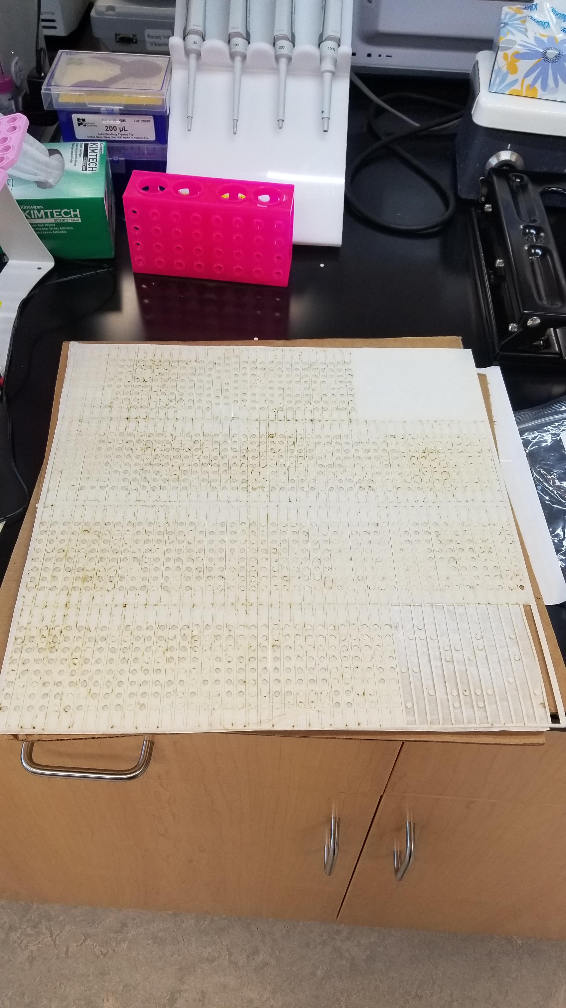

EVAPORATION-RESISTANT LIDS
Note: An inner lid and outer lid are needed for each MFA plate.

Inner Lid Fabrication
Using a razor blade and a straight-edge, carefully score a straight line ~4mm from each edge of the lid as indicated below. Using a pair of pliers, carefully snap off the excess plastic by bending along each scored line. Ensure that protective eyewear is used, as fragments can be projected during breaking.

Outer Lid Fabrication
Cut small strips (~20mm long) of weather stripping, 4 strips per lid. Peal the adhesive backing and apply to the inside of the lids as indicated in the diagram below.

EVAPORATION-RESISTANT SECONDARY CONTAINERS
At the surface where the container and its lid overlap, wrap weather stripping along the edge to fully seal the box (image below).

