May 19, 2021

RE: Manuscript ID JoVE62727

Dear Editor,

Thank you for considering our revised manuscript entitled “Production of Adeno-Associated Virus Vectors in Cell Stacks for Preclinical Studies in Large Animal Models” for publication in JoVE. We have carefully addressed all of the reviewer’s comments and these corrections can be identified by the highlighted text within the body of the manuscript as well as in our detailed response to reviewers attached.

Thank you for considering our manuscript for publication. I look forward to your final decision in due course.

Sincerely,

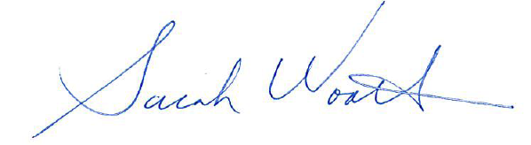

Sarah Wootton, Ph.D.
Associate Professor
Department of Pathobiology
Bldg 89, room 4836
University of Guelph
Tel: 519-824-4120 ext 54729
Email: kwootton@uoguelph.ca

