PARTICIPANT ID :
STUDY ID:

A /B | Cz | 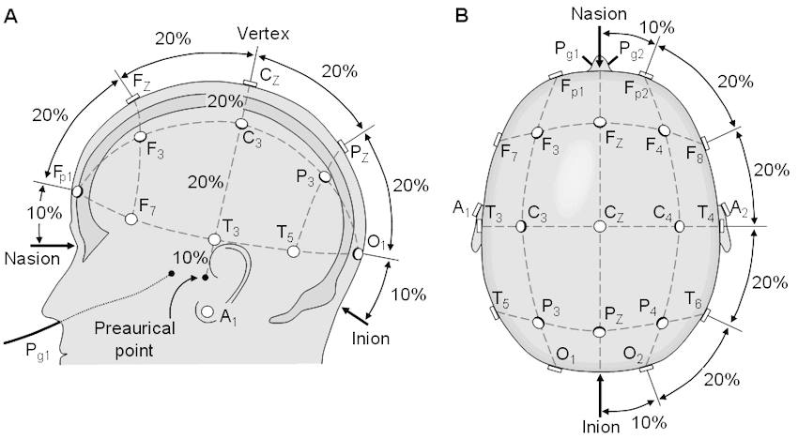  20%
31 | 15.5 | 6.2
32 | 16.0 | 6.4
33 | 16.5 | 6.6
34 | 17.0 | 6.8
35 | 17.5 | 7.0
36 | 18.0 | 7.2
37 | 18.5 | 7.4
38 | 19.0 | 7.6
39 | 19.5 | 7.8
40 | 20.0 | 8.0
41 | 20.5 | 8.2
42 | 21 | 8.4
43 | 21.5 | 8.6

Session 1 | Session 2 | Session 3 | Session 4
date: __ /__/__  time: ___:___ (start)  ___:___ (end) | date: __ /__/__  time: ___:___ (start)  ___:___ (end) | date: __ /__/__  time: ___:___ (start)  ___:___ (end) | date: __ /__/__  time: ___:___ (start)  ___:___ (end)
Experimenter: | Experimenter: | Experimenter: | Experimenter:
measures:  A (____) B (____) | measures:  A (____) B (____) | measures:  A (____) B (____) | measures:  A (____) B (____)
Sensations:  1 2 3 4 5 6 7 8 9 10  1 2 3 4 5 6 7 8 9 10  1 2 3 4 5 6 7 8 9 10  1 2 3 4 5 6 7 8 9 10  1 2 3 4 5 6 7 8 9 10 | Sensations:  1 2 3 4 5 6 7 8 9 10  1 2 3 4 5 6 7 8 9 10  1 2 3 4 5 6 7 8 9 10  1 2 3 4 5 6 7 8 9 10  1 2 3 4 5 6 7 8 9 10 | Sensations:  1 2 3 4 5 6 7 8 9 10  1 2 3 4 5 6 7 8 9 10  1 2 3 4 5 6 7 8 9 10  1 2 3 4 5 6 7 8 9 10  1 2 3 4 5 6 7 8 9 10 | Sensations:  1 2 3 4 5 6 7 8 9 10  1 2 3 4 5 6 7 8 9 10  1 2 3 4 5 6 7 8 9 10  1 2 3 4 5 6 7 8 9 10  1 2 3 4 5 6 7 8 9 10
Notes: | Notes: | Notes: | Notes:

