Supplemental Information:

Because the thiopropyl-sepharose 6B resin utilized in the protocol has been discontinued by the manufacturer, we have provided two alternative options.

First, while there is a commercially available alternative (activated thiol-sepharose 4B), preliminary data revealed nearly a five-fold decrease in binding capacity compared to the thiopropyl-sepharose 6B resin (Figure S1). Thus, the 4B resin needs to be used with consideration of its decreased binding capacity.

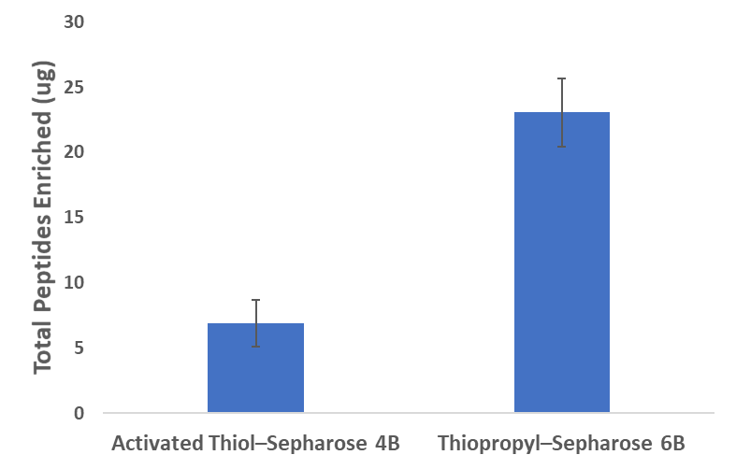
The second alternative is to synthesize the resin in-house using 2-(pyridyldithio) ethylamine hydrochloride and N-hyroxysuccinimide (NHS)-activated resin (NHS-Activated Sepharose 4 Fast Flow). This synthesized resin performs similarly to the 6B resin. A detailed procedure and assessment of the in-house resin synthesis and its performance, including supporting data, will be described elsewhere (Li et al., manuscript in preparation).

