Supplementary Information for "Synthesis and characterization of multi-modal phase-change porphyrin droplets": Other Protocols and Data
AUTHORS AND AFFILIATIONS:
Kimoon Yoo^{1,2}
Alexander Dhaliwal^{1,2}
Juan Chen¹
Paul S. Sheeran³
Gang Zheng^{1,2}

- Princess Margaret Cancer Centre, Toronto, Ontario, Canada
- Department of Medical Biophysics, University of Toronto, Toronto, Ontario, Canada
- Philips Healthcare, Bothell, Washington, United States

kimoon.yoo@mail.utoronto.ca
alex.dhaliwal@mail.utoronto.ca
juan.chen@uhnres.utoronto.ca
paul.sheeran@philips.com
gang.zheng@uhnresearch.ca

- Synthesis of Pyro-Lipids
The following steps outline how to synthesize approximately 80 mg of pyropheophorbide conjugated 1-stearoyl-2-hydroxy-sn-glycero-3-phosphocholine (Pyro-SPC) with a purity greater than 95%. This synthesis protocol was modified from the work done by Zheng et al.^{S1} Refer to Table S1 for List of Materials.
  - Prepare 15 mL of chloroform as the main diluent for the reaction.
CAUTION: Chloroform is a health hazard, irritant, and toxic. Wear a protective lab coat, eye protection, protective gloves, and avoid breathing fumes.
  - Add 100 mg of spirulina pacifica algae derived pyropheophorbide a (Pyro)^{S1} to the 15 mL of chloroform.
  - Add 93 mg of 1-stearoyl-2-hydroxy-sn-glycero-3-phosphocholine (SPC) to the chloroform.
  - Add 71.5 mg of N-(3-dimethylaminopropyl)-N′-ethylcarbodiimide hydrochloride (EDC-HCl) to the chloroform.
CAUTION: EDC-HCl is toxic and may cause organ damage. Wear a protective lab coat, eye protection, and protected gloves.
  - Add 11.8 mg of 4-(dimethylamino)pyridine (DMAP) to the chloroform.
CAUTION: DMAP is toxic and can be absorbed through the skin. Wear eye protection, protected gloves, and a protective lab coat.
  - Add 19 µL of N,N-diisopropylethylamine (DIPEA) to the chloroform.
CAUTION: DIPEA is flammable, corrosive, and toxic. Keep away from heat, flames, and sparks and avoid breathing fumes. Wear a protective lab coat, protective gloves, eye protection, and face protection. Handle in fume hood.
  - Shield the reaction mixture from light and stir under argon gas at room temperature for 36 h.
NOTE: The conjugation efficiency should be about 80% ^{S1}.
  - After the 36 h, place the reaction mixture in a rotary evaporator and evaporate the reaction solvent by setting the vacuum to -30 kPa (room temperature) for 10 min.
  - Set the rotary evaporator vacuum to -10 kPa gauge (room temperature) for 10 min to obtain crude Pyro-SPC.
  - Prepare a silica gel column by loading it with 12 g of silica gel (high purity grade, 6 nm diameter pores, 70-230 mesh) and pre-elute the column with dichloromethane (DCM) in a fume hood.
CAUTION: DCM is an irritant and may cause cancer. Wear a protective lab coat, protective gloves, eye protection, and avoid breathing fumes. Handle in fume hood.
  - Dissolve the crude Pyro-SPC in 1 mL of DCM and load it into the silica gel column.
  - Elute the crude Pyro-SPC in DCM through a silica gel column with DCM.
  - Prepare a solution of 95% DCM and 5% methanol %V/V and further elute the mixture in the silica gel column with it.
CAUTION: Methanol is a health hazard, irritant, toxic, and flammable. Wear a protective lab coat, eye protection, gloves, and avoid breathing fumes. Keep away from sparks and heat.
  - Prepare a solution of 84% DCM, 15% methanol, and 1% double-deionized water %V/V/V and further elute the mixture in the silica gel column with it.
  - Prepare a solution of 70% DCM, 28% methanol, and 2% double-deionized water %V/V/V and further elute and collect the fraction in the silica gel column.
  - After collecting the Pyro-SPC fraction, dehydrate it in the rotary evaporator at 37 °C with a vacuum at -5 kPa gauge for 30 min (creating 80 mg of Pyro-SPC with greater than 95% purity).
  - Collect and dissolve the purified Pyro-SPC into 8 mL of chloroform, then aliquot 1 mL into 2 mL plastic vials with caps. Label the vials.
OPTIONAL: Measure the Pyro-SPC concentration as described in Step 1.4 to 1.4.4 in the main protocol before aliquoting.

  - Vacuum spin the vials for 24 hours in a vacuum concentrator system (room temperature, -110 °C cool trap, centrifuge speed and pressure may depend on model) to remove moisture and solvents and create dried Pyro-SPC films.
  - Cap and label the vials and store them in the dark and at -20 °C.
- Gas Exchanger Assembly
The following protocol outlines how to assemble the gas exchanger. The gas exchanger serves the dual purpose to both eliminate atmospheric air dissolved in the aqueous solution and re-pressurize the vial headspaces with inert gases. The gas exchanger is based on the work by Sheeran et al.^{S1} Refer to Table S2 for List of Materials.
NOTE: "OD" stands for "Outer Diameter", "ID" stands for "Inner Diameter", and "NPT" stands for "(American) National Pipe Thread". Many of the units in this document are in Imperial units as the supplier also reports in Imperial.
  - Build the Gas Cylinder Assembly as shown in Figure S1.
CAUTION: The perfluorocarbon gas cylinder is under pressure and can explode if heated. Keep way from heat and impact. Perfluorocarbon gas is may cause oxygen displacement and suffocation. Wear proper eye protection and handle in a fume hood.
    - Ensure all valves are securely closed. The valves with the handles are closed when the handles are perpendicular to the flow path.
    - Applying thread seal tape to the (Push-to-Connect Tube Fitting for Air Straight Adapter, for 1/8" Tube OD x 1/4 NPT Male) threads clockwise with no more than 3 layers. Keep the vent/port clear of tape.
    - Ensure that the Air Regulator (Compact Compressed Air Regulator, Nonrelieving, Acetal Housing, 1/4 NPT Female, 0-25 psi) valve is closed (pull and turn counter-clockwise).
    - Look for the flow direction indicator arrows on the back of the Air Regulator (Figure S1A). On the 1/4 NPT port with the arrow pointing out of the Air Regulator, screw in the component from the previous step with an adjustable wrench while holding the Air Regulator by hand.
NOTE: Avoid overtightening any screw-on components as it can damage the threads.
    - Apply thread seal tap to a sealing screw (packaged with Air Regulator) and screw it on to one of the 1/8 NPT ports on the Air Regulator with a flat screwdriver (Figure S1A). This Air Regulator Assembly will be needed later (Step S2.1.10).
    - Ensure that the perfluorocarbon gas cylinder valve is securely closed (turn clockwise). Then remove the brass cap on the gas cylinder with adjustable wrenches.
CAUTION: Not closing the gas cylinder valve properly can cause the gas cylinder to vent or decompress.
    - Apply Thread Seal tape to the gas cylinder's threads clockwise with no more than 3 layers. Keep the vent/port hole clear of tape.
    - Screw on the (Brass Body On/Off Valve with T-Handle, 1/4 NPT Female x 1/4 NPT Male) onto the gas cylinder with adjustable wrenches (Figure S1B). Ensure the valve is closed.
NOTE: A way of checking for leaks is to apply dish soap to the connection points after assembly and watch if bubbles appear.
    - Apply Thread Seal tape to the (Brass Body On/Off Valve with T-Handle, 1/4 NPT Female x 1/4 NPT Male) threads clockwise with no more than 3 layers. Keep the vent/port hole clear of tape.
    - Screw on the Air Regulator Assembly (Step S2.1.5, Figure S1A) onto the T-Handle Valve by hand while holding the (Brass Body On/Off Valve with T-Handle, 1/4 NPT Female x 1/4 NPT Male) with an adjustable wrench (Figure S1B).
    - Apply thread seal tape to the (Vibration-&Corrosion-Resistant Gauge with Dual Scale, Compound, 1-1/2" Dial, 1/8 NPT Male Center Back Connection, 0-15 psi) threads with no more than 3 layers. Keep the vent/port clear of tape.
    - Screw component from the previous step on to an open 1/8 NPT port on the (Compact Compressed Air Regulator Nonrelieving, Acetal Housing, 1/4 NPT Female, 0-25 psi) by hand (Figure S1B).
  - Assemble the Manifold Inlets as shown in Figure S2.
    - Cut a piece of the (Tygon PVC Soft Plastic Tubing for Air and Water, Clear, 1/8" ID, 1/4" OD) (recommended length of 3.5 cm, see Figure S2A).
    - Cut five pieces of the (Tygon PVC Soft Plastic Tubing for Air and Water, Clear, 1/4" ID, 3/8" OD), (recommended length of 5 cm each, see Figure S2A and S2B).
    - On one of the 3/8" outlet port of the (Push-to-Connect Tube Fitting for Air and Water, 10 Outlet Manifold Reducer, 3/8" Inlet Tube OD), push the pieces that are shown in Figure S3A together to connect. The tubing should click-in when they are locked in place. This is the Gas Cylinder to Manifold connection.
    - On the other 3/8" outlet port of the (Push-to-Connect Tube Fitting for Air and Water, 10 Outlet Manifold Reducer, 3/8" Inlet Tube OD), push the pieces that are shown in Figure S3B together to connect. The tubing should click-in when they are locked in place. This is the Manifold to Vacuum connection.
  - Assemble the Manifold Outlets as shown in Figure S3.
    - Cut four pieces of (Tygon PVC Soft Plastic Tubing for Air and Water, Clear, 1/8" ID, 1/4" OD) (recommended lengths of 9.5 cm, 4.5 cm, 4.5 cm, & 3 cm, see Figure S3A).
    - Push or twist the pieces shown in Figure S3A together to connect. The tubes should click-in when they are locked in place.
    - Repeat Steps 2.3.1 to 2.3.2 five more times (alternating the lengths so the Polypropylene On/Off Valves aren't pushing against each other and the needles are at different heights, see Figure S3B) until all 10 Manifold Outlet ports are filled.
  - Connect the assembled pieces together as shown in Figure S4.
    - Link the Gas Cylinder Assembly (Step S2.1, Figure S1) to the Gas Cylinder side of the Manifold Inlet (Step S2.2.3, Figure S2A) with (Firm Polyurethane Tubing for Air and Water 1/16" ID, 1/8" OD). The tubing length will depend on the working area, equipment placement, and user's discretion.
    - Link the Vacuum side of the Manifold Outlet (Step S2.2.4, Figure S2B) to the membrane/diaphragm vacuum pump with (Tygon PVC Soft Plastic Tubing for Air and Water Clear, 1/8" ID, 1/4" OD). The tubing length will depend on the working area, equipment placement, and user's discretion.
CAUTION: The vacuum pump can burst if handled incorrectly. Do not use the vacuum pump with organic, acidic, or basic chemicals. Handle in fume hood and wear proper eye protection.
NOTE: The membrane/diaphragm vacuum pump should be capable of reaching -90 kPa (-13 psi, -900 mbar) gauge.
    - Place the Gas Exchanger in a fume hood, secure the gas cylinder with retort clamps, and place manifold on a different retort clamp to keep the needles off of the floor (see Figure S4).
- Gas Exchanging
The following steps outline how to use the Gas Exchanger for vacuuming, degassing, and re-pressurizing vials. Refer to Figure S4 for the names of specific valves.
NOTE: The gas exchanger requires serum vial(s) capped with a lyophilization-style gray chlorobutyl rubber stoppers and crimped with a tear-off aluminum seals (see Steps 2.9 and 3 in the main protocol).
CAUTION: Do not use the vacuum pump with organic, acidic, or basic chemicals. Wear proper eye protection and handle in fume hood.
  - Vacuum the headspace of the serum vial.
    - Ensure that ALL the valves are properly closed (turn Gas Cylinder Valve clockwise and turn Air Regulator Valve counter-clockwise) and the pump is turned off.
CAUTION: If done incorrectly, it is possible to vacuum out the gas cylinder causing rapid decompression and implosion.
    - Insert the manifold's needle through the center of the lyophilization-style gray chlorobutyl rubber stoppers on the sealed and crimped serum vial(s). Ensure the needle tip stays near the top of the serum vial to prevent any liquids from getting evacuated.
    - Turn on the vacuum and slowly dial the vacuum pump to -90 kPa (-13 psi, -900 mbar).
    - Open the appropriate manifold valves (ones with serum vials connected), then open Vacuum Valve A and Vacuum Valve B.
    - Wait at least 5 min to vacuum the serum vial headspace.
  - Degas the liquid in the serum vial.
    - After vacuuming the headspaces, leave the vacuum on, hold one of the serum vials to prevent from swinging, and rapidly tap the serum vial with a heavy pen or marker until gas bubbles and/or foam start to appear in the vial. Do not let any liquid or bubbles get vacuumed out.
NOTE: The vacuum alone (without boiling) doesn't have enough energy to nucleate the gases out of the liquid so the tapping is required.
    - Pause tapping (or tap another vial) if the bubble level rises too closely to the needle and resume tapping once the bubble level goes down. Occasionally check that the needle tip is well above the liquid as not to vacuum the liquid. Once there is no bubbles/foam in a vial and no new bubbles form when tapped (approximately 5 to 10 minutes per vial), the vial is degassed.
NOTE: This process is very tedious. Get an undergrad to do it.
    - Repeat Steps S3.2.1 to S3.2.2 for each serum vial. Rotate the retort stand to get better access to the other side of the manifold.
  - Re-pressurize the serum vial.
NOTE: The method in the main protocol (Steps 2.92 to 2.93) is a single-cycle gas exchange. The method in the supplementary protocol here is a three-cycle gas exchange, which is more secure.
    - Check that the needle tips are well above the liquid. Keep the serum vials connected in the same manifold needles as the manifold is connected to both the vacuum and gas cylinder. Keep the pump turned on and the appropriate Manifold Valves open.
    - Close Vacuum Valve A and Vacuum Valve B. Ensure everything between and including Pressure Valve A to the Gas Cylinder Valve are closed.
Double check to ensure the needles aren't too close to the liquid in the serum vial.
CAUTION: If done incorrectly, it is possible to vacuum out the gas cylinder causing rapid decompression and implosion.
    - Turn the Gas Cylinder Valve 1/16 to 1/8 counter-clockwise to partially open.
CAUTION: Do not open the Gas Cylinder Valve more than this as it could cause damage to the Air Regulator.
    - Open the T-Handle Valve.
    - SLOWLY turn the Air Regulator Valve clockwise until the gauge on the Air Regulator reads 3 psi (20.7 kPa).
    - (Double check and) close both Vacuum Valve A and Vacuum Valve B.
    - Open Pressure Valve A and Pressure Valve B. If there is liquid in the serum vial, you should see the gas flow perturb the liquid. Wait 30 s and keep your hands on the Pressure Valves in case of leaks (the gauge should still read 3 psi (20.7 kPa)).
CAUTION: If done incorrectly, it is possible to vacuum out the gas cylinder causing rapid decompression and implosion.
    - Close Pressure Valve A and Pressure Valve B.
    - Open Vacuum Valve A and Vacuum Valve B. Wait 30 s while keeping your hands on the Vacuum Valves in case of leaks.
CAUTION: If done incorrectly, it is possible to vacuum out the gas cylinder causing rapid decompression and implosion.
    - Repeat Step 3.3.6 to 3.3.9 two more times to ensure the gas has been properly cycled.
    - Close both Vacuum Valve A and Vacuum Valve B.
    - Turn off the vacuum pump.
    - Open Pressure Valve A and Pressure Valve B. Wait 30 s and keep your hands on the Pressure Valves in case of leaks (the gauge should still read 3 psi (20.7 kPa)).
    - One manifold valve & serum vial at a time: close a Manifold Valve, remove the corresponding serum vial from the needle and carefully sheath the needle. The gauge should still read 3 psi (20.7 kPa).
    - Repeat Step 3.3.14 for each inserted serum vial.
    - Ensure all the Manifold Valves are closed.
    - Securely close the Gas Cylinder Valve by turning it clockwise.
    - Relieve positive pressure in the Air Regulator by: slightly open one of the Manifold Valves until the gauge reads 0 psi (or comes to a resting position) and close the Manifold Valve.
    - Close the T-Handle Valve, close the Air Regulator Valve (turn counter-clockwise), close Pressure Valve B and Pressure Valve A.
    - Ensure ALL valves are closed, all needles are sheathed, and the pump is turned off.
    - Label the serum vials to note they have been gas exchanged.
- Dynamic Light Scattering
Droplets were also sized with dynamic light scattering (DLS) to obtain both the intensity-weighted (DLSi) and number-weighted (DLSn) size distributions to supplement the Counter counting data. Refer to Table S3A for List of Materials.
  - Turn on the DLS machine, wait for the laser to equilibrate, and set the temperature to 10 °C and set the scan for at least 3 replicates.
  - Once the DLS machine is ready, dilute the droplets 20-fold by volume into filtered (0.2 µm pore polyethersulfone) phosphate buffered saline (PBS, 7.4 pH, 1X), mix without creating bubbles.
NOTE: Since DLS operates on the principle that the same is homogeneously distributed across the scan time, it is not ideal for buoyant samples such as microbubbles which float/dissolve out of solution in PBS across a sizing measurement, affecting the results over time.
  - Fill a 1 cm path length cuvette (that's compatible with the DLS machine) with the diluted droplets to a sufficient height (depends on machine and cuvette model), and measure. See Figures S9 for DLS graphs and Table S3 for sizing statistics.
NOTE: Table S3B and S3C reports the DLS sizing statistics. Errors indicate standard deviation. Figure S5 shows representative graphs of the different Pyro loaded droplets.
- Spinning and washing bubbles
The post-agitation and size-selected microbubble sample will inevitably contain assemblies that are not bubbles, such as multilamellar vesicles, liposome, and micelles. A possible method of eliminating the smaller, non-bubble assemblies is to centrifuge the post-agitated, size-selected sample to the larger, more buoyant bubbles. However, this process both reduces the total population of bubbles capable of participating in the condensation procedure and is not able to isolate smaller micro- and nanobubbles, resulting in larger droplet populations with lower overall yield. Because such populations do not suit an intended droplet application that takes advantage of passive accumulation mechanisms unique to nanomaterials below a certain size threshold, they were not utilized in the main body of this work. Nonetheless, the process is described here, as it may be useful for other groups with different intended applications, especially those that prioritize a product that is purely droplets. This may hinder passive accumulation in-vivo. The additional materials needed are listed in Table S4. The methods were based on the work done by Feshitan et al.^{S3}
  - Mix 1 mL of propylene glycol, 1 mL of glycerol, 8 mL of phosphate buffer saline (PBS, 1X, 7.4 pH) until homeneous.
  - Aliquot 2 mL of the solution from Step S5.1 into 3 mL borosilicate glass clear serum vials (7 mm inner mouth diameter, 13 mm outer mouth diameter).
NOTE: This will be referred to as the Excipient Diluent.
  - Cap the serum vials with lyophilization-style gray chlorobutyl rubber stoppers (7 mm inner mouth diameter, 13 mm outer mouth diameter) and secure the rubber stopper with tear-off aluminum seals (13 mm outer mouth diameter) and a crimper.
  - Vacuum, degas, and re-pressurize the Excipient Diluent as described in Steps S3 to S3.3.21.
  - Store the Excipient Diluent at 4 °C until ready to use.
  - Prepare size-selected bubbles as described in the main protocol Steps 4 to 4.12.1, but withdraw 0.7 mL of the size-selected microbubble sample into a 3 mL plastic syringe instead of a 1 mL syringe and a 20-gauge needle.
  - Equilibrate the Excipient Diluent from Step S5.5 to room temperature while size-selecting the microbubbles.
  - Uncap the Excipient Diluent with a decapper. With a fresh 20-gauge needle, withdraw the Excipient Diluent into the 3 mL syringe containing the size-selected microbubble sample to a total volume of 1 mL. Then carefully remove the needle.
  - Keep excess air in the syringe then carefully close the syringe nozzle with a syringe twist-on syringe cap. With excess air in the syringe, gently invert and revert the capped syringe until uniformly mixed. Holding the syringe upwards, uncap, carefully expel any remaining air, and then recap the syringe.
  - Place the syringe nozzle down/plunger up in a balanced centrifuge, and spin the syringe at 50 relative centrifugal force (rcf) for 8 minutes ^{S3,S4}.
  - Immediately after the centrifugation step finishes, carefully retrieve/move the syringe while keeping the nozzle down/plunger up orientation, carefully uncap the syringe, and push out the infranatant (the more translucent, bottom partition) into a fresh vial. Reserve the supernatant (the bubble/foaming "cake"-like partition, approximately 50 µL).
  - Dilute the supernatant "cake" with Excipient Diluent up to a total volume of 1 mL into the same 3 mL syringe. Repeat Step 5.9 to homogenize syringe contents.
  - Repeat Steps S5.10 to S5.12.
  - Transfer a small volume in the syringe to size on the Coulter counter (CC) as described in Step 5.3 to 5.3.3 in the main protocol to verify if the precursor microbubble population falls within the intended size range for the chosen application.
  - Transfer the remaining volume in the 3 mL syringe into a vented decafluorobutane vial and condense as described in Steps 4.10 to 4.16 in the main protocol.

  - Size the condensed product from the previous step as described in Steps 5.2 to 5.2.4 in the main protocol.
NOTE: Figure S6 shows the size distribution of spun 30% Pyro bubbles from Step S5.14 and corresponding condensed droplets from Step S5.16 sized on the Coulter counter with the 10 µm aperture.

Table S1: Materials needed to synthesize Pyro-SPC
Name | Company | Catalog #
Spirulina Pacifica algae derived pyropheophorbide a | Cyanotech
1-stearoyl-2-hydroxy-sn-glycero-3-phosphocholine | Avanti | 855775
N-(3-dimethylaminopropyl)-N′-ethylcarbodiimide hydrochloride (EDC-HCl) | Any brand
4-(dimethylamino)pyridine (DMAP) | Any brand
N,N-diisopropylethylamine (DIPEA) | Any brand
Chloroform | Any brand
Dichloromethane (DCM) | Any brand
Methanol | Any brand
Double-deionized water | Any brand
Rotary Evaporator, capable of up to -30 kPa vacuum | Any brand
Silica Gel, high purity grade, 6 nm diameter pores, 70-230 mesh | Any brand
Gel Column with bottom valve | Any brand
Vacuum Concentrator | Any brand

Table S2: Gas Exchanger Components
Name | Quantity | Company | Catalog #
Brass Body On/Off Valve with T-Handle,  1/4 NPT Female x 1/4 NPT Male | 1 | McMaster Carr | 4082T42
Compact Compressed Air Regulator,  Nonrelieving, Acetal Housing, 1/4 NPT Female (0-25 psi) | 1 | McMaster Carr | 6746K42-6746K27
Vibration-&Corrosion-Resistant Gauge with Dual Scale,  Compound, 1-1/2" Dial, 1/8 NPT Male Center Back Connection (0-15 psi) | 1 | McMaster Carr | 38545K29-38545K52
Push-to-Connect Tube Fitting for Air,  Straight Adapter, for 1/8" Tube OD x 1/4 NPT Male | 1 | McMaster Carr | 5779K243
Firm Polyurethane Tubing for Air and Water,  Black, 1/16" ID, 1/8" OD | 5 ft  1.52 m | McMaster Carr | 5648K22-5648K221
Push-to-Connect Tube Fitting for Air,  Straight Reducer, for 1/4" x 1/8" Tube OD | 1 | McMaster Carr | 5779K352
Push-to-Connect Tube Fitting for Air,  Straight Reducer, for 3/8" x 1/4" Tube OD | 1 | McMaster Carr | 5779K355
Tygon PVC Soft Plastic Tubing for Air and Water,  Clear, 1/4" ID, 3/8" OD | 5 ft  1.52 m | McMaster Carr | 6516T21
Tygon PVC Soft Plastic Tubing for Air and Water,  Clear, 1/8" ID, 1/4" OD | 5 ft  1.52 m | McMaster Carr | 6516T14
Push-to-Connect Tube Fitting for Air and Water,  10 Outlet Manifold Reducer, 3/8" Inlet Tube OD | 1 | McMaster Carr | 52045K206
Polypropylene On/Off Valve for Drinking Water,  Push-to-Connect Female for 1/4" Tube OD | 10 | McMaster Carr | 4503K23
Polypropylene On/Off Valve for Drinking Water,  Push-to-Connect Female for 3/8" Tube OD | 4 | McMaster Carr | 4503K25
Plastic Quick-Turn Tube Coupling,  Plugs, for 1/8" Barbed Tube ID, Nylon | 1 pack = 10 | McMaster Carr | 51525K123
Conventional Needles, Luer Lock Connection, Regular Bevel Tip,  20 gauge, 1" length | 1 box = 100 | BD | 305175
Conventional Needles, Luer Lock Connection, Regular Bevel Tip,  23 gauge, 3/4" length | 1 box = 100 | BD | 305143
Conventional Needles, Luer Lock Connection, Regular Bevel Tip,  25 gauge, 5/8" length | 1 box = 100 | BD | 305122
Polytetrafluoroethylene Thread Seal Tape, 0.5 to 1 inch width | 1 | Any brand
Membrane Vacuum Pump,  Adjustable Setting | 1 | Sartorius Stedim | 16694-1-60-06
Decafluorobutane (C₄F₁₀) Gas Cylinder | 1 | FluoroMed | APF-N2M

Table S3A: Materials needed for Dynamic Light Scattering (DLS) Sizing
Name | Company | Catalog #
Dynamic Light Scattering (DLS) Machine,  Capable of temperature control | Any brand
Dynamic Light Scattering (DLS) Machine compatible Cuvette | Any brand
Phosphate Buffer Saline (PBS, 1X, 7.4 pH) | Any brand
Plastic Syringe | Any brand
Polyethersulfone (PES) Membrane Filter, 0.2 µm pore size | Any brand

Table S3B: Intensity-Weighted DLS Statistics for Droplets with different Pyro loadings.
Pyro % | 0 | 1 | 10 | 20 | 30 | 40 | 50
Peak [nm] | 295.3  ± 19.0 | 295.3  ± 59.3 | 342.0  ± 58.1 | 255.0  ± 0.0 | 342.0  ± 70.6 | 342.0 ± 27.1 | 295.3  ± 70.6
Mean [nm] | 319.0  ± 25.2 | 342.3  ± 82.3 | 359.6  ± 65.9 | 291.0  ± 2.5 | 370.8  ± 88.8 | 386.6  ± 54.9 | 363.0  ± 74.6
Median [nm] | 295.3  ± 19.0 | 295.3  ± 59.3 | 342.0  ± 66.5 | 255.0  ± 0.0 | 342.0  ± 70.6 | 342.0  ± 27.1 | 295.3  ± 50.4
Errors indicate standard deviation.

Table S3C: Number-Weighted DLS Statistics for Droplets with different Pyro loadings
Pyro % | 0 | 1 | 10 | 20 | 30 | 40 | 50
Peak [nm] | 190.1  ± 37.4 | 255.0  ± 53.7 | 255.0  ± 43.3 | 164.2  ± 26.4 | 255.0  ± 52.6 | 255.0  ± 52.6 | 255.0  ± 0.0
Mean [nm] | 220.1  ± 22.7 | 238.2  ± 67.2 | 275.0  ± 47.1 | 199.0  ± 18.9 | 258.4  ± 50.0 | 296.4  ± 9.3 | 276.3  ± 12.8
Median [nm] | 190.1  ± 26.4 | 220.2  ± 62.7 | 255.0  ± 49.6 | 190.1  ± 12.2 | 255.0  ± 52.6 | 255.0  ± 20.2 | 255.0  ± 0.0
Errors indicate standard deviation.

Table S4: Additional materials needed to eliminate lower populations
Name | Company | Catalog #
Plastic Syringe, 3 mL | Any brand
Twist-on (Luer Lock) syringe cap that compatible with the 3mL plastic syringe | Any brand
Centrifuge capable of holding at least two 3 mL syringes, and capable of reaching 50 relative centrifugal force | Any brand

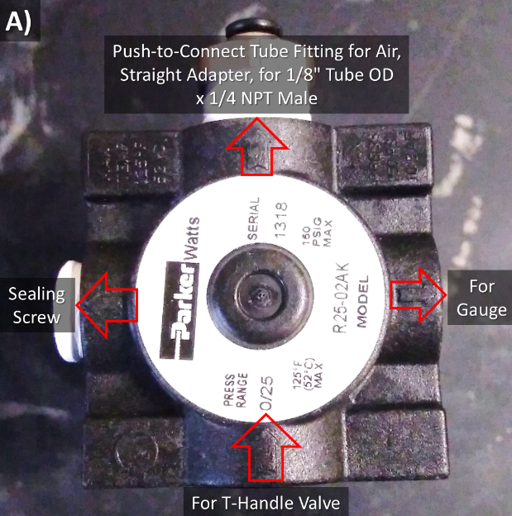 | 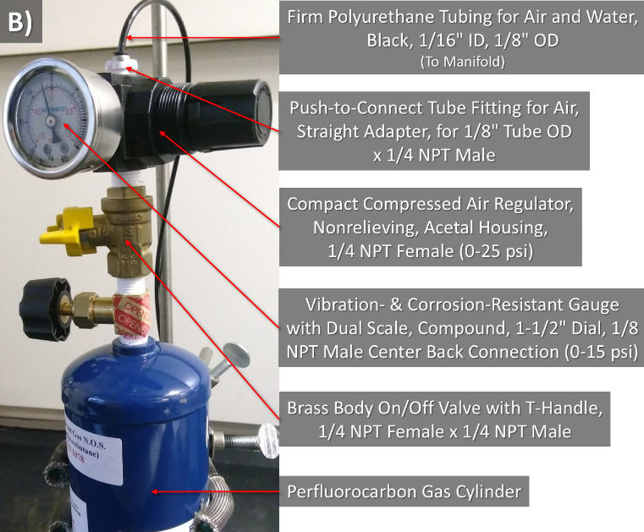
Figure S1: Gas Cylinder Assembly. A) Air Regulator Assembly. The gas flow direction arrow indicators have been highlighted with red arrows for clarity. B) Components attached on top of the perfluorocarbon gas cylinder.

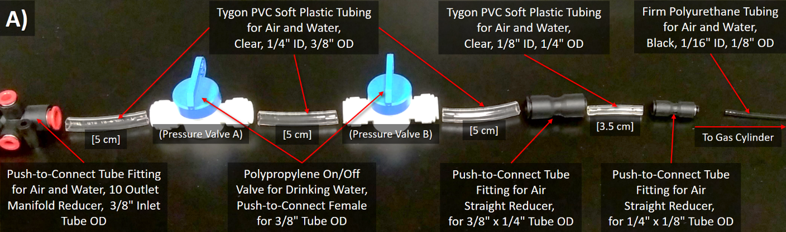
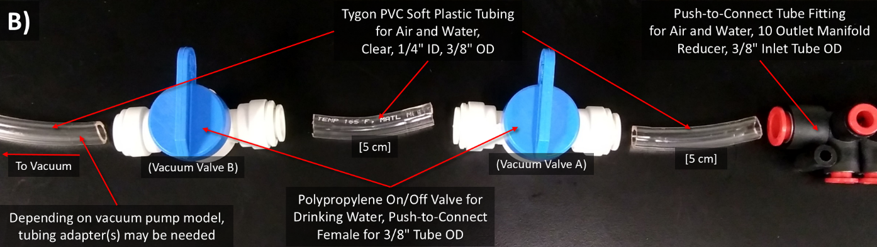
Figure S2: Manifold Inlet connections. Simply push the shown pieces in to connect. Square brackets indicate recommended tubing lengths. A) Gas Cylinder to Manifold connections. B) Manifold to Vacuum connections.

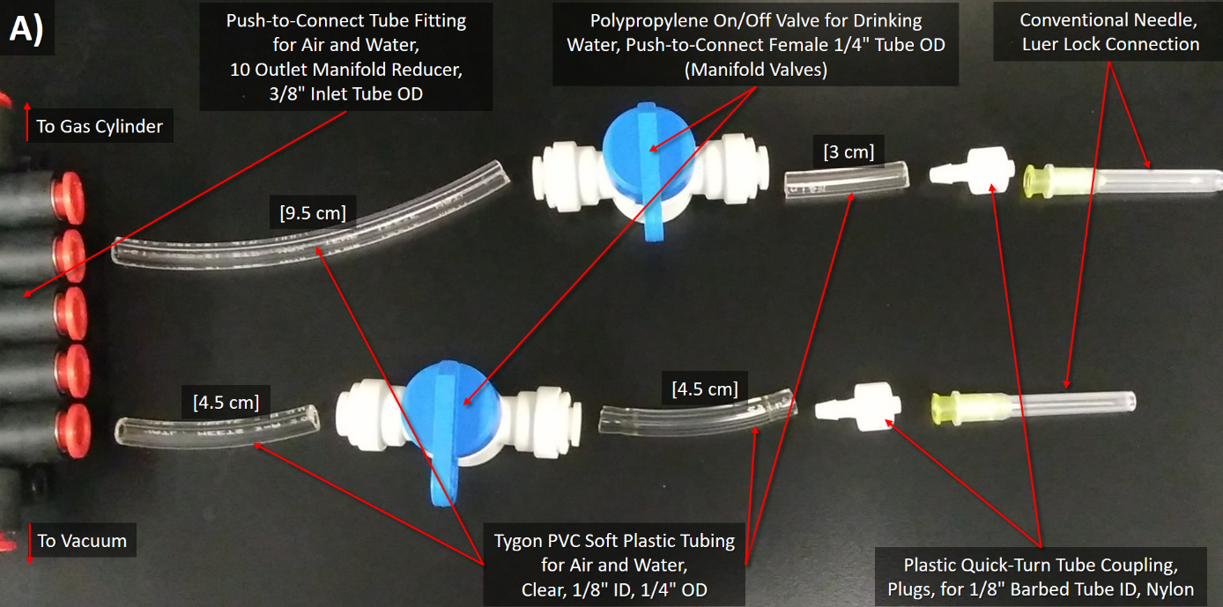
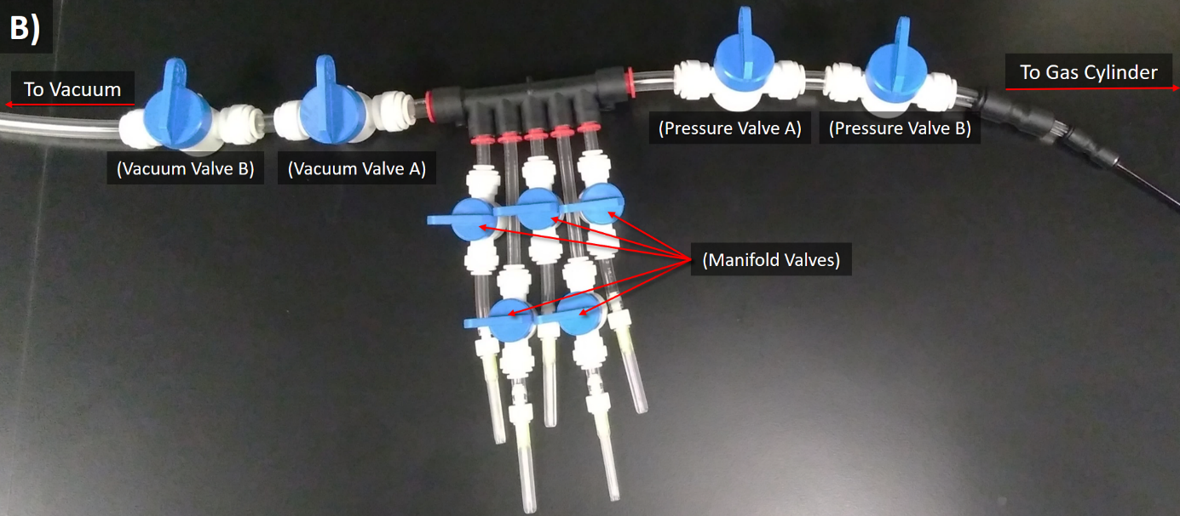
Figure S3: Manifold Outlet connections. A) Pieces needed for the Manifold Outlets. Simply push or twist the shown pieces to connect. Square brackets indicate recommended tubing lengths. B) One completed side of the Manifold Outlets. Different tubing lengths are used so the valves won't push against each other.

Figure S4: The completed Gas Exchanger. Valves have been labelled for reference. Retort bars are used to hold the manifold off of the floor and secure the gas cylinder.

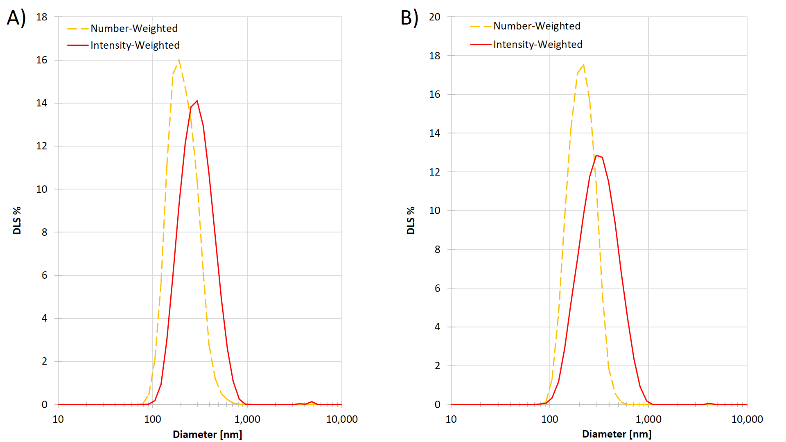
Figure S5: Representative DLS sizing for A) 0% Pyro Droplets. B) 1% Pyro Droplets

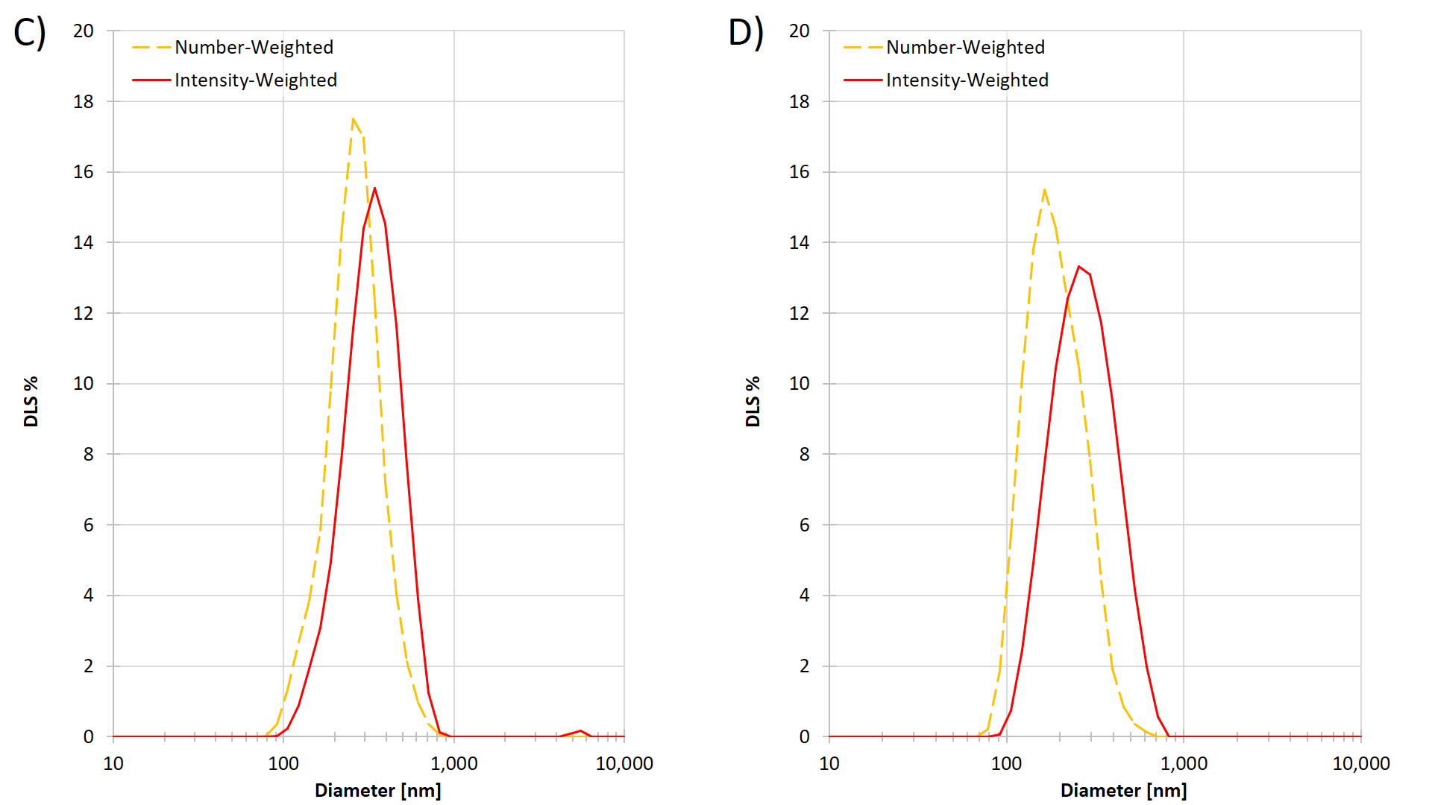
Figure S5: Representative DLS sizing for C) 10% Pyro Droplets. D) 20% Pyro Droplets

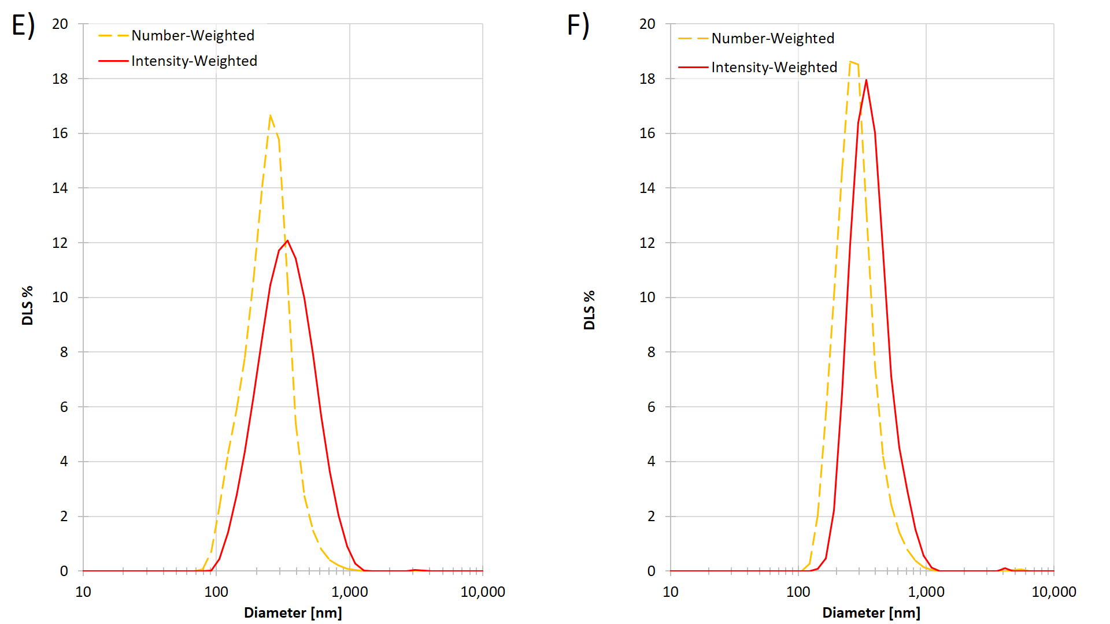
Figure S5: Representative DLS sizing for E) 30% Pyro Droplets. F) 40% Pyro Droplets

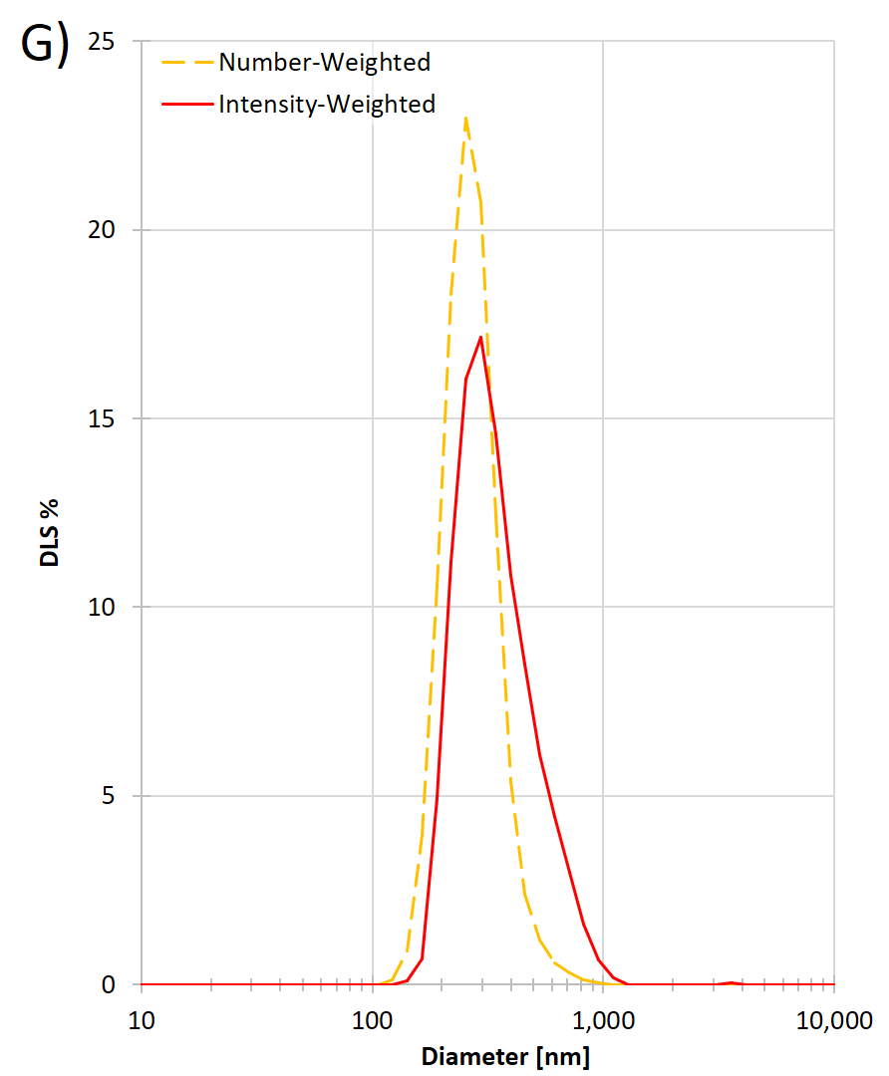
Figure S5: Representative DLS sizing for G) 50% Pyro Droplets.

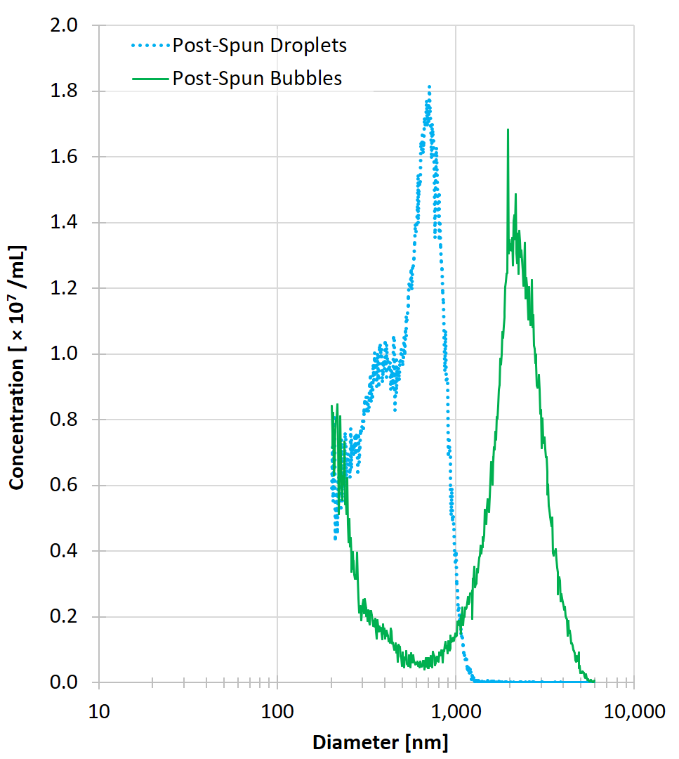
Figure S6: Centrifuged and washed 30% Pyro bubbles and corresponding droplets sized on the Coulter counter with a 10 µm aperture (n = 1). The post-spun bubble population had a peak diameter or 1961 nm while the post-spun droplets had a peak diameter of 713 nm.

ACKNOWLEDGMENTS:
The authors would like to thank Dr. Brandon Helfield for helping build the gas exchanger.

REFERENCES:
S1. | Zheng, G. et al. Low-density lipoprotein reconstituted by pyropheophorbide cholesteryl oleate as target-specific photosensitizer. Bioconjugate Chemistry. 13 (3), 392-396 (2002).
S2. | Sheeran, P. S., Luois, S. H., Mullin, L. B., Matsunaga T. O., Dayton, P. A. Design of ultrasonically-activatable nanoparticles using lower boiling point perfluorocarbons. Biomaterials. 33 (11), 3262-3269 (2012).
S3. | Feshitan, J, Chen, C. C., Kwan, J. J., Borden, M. A. Microbubble size isolation by differential centrifugation. Journal of Colloid and Interface Science. 329 (2), 316-324.
S4. | Pellow, C., Acconcia, C., Zheng, G., Goertz, D. E. Threshold-dependent nonlinear scattering from porphyrin nanobubbles for vascular and extravascular applications. Physics in Medicine and Biology. 63 (21), 215001 (2018).

