Starting state.
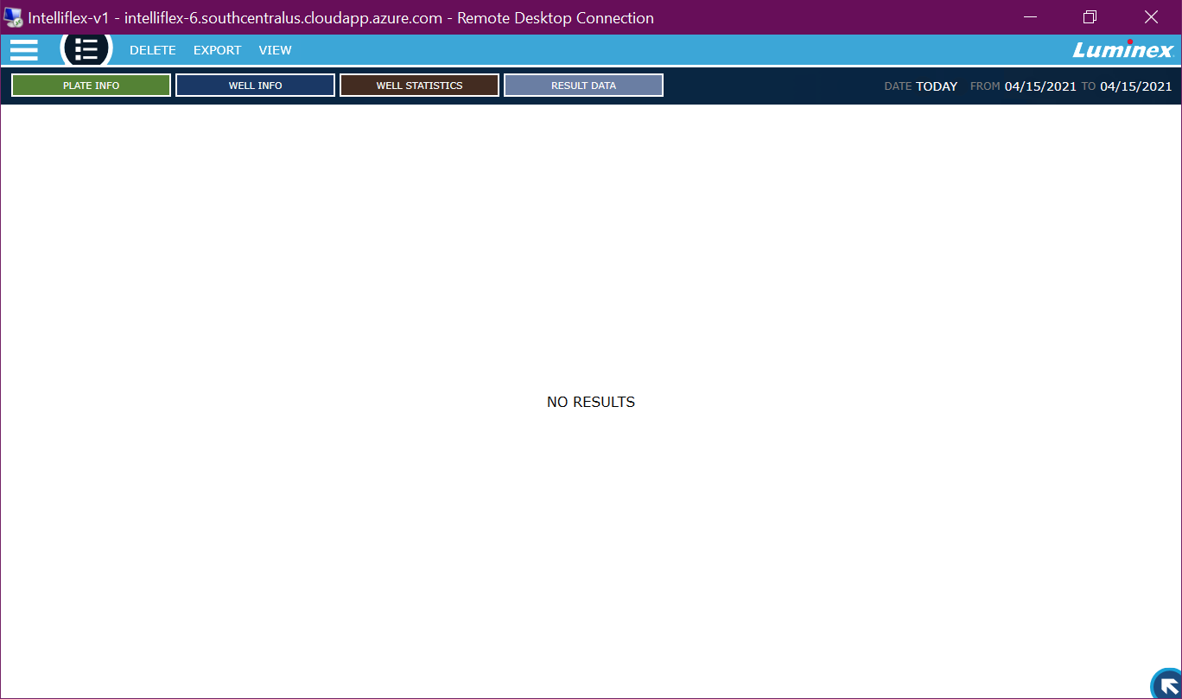

User clicks the top-left system navigation button, opening the system navigation menu
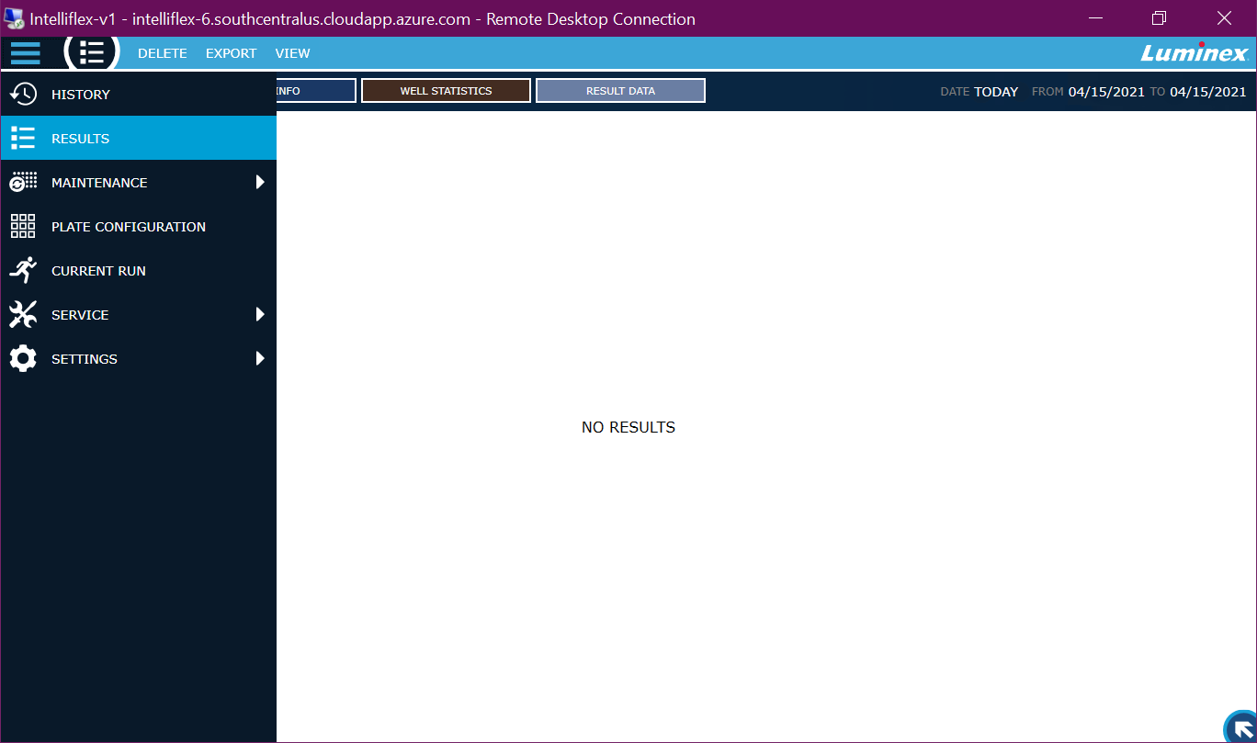

User selects ‘PLATE CONFIGURATION’ from the system navigation menu and is taken to the LAYOUT page.
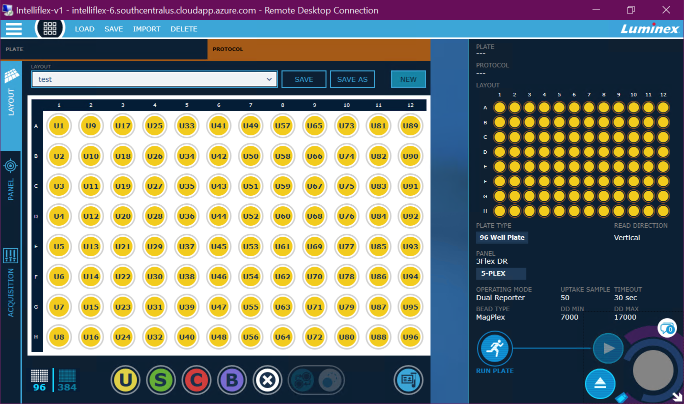

User presses the RUN PLATE button, which becomes highlighted.
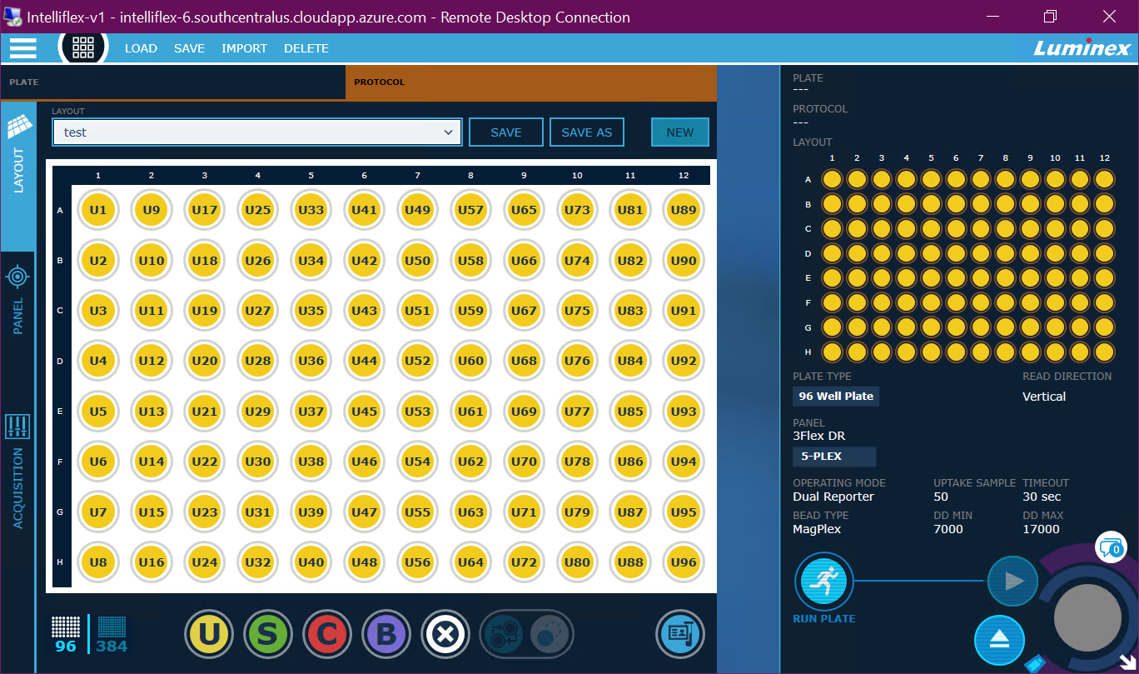

User is taken to the Current Run page.
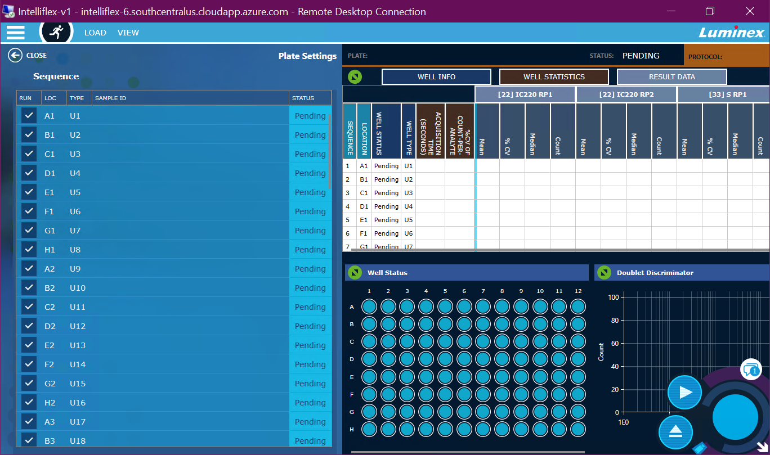

User presses the Eject button. The Eject and Play buttons are grayed out while the tray is ejecting.
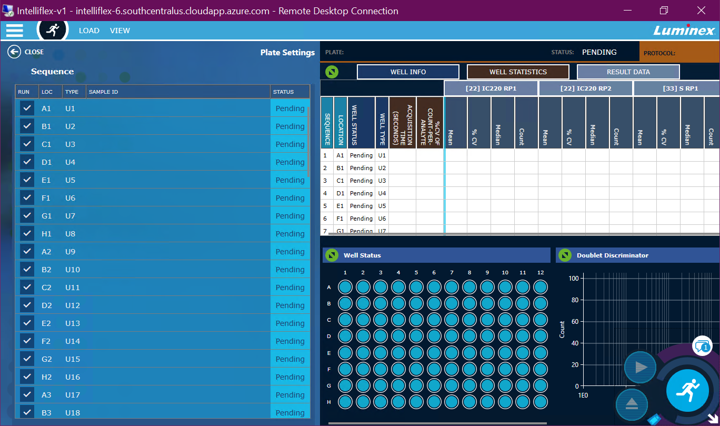

The tray is in an ejected state. The Eject button icon changes to a Retract icon.
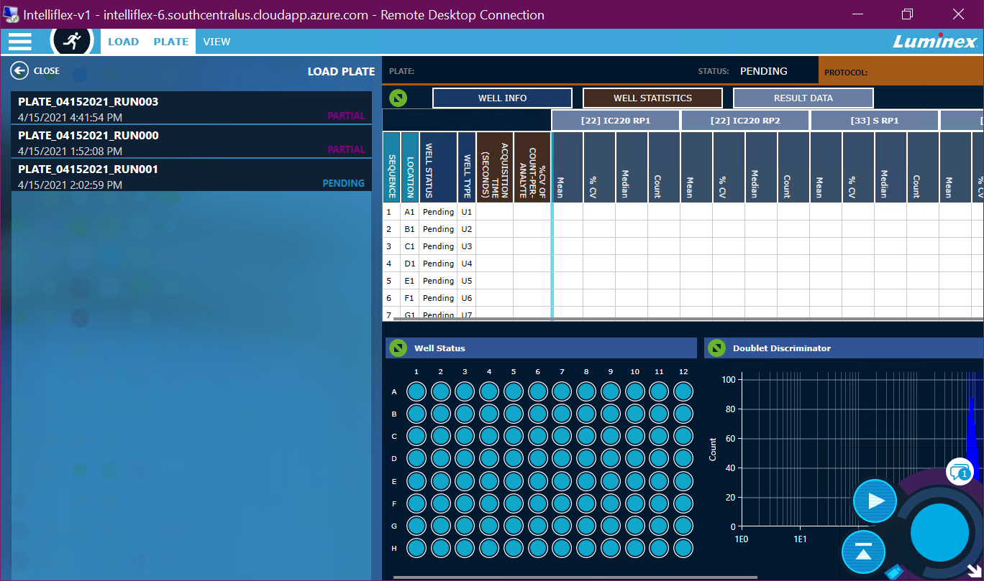

The user places the tray into the instrument and presses the Retract button. The Retract and Play icons are disabled while the tray is retracting.
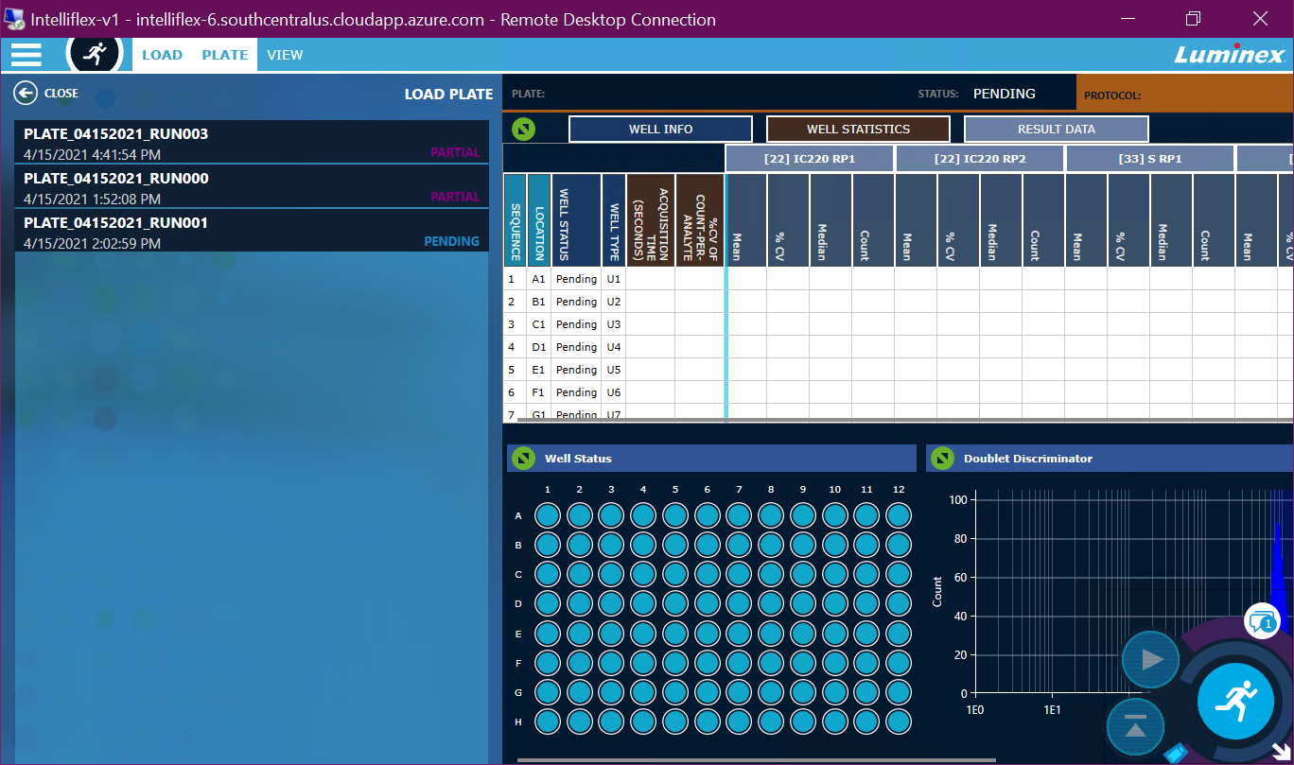

Plate is ready to run.
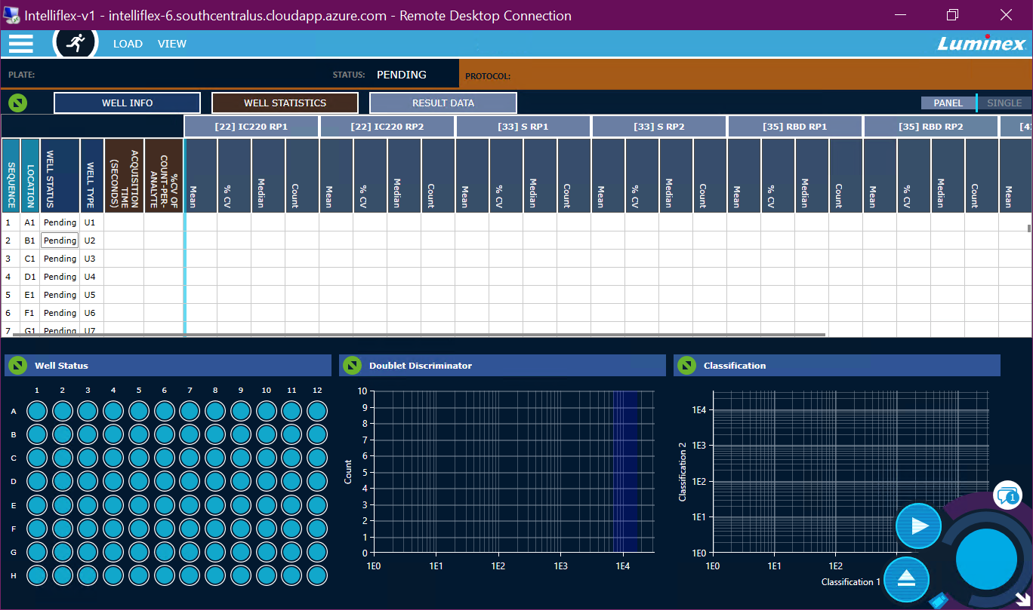

User presses the Play button. The Play button icon changes to a Stop icon and the Retract button is disabled. The BPS gauge at the bottom right begins to populate with bead data.
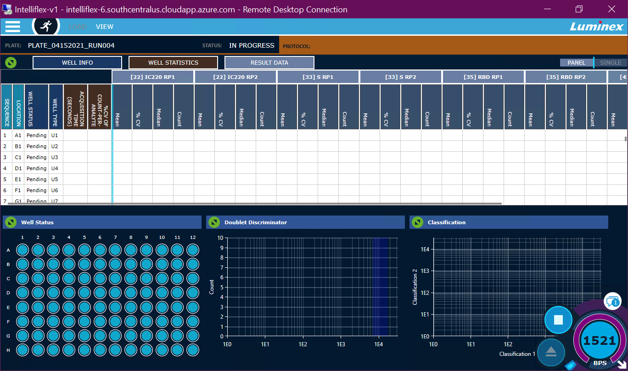

The 1st well changes to a purple color in the Well Status view, indicating that the while is being acquired. The BPS gauge continues to show data.
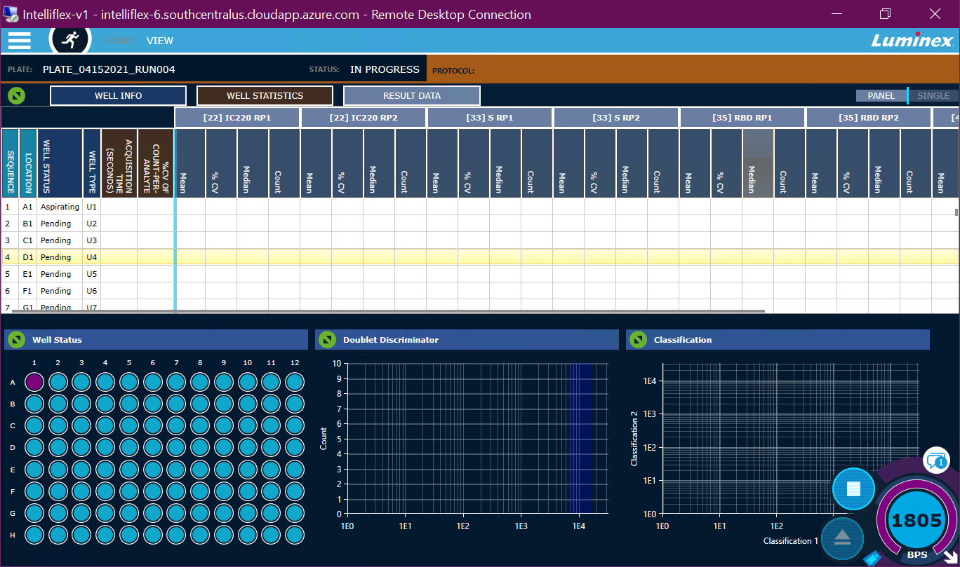

The 1st well turns green, indicating a successful acquisition, the 1st row in the data grid populates with results, the dot plot and histogram are populated with data from the 1st well. The 2nd well turns purple as it begins being acquired.
This process will continue until the plate completes.
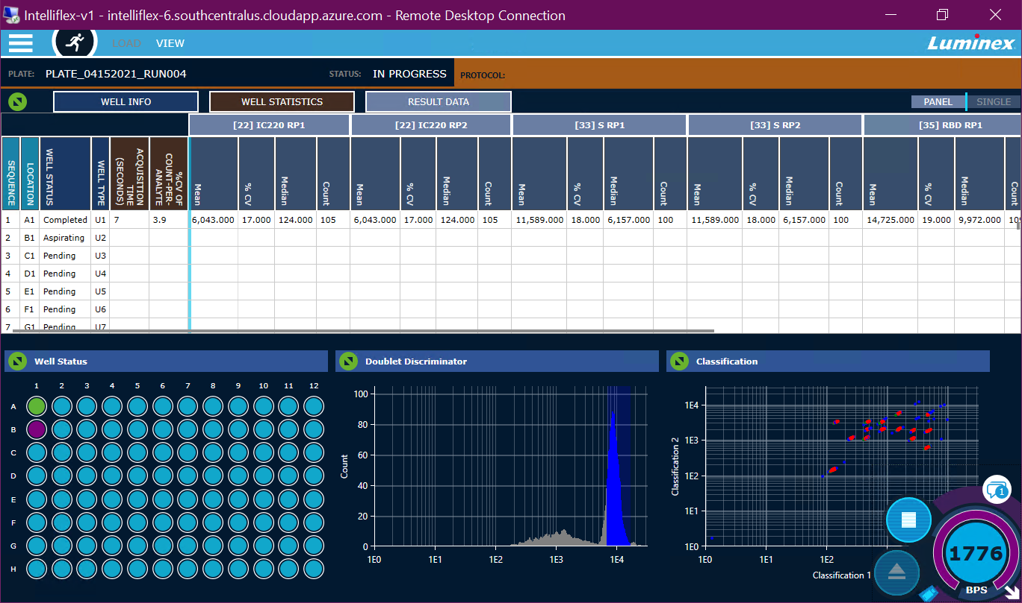

Run is complete.
