Bettina A. Buttaro, Ph.D.
Department of Microbiology and Immunology
3400 N. Broad St.
Philadelphia, PA 19140
+1.215.707.3212
bbuttaro@temple.edu

May 4, 2021

Dear Dr. Nguyen,

This letter accompanies the revised version of our manuscript “Bead movement based computational framework for 3-dimensional analysis of biofilm material heterogeneity” by B. Buttaro and G. Queisser. Following this cover letter, is a point-by-point response to the reviewers. The reviewer’s comments are in black. Our responses to the reviewers are in blue in the response letter and the manuscript.

We could not address one issue raised about the quality of the images. The images are the ones used in the Journal of Bacteriology article, so they should be of significant quality. Perhaps it was a problem with the assembled pdf? We are happy to work with you to meet the quality requirements.

We hope these changes will make the manuscript suitable for publication.

Bettina A. Buttaro, Ph.D. Gillian Queisser, Ph.D.
Assoc. Prof. Microbiol. Immunol. Assoc. Prof. Mathematics

Editorial comments:
Changes to be made by the Author(s) regarding the written manuscript:
1. Please take this opportunity to thoroughly proofread the manuscript to ensure that there are no spelling or grammar issues. We hope we have not missed any errors.
2. Please provide emails and affiliations for both authors. Affiliations were added.
3. JoVE cannot publish manuscripts containing commercial language. This includes trademark symbols (™), registered symbols (®), and company names before an instrument or reagent. Please remove all commercial language from your manuscript and use generic terms instead. All commercial products should be sufficiently referenced in the Table of Materials. I do not think there is any commercial language in the manuscript.
4. Please provide a legend for each supplemental video. The legends have been provided.
Response to Reviewers:
We thank the reviewers for their comments. Below are the point-by-point responses to the reviewers.

Change in title:
We have decided to change the title to “Bead movement based computational framework for analysis of 3-dimensional biofilm material heterogeneity”. The addition of “3-dimensional” sets the technique apart from microrheology that analyzes bead movement in 2D. The addition of the word heterogeneity better reflects how these differences can be heterogeneous within different parts of the same biofilm.
Point by point response to the reviewers:
Reviewers' comments:
Reviewer #1:
Manuscript Summary:
The authors describe a method for analyzing and quantifying the movement pattern of 1μm glyoxylate beads added to bacterial biofilms grown in multiwell plates after several washing procedures. Then they pretend to use the movement patterns of the beads to quantitate differences in material properties of biofilms.
Major Concerns:
The washing procedures introduce un-controlled steps in the protocol. The beads are post-added and probably stuck to the biofilm surface and the sealing of the coverslip is expected to significantly alter the biofilm material properties — the issue is not addressed. The material properties the authrors are talking about are not defined. The measurements are so scatterred that I don't understand how they can be interpreted in terms of brownian motion with a linear dependence of the MSD with time. The reviewers comments have been broken down into the following subjects:
Pretending to use the movement pattern to quantitate differences in material properties and the material properties are not defined (reviewer 2) and differences in microrheology (reviewer 2). This statement may arise from different application of terminology arising from different fields. The 4D videos over 20 minutes played at approximately 100X revealed visually different overall material properties of the biofilms. Some biofilms are more homogeneous and show a viscous fluid-like movement versus biofilms that appeared rigid with no visible movement as well as curli mutant biofilms that had a mixture of viscous and rigid areas (heterogeneous biofilms). These properties are likely derived from different material properties. These material properties would include, the contribution of amyloids shown for the Enterobacteriaceae biofilms, as well as cell density contributions, and chemistry differences. While microrheology tracks can be used to analyze viscoelastic properties in 2D, there was not a good way to quantitate these clearly different overall behaviors in 3D. 3D tracking over time (4D) is important for properties like the movement of bacteria (proxy for the carboxylate beads with bacteria-like charge) or antibiotic movement through 3D structures. We can track bead movements over 20 minutes and generate trajectories for each bead in the biofilm. The bounding box and velocity of the bead movement corresponds to visual inspection of the bead movement when observing the beads in the video associated with more fluid-like (viscous) and more rigid regions of the biofilm. While, we agree, we are not directly providing quantitative measurement of elastoviscosity of the biofilms, we are providing a method for quantitating observed visual differences as well as a method for tracking movement of particles through biofilms with different material properties.
Washing steps: The washing steps are necessary to remove our bacterial growth medium that has a strong green channel autofluorescence and to move unassociated beads from the biofilm. The background of unassociated beads would increase the data set. This was mentioned in step 2.1.2 as an optional wash step. We have added a discussion about the technical challenges of the wash steps to the critical steps. Our technique is easily applicable to biofilms that do not need to be washed. This explanation was added Lines 583-586.

Post adding of the beads: We choose to use excess beads and remove unassociated beads by washing to maximize the associated beads to get the most accurate characterization of the observed regions. We agree that the beads associated with the biofilm are in some sense “stuck”, they are associated with the biofilms and do not easily wash off. If the beads were moving through with no association that would be more a measure of penetrance than biofilm material property. The choice of carboxylate beads with the approximate charge of bacterial cells was intentional as a proxy for movement of things such as bacteria through these biofilms. The addition of beads during biofilm growth could be an interesting way to get the beads “trapped” in the biofilm rather than associated with the biofilm for a more accurate measure of biofilm movement without risk of disassociation of the beads in a viscous biofilm. A section describing this has been added to the Modifications and Future Applications (Lines 603-616).

Mounting on coverslip: We agree a mounted coverslip may introduce artifacts, which is the reason that throughout the manuscript, we presented data in each figure comparing the mounted E. faecalis to one in an optic bottom well (E. faecalis bottom). We found them to be very similar to the mounted coverslip in each figure (E. faecalis). Then in the critical steps, we discussed the limitations we did note when using a mounted coverslip. Finally, the use of coverslips was listed as the biggest technical challenge in the discussion section. The reason the mounted coverslip was used in our studies is because of the technical challenges with some aerobic pellicle biofilms, that even in the hands of Enterobacteriaceae experts, could not be properly grown in an optic bottom plate or in a flow cell that would allow imaging without mounting (this was discussed under the heading of “bounding box analysis”).

“I don't understand how they can be interpreted in terms of brownian motion with a linear dependence of the MSD with time” To analyze the general movement pattern of beads we computed the mean square displacement for each bead over time. Given that a linear time profile of the MSD means that the particle is moving diffusively we performed a least squares fit to all trajectories and evaluated the weight of the second order term. If the second order term was significantly smaller than the first order term, we concluded that the MSD develops linearly over time. This could be confirmed for the analyzed data, bringing us to the conclusion that beads move passively by diffusion through the medium.
Reviewer #2:
Manuscript Summary:
Buttaro and Queisser describe a technique to probe biofilm structural properties by flowing 1 um beads and analyzing their paths. The method is then applied to the study of the biofilms formed by Enterococcus faecalis, Salmonella enterica serotype Typhimurium and Escherichia coli. Bead trajectories are analyzed and reconstructed using the Mosaic plugin in Image J and movement data. In this work the authors present the workflow from data collection to the analysis and present results regarding biofilm material properties related to the presence of curli.
The manuscript is well written and the procedure is interesting. I recommend to follow up with the video, after the following comments are addressed.
Major Concerns:
- The description of the procedures to prepare the sample for imaging is difficult to follow with just the description. Please make sure that in the video this part is well explained and shown.
We added some more details to the various steps of the protocol to try and paint a clearer picture of each step. We agree that some of this may require a video to clarify the written descriptions. Lines 134-149.
- Lines 92-92: "reveal the material properties responsible for movement of beads we observed in biofilms that were not under flow" is routinely done by microrheology (see [1,2]), so I would not sell this as an element of novelty of the technique. I would suggest to discuss the technique in light of results obtained with microrheology.
We had references 1 and 2 in our version of the manuscript but we had not appropriately discussed them. One of the major differences is microrheology is a 2D particle tracking technique. Viscoelasticity of different regions of a biofilm could be determined by 2D microrheology at different Z positions. However, this technique does not allow contiguous tracking of particle movement through 3D biofilms, which is the goal of our technique. We modified the Introduction Lines 79-85 and added 3D to the Title to better discuss these differences.

We also more carefully explained that the differences we observed are due to movement in three directions is based on material properties, cellular density, interactions of the beads with the chemistry of the matrix and 3D heterogeneity. Lines 412-413.
- Would it be possible to implement this procedure in microfluidic channel, without displacing the biofilm sample? This would allow avoiding the problems described at lines 343-344. As also mentioned in the Discussion, the fact of not being in-situ is the main limitation of the technique.
Absolutely, this was briefly mentioned in the original introduction and has been emphasized there and a section has been added to the modifications and future applications. Line 106 and 602-607
- Line 358: Do the authors take the image of a single layer? This point should be precisely discussed and the influence of the 2D vs 3D geometry on the results should be carefully discussed.
We use the 3D data set for our analysis. Below are two visualizations of the 3D trajectory of 2 beads with its coordinates in μm. In the case of this bead, from the E. coli biofilm moved 0.04 μm in Z, 0.4 μm in Y and 0.4 μm in X. In the case of the E. faecalis bead on the right it moved 7 μm in Z, 16 μm in Y and 12 μm in X. The trajectory visualization is not part of the current tool because of limitations in bead trajectory stitching. The use of 3D has been clarified throughout the manuscript and added to the title.
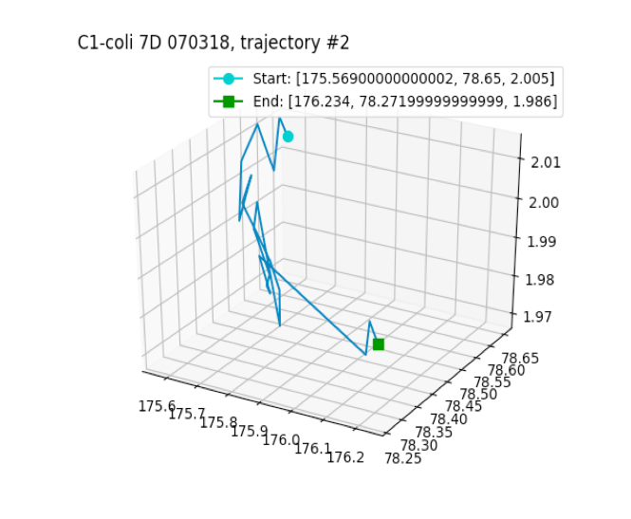
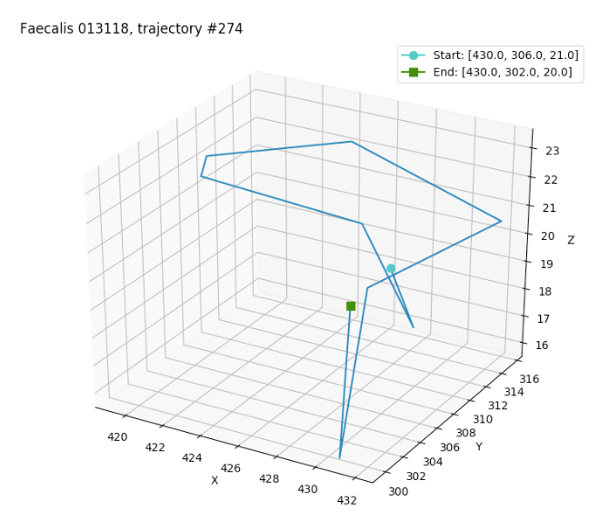

- Line 390: What could be the impact of the particle surface properties on the results?
Good point. That has been added to the manuscript Lines 411-412.
- The optical quality of the figures is quite poor. I suspect it could be due to the PDF preparation, but the problem should be addressed in the final version.
We are not sure what happened here since JoVE assembled the final pdf. We will make sure the optical quality is good for publication.
Minor Concerns:
- Lines 72-73: The authors say that the target for their research is the movement of plasmids- they should say explicitly that they are transported by bacteria, and so basically they target the motion of bacteria in the biofilm.
We are using 3 different fluorescent wavelengths tagging, donors, recipients, and the plasmid itself to follow movement of the added donor cell to the recipient population, docking, and plasmid transfer. This has been clarified Lines 110-111.
- Line 130: Could the growth condition of each biofilm be clarifies for the reproducibility of the results?
Growth conditions have been added to the manuscript, we apologize for the oversight. Step 1.2 Lines 147-149.
- Line 158: What is the Crimson bead concentration? The procedure described in 2.1.3 is not clear.
The concentration of the beads was 2x10⁷/ml as outlined in Step 2.1.1. In Step 2.1.3 for 24 well coverslip biofilms 1 ml was added giving a total of 2x10⁷ beads and for the 96-well optic bottom biofilms 0.2 ml was added giving a total of 4x10⁶ beads. This clarification was added to steps 2.1.3. Lines 177-179.
- Line 412: Could some details about the procedure used to calculate the cell density be given?
The cellular density was computed by averaging the Syto9 voxel data over the bounding box of each trajectory edge. Thus, the bead velocity can be weighted by the edgewise (local) cell densities. This was added to the manuscript Lines 438-441.
These were included but not well discussed in the original version.
[1] S. C. Chew, B. Kundukad, T. Seviour, J. R. C. Van der Maarel, L. Yang, S. A. Rice, P. Doyle, and S. Kjelleberg, Dynamic Remodeling of Microbial Biofilms by Functionally Distinct Exopolysaccharides, MBio 5, e01563 (2014).
[2] A. Birjiniuk, N. Billings, E. Nance, J. Hanes, K. Ribbeck, and P. S. Doyle, Single Particle Tracking Reveals Spatial and Dynamic Organization of the Escherichia Coli Biofilm Matrix, New J. Phys. 16, (2014).
Reviewer #3:
Manuscript Summary:
Buttaro et al. is using time lapse fluorescence confocal microscopy looking at fluorescent bead movement within a biofilm. They have also created a workflow to monitor the movement using various software. The technique is interesting and allows for a unique way to study the viscoelastic properties of microbial communities. This technique seems appropriate for publication in JOVE, but there are several minor things in the manuscript that need to be addressed prior to publication.
Major Concerns:
Lines 63-64. The authors state that they were unable to see any amyloids present in E. faecalis. What staining method was performed to look for amyloids? If using Congo Red from the (9) citation, this is not a reliable stain for amyloids. Khurana et al. 2001 J Biol Chem.
We did use Congo Red at the time this experiment. However, in our case, since we did not see staining, we felt this was sufficient for these studies. Had we seen staining, the experiments would have been repeated with Congo Red FSB (Reichardt 2018) to provide better specificity for amyloid.
Lines 53-68. This paragraph appears to be making the argument that a major difference between Enterobacteriaceae and E. faecalis biofilms is the presence of amyloids. I think it is incorrect to say that the difference between E. faecalis biofilm and others are amyloids. It is an exhaustive process to find amyloids within a biofilm, and the authors did not prove conclusively that this isolate does not produce an amyloid in this biofilm model. Additionally, there are many differences in extracellular DNA, cell wall, extracellular sugars, and proteins between this Gram-+ isolate and the Enterobacteriaceae evaluated in this study that could all effect the rigidity or physical properties of the biofilm. This means there are too many differences for the authors to say the main difference in viscoelasticity in the biofilm is due to the presence or absence of an amyloid. The authors should more generally talk about the differences in the biofilms. Comparing E. coli and S. enterica WT and curli mutants IS a direct way to elucidate the role of microbial amyloids in viscoelasticity in this assay.
This is what we meant to say and did not say it well at all. This section has been reworded. Lines 64-77.
Minor Concerns:
Line 45-46. Curli are not just specific for Enteric bacteria. Dueholm et al. 2012 Plos one
This paper has been included in the references and the statement broadened. Lines 51-52.
Lines 60-62. The authors state that their strain does not have the gene encoding Esp. The authors should state what bioinformatic method was used to ensure that esp is not present.
We just used a standard BLASTn and BLASTp searches and it has been added to the manuscript. Line 70
Line 64, do the authors mean "E. faecalis" not "S. Typhimurium"?
We did mean E. faecalis. Thank you.
The authors refer to the other evaluated strains by their species names (E. coli, E. faecalis), but consistently use S. Typhimurium instead of S. enterica. There should be consistency in nomenclature used in the manuscript.
S. Typhimurium is a standard way to refer to S. enterica serovar Typhimurium because S. enterica serovars are significantly different. The original paper containing this technique was published with C. Tukel, an expert on S. Typhimurium, who used this nomenclature in the manuscript from which many of these figures are described.
The figures are very pixelated and difficult to see. They should be re-captured.
We will make sure the final pictures are not pixelated. Thanks.
Figure 2B and D. Were these experiments stopped short of the rest of the experiments? There should be consistent data capture between runs that are being compared.
The runs were of equal length. The trajectory lifespans are shorter because the beads either make large movements that cannot be stitched, or the beads disassociate and reassociate with the biofilm. Thus, no one trajectory was followed for longer than 10 minutes although beads could be observed associated with the biofilm the entire time. This is discussed in lines 385-394.
The E. coli WT and curli mutant videos are taken from different angles. This can also be seen in Figure 1B. All the videos and stills should be at consistent angles, zoom, and timeframes to
allow for proper comparison.
An important aspect of the images is to show the beads associated with the biofilm. Due to the presence of heterologous rigid structures, which can obscure the beads, different orientations are necessary to make sure the beads are visible.
The authors don't specifically mention all the subfigures within the text. I'm not sure if this is JOVE specific or not, but Figure 1a, 1b, 1c are not mentioned in the text.
These were accidently omitted from the first version. Fig. 1A is at line 87. Fig. 1B in line 319 for the description of the representative results.
Fig. 3I and J are mentioned in the text prior to 3a. Also, the figure 3 legend discusses 3c prior to 3a.
This reference to Fig. 3I and 3J was moved to a more appropriate section of the manuscript around line 380 at the conclusion of the bounding box section.
One of the most interesting things about this data, that the authors don't really discuss is the median vs. mean displacement seen in the WT and curli mutants. The mean data (Fig 3J) shows that curli are important for decreasing overall movement of these fluorescent objects in the biofilm. But, they have almost identical medians (Fig. 3B), showing that any particular location in the biofilm can halt movement of physical objects to a similar degree, but the presence of the amyloid almost eliminates all areas of the biofilm that allow for a physical object to move. I think this piece of data is quite intriguing and it isn't discussed in the manuscript.
We agree, the bounding box volumes were consistently small (0-10 μm³) even in low density regions of the biofilm. This observation is consistent with our previous observations that curli can be present in low cell density regions of the biofilm. The small bounding box volume data in Figure 3B confirms this observation and well as the low mean square displacement in Fig. 3J. This has been added to the manuscript at Lines 371-373.

