Rebuttal letter

Dear Editor,

Thanks for the opportunity to revise our work.

We would like to thank the Editorial Board Members and the reviewers for their positive evaluation and for the useful comments that helped us improving the manuscript that we hope is now suitable for publication.

Please find below a point-by-point response to reviewers’ comments. Text modifications are clearly stated below (in red) and are also highlighted in yellow in the submitted revised version of the manuscript.

Kind regards

Sara Cristinelli

Editorial and production comments:
Changes to be made by the Author(s) regarding the written manuscript:
1. Please take this opportunity to thoroughly proofread the manuscript to ensure that there are no spelling or grammar issues.
2. Please revise the following lines to avoid previously published work: 20-23, 443-768
Line 22-25 have been replaced by:
The role of RNA modifications in biological processes has been the focus of an increasing amount of studies in the last years and is nowadays known as epitranscriptomics. Among others, N6-methyladenosine (m⁶A) and 5-methylcytosine (m⁵C) RNA modifications have been described on mRNA molecules, and may have a role in modulating cellular processes.
Line 454-494:
This paragraph contains the description of a commercialized kit. We used the kit, following manufacturer’s instructions with only few modifications. To make this point clearer we have now added the statement as described below:
Line 455-456
Bisulfite conversion was carried out with a commercially available RNA bisulfite conversion kit following manufacturer’s procedure as stated below :

- JoVE cannot publish manuscripts containing commercial language. This includes trademark symbols (™), registered symbols (®), and company names before an instrument or reagent. Please remove all commercial language from your manuscript and use generic terms instead. All commercial products should be sufficiently referenced in the Table of Materials.
  - For example: Trizol, Nanodrop, Dynabeads, etc.
- Please revise the text to avoid the use of any personal pronouns (e.g., "we", "you", "our" etc.).
- Please discuss limitations of the protocol in the discussion.
- Changes to be made by the Author(s) regarding the video:
- Please take this opportunity to thoroughly proofread the manuscript to ensure that there are no spelling or grammar issues.
This issue has been reviewed and modifications are highlighted in yellow in the manuscript

The video has been submitted here:
https://www.dropbox.com/request/NCuYKOfsdN9h9aT40rsB?oref=e

Point by point response to reviewers' comments:
Reviewer #1:
Manuscript Summary:
Authors describe a very detailed protocol to prepare polyA RNA samples for m6A determination using the m6A-seq strategy as well as 5mC determination through bisulfite conversion using an HIV-infected T-cell line as a model.
Major Concerns:
- While authors provide a very detailed protocol for RNA sample preparation either for m6A-seq or bisulfite conversion, they do not provide details on library preparation, sequencing and bioinformatic analyses, which limits de impact that this work could have on the readers.

We thank the reviewer for this useful comment. Starting from the fragmentation step, the library preparation protocol and the sequencing were carried out in a facility using common Illumina procedures. However, we agree with the reviewer that adding the bioinformatics pipeline could increase the impact of the paper. We have now added a paragraph describing the bioinformatic pipeline and supplied an additional figure depicting the bioinformatics workflow.
Figure 4 and [line 562 – 647].
- Bioinformatics analyses
  - m⁶A data processing
    - run FASTQC²⁴ to assess read quality in m⁶A and input FASTQ files from sequencing.
    - run Atropos²⁵ to trim low-quality end and adapter sequences from the reads. Set the following parameters in running Atropos.
. adapter sequences to be removed: AGATCGGAAGAG, CTCTTCCGATCT, AACACTCTTTCCCT, AGATCGGAAGAGCG, AGGGAAAGAGTGTT, CGCTCTTCCGATCT
. Phred quality cutoff: 5, for trimming low-quality ends as specified by the manufacturer (https://support.illumina.com/downloads/illumina-adapter-sequences-document-1000000002694.html).
. Minimum read length after trimming: 25 base pairs.
    - merge GRh38 human genome and HIV [Integrated linear pNL4-3ΔEnv-GFP] reference in FASTA format.
    - index the merged reference with HISAT2²⁶.
    - run HISAT2 on trimmed reads to aligned to the indexed reference. Use default HISAT parameters.
    - sort and index the aligned reads with SAMtools²⁷
    - run SAMtools stat and Qualimap 2^{28,} for post-alignment quality check of the sequenced libreries.
    - optionally, quality measures from the previous step could be collected and summarized with multiQC²⁹.
    - HIV genome has homologous 634 bp sequences in the 5’ LTR and 3’ LTR: realign multimapping reads from 5’ LTR to the corresponding 3’ LTR region with SAMtools
    - in order to identify the m⁶A peaks, run the peak calling software MACS2³⁰ (v 2.1.2). Caution must be applied in the choice of MACS2 running parameters, to allow the toll to correctly work on RNAseq data. In RNA-Seq data the peak calling can be affected by the gene expression level, and short exons may potentially be miscalled as peaks. Hence, signal from input must be subtracted from m⁶A signal, without the smoothing routinely applied by MACS2 to DNA based data. Apply the following parameters to the ‘callpeak’ sub-command from MACS2:
. –keep-dup auto (controls the MACS2 behavior towards duplicate reads, ‘auto’ allows MACS to calculate the maximum number of reads at the exact same location based on binomial distribution using 1e-5 as p-value cutoff)
. -g 2.7e9 (size of human genome in bp)
. -q 0.01 (minimum FDR cutoff to call significant peaks)
. --nomodel (to bypass building the shifting model, which is tailored for ChIP-Seq experiments)
. --slocal 0
. –llocal 0 (setting this and the previous parameter to 0 allows MACS2 to directly subtract, without smoothing, the input reads from the m⁶A reads)
. --extsize 100 (average length of fragments in bp)
. -B
    - run the differential peak calling sub-command of MACS2, ‘bdgdiff’ to compare infected vs non-infected samples. ‘bdgdiff’ takes as inputs the bedGraph files generated by ‘callpeak’ in the previous step. For each time point, run the comparison of infected versus non-infected samples with ‘bdgdiff’, subtracting the respective input signal from the m⁶A signal and providing the additional parameters: -g 60 -l 120.
  - m⁵C data processing
    - run Cutadapt³¹ to trim adapter sequences from the raw reads, with the following parameters:
. adapter “AGATCGGAAGAGCACACGTCTGAAC”
. –minimum-length=25.
    - reverse complement the trimmed reads using seqkit³², as the sequencing protocol produces reads from the reverse strand.
    - run FastQC to examine read quality.
    - merge GRh38 human genome and HIV [Integrated linear pNL4-3ΔEnv-GFP] reference in FASTA format.
    - index the merged reference with the application meRanGh from the meRanTK package³³
    - aligning with meRanGh, with the following parameters:
. -UN enabling unmapped reads to be written to output files
. -MM enabling multi-mapped reads to be written to output file
. -bg for output in bedGraph
. -mbgc 10 filter reported region by coverage (at least 10 reads of coverage)
    - HIV genome has homologous 634 bp sequences in the 5’ LTR and 3’ LTR: realign multimapping reads from 5’ LTR to the corresponding 3’ LTR region with SAMtools
    - run methylation calling via the meRanCall tool, provided by meRanTK, with parameters:
. -rl = 126, read length
. -ei = 0.1, error interval for the methylation rate p-value calculation
. -cr = 0.99, expected conversion
    - run the MeRanTK’s utility estimateSizeFactors.pl for estimating size factors of each sample. The size factors will be used as parameters in the next step.
    - run MeRanCompare for differential methylation analysis of not infected vs infected) across time points 12, 24, and 36h. The following parameters are applied:
- significance value of .01 as the minimal threshold for reporting
- size factors from previous step

- Indeed, authors mention they developed a home made pipeline for m6A analyses, which is not described in the manuscript. Since peak assignment is critical in m6A-seq analyses, authors should provide the reader with a guide to perform m6A peak determination.
These details have now been integrated to the manuscript in the bioinformatics analysis paragraph [line 588-613] (and answer here-above)
- In the introduction section, authors should mention additional strategies allowing determination of m6A residues with single-nucleotide resolution as well as additional methodologies employed for 5mC determination.
We would like to thank the reviewer for this comment. Additional technologies are now added in the introduction
[line 66 to 77]
To date various techniques can be used to detect epitranscriptomic marks at transcriptome-wide level. Most used techniques for m⁶A identification rely on immune precipitation techniques such as MeRIP-Seq and mi-CLIP. While MeRIP-Seq rely on RNA fragmentation to capture fragments containing methylated residues, miCLIP is based on the generation of α-m⁶A antibody specific signature mutations upon RNA-antibody UV crosslinking, thus allowing a more precise mapping.
Detection of m⁵C modification can be achieved either by antibody-based technologies as for m⁶A detection (m⁵C RIP), by bisulfite conversion or by AZA-IP or miCLIP. Both Aza-IP and m⁵C miCLIP capture only the RNA targets that are undergoing methylation by the enzyme with a covalent linkage. In Aza-IP, the cytidine analog 5-azacytidine sites are randomly introduced into nascent RNA following cellular exposure to 5-azacytidine, and in miCLIP, the NSun2 protein is engineered to harbor the C271A mutation^{8,9}
- Figures 2 and 3 should include the cDNA library preparation step in order to avoid confusions with the Direct RNA sequencing strategy using Oxford Nanopore Technologies.

- Figure 2 and 3 have been modified to include the library preparation step as requested.

- Revised figure 2

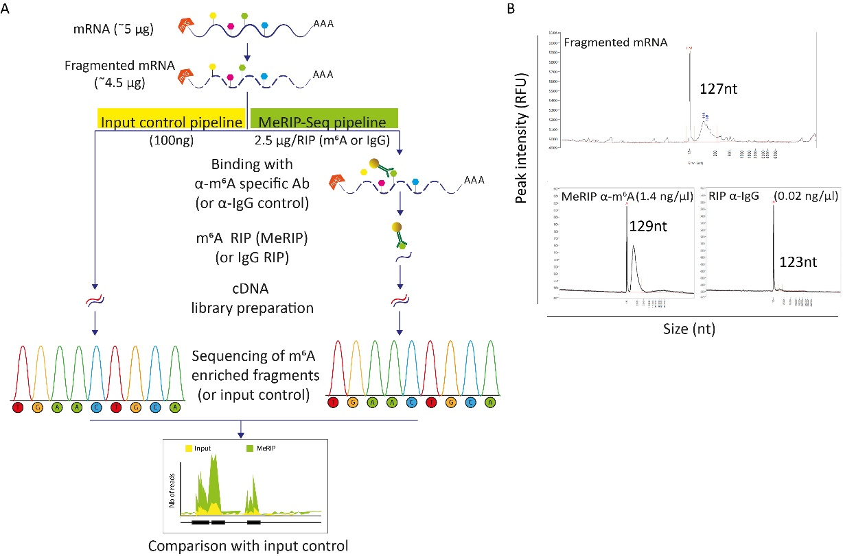

- Revised figure 3

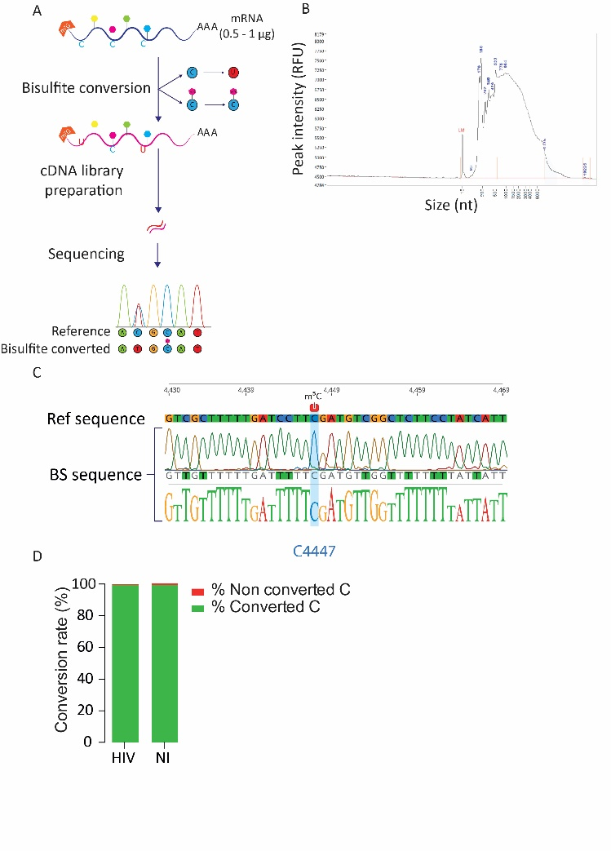
- Since authors are using HIV as an example, they should present some m6A-seq and 5mC data
analysis on viral transcripts

We thank the reviewer for the interest in our work. We used this pipeline in particular to assess the differences in the epitransciptomic landscape of infected cells versus non-infected once, as presented in figure 5. We think that presenting the results of HIV transcripts or viral particles is out of the scope for this method issues. However, all these data are published in our original research work https://doi.org/10.1101/2021.01.04.425358
Minor Concerns:
- There is no mention to the brands of reagents with the exception of Zymo Research kits (e.g., fragmentation reagent, anti-m6A antibody, Magna Beads, etc). Is there any reason for this?
We agree with the reviewer that having the reagents brand and reference within the paper could be handful; however, it is a journal policy not to integrate this information in the paper. These informations are available in the dedicated excel table.
- Some Buffer compositions such as that of the IP buffer should be provided
We thank the reviewer for noticing this mistake. Whenever possible buffer composition is stated in the text. In case of commercial buffer, the information is provided in the method table as per journal policy
[line 350-351] for IP buffer
For each sample : Prepare 4 ml of 1x IP buffer in a new conical tube by diluting 800 μl mRNA IP buffer 5x (50 mM Tris-HCl pH 7.4 750 mM NaCl 0.5% Igepal CA-630 Nuclease-free water) with 3.2 ml of nuclease-free water.
- Point 7.1.6 needs rewording
We have now clarified the sentence in the text as follow:
[Line 362-363]
Add ten times more 1X IP buffer (from step 7.1.1) with respect to the original volume of beads used (i.e. 250 μl of 1x IP buffer per 25 μl of magnetic beads).

Reviewer #2:
In their review entitled "Exploring m6A and m5C epitranscriptomes upon viral infection : an example with HIV", the authors described two methods, called meRIP-seq and BS-seq, allowing the detection of epitranscriptomic modifications (m6A and m5C, respectively) on messenger RNAs (mRNAs). Overall, this technical review is extremely well written and provides two clear and highly detailed protocols that will definitively help researchers to perform both techniques. The section "Representative results" brings a nice addition to the present review. The reviewer has only a few minor remarks/suggestions :
We would like to thank the reviewer for this positive evaluation and for appreciating our work.
- The present review is focused on the detection of epitranscriptomic modifications on polyA-selected RNAs. Since many nonpolyadenylated transcripts could also harbor epitranscriptomic modifications, the reviewer would appreciate a comment on putative protocol adaptations to perform meRIP-seq and BS-seq on non-polyadenylated transcripts.

To analyze non polyadenylated RNA, the same procedure could be applied either on tot RNA or on rRNA-depleted RNA.
This is now further clarified in the text as shown below:
[line 229-232]
Please keep in mind that if you aim at analyzing methylation of non-polyadenylated viral RNAs, you should favor rRNA depletion rather than polyA selection or eventually perform the analysis on tot RNA.
and
[line 782-784]
However, if the focus of the study is non-polyadenylated RNA, the RNA extraction step should be adapted in order to avoid discarding small RNA (in case of column based RNA extraction) and to privilege ribosome-depletion techniques rather than polyA selection to enter the pipeline
- Point 2.1.7 : which volume should be recovered in the aqueous phase to prevent pipetting of the interphase ?
The amount of aqueous phase should be very similar to the amount of chloroform added; however, this could slightly change depending on the sample. To clarify this point, we added a note in the manuscript:
[Line 157-158]
Note: the amount of aqueous phase may vary among samples but should be close to the amount of chloroform added to the sample (i.e. 1 ml)
- In each protocol, the RNA quality is assessed using a fragment analyzer which is not a common laboratory equipment. Is there any alternative to this equipment to evaluate RNA quality?
Fragment analyzer or bioanalyser are the best options to assess RNA quality and know beforehand if it is worth to proceed with the experiment. However, if this is not available total RNA and mRNA quality can be visually assessed by running a few ng of sample on agarose gel. The quality and amount of immune precipitate and bisulfite converted RNA however can only be assessed with highly sensitive methods, if this is not available it is always possible to proceed blindly to library preparation.
This point is now further discussed in the text
[Line 785-789]
In order to ensure high quality RNA, correct fragmentation and suitable m⁶A-enriched and BS converted RNA quality for library preparation we strongly advise to use a fragment analyzer or a bioanalyzer. However this equipment is not always available. As an alternative, quality of RNA, mRNA and size of fragmented RNA could also be assessed by visualization on agarose gel. Alternatively library preparation can be performed without previous assessment of RNA quantity.
- Point 2.1.11 : the authors recommend the use of molecular biology grade ethanol. Is this recommendation also important when using isopropanol ?

Yes, we recommend to use molecular grade isopropanol as well. This recommendation has now been added to text
[Line 159]
2.1.8. Add 0.5 ml of 100% molecular grade isopropanol to the aqueous phase.
- Regarding the use of specific kit, such as Quick RNA Viral kit, High-Capacity cDNA reverse Transcription kit or PCRapace, it is maybe important to mention the name of the private companies selling these kits for patent reasons ?

We apologize for the mistake, indeed as per journal policy, we will not be able to use the kit name in the paper. The manuscript has now been corrected using only generic names within the main text and providing kit names and references in the method table as requested by the editor.
- Point 3.2.4 : how long the tubes should be placed on ice ?

The incubation time does not need to be precise, however according to the number of samples and technical settings it is important that the incubation time does not exceed 1h. Maintaining RNA on ice is important to avoid possible degradation.
This point has now been clarified in the text:
[Line 256-259]
Place immediately on ice until you are ready to proceed to the next step.
Note: Incubation time may vary according to the amount of samples to be processed but should not exceed 1h to avoid any RNA degradation.
- When pipetting liquid containing magnetic beads, should we use cutted tips to avoid beads retention?

The size of beads available today does not require the tips to be cut out, nor the use of any special wide bore pipette tips.
- Point 3.3.5 : to improve washing steps, would it be an alternative to place the tubes during 5 minutes on a rotating wheel as performed in common ChIP protocols ?

We would like to thank the reviewer for the helpful advice that we may use in the future. However, at this stage and according to our experience, simple washing without wheel incubation is sufficient to provide high quality mRNA.
- Point 5.7: how long should the tubes be placed on ice?

please see response to point 3.2.4
[Line 320-322]
5.7. Spin down and let sit on ice until you are ready to proceed to the next step.
Note: Incubation time may vary according to the amount of samples to be processed but should not exceed 1h to avoid any RNA degradation.
- Point 6.8 : no centrifugation step to further eliminate all putative contaminants from the wash buffer (such at point 2.2.2.13) ?

We thank the reviewer for pointing out this mistake. Indeed, a further centrifugation step is recommended to remove any further contaminant. However, as per journal policy we had to remove any reference to particular kit and protocols. Therefore, this part of the protocol description has to be removed.

- Point 8.2.10 : discard the flow through ?

Discarding the flow through at this point it is not necessary as the amount of washing buffer plus Desulphonation Buffer (total of 400 µl) is lower than the total volume that a collection tube can handle without reaching the column filter (700µl)

Reviewer #3:
The RNA modifications in the field of virology are expanding. A few reports investigated the m6A and m5C on HIV-infected cellular and HIV viral RNA in the previous study. This article provided a good resource and detailed protocol for performing the m6A and m5C sequences on RNA. Some minor issues need to be addressed.
- This study uses HIV as a model to study m6A and m5C RNA methylation. Although this is a method article, some previous findings related to m5C and m6A RNA methylation in HIV should be used as reference.

We thank the reviewer for the useful comment. We have now highlighted the previous works performed on HIV epitranscriptomics in the text.

[line 63-65]
In the field of HIV epitranscriptomics, modification on viral transcripts have been widely investigated and have overall shown that presence of this modification was beneficial for viral replication⁸⁻¹³.
- Using the HIV viral RNA as a material, how to get enough viral RNA for the study in a short infection time (24h infection) should be considered. The author may need to consider concentrating the virus first.

We thank the reviewer for the insightful comment. Since HIV RNA is polyadenylated, direct RNA extraction without further mRNA isolation is sufficient to proceed to epitranscriptomic analysis. Hence only 1-2 ml of infectious supernatant are normally enough to retrieve 1 ug of viral RNA to proceed with the analysis. We also performed RNA extraction from concentrated viral particles. However, upon column-based RNA extraction, the RNA quality was unfortunately very low and we needed to switch to phenol-based methods.
This is now clarified in the text
[line 183-186]
Note: Since HIV RNA is polyadenylated, direct RNA extraction without further mRNA isolation is sufficient to enter the MeRIP-Seq and BS-Seq pipelines. Normally 1-2 ml of viral supernatant from universally infected cells should provide enough RNA to perform the entire workflow.
- For the m6A study, how much anti-m6A antibody did the author use in this study? How many different anti-m6A antibodies from other vendors did the author test?

We tested 3 different antibodies from 3 different vendors,
- Mouse monoclonal anti m6A : SYSY (clone 212B11)
- Rabbit polyclonal anti m6A: NEB (ref E1610S)
- Mouse monoclonal anti-m6A: Millipore (clone 17-3-4-1)
All tested antibodies performed very similarly, however clone 17-3-4-1 was the one resulting in cleaner peaks upon elution. Hence, we decided to continue working with that one.

- To remove the false positive of m5C on RNA, the author mentioned that they performed three cycles of denaturation/ bisulfite conversion. The bisulfite conversion is harsh, and some RNA will be lost each cycle. Although the accuracy is increased, some m5C sites may lose. The author should discuss this.

The reviewer is absolutely right about it. However, in our setting we preferred to settle for a slightly lower resolution in order to have very robust data with the lowest false positive rate as possible.
This is now discussed in the text as follows
[Line 808-811]
One of the limitations linked to this technique is that bisulfite conversion is very harsh and three cycles of denaturation/bisulfite conversion could degrade some RNA and hence reduce resolution. However, in our setting we choose to settle for a potentially slightly lower resolution in order to increase the quality of the dataset.

- There are a few methods to measure the m5C RNA. Have the author tested other methods, like miCLIP and AZA-IP? Do you have any comments about this?

We would like to thank the reviewer for noticing this. And we apologize as we forgot to discuss this in the manuscript.
Indeed, although we are aware of the presence of other methods to investigate m5C we did not test them as we are convinced that bisulfite conversion was the method that was best fitting our study design. In the epitranscriptomic field there is still a lot of uncertainty and performing AZA-IP or miCILP method would have forced us to be dependent on the 2 known m5C methylatransferases (DNMT2 and NSUN2) not allowing to describe additional sites potentially added but yet to be discovered methyltransferases. Furthermore, these techniques presented the same limitation we had to face for m6A investigation (high amount of starting material) without adding any significant advantage to bisulfite conversion.
This is now clarified in the introduction.
[Line 72-77]
Detection of m⁵C modification can be achieved either by antibody-based technologies as for m⁶A detection (m⁵C RIP), by bisulfite conversion or by AZA-IP or miCLIP. Both Aza-IP and m⁵C miCLIP capture only the RNA targets that are undergoing methylation by the enzyme with a covalent linkage. In Aza-IP, the cytidine analog 5-azacytidine sites are randomly introduced into nascent RNA following cellular exposure to 5-azacytidine, and in miCLIP, the NSun2 protein is engineered to harbor the C271A mutation^{8,9}.
- According to the results you got, did you confirm any results from other studies? Did you find a similar m5C /m6A position in HIV viral RNA compared to other studies?
We confirmed some of the modifications already published for the m⁶A HIV profile. However the profile we recovered for m5C shows a different pattern with respect to the one published by Cullen in 2019. These details are further discussed in our original work (doi: https://doi.org/10.1101/2021.01.04.425358). However, these data were not discussed in this paper as we felt they were out of the scope of this Jove issue.

