Friday August 6 2021

To the JoVE Editorial Staff:

We have uploaded a new version of our video to dropbox and submit here a revised manuscript addressing all editorial concerns.

We thank you for your time and consideration and we look forward to hearing from you.

Sincerely,

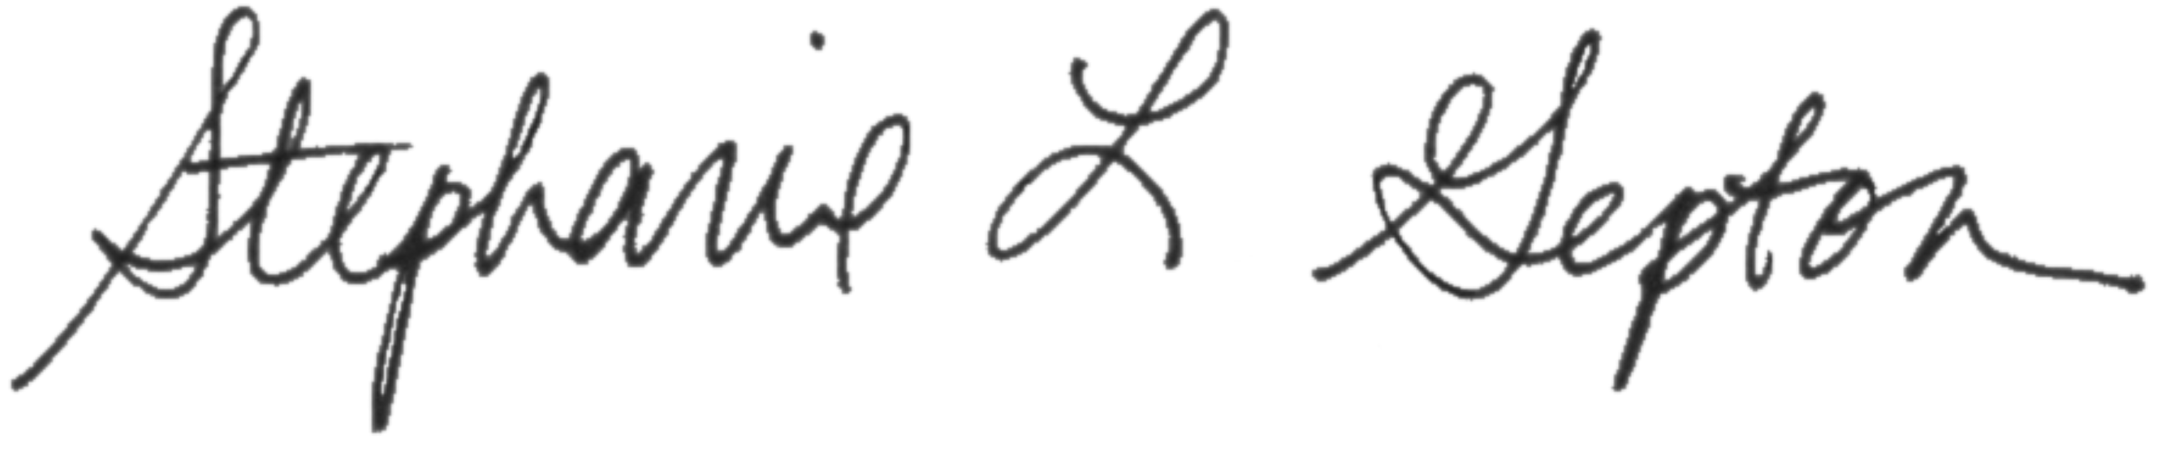

Stephanie L. Gupton, Ph.D.
Associate Professor, Department of Cell Biology and Physiology
Neuroscience Center
University of North Carolina at Chapel Hill

