Permission for figure 2, modified from the following Nature Methods Article:
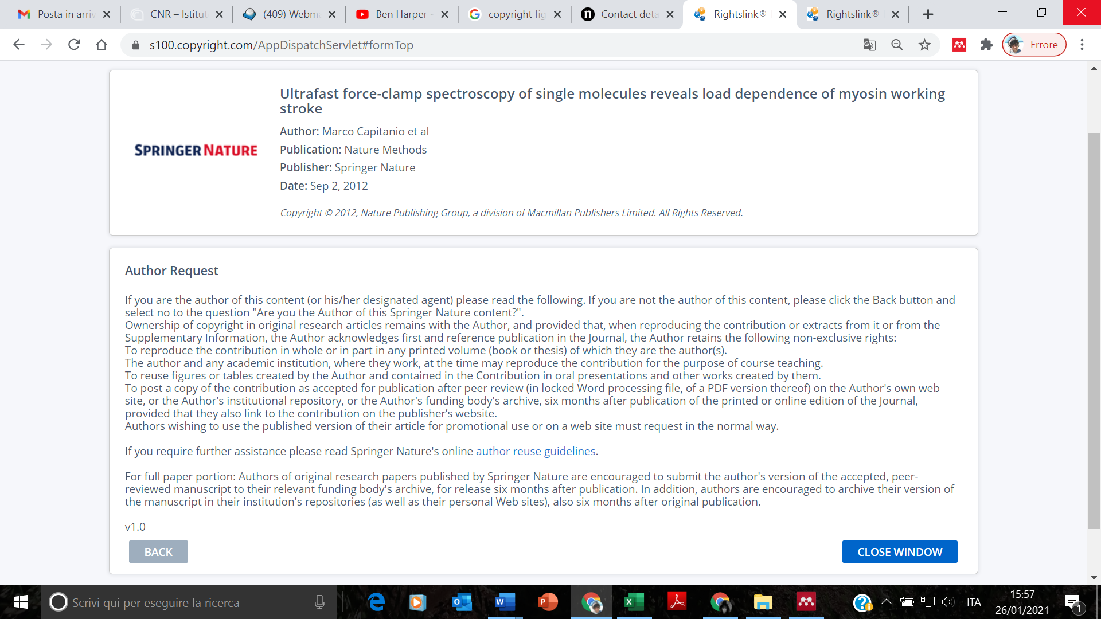

Permission for figures 1, 4 and 5, modified from the following Nature Communications Article:
