Jessie D. Ringley¹, Stephen A. Sarles¹

¹Department of Mechanical, Aerospace and Biomedical Engineering, University of Tennessee, Knoxville

Supplemental Information

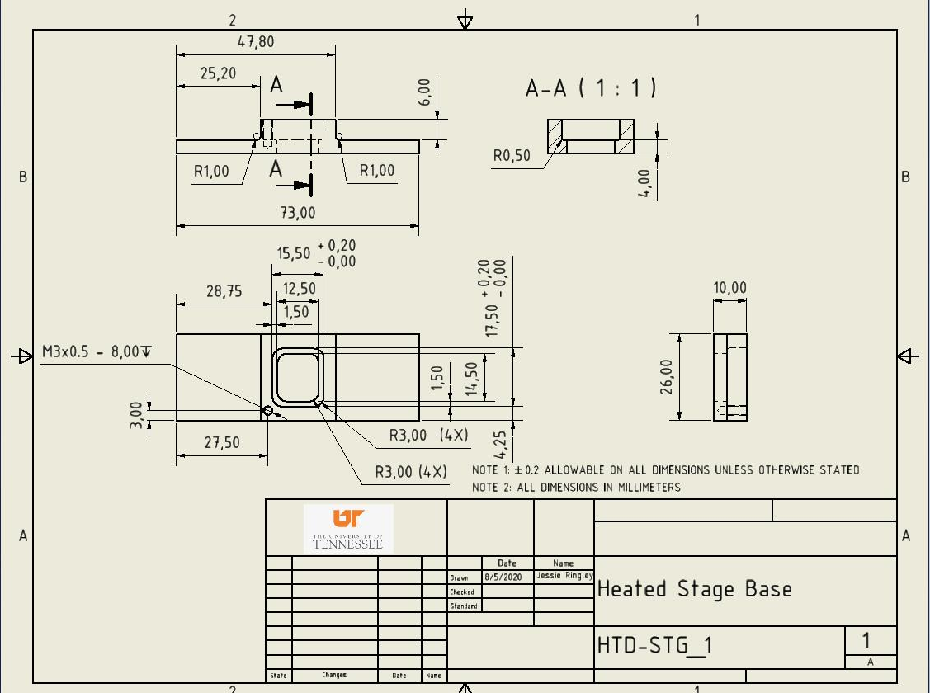
Figure S1: Aluminum Fixture This drawing shows the necessary dimensions and features for fabrication of the aluminum fixture that is the base of the heated stage. The 25.2 mm X 26 mm flat spots adjacent to the oil well were designed to allow for a maximal amount of surface-area contact between the fixture and the heating elements for heat conduction. Likewise, aluminum was chosen for the base fixture material due to its high thermal conductivity. The M3 X 0.5 mm screw hole called out in the print is used to secure and position the thermocouple in the oil well.
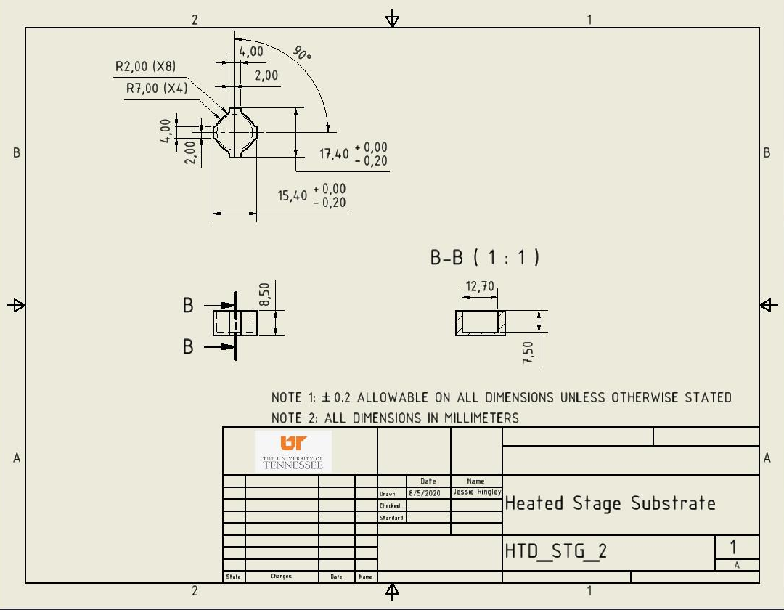
Figure S2: Acrylic Substrate The acrylic substrate is relatively simple piece to fabricate, with no critical outstanding features, except for the profile. The exterior profile was designed with Poka -yoke in mind so the acrylic substrate can only be oriented in the fixture in such a way to allow ample room for the thermocouple to fit in the oil well.

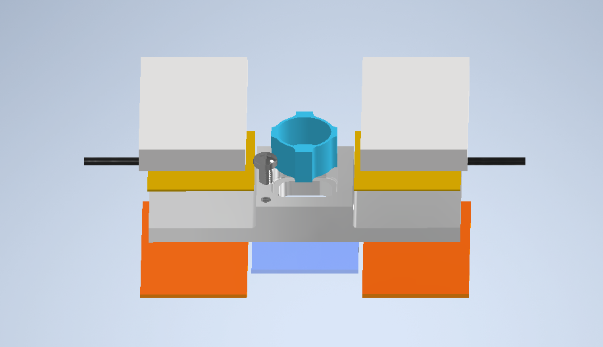
Fill Location
Glass Coverslip
Heating Element
M3 Screw
Thermal Insulation Layer (Bottom)
Thermal Insulation Layer (Top)
Acrylic Reservoir
Figure S3: Acrylic Substrate An exploded view of the assembled-heated stage has been provided to aid the experimenter during initial setup. Also, take note of the area highlighted by the dashed circle, as this is the ideal position to fill the aluminum fixture with oil during protocol step 1.8.

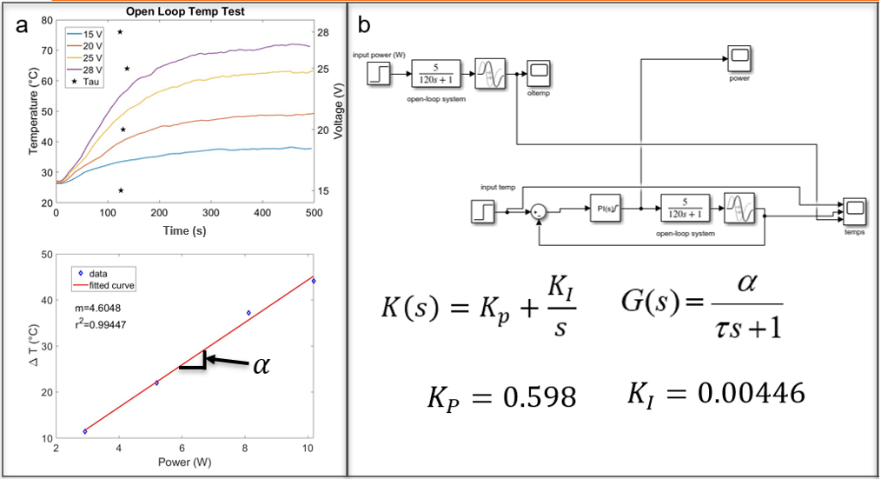
Figure S4: Open Loop Data and Simulink Modeling Panel (a) shows the open-loop temperature responses to varying dc power levels that were used to assess the delay time, $t_{d}$, the time constant, $τ$, and open-loop heating gain, $α$, of the system. The delay time represents the time lag before temperature starts rising (~20 s). Each value of $τ$ (marked by *, ~125 s) is defined as the time required for 63.2% of the total rise in temperature to occur. Panel (b) shows the steady-state change in temperature ($∆T$) versus the applied power. The slope of the data plotted in (b) was used to compute the $α$, which represents the ratio of temperature change per supplied power. These parameters were used in the Simulink model shown in panel (c) and provided as a supplementary file to tune the PI controller to achieve a desired closed-loop temperature control response.

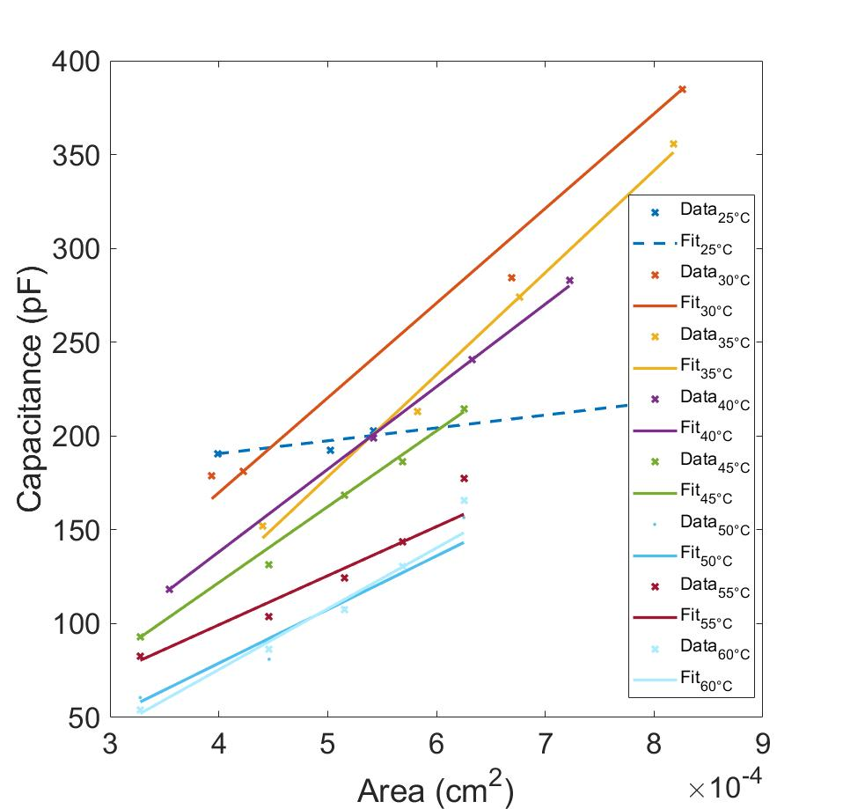
Figure S5: Additional Specific Capacitance Data The plots shown in Figure 6a and 6b were compiled from this specific-capacitance ($C_{M}$) data set. This plot also showcases the inability to accurately measure capacitance at temperatures of 25 °C and below, therefore this measurement was excluded from the dataset. The area changes necessary for an accurate $C_{M}$ measurement require excessive force to be applied to the droplets from the micro-manipulators, which causes sever distortion of the droplets shape and area of contact.

