

Jonathan Morrison, PhD, FRCS, FEBVS, FACS,
Assistant Professor of Surgery
Attending Vascular & Trauma Surgeon

22 S. Greene Street
Room T1R66
Baltimore, Maryland 21201
410-328-3534 | 410-328-6382 FAX
jonathan.morrison@umm.edu

March 31, 2021
Dear Editors,

On behalf of all the authors we thank the reviewers for their comments on our manuscript and have made revisions to address their concerns.

We specifically added steps in the protocol to detail animal and laboratory worker welfare as well as discussed some of the nuances of the pressure-volume loop catheter uses in the introduction and discussion.

We anticipate that our manuscript will be acceptable for publication in JoVE. Please see the attached document for responses to each of the reviewers’ comments.

Yours Sincerely,
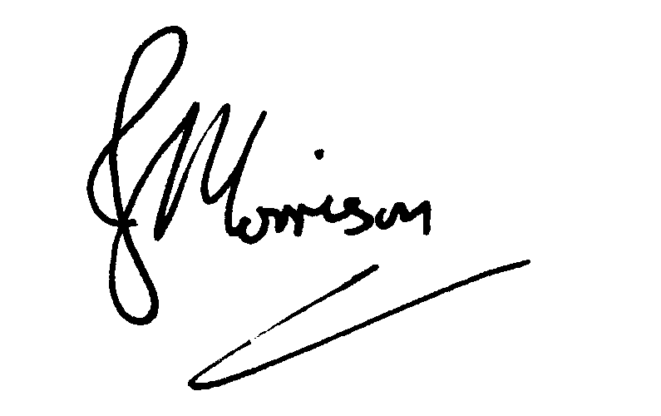

Jonathan J Morrison, PhD, FRCS, FEBVS, FACS,
Assistant Professor of Surgery,
School of Medicine, University of Maryland,

Attending Trauma and Vascular Surgeon,
R Adams Cowley Shock Trauma Center

Reviewer #4:
Manuscript Summary:
The manuscript describes potentially useful, albeit quite sophisticated methods to assess cardiac output in a porcine model. While the measurements are interesting and worth the publication of a standardized method, there are some methodical concerns regarding animal handling, animal welfare and workplace safety that have to be specified before publication.
Concerns:
Introduction
Sources and references are completely missing.

We apologize for this error. The introduction has been revised to include all sources and references.
Preparation
3. Specific housing requirements/cage sizes etc. are missing

Housing requirements can vary upon institutional guidelines and availability. I have added the specifications of our institution to the methods section of our manuscript.
4. Not specific enough. What exactly is monitored. Are there exclusion criteria and if so, who, when and how often where they assessed?

Thank you for pointing this out. We specifically monitor oral and nasal mucosa for signs of infection such as discharge. We note respiratory effort as well as swine are prone to pneumonia. Signs of injury on the skin such as large or deep cuts, scrapes, and abrasions are also noted. Any abnormalities are reported to the veterinary staff and excluded from the study. This has been added to the methods section.
Sedation and induction of general anesthesia
3. Induction of anesthesia with volatile agents in pigs is not a standard procedure. Aside from workplace safety considerations of gas concentrations in the lab, why not establish i.v. access prior to intubation? Explain and specify, if safety measures are taken to prevent lab worker exposure to isoflurane.

Animal and laboratory staff safety is of utmost concern. To that end, our IACUC has allowed sedation by intramuscular injection of Telazol/xylazine and rapid induction of general anesthesia by Isoflurane to facilitate quick airway securement by endotracheal intubation. This eliminates the need to obtain IV access under time-limited light sedation without a secure airway. For lab worker safety, the volatile agent vaporizer is only active when the snout mask is securely placed around the snout of the animal or connected to the ET tube. The procedure room must be well ventilated and a scavenging/ventilation system must be used to eliminate inhalation exposure. Any time the mask is removed, the vaporizer is turned off and purged with pure oxygen for 5-10 seconds. Additionally, minimal isoflurane fraction is used to maintain surgical plane anesthesia.
4. Intubating pigs can be difficult. Which tube size is used?

We use an 8-0 endotracheal tube. This detail has been added to the methods section.
8. Analgesic qualities of isoflurane are debatable and no other analgesics are given to the animals. Specify if and how exactly animal distress would be detected and adequately treated to prevent unnecessary pain and suffering.

We again agree that animal welfare is a top priority. Given that our only invasive procedure in these animals are two points of percutaneous vascular access our IACUC (Institutional animal care and use committee) has deemed the procedure minimally stimulating. Therefore, we manage animal pain (typically noted by animal movement during cannulation) and distress (tachycardia on ECG) by titrating the percent Isoflurane given through the airway circuit between 1.5-3%.
Ventriculography
4. What kind of fluoroscope? Are there any measures necessary to prevent lab worker harm during DSA imaging?

We use a GEHealthcare OEC 9800 X-ray fluoroscope as noted in the materials list. Thank you for pointing out lab worker protection during this protocol. All personnel in the room must wear 0.5 mm equivalent lead apron shielding as well as thyroid shielding. Any personnel working within 1 m of the emitter must also wear leaded eye-protection. All personnel must stand as far away from the emitter as possible while still being able to perform the steps in the protocol. We also minimize beam-on time as much as possible and collimate the emitter as much as possible. This has all been added to the methods section of the manuscript.
Euthanasia
1. Which concentration? Which volume? How is the animals death confirmed? Is sedation provided until the confirmed death of the animals?

We use a 2 mEq/mL solution of KCl and use a rapid intravenous dose of 2 mEq/kg (typically requiring 50-70 mL volume of injection depending on animal weight) to induce cardiac arrest. Death is confirmed by absence of ECG activity as well as drop in end-tidal CO₂ value to zero. This has been added to the methods section of the manuscript. General anesthesia is maintained until death is confirmed. This has been added to the methods section of the manuscript.

Manuscript Summary:
This manuscript aims to compare three different methods of cardiac output measurements - transpulmonal thermodilution, DSA derived ventriculography, and LV PV loop. When correlated in 5 animals, all three methods are reported comparable with only a small difference between them (2, 3, and 6%).
The study has a short introduction summarizing the need for hemodynamic monitoring in animal model research, simple methodology, and a brief discussion.
Based on the methodology described, I am afraid that the results in CO measurements can be influeced by multiple errors. First PV loop method in the way that is used here cannot provide realistic measurement. Second, I am very surprised by the highly precisly correlating results of ventriculographic measurements.
Furthermore, the result values are reported different between the abstract/figures and the text.
The work needs major revisions before it can be considered for publication.
Major Concerns:
The study was performed on 5 healthy young pigs. Are the presented methods of CO measurments being used also in human medicine? Please comment on that. What are pros and cons of each of those three methods?

Thank you for the insightful questions. All of these methods are used to an extant in human medicine to some degree. Thermodilution is most commonly used in the form of a pulmonary artery catheter that uses a heating electrode and temperature sensor to perform thermodilution measurements on the right side of the heart. Ventriculography is commonly used in the cardiac catheterization suite to measure cardiac output and ejection fraction. Pressure-volume loops are less commonly used in human medicine due to inherent risks of prolonged ventricular cannulation (ie. Arrhythmia, thrombus formation, and myocardial injury) however, they are occasionally used for short durations during cardiac catheterization procedures to measure stroke volume and stroke work. This was added to the discussion section of the manuscript.

PV-loop allows real-time, continuous measurements of cardiac performance in addition to providing additional data compared to other methods such as end-diastolic and end-systolic volumes, ejection fraction, and stroke work. Risks include cardiac arrhythmia, thrombus formation, and potential myocardial injury during prolonged cannulation.

Ventriculography does not require specialized acquisition equipment other than a fluoroscope. Limitations include operator variability during LV border tracing, and only snapshot data acquisition.

Finally, thermodilution accounts for cardiac output across both chambers of the heart simultaneously. It provides snapshot information but is easily repeatable if catheters and probes are left in place during experiments. Downsides include potential error introduced by heat exchange with inspired air in the pulmonary vascular bed.
Thermodilution - the sensor is placed in the aortic root. Can this setting result in values different from a S-G catheter placed in the PA?

Yes, agreed. This different placement of the temperature probe can result in different values measured compared to Swan-Ganz catheters. The cold bolus infusion must traverse the pulmonary vascular bed before reaching the temperature probe in our case. There may be heat exchanging effects with inspired air that can skew results. However, we have demonstrated that these effects if there are fairly minute. Additionally, Swan-Ganz catheters only measure right sided output which can change quickly with sudden changes in circulation (exercise) or blood distribution (change in posture, respiratory variation). Left ventricular output must then adjust several cycles later to accommodate this increase or decrease in right ventricular output. This discrepancy is largely avoided when performing thermodilution across both the right and left side of the heart as we have done in this manuscript.
It would be nice to have a correlation to real cardiac output, why didn't you measure invasively with a flow probe to have a CO reference?

Agreed this information would be very helpful. Unfortunately, at this time our lab is not equipped for open thoracic procedures. We aim to tackle this in the near future.
What was the mean difference in repeated cardiac output measurements by thermodilution for each of the animals?

The results reported are averaged over three measurements. They are as follows: 3.9 ± 0.23 L/min, 4.5 ± 0.34 L/min, 5.1 ± 0.29 L/min, 6.1 ± 0.41 L/min, 6.2 ± 0.35 L/min.
What was the SV which the PV system was calculating with during measurements? How does the PV loop catheter estimate the actual SV? Without proper SV calculation, the PV system cannot give correct results.

The average SV calculated by PV-loop was 58.0 ± 12.0 mL. There are different types of PV loop catheters namely electrical conductance and admittance systems. Our system uses the difference in electrical admittance of blood and cardiac muscle and Wei’s equation to estimate chamber size. This system is considered to have certain advantages over traditional conductance type catheters by eliminating parallel conductance between blood and muscle tissue. This allows the catheter to remain accurate despite acute changes in cardiac performance.
Minor Concerns:
How was the body temperature controlled during the prep?

Temperature was monitored using a rectal temperature probe. The animal was kept warm by placing a heating pad underneath it set to 37° C. This has been added to the methods section.
How can remodeling or dilation of the LV affect ventriculographic measurements? Is DSA necessary for the acquisitions or would a classic fluoroscopy serve good as well?
Language corrections are needed.

Indeed, LV remodeling or dilation can affect ventriculographic measurements. The Dodge-Sandler method of ventriculography assumes an elliptical shape of the LV to provide accurate measurements. Of course, this is not always the case especially in diseased or remodeled hearts and would therefore introduce error to the measurements. However, for labs using healthy swine as their model, this method remains useful. Classic fluoroscopy will can be used in ventriculographic measurements as well as DSA. These comments have been added to the discussion and method section respectively.

