Dear All
We thank all the reviewers and editor of the journal for the detailed, constructive feedback. Below, we have responded line-by-line to each question. We believe this process has helped to significantly improve the quality of our manuscript.
Thank You
________________________________
Reviewers' comments:
Reviewer #1:
Manuscript Summary:
This manuscript presents a relevant and interesting research topic concerning green energy production -- namely, membrane synthesis and engineering processes. The manuscript describes the preparation process for both the ion-exchange membranes and the reverse electrodialysis cell stack, and then estimates the overall system performance. The discussion does a good job of relating the membrane properties to the characteristics of the reverse electrodialysis stack, presenting a final calculation of the theoretical resistance and performance of the latter.
Major Concerns:
The basic properties of the membranes were added to the final manuscript incorporating essential and important information to the work presented.
Minor Concerns:
The minor concerns were handled, thus improving the manuscript quality. An extended and detailed protocol was added to the manuscript allowing a better understanding of the membrane preparation, assembly of the RED stack, and the power calculation.

Reply: We want to thank reviewer 1 for their positive comment, spending time in studying our manuscript, and providing insightful comments with constructive feedback.

Reviewer #2:
Manuscript Summary:
The revision R1 has introduced some marginal imprvement, but still is not very useful for potential readers. Much more detailed experimental details and calculations on reverse electrodialysis have been published already (including videos on yotube).
Major Concerns:
My main point raised for the original manuscript has not been answered in R1. What I asked was about presenting all calculations / mass balances... Otherwise, all the equations presented in the results section (except for that for gross power) should be presented in the introduction or even better addresing the readers to appropriate reference(s).
It appears that the only calculation that the authors have done in their study is to multiply the voltage by current and then divide this by the total exposed membrane area...
Even this is not presented clearly enough, since in order to obtain the power density one normally uses a range of external loads in order to obtain the power versus current density curves (with OCV with OCV with no load).
It is not clear what external loads (if any) were used to produce, in fact, the only experimental graph (Fig. 5a), which can be obtained in a very short time (minutes range)...
What about Ploss? How was it calculated? What is the net power obtained? What are the respective resistances, etc.?

Reply: This is an interesting question, and it could be a subject for further study because when we started writing this manuscript our main focus is to make this article for the educational purpose for the student who just jumpstarts their research.
We agree with the referee that there are already reported articles on RED cell preparation and videos are reported on other platforms. But, here our main objective is to provide basic information about ion-conducting membrane preparation and its application in reverse electrodialysis at a single platform. So that, students around the globe can attract to this field and can understand the fundamentals of how membrane chemistry affects RED cell performance. We are specifically motivated towards the basic research of ion-conducting membrane therefore, we restrict ourselves going towards the use of in-depth study on any of the topic presented in this particular article (including, membranes chemistry, and device physics, etc. ) and consider as out of scope for this manuscript.

In this article, we emphasize how we can enhance the understanding of membrane synthesis and its device fabrication at the initial level (beginners). We believe that the basic research demonstrated or carried out in this manuscript is focused on the basic principle and deals with acquiring knowledge that has universal applicability. We are confident that our revised manuscript expands scientific knowledge in understanding the RED systems for educational purposes and there is no other financial or competent interest. This type of research doesn’t show enormous potential at the cutting-edge but enhancing our awareness of science to the beginner at school and university level. We think that our manuscript will be used to help us in understanding a real-world problem or will research further for our general intelligence. This manuscript not only bridging the theoretical and experimental aspects of the membranes and their application but also contributes to paving a path for developing a basic understanding of this real-world problem.
At last, we hope the reviewer will consider our description for the revised manuscript.

Some changes have been made in the manuscript, which is as follows:
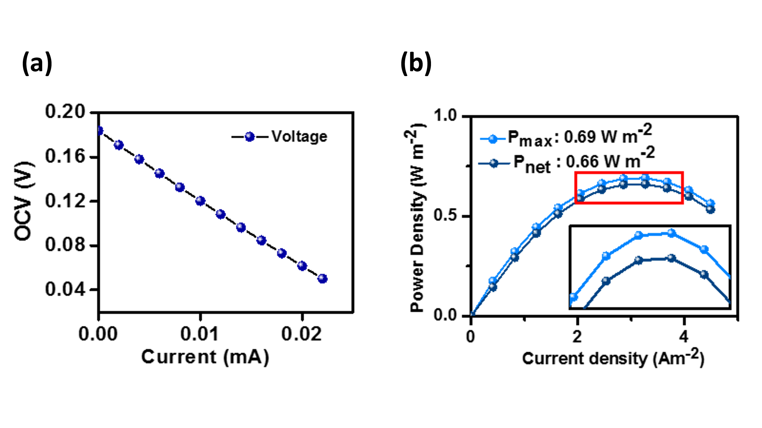
Figure 6 Output performance of the revers electrodialysis device: (a) variation of output voltage with varying current, and (b) net power density with a varying current density of the RED stack.

Regarding applied load: All measurement is carried out under 0.05 V static voltage with fixed sweep current which is 10 mA.
Changes made in the manuscript:
Note: In the galvanostat method, a constant current is applied across electrodes and measure the resulting current. The resulting current is the current generated due to the electrochemical reaction in the stack. The measurement is carried out under 0.05 V static voltage with a fixed sweep current which is 10 mA.

Regarding Power loss calculation: The hydrodynamic power loss or pumping power loss generated by the pump is subtracted from the maximum power and given by following equation 2.
$P_{net}=P_{max}-P_{loss}$ (2)

Here, P_{loss} is a hydrodynamic pumping power loss (W m⁻²) produced in the RED stack by internal loss. P_{max} is the maximum power (W m⁻²) obtained from the experiment.
Power loss is represented as a difference of pressure at inlet and outlet of HC and LC solution at the stack and given by pressure drop ($∆P$), flow rate (Q), and pump efficiency ($η_{pump}$).

$P_{loss}=\frac{∆P_{H }Q_{H}+∆P_{L}Q_{L}}{η_{pump}}$ (3)

Here, Q_{H} and Q_{L} are the flow rate (mL mim⁻¹) of a high-concentration solution and low concentration solution in mL min⁻¹ and $∆P_{H }$and $∆P_{L}$ is the pressure drop at the high -concentration side and low concentration compartment in Pa. Here, the measured pressure drop from the pressure gauge for the HC compartment is 11790 Pa and LC compartment is 11180 Pa. The calculated pumping power loss is 0.038 W m⁻².

The bulk resistance of both CEM and AEM are calculated from the EIS workstation and the resistance of the solution HC and LC are estimated from the conductivity meter. However, The membrane resistance in the stack predominately affects the overall performance of the cell therefore we have provided the calculated conductivity of the respective membrane in table 1.

Minor Concerns:
A number of grammatical problems and wrong dimensions can still be found in R1.
Also there is wrong numbering of sub-sections... Please, check and correct them accordingly.
Reply: We apologies for any inconvenience experienced. Now changes have been made in the main manuscript. We have gone through each paragraph, line by line, all modified portion is marked with yellow color. (Please see the revised main manuscript and other supplementary files)
Changes made in the main manuscript:
In “1 Experimental requirement:” sections the last point “1.8” is replaced by “1.9”
In “4. Measurement of Reverse electrodialysis:” section the last point “5.1.3” is replaced by “4.1.3”.

Reviewer #3:
Manuscript Summary:
The authors have well-addressed all the necessary comments.
Reply: We thank reviewer 3 for carefully reading our work, and recognizing its promise.

