Author Bios

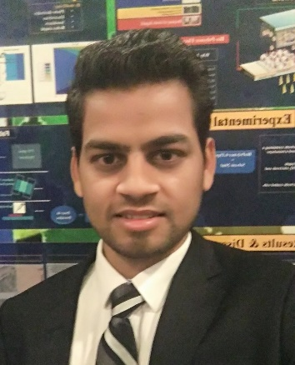

Dr. Rahul Singh
Dr. Rahul Singh is a researcher in the Mechanical Engineering Department at Sogang University, Republic of Korea. He received his Ph.D. degree in Nanoscience and Technology from Sharda University, India. In 2015, he was awarded the "Bhaskara Advanced Solar Energy (BASE) fellow award". He has been serving as an editorial board member as a topic editor of the prestigious journal 'Membranes' of the MDPI Publishing Group. His research interest mainly focused on organic and inorganic frameworks for nanostructure membranes-based electrochemical devices.

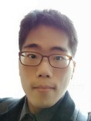

Mr. Seok Hoon Hong
Mr. Seok Hoon Hong is studying in the Mechanical Engineering Department at Sogang University, Republic of Korea. He is researching the Reverse Electrodialysis system at Energy Engineering Laboratory. His research interests deal with the modeling of Reverse Electrodialysis systems and the synthesis of ion-conducting membranes.

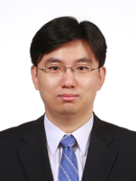

Prof. Daejoong Kim
Prof. Daejoong Kim is a Full Professor in the Department of Mechanical Engineering, Sogang University, Republic of Korea. He received his Ph.D. in Mechanical Engineering from Stanford University, USA, in 2007. He worked as a Visiting Scholar at Korea Institute of Science and Technology, Seoul, Korea, from 2014 to 2015, as a postdoctoral research associate at the University of Illinois at Urbana-Champaign, Urbana, Illinois, USA, from 2007-2008. He obtains his BS and MS degree in Mechanical and Aerospace Engineering from Seoul National University, Republic of Korea. He has over 14 years of experience, and his group focuses on developing Fuel cells, Reverse electrodialysis (RED), Micro Pulsating Heat Pipe (MPHP), and Nanoscale simulation using Molecular Dynamics (MD). He has successfully supervised and examined 5 Ph.D. students, three postdoctoral fellows, and 14 Master’s students since he started the Energy Engineering laboratory. He also served as a PI and co-PI in several projects. Especially, conducted six funded research in 11 consecutive years between 2008 and 2019. He has published more than 60 papers in reputed journals in Korean, five book and book chapters.

