1 The “one-hot” encoding form
We introduce a simple digitization method for biological sequences, namely, one-hot encoding. For a DNA sequence, bases A, C, G and T can be represented by one-hot vectors of [0,0,0,1], [0,0,1,0], [0,1,0,0] and [1,0,0,0], respectively. Such one-hot vectors are connected according to the base order in the DNA sequence. Therefore, a DNA sequence of length L can be represented by a base one-hot matrix with length L and width 4. If the complementary strand is included in the matrix, the matrix will have a length of 2L and width of 4. Similarly, for the protein sequence, each amino acid can be represented by a one-hot vector containing 20 bits, in which 19 bits are 0 and a specific bit is 1. For example, amino acid A can be represented as [0,0,0,0,0,0,0,0,0,0,0,0,0,0,0,0,0,0,0,1], amino acid C can be represented as [0,0,0,0,0,0,0,0,0,0,0,0,0,0,0,0,0,0,1,0] and so on. In this way, a protein sequence with length L can be represented by an amino acid matrix of length L and width 20.

2 Artificial neural network construction
The construction methods for artificial neural networks are diverse. Herein, we introduce a simple construction method. Figure S1 shows the structure of an artificial neural network. This structure is easily implemented with a few lines of code (shown in red text in Figure S1) in the deep learning package Keras.

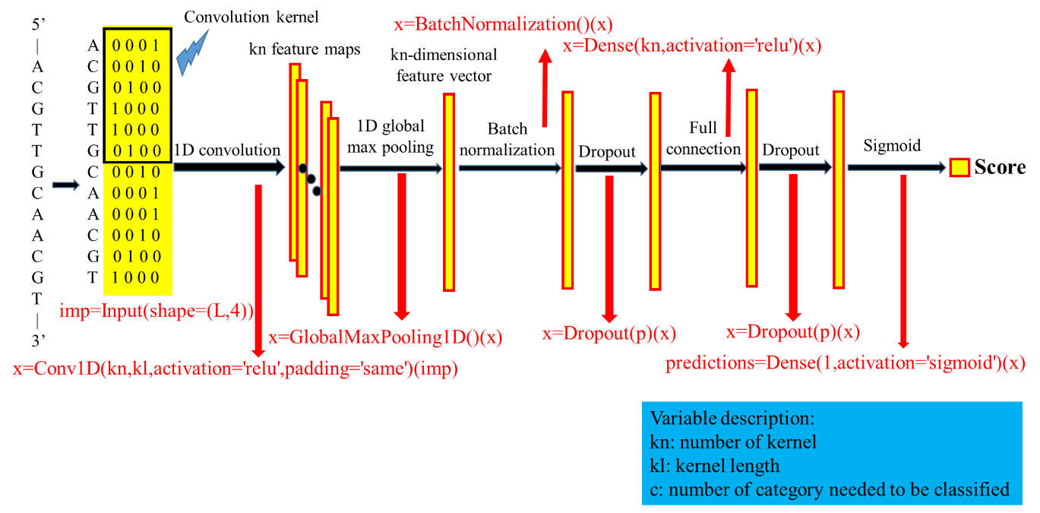
Figure S1. Construction of the artificial neural network. The red text represents the Keras code for the corresponding layer in the neural network. The neural network takes a biological sequence as input and outputs a score between 0-1. A higher score means that the input sequence is more likely to be a positive class.

With the structure shown in Figure S1, the programmer should first specify the size of the input one-hot matrix. For the example in Figure S1, the DNA sequence is represented by a base one-hot matrix; in such cases, the corresponding Keras code is:
imp=Input(shape=(L,4))
where L represents the length of the one-hot matrix (the sequence length). If the corresponding matrix is an amino acid one-hot matrix, the second parameter of 4 should be set to 20.

Then, a 1D convolution operation is performed over the one-hot matrix. In such operations, multiple convolution kernels scan the one-hot matrix, and each kernel will generate a feature map. The code for the 1D convolution layer in Keras is:
x=Conv1D(kn,kl,activation='relu',padding='same')(imp)
where kn represents the number of kernels and kl represents the length of the kernel. The convolution operation can be interpreted as eyes scanning over a picture. The convolution kernel is equivalent to an eye, the number of kernels is equivalent to the number of eyes, and the kernel length is equivalent to the vision field of each eye. It is worth noting that higher kn and kl values are not necessarily better. The “relu” parameter is a nonlinear function that performs a nonlinear transformation on the one-hot matrix. The nonlinear transformation can be viewed as similar to human thought processes.

After the 1D convolution, a 1D global max pooling operation is performed on each feature map. In this process, each feature map is represented by its maximum value. In this way, the kn feature maps can be reduced to a kn-dimensional feature vector. The code of the 1D global max pooling layer in Keras is:
x=GlobalMaxPooling1D()(x)

The kn-dimensional feature vector then goes through a batch normalization layer. The code of the batch normalization layer in Keras is:
x=BatchNormalization()(x)
The kn-dimensional feature vector then goes through a “dropout” layer, which can prevent overfitting in the training process. The code of the “dropout” layer in Keras is:
x=Dropout(p)(x)
where p represents the dropout probability.

The kn-dimensional feature vector then goes through a fully connected layer, which can be viewed as deep thinking in a human brain. The code of the fully connected layer in Keras is:
x=Dense(kn,activation='relu')(x)

Again, the kn-dimensional feature vector then goes through a “dropout” layer. The code of the “dropout” layer in Keras is:
x=Dropout(p)(x)

Finally, the feature vector goes through a sigmoid layer that calculates the score for the input DNA. The code for the sigmoid layer in Keras is:
predictions=Dense(1,activation='sigmoid')(x)

