Manuscript Title: Techniques of robot-assisted kidney transplantation
Reviewer response form

Manuscript Number: JoVE62220

<Reviewer #1>
1. The authors report that "We propose to place the allograft on the peritoneal pouch lateral to iliac vessels. Although it may be safe procedures to put an allograft medially during anastomosis and flip it to peritoneal pouch, this technique may be not familiar for inexperienced surgeons. Furthermore, it is more natural to perform vascular anastomosis with the allograft in the peritoneal pouch and renal vessels in proper position". Why didn't the authors follow the established technique for RAKT as described by Menon et al. and Breda et al.? Why introducing this novelty, which may expose to more challenges when performing the vascular anastomoses? Please also take into consideration that the "standard" technique for RAKT leads to an optimal "extraperitonealization" of the graft in the early postoperative period (please refer to Campi R, Vignolini G, Savi E, Sessa F, Agostini S, Serni S. Robotic kidney transplantation allows safe access for transplant renal biopsy and percutaneous procedures. Transpl Int. 2019 Dec;32(12):1333-1335. doi: 10.1111/tri.13517. Epub 2019 Oct 4. PMID: 31483897).
Response : We appreciate the Reviewer’s opinion. It was not our intention that we would not follow the established technique for RAKT as described in previous reports. Instead, we tried to introduce an alternative technique for RAKT which can be performed safely and easily according to our experiences. To resolve a possible misunderstanding, we have modified sentences as follows; “Although it is more common to place the kidney allograft in the pelvis medially during vascular anastomosis according to previous reports, we suggest that it is an alternative method to place the allograft on the peritoneal pouch lateral to iliac vessels. Although it may be safe procedures to put an allograft medially during anastomosis and flip it to peritoneal pouch, it is also feasible to perform vascular anastomosis with the allograft in the peritoneal pouch and renal vessels in proper position with safety and ease.”
In addition, we adhere to the standard technique of the Vattikuti-Medanta for an optimal extraperitonealization of the graft by reapproximating two peritoneal flaps prepared at the beginning of surgery as the Reviewer suggested. Therefore, we have modified sentences as follows; “After creating an extraperitoneal pouch for the kidney allograft by raising peritoneal flaps on both sides over the psoas muscle, iliac vessels and bladder are dissected.” “The peritoneum is incised along the right paracolic gutter to make an extraperitonal pouch for the kidney allograft with monopolar curved scissors (Arm II), fenestrated bipolar forceps (Arm III), and Prograsp forceps (Arm IV).”

2. Please clarify the reason for stating: "RAKT may be not considered if a recipient is younger than ten or is older than 70 years old" and "RAKT is not recommended if a patient has a history of major abdominal surgery or severe intraperitoneal adhesion".
Response: We see the Reviewer’s point. Considering the inclusion/exclusion criteria of previous reports, we have changed the exclusion criteria in terms of age as follows; “RAKT may be not considered if a recipient is younger than eighteen years old.”
In addition, we have modified the next sentence as follows; “RAKT is not recommended if a patient has multiple previous abdominal surgeries or severe intraperitoneal adhesion.”

3. Why did the authors use 2 bed-side assistants for RAKT?
Response: As we commented in the Discussion, we do not usually use a 12-mm laparoscopic port for the assistants. Instead, we make two or three ports on the gel port for assistants. It is possible to perform RAKT with only one bed-side assistant. However, it is more effective if another assistant can help on the opposite side of the first assistant when the direction of laparoscopic equipment matters.

4. "Consider arterial reconstruction if there are multiple renal arteries". Please specify (see reference 24)
Response: We appreciate the Reviewer’s recommendation. We have modified the sentence as follows; “Consider arterial reconstruction if there are multiple renal arteries such as side-to-side anastomosis, end-to-side anastomosis of polar artery into main renal artery, and polar artery anastomosis to the inferior epigastric artery.”

5. Why did the authors place the gel port (6cm Pfannenstiel incision) on the right suprapubic area (the target anatomy) instead of in the middle suprapubic area? This may lead to inferior cosmetic results.
Response: We see the Reviewer’s point. We make Pfannestiel incision on the right lower abdomen rather than on the midline for easier access to the operative field for the assistants or for any emergent situation as we commented in the Discussion. We think that Pfannestiel incision near the target anatomy is more useful especially when the recipient is obese. We don’t think that 6cm Pfannenstiel incision on the right suprapubic area may lead to inferior cosmetic results. That incision is usually covered by the underwear.
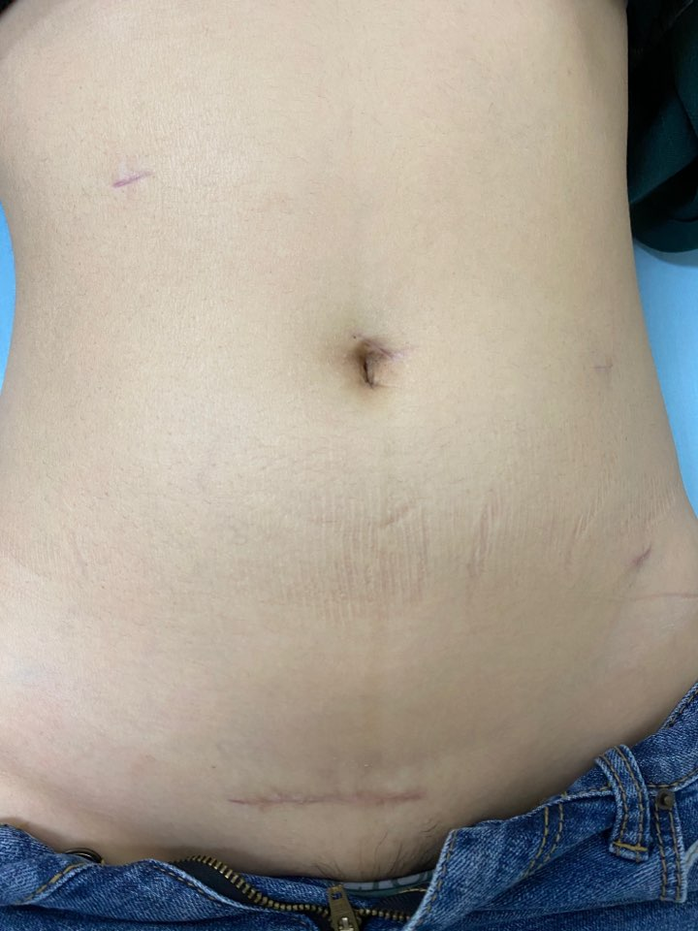

6. "Keep the allograft as cold as possible with cold normal saline". Please clarify.
Response: We see the Reviewer’s point. We think that it is possible to use cold normal saline as well as slushed ice through gel port. Therefore, we have modified the sentence as follows; “ Keep
the allograft as cold as possible with either slushed ice or cold normal saline.”

7. REPRESENTATIVE RESULTS: why did the authors first report one case and then discuss the results of the whole RAKT series (n=21) at their Institution? Please report only the aggregate data from the whole series (there is no benefit of describing a single case and the whole series thereafter).
Response: We understand the Reviewer’s opinion. As the Reviewer’s recommendation, we have deleted the single case report and modified the paragraph.

8. "Considering the learning curve in RAKT, our performances are not inferior with previously reported data". This statement should be removed as the authors could not investigate this point in their study and the study was not designed to answer this clinical question.
Response: As the Reviewer suggested, we have removed the statement.

9. Please provide a brief video accompanying the manuscript to show exactly how RAKT is performed, especially considering the technical modifications made by the authors as compared to the "gold standard" technique for RAKT described by previous groups.
Response: As the Reviewer suggested, we have provided a brief video of our own RAKT.

10. Please add this reference: Ahlawat R, Sood A, Jeong W, Ghosh P, Keeley J, Abdollah F, Kher V, Olson P, Farah G, Wurst H, Bhandari M, Menon M. Robotic Kidney Transplantation with Regional Hypothermia versus Open Kidney Transplantation for Patients with End Stage Renal Disease: An Ideal Stage 2B Study. J Urol. 2021 Feb;205(2):595-602. doi: 10.1097/JU.0000000000001368. Epub 2020 Sep 16. PMID: 32941100.
Response: As the Reviewer recommended, we have added the reference as follows; “Recently, it was reported that RAKT with regional hypothermia was associated with a lower incidence of post-transplant complications and improved patient comfort compared with open KT.²⁷”

<Reviewer #5>
1. In the PROTOCOL section 4.3., How was the peritoneum incised when the bladder was dissected? Was it connected to the peritoneal incision on the graft bed?
Response: We see the Reviewer’s point. Dissection of the bladder is performed for ureteroneocystostomy which is separated from peritoneal incision for the kidney allograft.
2. In the PROTOCOL section 5.4. and 5.10., please describe the anastomosis procedures in more detail. For example, how did the authors use the stay sutures? Or was it a parachute anastomosis without any stay sutures? Did the authors suture the posterior wall intraluminally? Did the authors use any everting technique to make the intimas adhere to each other?
Response: We see the Reviewer’s point. After making a knot at the caudal end of veins or arteries, the posterior wall is sutured intraluminally in a continuous manner. Thereafter, the anterior wall is sutured in a continuous manner.
3. In the PROTOCOL section 5.9., the author should describe that they did create a round-shaped hole with Potts scissors and without an arterial punch.
Response: As the Reviewer recommended, we have added a comment.
4. In the PROTOCOL section 5.5., 5.11., and 5.16., how did the authors put the saline? Was it by the first assistant's irrigation tube or opening the gel port?
Response: We see the Reviewer’s point. As we commented in the Discussion, we do not usually use a 12-mm laparoscopic port for the assistants. Instead, we make two or three ports on the gel port for assistants. We flush the vascular lumen with heparinized normal saline just before knotting the anastomosis using a silastic tube through the gel port. In addition, warm normal saline is applied on the allograft with an irrigation tube through the gel port.
5. Didn't the authors check the renal blood flow by ultrasonography after the vascular anastomosis was completed?
Response: We do not routinely check the renal blood flow by intraoperative ultrasonography after the vascular anastomosis is completed. Instead, renal Doppler ultrasonography is performed one day post-transplant.
6. In the PROTOCOL section 6.3., what did the semicontinuous suture mean? The continuous suture with two stay sutures?
Response: We see the Reviewer’s point. We don’t think ‘semicontinuous suture’ is a right term. We have changed ‘semicontinuous’ to ‘continuous’.

