Editorial comments:
1. Please take this opportunity to thoroughly proofread the manuscript to ensure that there are no spelling or grammar issues.

Thanks, we did it.
2. Please define all abbreviations during the first-time use.

Thanks, we did it.
3. Please revise the following lines to avoid previously published work: 65-69, 156-161,171-173, 175-177.

Thank you for making us notice it, we fixed the indicated lines
4. Please add more details to your protocol steps. Please ensure you answer the “how” question, i.e., how is the step performed? Alternatively, add references to published material specifying how to perform the protocol action.

We added more details to the protocol steps
5. Step 1.1.: Please include how do you perform euthanasia in your experiment. Any age and sex specific bias?

Thanks, we specified these points after step 1.1
6. Please specify all volumes and concentrations used throughout. e.g., step 1.1 RPMI, step 1.2 erythrocyte lysis buffer, step 2.1, etc.

Thanks, we specified the volumes
7. Please convert centrifuge speeds to centrifugal force (x g) instead of revolutions per minute (rpm)

Thanks, we did it
8. Line 115: Please provide the details of pre-cooling. How long and what temperature is used for pre-cooling?

Thanks, we did it before step 2.1

9. Line 117: Please include the number of cells

The number of cells cannot be indicated since it depends on the previous steps; we clarified to use all the cells obtained and to adjust the volumes of the solutions accordingly
10. Line 137: Please include how this is done.

Thanks, we did it
11. Line 171-173: Please provide more details on the washing steps, volume used, etc.

We added more details
12. Line 209: Please define the percentage of confluency.

Thanks, we did it
13. There is a 10-page limit for the Protocol, but there is a 3-page limit for filmable content. Please highlight 3 pages or less of the Protocol (including headings and spacing) that identifies the essential steps of the protocol for the video, i.e., the steps that should be visualized to tell the most cohesive story of the Protocol.

We highlighted the essential steps for the video
14. In the discussion section please also include some limitations of the protocol as well.

We added that the availability of iVα14-Jα18 transgenic mice could constitute a limitation to of the reproducibility of the protocol.
15. Figure 1: Please mention what the numbers represent (i.e., 0, 5, 7, 14) either in the figure or the Figure Legend. Please define whether the frequencies represented in Figure 1B and Figure 3 are in percentage.
Thank you for making us notice it, we added the definition of “day” in Figure 1. We specified that the frequencies in figure 1B and figure 3 are in percentage in the figure legend.

16. Please sort the table of materials in alphabetical order.
We did it
____________________________________
Reviewers' comments:
Reviewer #1:
Manuscript Summary:
In the Manuscript by Delfanti et al, they describe how to isolate and expand mouse iNKT cells. The protocol is overall written in a way that it can be understood and replicated. The manuscript can be considered for publication, if following can be addressed:
Major Concerns:
- In representative FACS-plots, axis units must be shown.

We did it, however for the axis unit we couldn’t use the recommended 20pt font otherwise the graphs would have been too big.
- In representative FACS-plots, the plots following expansion has been cropped (or there is a threshold in FSC). This has to be shown in full. This protocol use CD3/CD28 expansion with contamination of T cells (Fig 1B), thus it is important to verify purity following expansion by showing graphs in full. Alternatively, consider an additional FACS purification step.

There was a gating on the TCRβ⁺ but now we took it off, and the gating is directly on viable cells.
We are aware that activation with CD3/CD8 beads could induce also expansion of contaminant T cell; however, very few TCRβ⁺ CD1d tetramer– cells are present along the expansion (figure 3 A). Moreover, the strong activation with CD3/CD8 beads is inducing the downregulation of the iNKT cell TCR expression on the cell surface, and a double negative population is appearing (figure 3A)
- Complete flow cytometric controls (w/wo PMA + technical controls (e.g. FMO or isotype control)) has to be shown in Figure 3 to justify gates drawn (especially 3C right).

Thank you for letting us notice that the gating strategy was unclear.
The gates in figure 3C right panel were drawn on the non-activate control (without PMA/Ionomycin) shown in the left panel. We added the gating strategy in the figure legend for clarity.

- Flow cytometric confirmation should be shown for all expanded iNKTs as bar graphs (As for expansion in fig 2), or sufficient explanation should be provided.

We always check iNKT cell purity at day 0, 7 and 14 of culture and in figure 3A we showed one representative expansion. In figure here attached, you can see other 5 representative expansions with consistent percentages.

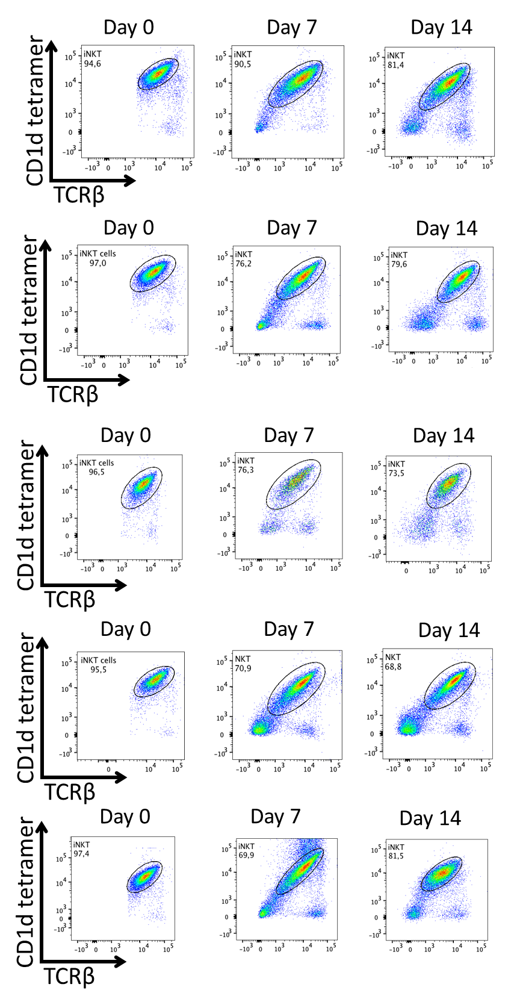
- Consider revising Figure 2 to show expansion curves for all experiments, merging A and B

We revised figure 2 plotting the curves of 3 experiments, previously shown as mean data. We can’t show growth curves for all the expansions depicted in figure 2B, because we usually count the cells at day 7 and 14 post-activation, when we check iNKT cell purity. The experiments in figure 2A were made on purpose to have a cell growth curve.
Minor Concerns:
- In the method section, all units should be described in a reproducible way, e.g. RPM-->RCF

We fixed this
- Discussion should be up to date, with mouse and human iNKTs regarding clinically relevant phenotypes and how this expansion protocol is relevant. Also a balanced discussion of the functional impact of expansion should be extended.

We modified the discussion adding the clinical relevance of iNKT cells and the need for their expansion.
Reviewer #2:
Manuscript Summary:
The manuscript of Delfanti et al. addresses an interesting issue, i.e. the isolation and expansion of murine iNKT cells. This lymphocytic population is relatively rare and it is particularly difficult to perform ex-vivo experiments with them, as a consequence of their low abundance.
The scientific need is well explained, the protocol is generally clear and easy to follow and the discussion tackles the main topics of interest.
However, some minor corrections may improve the clarity of the manuscript.
Major Concerns:
Protocol:
_the majority of the descriptions within subchapters should be rendered less discursive and more protocol-like (i.e., within each description often 2/3 technical passages are present which should be subdivided)

Thanks, we separated steps into more sub-steps and tried to render them less discursive.
_although brands and descriptions of the reagents are present at the end of the manuscript, it should be better to write a minimal description of the reagents within the protocol (ie: ACK, MB)

We added the composition of the solutions also in the text.
_the "Comments and descriptions" at the end of the manuscript, that are intended to explain in house reagents compositions and antibody clones, does not have any recall in the main text. It should be added

Thanks for letting us noticing. At the beginning of the protocol, we added a statement recalling the provided Excel Table of Materials.
_Tetramer staining:
* it should be better specified that beside the one used in the protocol (provided by the NIH tetramer facility), other types of commercial tetramers/dextramers might be successfully implemented.
* It should be better specified what PBS57 stands for and comment on the possibility that using other types of tetramers/dextramers the antigen might be called differently by other vendors (ie, classically aGalCer)

We added a note after step 3.2 to explain what PBS-57 is and the existence of other commercially available CD1d multimers.
* a staining with the empty dimer should be added as control

We added a staining with an unloaded tetramer in figure 1.
Minor Concerns:
Discussion:
It should be added more extensively for which purposes iNKT cells could be used, and thus why this protocol might be useful in those contexts.

We modified the discussion adding the clinical relevance of iNKT cells and the need for their expansion.

