Protocol Name: JoVE Protocol 62213 Ready for Review Co-culture of Glioblastoma Stem-like Cells on Patterned Neurons to Study Migration and Cellular Interactions
Date: 2021/05/25

Neuronal Network Analysis - From 03:55

03:55 to 04:18 => OK

04:18 to 04:26
Current image(s) | Desired image (only one)
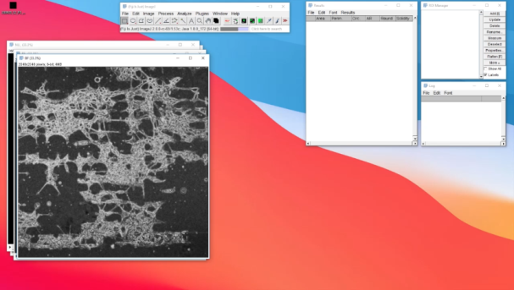  From 04:19  It is a processed image | 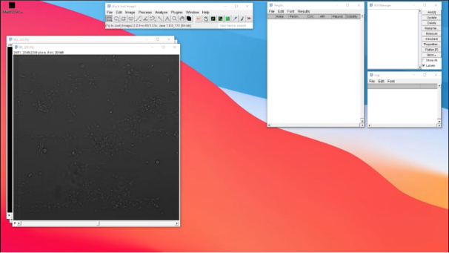  From 04:18  It is the gray channel

04:26 to 04:52
Current image(s) | Desired image (only one)
From 04:19  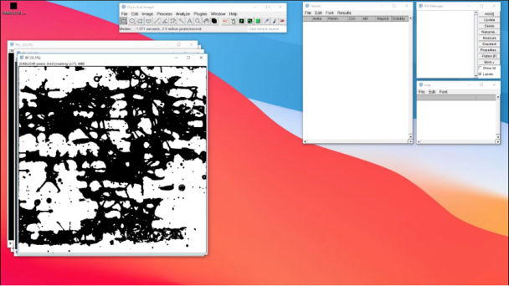  From 04:34  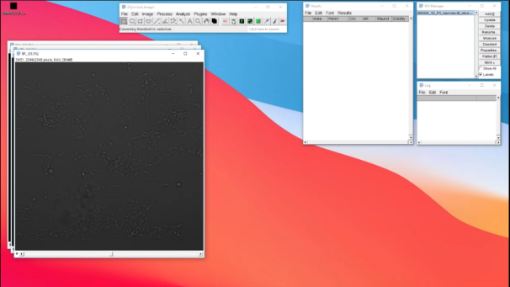  From 04:44 | From 04:19  It is a processed image  (Contrast Stretch Enhancement+Sobel Edge Detector)

04:53 to 05:00
Current image(s) | Desired image (only one)
From 04:44 | 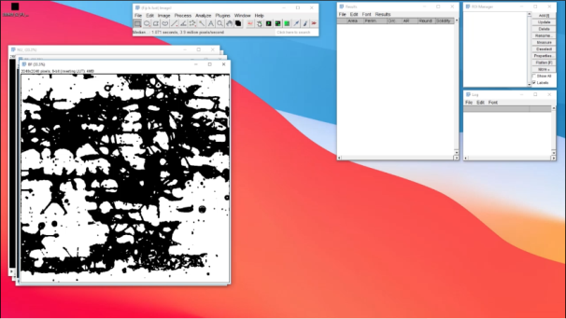  From 04:34  It is the binary image

05:01 to 05:15
Current image(s) | Desired image (only one)
From 04:44  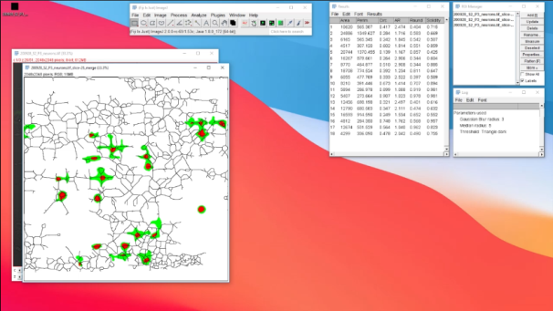  From 05:05 | 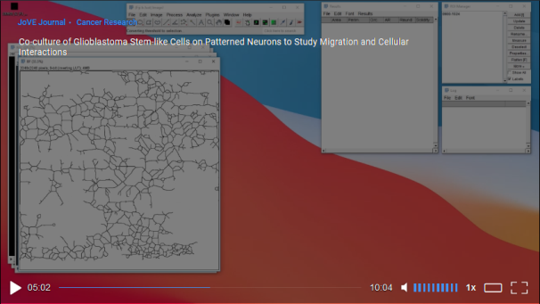  From 05:02  It is a image with a simply network

05:15 to 05:32
Current image(s) | Desired images
From 05:05 | 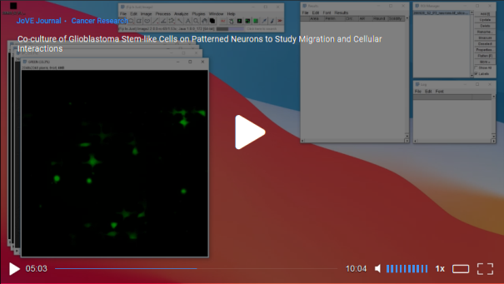  From 05:03  It is the green image with its following analyse particles  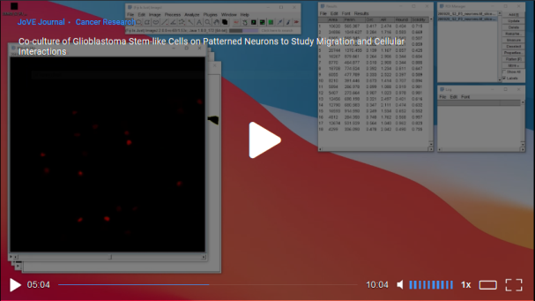  From 05:03  It is the red image with its following analyse particles

05:33 to 05:42
Current image(s) | Desired video
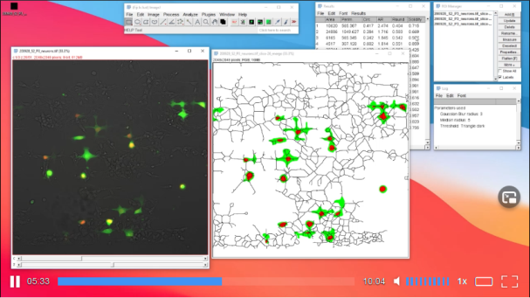  From 05:33 | From 05:05 to the end without freezing  It is the simple RGB image

Single-Cell Motility Analysis - From 05:43

05:43 to 06:08 => OK

06:14
Desired image
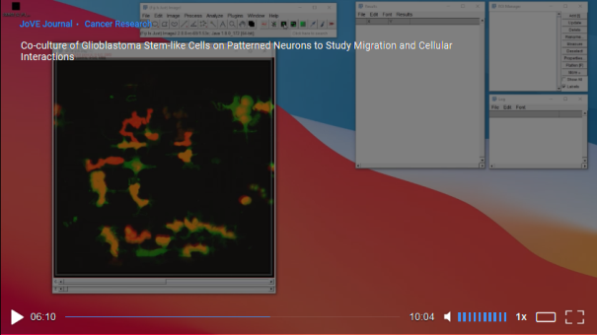
From 06:10
It is the image with a Z-projection

06:17
Desired image
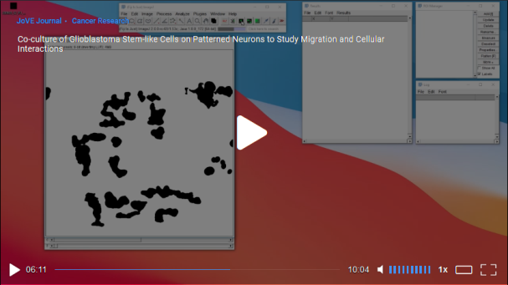
From 06:11
It is the binary image (via the mask conversion)

From 06:26 to 06:42 => OK

06:43 to 06:46
Desired image
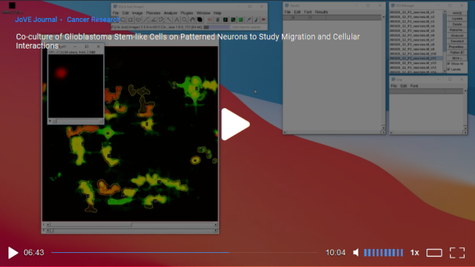
From 06:43
It is the red image

06:46 to 06:53
Desired image
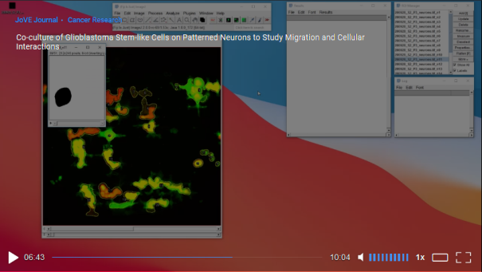
From 06:43
It is the binary image

06:53 to 07:03 => OK

Multiple-Cell Motility Analysis - From 07:04

07:04 to 07:42 => OK

