JoVE62153 Rebuttal Document
TITLE:
Platform Incubator with Movable XY stage: A New Platform for Implementing In-Cell Fast Photochemical Oxidation of Proteins

AUTHORS AND AFFILIATIONS:
Danté Johnson¹, Benjamin Punshon-Smith², Jessica A. Espino¹, Anne Gershenson³ and Lisa M. Jones¹

¹Department of Pharmaceutical Sciences, University of Maryland Baltimore, Baltimore, MD, USA
²Technology Research Center, University of Maryland Baltimore County, Catonsville, Maryland, USA
³Department of Biochemistry and Molecular Biology, University of Massachusetts, Amherst, Massachusetts, USA

Corresponding Author:
Lisa M. Jones

Email Addresses of Co-authors:
Danté Johnson,
Benjamin Punshon-Smith, ben35@umbc.edu
Jessica A. Espino, jespino@umaryland.edu
Anne Gershenson, gershenson@biochem.umass.edu

The authors thank the reviewers for their comments. We detail our response to these comments below.

Editorial comments:
Changes to be made by the Author(s):
1. Please take this opportunity to thoroughly proofread the manuscript to ensure that there are no spelling or grammar issues. Please define all abbreviations at first use.
R: The manuscript has been proofread and all abbreviations have been defined
2. Please revise the following lines to avoid overlap with previously published work: 80 (cell culture…)-83 (…CO2), 85 (for…)-88 (bench), 93 (each…)-96, 307-321, 331-338, 345-348, 356-371, 383-387, 395-401, 438 (incubator…)-441, Figure 1 legend (445-449 irradiation), Figure 6 legend (471-477)
R: All above lines have been revised.
3. Please revise the text, especially in the protocol, to avoid the use of any personal pronouns (e.g., "we", "you", "our" etc.).
R: All personal pronouns have been removed, and sentences have been revised.
4. For in-text formatting, corresponding reference numbers should appear as numbered superscripts after the appropriate statement(s), but before punctuation.
R: All reference numbers appear as numbered superscripts after the appropriate
before punctuation.
5. JoVE policy states that the video narrative is objective and not biased towards a particular product featured in the video. The goal of this policy is to focus on the science rather than to present a technique as an advertisement for a specific item. To this end, we ask that you please reduce the number of instances of "PIXY" within your text. The term may be introduced but please use it infrequently and when directly relevant. Otherwise, please refer to the term using generic language.
R: The number of times the word “PIXY” is found in the text has been greatly reduced.
The new generic term used is “platform incubator”. The word PIXY will only be
included in the abstract, introduction, and where relevant.
6. JoVE cannot publish manuscripts containing commercial language. This includes trademark symbols (™), registered symbols (®), and company names before an instrument or reagent. Please remove all commercial language from your manuscript and use generic terms instead. All commercial products should be sufficiently referenced in the Table of Materials and Reagents.
For example: H301-T Unit-BL-PLUS, CO2 UNIT-BL, Okolab, MadMotor, Mad City Labs, LabView software, Eppendorf, Thermo Fisher Scientific, Pierce Mass Spec Sample Prep Kit, Pierce Rapid Gold BCA Protein Assay Kit, Legend Micro 21, Pierce Quantitative Colorimetric Peptide Assay, Waters Acquity UPLC-M Class, Thermo Orbitrap Fusion Lumos Tribrid Mass Spec, Proteome Discoverer 2.2 etc.
R: All commercial product names have been replaced by generic names in the text.
7. Please ensure that all text in the protocol section is written in the imperative tense as if telling someone how to do the technique (e.g., “Do this,” “Ensure that,” etc.). The actions should be described in the imperative tense in complete sentences wherever possible. Avoid usage of phrases such as “could be,” “should be,” and “would be” throughout the Protocol. Any text that cannot be written in the imperative tense may be added as a “Note.” However, notes should be concise and used sparingly. Please include all safety procedures and use of hoods, etc.
R: Each step begins with an action verb in the imperative tense.
8. Please note that your protocol will be used to generate the script for the video and must contain everything that you would like shown in the video. Please add more details to your protocol steps. Please ensure you answer the “how” question, i.e., how is the step performed? Alternatively, add references to published material specifying how to perform the protocol action. Please add more specific details (e.g., button clicks for software actions, numerical values for settings, etc) to your protocol steps. There should be enough detail in each step to supplement the actions seen in the video so that viewers can easily replicate the protocol.
9. 7.4: please check if you mean 16,000 x g or 16 x g.
R: The proper term is 16,000 x g. This changed was made throughout the text.
10. For the purpose of filming, please consider adding general instructions as notes to the protocol and write the protocol for the specific example mentioned in the representative results. Please move the information about the cells used (culture etc) to the beginning of the section on cell culture.
R: The protocol for the transient transfection protocol was moved from the
representative results to the cell culture section. However, what remains in the results
section is only what is pertinent.
11. Please obtain explicit copyright permission to reuse any figures from a previous publication. Explicit permission can be expressed in the form of a letter from the editor or a link to the editorial policy that allows re-prints. Please upload this information as a .doc or .docx file to your Editorial Manager account. The Figure must be cited appropriately in the Figure Legend, i.e. “This figure has been modified from [citation].”
R: Please see attached screenshots. Permission for this particular request is granted for print and electronic formats, and translations, at no charge. Figures and tables may be modified. Appropriate credit should be given. Please print this page for your records and provide a copy to your publisher. Requests for up to 4 figures require only this record. Five or more figures will generate a printout of additional terms and conditions (next screen shot).

Appropriate credit should read: "Reprinted with permission from Johnson, D. T.; Punshon-Smith, B.; Espino, J. A.; Gershenson, A.; Jones, L. M., Implementing In-Cell Fast Photochemical Oxidation of Proteins in a Platform Incubator with a Movable XY Stage. Analytical Chemistry, 92( 2), 1691–1696 2019. Copyright 2020 American Chemical Society."

I have included this after each figure I reused.
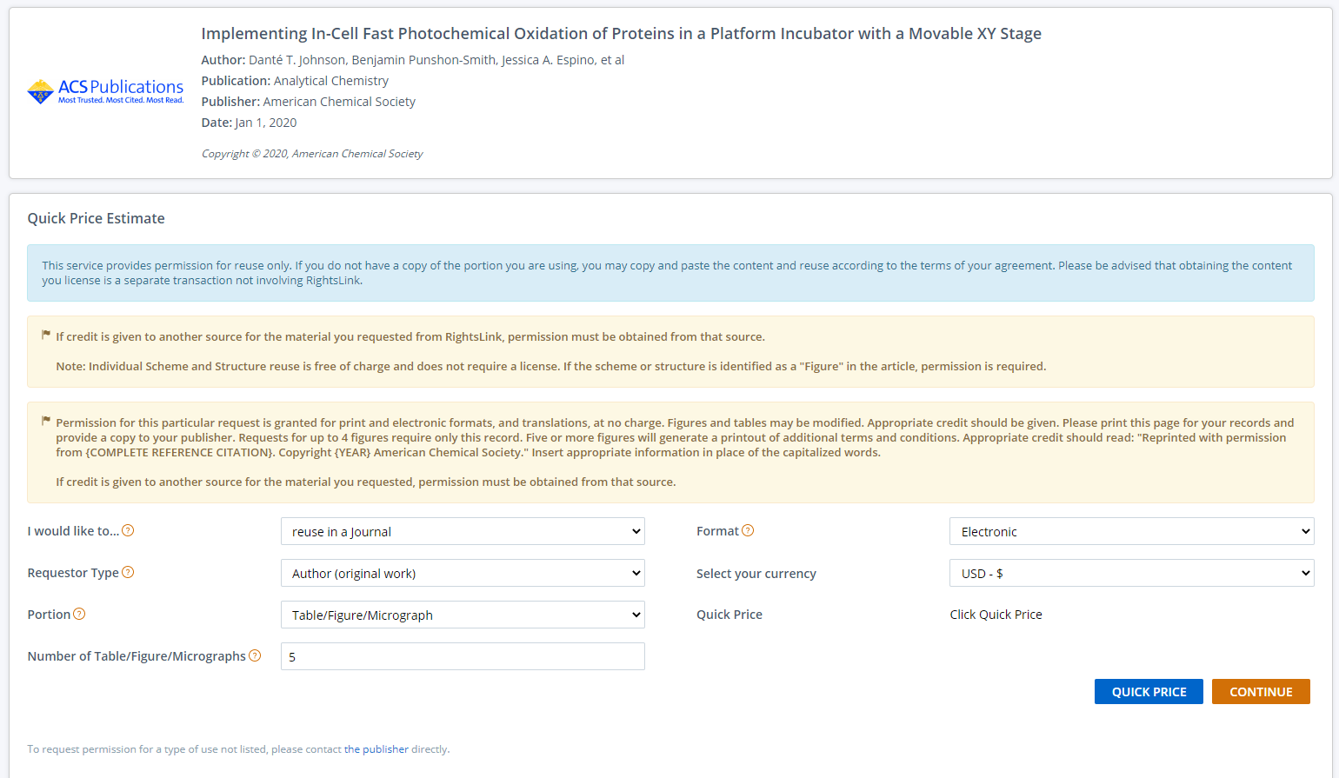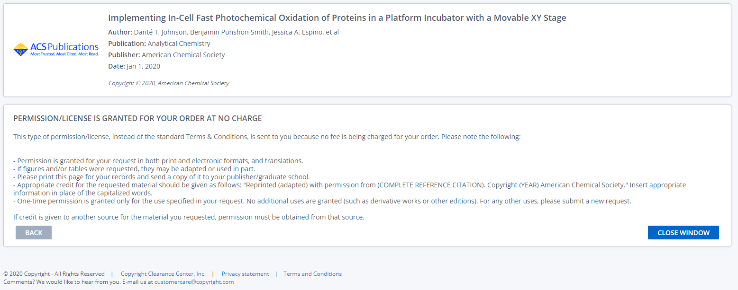
12. As we are a methods journal, please add to the Discussion with citations:
a) Any limitations of the technique
b) The significance with respect to existing methods
R: The above aspects have been included in the discussion section.
13. Please ensure that the references appear as the following: [Last name, F.I., Last Name, F.I., Last Name, F.I. Article Title. Source. Volume (Issue), FirstPage–LastPage (YEAR).] For more than 6 authors, list only the first author then et al. Please include volume and issue numbers for all references, and do not abbreviate journal names.
R: All references have been revised accordingly as above.

Reviewer #1:
The authors are laboratory is well known for performing cutting-edge FPOP experiments that report on protein structure and dynamics, for proteins in solution and also within living cells. The PIXY system described in this manuscript appears to be a useful addition to this overall toolbox, and it will be of interest to the JOVE readership. I only have a few comments, all of which will be easy to address:
p. 3: Introduction, first sentence. In addition to reference 1 add cast a wider net and include studies from other labs (e.g. Michael Gross' recent review in Chem. Rev.)
R: The following citations were added.

Liu, X. R.; Zhang, M. M.; Gross, M. L., Mass Spectrometry-Based Protein Footprinting for Higher-Order Structure Analysis: Fundamentals and Applications. Chemical Reviews., 120 (10), 4355-4454, 2019.
Li, J.; Chen, G., The use of fast photochemical oxidation of proteins coupled with mass spectrometry in protein therapeutics discovery and development. Drug Discovery Today., 24 (3), 829-883, 2019.
Zhao, B.; Zhuang, J.; Xu, M.; Liu, T.; Limpikirati, P.; Thayumanavan, S.; Vachet, R. W., Covalent Labeling with an α,β-Unsaturated Carbonyl Scaffold for Studying Protein Structure and Interactions by Mass Spectrometry. Analytical Chemistry. 92(9), 6637–6644, 2020.
p. 3: "of 19 of the 20" which one is missing? Gly? Realistically, this statement is too optimistic, because typically the modifications are preferentially seen for the most reactive residues.
R: The following worded was added to the manuscript at lines 66-69.
Theoretically, 19 of the 20 amino acids, can be oxidatively modified with Gly being the lone exception. However, owing to the variant reactivity rates of amino acids with hydroxyl radicals, modification of only a subset of these has been observed experimentally. Still, the method does have the potential for analysis over the length of a protein sequence⁵.

Perhaps I missed it, but the authors should discuss what types of cells are amenable to this approach (any cells grown in culture?) How about intact organisms such as C. elegans?
R: Validation studies have only been published in HEK293T cells in PIXY, however, all adherent cells are amenable to the approach. C. elegans are amenable to this approach as well. Evidence is represented in Figure 7 and well as in the text in
the representative results section. The revisions are restated below for quick reference.
Espino et al. demonstrated the capacity of FPOP to be performed in vivo (IV-FPOP) within C. elegans, a worm model for human disease states. While IV-FPOP is also performed via a flow system, the PIXY system was tested for compatibility with the worms. Approximately 10,000 worms were incubated in each well in the platform incubator at 20°C. LC−MS/MS analysis revealed 792 proteins were modified by IV-FPOP in the platform incubator compared to the 545 proteins modified with the flow system (Figure 7). These results demonstrate that in addition to 2D cell culture, this new methodology is also compatible with the study of other biological systems such as C. elegans.

The following wording has also been added to the discussion section (lines 1646-1651) to note the potential of this platform to study other cell lines.

Current studies in this platform incubator have been performed on HEK293T cells and in C. elegans. The IC-FPOP method has been shown to be compatible with a wide variety of cell lines including Chinese hamster ovary (CHO), Vero, MCF-7, and MCF10-A cells. Since the general IC-FPOP method is translatable to this static platform, these cells lines should be amenable for study using PIXY as well.

Are any specific considerations required to allow for H₂O₂ diffusion into the cells? To what extent will the H₂O₂ affect the viability and the physiology of the cells?
R: Hydrogen peroxide readily diffuses through the cell membrane. Generation of hydroxyl radicals by laser induced photolysis of hydrogen peroxide is a reaction that occurs on a microsecond timescale, theoretically eliminating structural changes induced by labeling. Also, in the PIXY system, cells are only exposed to 200 mM hydrogen peroxide for 10 seconds. Cell viability studies have been done to make sure cells are viable at the concentration as well as time frame. Please see bar graph below including citation.

Johnson, D. T.; Punshon-Smith, B.; Espino, J. A.; Gershenson, A.; Jones, L. M., Implementing In-Cell Fast Photochemical Oxidation of Proteins in a Platform Incubator with a Movable XY Stage. Analytical Chemistry. 92(2), 1691–1696 2019.

The following sentence has been added to the discussion section with appropriate reference in lines 2013-2014.

Cell viability studies demonstrated the cell were viable in the presence of H₂O₂ concentrations up to 200 mM.
p. 11: "Results show PIXY significantly outperformed the standard incubator, with a 1.13-fold higher transfection efficiency" To me, this means that PIXY shows about the same performance. "significantly outperformed" sounds like a bold exaggeration? Is this 13% increase even statistically significant?
R: The transfection efficiency difference between PIXY and the
standard was statistically significant confirmed by calculating the
probability of error (p value) by unpaired t-test. P<0.05. The sentence was
written in a way not to exaggerate, but to showcase a statistically significant
increase of cell culture efficiency. The word significantly was removed from the text at line 1011
Reviewer #2:
Manuscript Summary:
A useful and detailed protocol is presented for the assembly and use of an in-cell photochemical foot printing (oxidative labelling) system.
Major Concerns:
Immobilized cells (adhering to surface coated with specific protein) might behave differently than free-floating cells. This is well studied for bacteria (biofilm vs. floating) but also relevant for other cells - please comment if controls are needed.
R: We have not seen a difference in behavior for cells under constant flow
compared under to cells adhered to collagen coated plates. However, cells in
suspension may be amenable to the PIXY system and could be studied
in the future after specific parameters are sorted.

How quickly are the cells "mixed" with H₂O₂ upon infusion, i.e. what total delay between removal of culture medium and start of the FPOP experiment?
R: The dimension of a single well is 35 mm; the peristaltic pump tubing is 3.14
mm that leads into microtubing tubing of 1.59 mm. However, it is the placement of the tubing along with the fast flowrate that ensures efficient mixing of chemicals. The flow rate used for experimentation is 35 ml/min (35000ul/min) that is being infused over the course of the 20 second experiment. The tubing being flushed to the well wall right above the adhered layer of cells submerged under the 2 ml volume of DPBS under such a fast flowrate helps to ensure proper mixing. The total delay between removal of culture medium and the start of the FPOP experiment is 15 seconds. The infusion of H₂O₂ takes another 10 seconds. This incubation is immediately followed by the laser pulse and 1 second after the pulse, hydroxyl radicals are quenched by an infusion of quench buffer. To support these findings, we performed a simple experiment utilizing red and blue food coloring to watch the dispersion of reagents at their infusion timepoint. A video of this experiment is available and can be sent upon request if necessary. Therefore, we trust that each cell is getting complete exposure to each chemical. We since have moved to using premixed H₂O₂ that we infuse post media removal.

Do the cells die when they are exposed to the peroxide - or are continuous time-resolved experiments feasible?
R: Please see response to Reviewer 1 above

Why are four pumps used, there are six wells?
R: Each pump has four channels. Therefore, 16 tubes can be used to infuse the proper chemicals in each well. In a typical IC-FPOP experiment, each well needs three tubes. One tube for H₂O₂ infusion, one tube for quench infusion, and one tube for cell media withdrawal prior to FPOP. One pump out of the four pumps is solely used for withdrawing media out of the wells so these channels utilize six tubes instead of four using Y-junctions to increase the number of tubes per pump.
Why the specific PBN / DMTU quench used here, briefly explain how it works. Is this the same quench as used in the flow setup?
R: For in vitro FPOP, catalase and methionine are added to labeled samples to quench H₂O₂ and hydroxyl radicals, respectively. Since these molecules are not cell permeable, they will not be useful in quenching the reaction inside cells. For IC-FPOP, the cell permeable molecules DMTU and N-tert-butyl-α-phenylnitrone (PBN) were used to quench H₂O₂ and hydroxyl radicals, respectively. These two chemicals are both well studied free radical scavengers only used in our in cell FPOP studies. The cell permeability of these reagents is now noted in the manuscript in Protocol section 4 “Make quench buffer and H₂O₂”.
Explain cell confluency.
R: In cell culture biology, confluency is the term commonly used as a measure of the number of the cells in a cell culture dish or a flask and refers to the coverage of the dish or the flask by the cells. In our lab, we follow the Thermo “Useful Numbers for Cell Culture” table to assess cell confluency. We found that experimentation is best done with cells that are 80 % confluent as they are most viable, not undergrown, or over crowed within the flask or well.

A note has been added on line 414 to the cell culture steps to explain confluency.

Can you list all known hydroxyl radical side chain modifications here (with their delta mass)? R: The following table was added to the document figure file and manuscript introduction as Table 1.
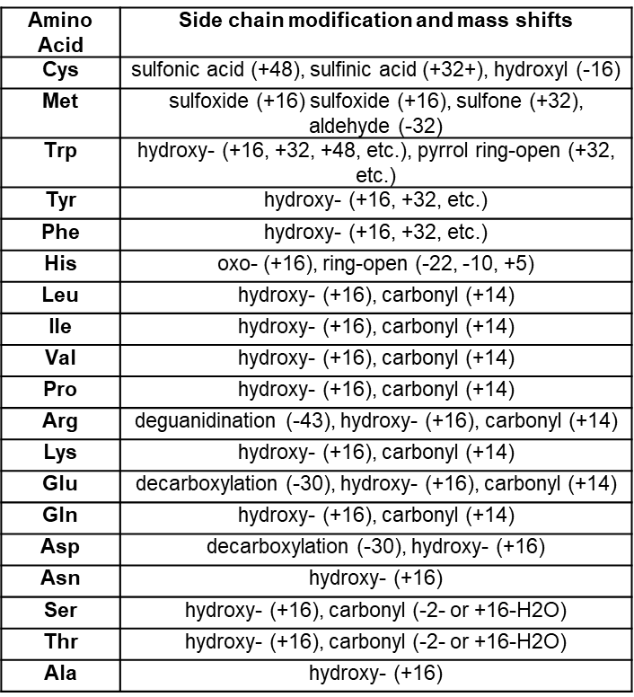
Please comment in Fig. 6 why some extensive modifications are only seen in PIXY but not in flow, is the side chain reactivity the same? Are background peroxide oxidations (i.e. without laser, as control) causing this?
R: This question is directly addressed in the following publication on which the JOVE submission is based: Johnson, D. T.; Punshon-Smith, B.; Espino, J. A.; Gershenson, A.; Jones, L. M., Implementing In-Cell Fast Photochemical Oxidation of Proteins in a Platform Incubator with a Movable XY Stage. Analytical Chemistry. 92(2), 1691–1696 2019.

Please see the excerpt below.

The 5 peptides modified in the PIXY samples contain 12 modified amino acids, while only 4 amino acids were modified with the flow system (Figure 4C).
The increase in modification coverage is further demonstrated
with the protein tubulin, where 67 residues were modified with
PIXY, while only 15 were modified using the standard ICFPOP
conditions with the flow system (Figure S3).
Owing to actin having both a monomeric and polymeric
form, we cannot rule out the possibility that the low number of
modifications with the flow system are due to the polymerized,
more protected, form (F-actin) being the dominant species in
these samples. We calculated the solvent accessible surface area
(SASA) (Table S2) of the F-actin polymerized structure and
found residues M190, P322, M305, and K326 to all be solvent
accessible. While all four of these residues are modified with
PIXY, only P322 is modified with the flow system.
Interestingly, the highly reactive methionine residues are not
modified with the flow system, even though they are solvent
accessible. In both cases, we do see residues with low
accessibility modified, which could be a result of the difference
in solution and static crystal structure conditions. It also could
be due to the effects of molecular crowding within the cell that
are not considered in the crystal structure.
Minor Concerns:
The term "English optical breadboard" is not wide-spread and might be a bit unclear. Metric instead of English also possible?
R: The term Imperial optical breadboard was confirmed on manufacturer website. This word was changed in the text.
Why is some text marked yellow?
R: Some text was marked in yellow according to the JOVE submission guidelines to highlight experimental steps that would be used for filming.
p26: text fragment
Comments/description: what does this refer to?
R: This error cannot be found in the text. However, all text fragments have been
addressed and revised in the text.
Figure 7: this should be a 1.45-fold increase (not 0.45)
R: This error has been addressed and revised in the text.

