Supplementary Material
Contents page
Appendix A. Informed Consent (Step 1) 2
Appendix B. Demographic and Predispositions Questionnaires (Step 3) 3
1. Printed Versions of the Four Questionnaires Together with Four Counterbalanced Orders 3
1. Demographic Information Questionnaire 3
2. Sense of Competence Questionnaire 3
3. Mastery Approach Goals Questionnaire 3
4. Metacognitive Regulation Questionnaire 4
Appendix C: Pre-test of Previous Academic Knowledge (Step 5) 5
Appendix D: Materials of the Two Learning Conditions (Step 6) 6
1. Printed Version of all Materials Together for the Two Conditions 6
2. Worked Example 7
3. Invention Problem 12
4. Practice Problem 13
Appendix E: Further description of the Lecture (Step 7) 14
Appendix F: Curiosity Questionnaire (Step 8) 16
Appendix G: Learning Post-test (Step 9) 17
Appendix H. Materials to be Provided to Students at the End (Step 10) 20
Appendix I. Answer Keys for Coding (Step 11) 21
1. Pretest Answer Key 21
2. Posttest Answer Key 22

Appendix A. Informed Consent (Step 1)

Informed Consent Form
The present study follows the Helsinki Declaration of Ethical Principles for the Investigation with Humans and has been approved by the Ethical Committee for the Investigation of the Principality of Asturias (Reference: 242/19).
Objectives and description of the study. The first objective is to explore the efficacy of two educational approaches for learning statistics. To facilitate this comparison, you and your classmates will be randomly assigned to perform different activities. Yet, all of you would cover the same contents. Also, activities of the two conditions will be available to all of you at the end. The second objective is to identify the cognitive factors that can foster learning in both approaches. For this, you and your classmates will be asked to complete short questionnaires and tests before starting the learning process.
Free decision to participate. You are free to participate in the study or abandon it at any time without any prejudice to your learning opportunities nor to your grade. If you do not want to participate, you can perform the learning activities without handing them in, and during the short time that other students are answering the questionnaires, you would be allowed to study other materials.

Confidentiality and anonymity. Your responses cannot be associated with your identity at any time. To help us connect your responses from different activities and questionnaires, you will be assigned an arbitrary identification number, and you will be asked to report this number in each activity.
Feedback about learning. At the end of the evaluation process you will have access to the correct responses in the learning tests, together with all the learning activities used in all conditions.
Information about results. Once the data is analyzed, your professor will give you access to the results of the investigation.
Further information. If you have any questions related to this investigation you can contact: (to be completed with data of the principal researcher).

After having read the information in this document and to consent to your participation in the present investigation, please sign below. You are allowed to interrupt your participation at any time, for any reason.

Signed: Place: Date:

Appendix B. Demographic and Predispositions Questionnaires (Step 3)

1. Printed Versions of the Three Questionnaires Together with Four Counterbalanced Orders
The four printed versions, each with a different order presentation, can be accessed at the following link: https://www.dropbox.com/sh/uv9t85wabivvurm/AAAVSezPwdcJuU6cf4gZSvdxa?dl=0

1. Demographic Information Questionnaire
Age: Sex: Male/Female
Course: Educational Institution:

2. Sense of Competence Questionnaire
Please describe your level of agreement regarding the following statements about how you feel in learning statistics
 | Strongly  Disagree |  |  | Neither agree  nor disagree |  |  | Strongly  Agree
1. I will have trouble understanding statistics because of how I think |  | 1 | 2 | 3 | 4 | 5 | 6 | 7
2. I will have no idea of what is going on in this statistics course |  | 1 | 2 | 3 | 4 | 5 | 6 | 7
3. I will make a lot of math errors in statistics |  | 1 | 2 | 3 | 4 | 5 | 6 | 7
4. I can learn statistics |  | 1 | 2 | 3 | 4 | 5 | 6 | 7
5. I will understand statistics equations |  | 1 | 2 | 3 | 4 | 5 | 6 | 7
6. I will find it difficult to understand statistical concepts |  | 1 | 2 | 3 | 4 | 5 | 6 | 7

3. Mastery Approach Goals Questionnaire
Please describe your level of agreement of these statements about your goals in this class
 | Totally  Disagree |  |  | Neither agree  nor disagree |  |  | Totally  Agree
1. My aim is to completely master the material presented in this class |  | 1 | 2 |  | 3 | 4 |  | 5
2. I am striving to understand the content of this course as thoroughly as possible |  | 1 | 2 |  | 3 | 4 |  | 5
3. My goal is to learn as much as possible |  | 1 | 2 |  | 3 | 4 |  | 5

4. Metacognitive Regulation Questionnaire
The purpose of this questionnaire is assessing your awareness about learning. For each statement, please respond how typical they are on you
 | Not at all typical of me | Not very typical of me | Somewhat typical of me | Fairly typical of me | Very typical of me
1.I ask myself periodically if I am meeting my goals | 1 | 2 | 3 | 4 | 5
2. I ask myself if I have considered all options when solving a problem | 1 | 2 | 3 | 4 | 5
3. I consciously focus my attention on important information | 1 | 2 | 3 | 4 | 5
4. I ask myself if there was an easier way to do things after I finish a task | 1 | 2 | 3 | 4 | 5
5. I consider several alternatives to a problem before I answer | 1 | 2 | 3 | 4 | 5
6. I periodically review to help me understand important relationships | 1 | 2 | 3 | 4 | 5
7. I ask myself questions about the material before I begin | 1 | 2 | 3 | 4 | 5
8. I think of several ways to solve a problem and choose the best one | 1 | 2 | 3 | 4 | 5
9. I summarize what I’ve learned after I finish | 1 | 2 | 3 | 4 | 5
10. I ask others for help when I don’t understand something | 1 | 2 | 3 | 4 | 5
11. I find myself analyzing the usefulness of strategies while I study | 1 | 2 | 3 | 4 | 5
12. I focus on the meaning and significance of new information | 1 | 2 | 3 | 4 | 5
13. I create my own examples to make information more meaningful | 1 | 2 | 3 | 4 | 5
14.I find myself pausing regularly to check my comprehension | 1 | 2 | 3 | 4 | 5
15. I ask myself how well I accomplish my goals once I’m finished | 1 | 2 | 3 | 4 | 5
16. I draw pictures or diagrams to help me understand while learning | 1 | 2 | 3 | 4 | 5
17. I ask myself if I have considered all options after I solve a problem | 1 | 2 | 3 | 4 | 5
18. I try to translate new information into my own words | 1 | 2 | 3 | 4 | 5
19. I pace myself while learning in order to have enough time | 1 | 2 | 3 | 4 | 5
20. I change strategies when I fail to understand | 1 | 2 | 3 | 4 | 5
21. I use the organizational structure of the text to help me learn | 1 | 2 | 3 | 4 | 5
22. I read instructions carefully before I begin a task | 1 | 2 | 3 | 4 | 5
23. I ask myself if what I’m reading is related to what I already know | 1 | 2 | 3 | 4 | 5
24. I reevaluate my assumptions when I get confused | 1 | 2 | 3 | 4 | 5
25. I organize my time to best accomplish my goals | 1 | 2 | 3 | 4 | 5
26. I try to break studying down into smaller steps | 1 | 2 | 3 | 4 | 5
27. I focus on overall meaning rather than specifics | 1 | 2 | 3 | 4 | 5
28. I ask myself questions about how well I am doing while I am learning something new | 1 | 2 | 3 | 4 | 5
29. I ask myself if I learned as much as I could have once I finish a task | 1 | 2 | 3 | 4 | 5
30. I stop and go back over new information that is not clear | 1 | 2 | 3 | 4 | 5
31. I stop and reread when I get confused | 1 | 2 | 3 | 4 | 5
32. I think about what I really need to learn before I begin a task | 1 | 2 | 3 | 4 | 5
33. I know how well I did once I finish a test | 1 | 2 | 3 | 4 | 5
34. I set specific goals before I begin a task | 1 | 2 | 3 | 4 | 5
35. I slow down when I encounter important information | 1 | 2 | 3 | 4 | 5

Appendix C: Pre-test of Previous Academic Knowledge (Step 5)

Identification number:
Please answer the following questions:
- The following shows the timing expressed in seconds for a group of 9 students in a 25 meters swimming competition: 12, 14, 16, 14, 18, 16, 13, 14, 18
¿What is the mean, the median, and the mode of the timing of this group?

- In the previous distribution, ¿What would the quartile 1 and the quartile 3 be?

- In a different group of 5 students, the mean for the 25 meters swimming competition is 20 seconds. The incorporation of an additional member to this group changes the group mean to 19 seconds. What is the time of this additional student?
  - 119 seconds
  - 19 seconds
  - 14 seconds
  - 15 seconds
  - None of the above

- What is the most appropriate measure of central tendency to address the performance of this group of students? Why?
  - La median, because it is an ordinal variable.
  - The mean, because it is an ordinal variable.
  - The median, because it is an interval variable.
  - The mean, because it is a ratio variable.
  - None of the above.

- The heart rate per minute of a group of 20 adults is displayed in the dot diagram below. For example, 3 adults have a rate of 60 beats per minute. Based on this data set, how many individuals from a similar group of 40 adults would be expected to have a heart rate of at least 90 beats per minute?

    - 12 adults
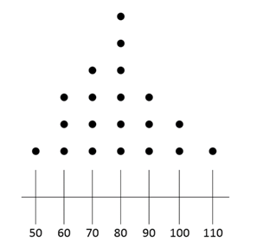

    - 6 adults
    - 3 adults
    - 28 adults
    - None of the above

Appendix D: Materials of the Two Learning Conditions (Step 6)

Printed Version of all Materials Together for the Two Conditions
The taskbook for each learning conditions, the PS-I condition and the direct instruction condition, can be accessed at the following link:
https://www.dropbox.com/sh/wy52p6wvxgkebcn/AADWPjSby5ZszYBeCyyBFFZVa?dl=0

2. Worked Example

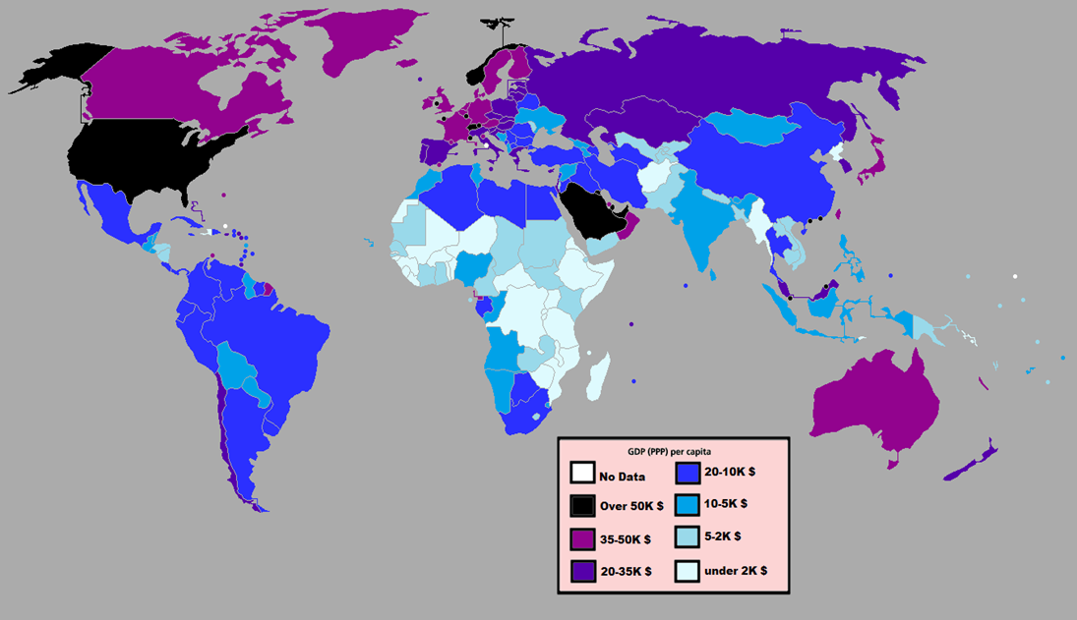
This image shows the average
income (GDP per capita) of the
countries in 2012. We can see
that, for example, Spain and
Russia have a similar average
income. However, only with the
average income, can we have
an idea of the wealth of the
inhabitants?

Below you can see four imaginary countries. Although the average income is the same in all of them, it is easy to see that they differ on how inequality strongly affects the wealth of their inhabitants.
How can we measure inequality?
There are multiple solutions that can help us to measure inequality and compare the inequality of these four countries. In the following pages we will show you three of the most accepted solutions.
Try to learn their calculation procedures and comprehend their affordances and limitations.
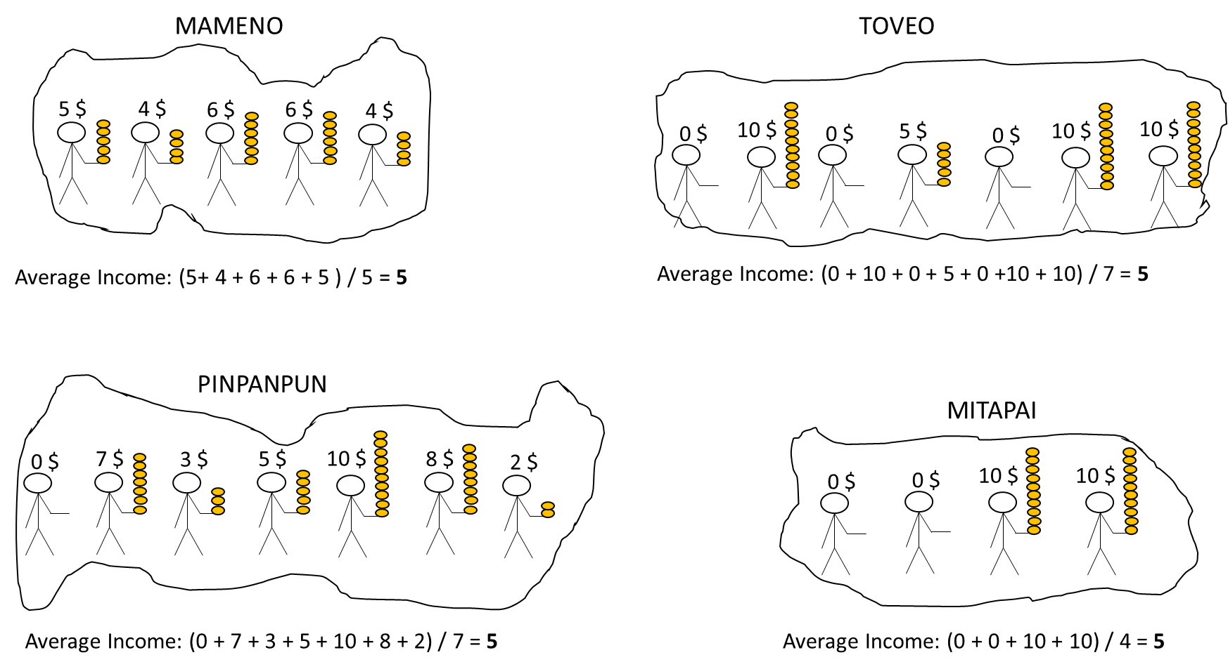
(continue to the next page)

SOLUTION 1: THE RANGE
- It is the difference between the maximum and the minimum value of the distribution.

How is it calculated?
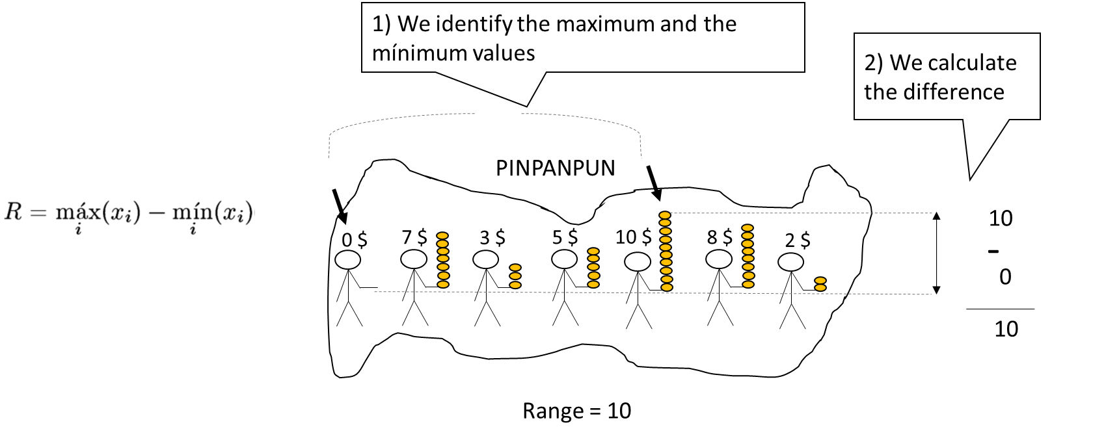

Solution:
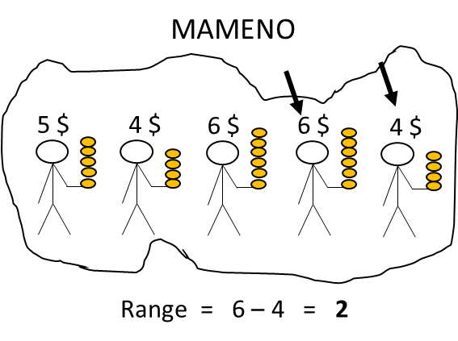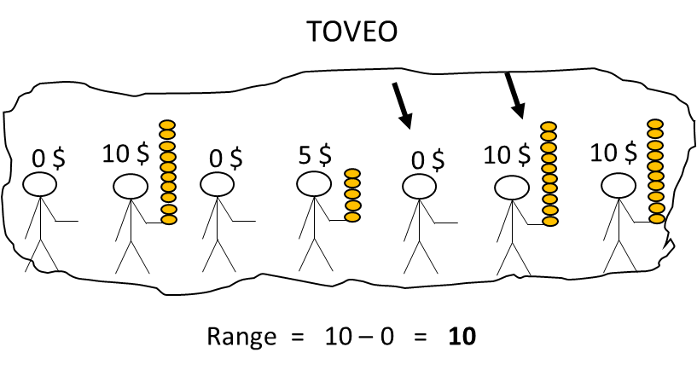
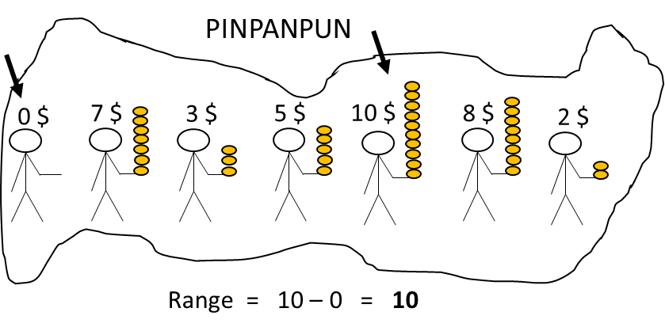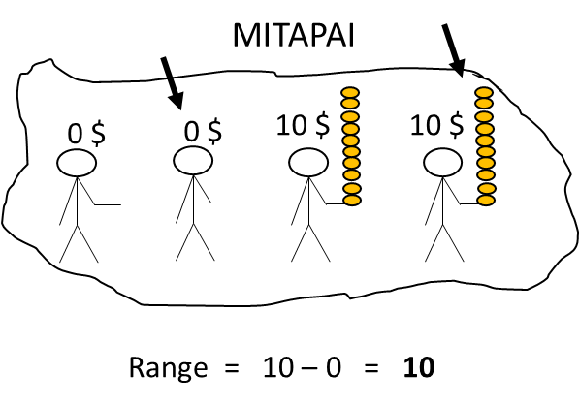
LIMITATIONS:
It only takes into account the two extreme values of the
distribution, the richest and the poorest person.
Therefore, it is not possible to identify the different
degree of inequality between Toveo, Mitapai and
Pinpanpun, in which the extreme values are the same.
ADVANTAGES OF THE RANGE:
It is easy to be calculated, and in some cases is
a good indicator of inequality. For example, the
lower range of Mameno certainly corresponds with a lower inequality in this country than in the rest of the countries.

(continue to the next page)
SOLUTION 2: INTERQUARTILE RANGE (IQ)
- It is the difference between quartile 3 and quartile 1. In other words, the amplitude of the range that contains the central half of the distribution.
How is it calculated?
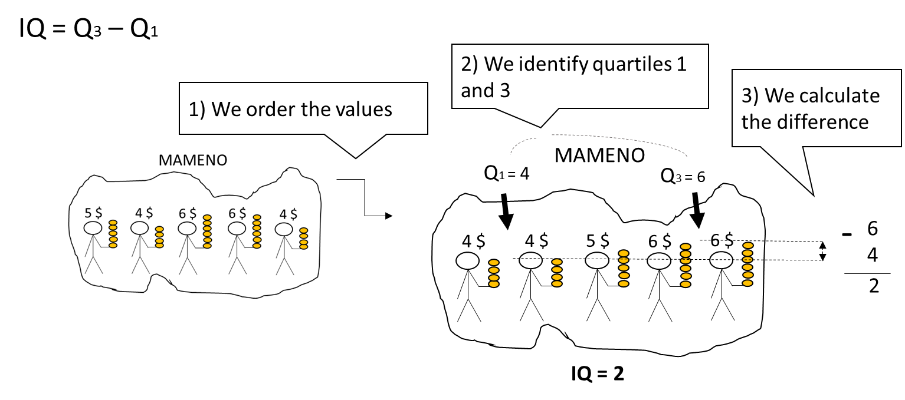
Solution:
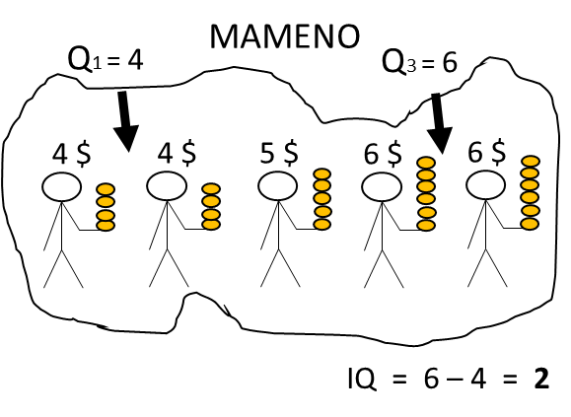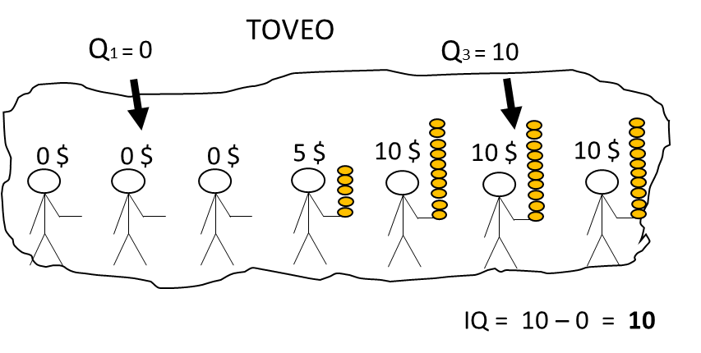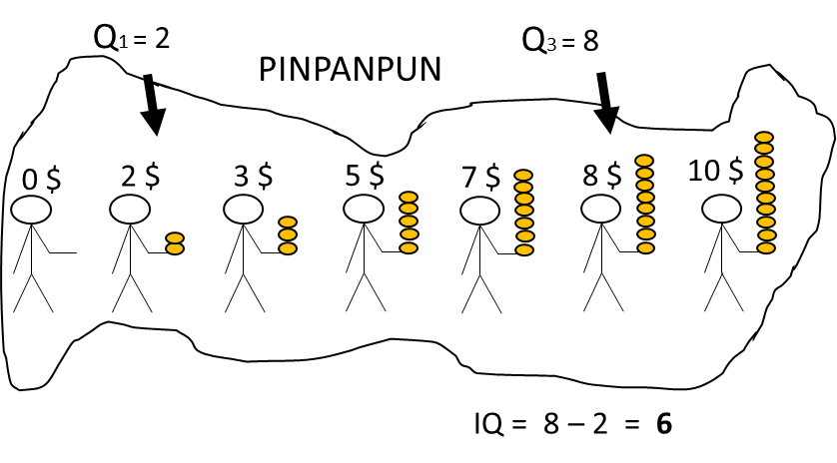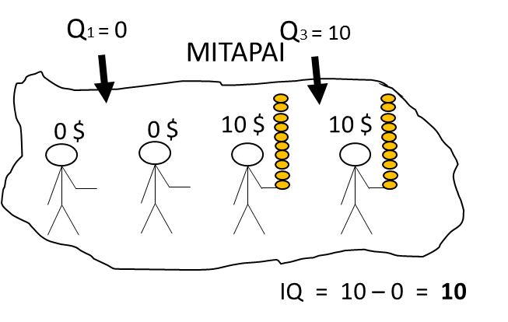
LIMITATIONS OF THE INTERQUARTILE RANGE:
Its exhaustiveness can be improved because it does not consider the differences across all cases. That is why we cannot identify the different levels of inequality between Toveo and Mitapai, where Q1 and Q3 are the same.

ADVANTAGES OF THE INTERQUARTILE RANGE:
It is not distorted by extreme scores because it only considers the central differences.
It is relatively comprehensive. Although it only considers differences in the central half of the distribution, these differences are expected to be representative of differences in the whole distribution. It allows us to see that there is more equality in Pinpanpun (IQ = 6) than in Toveo and Mitapai (IQ = 10).

(continue to the next page)

SOLUTION 3: THE STANDARD DEVIATION
- It is an average of the differences from the mean.

How is it calculated?
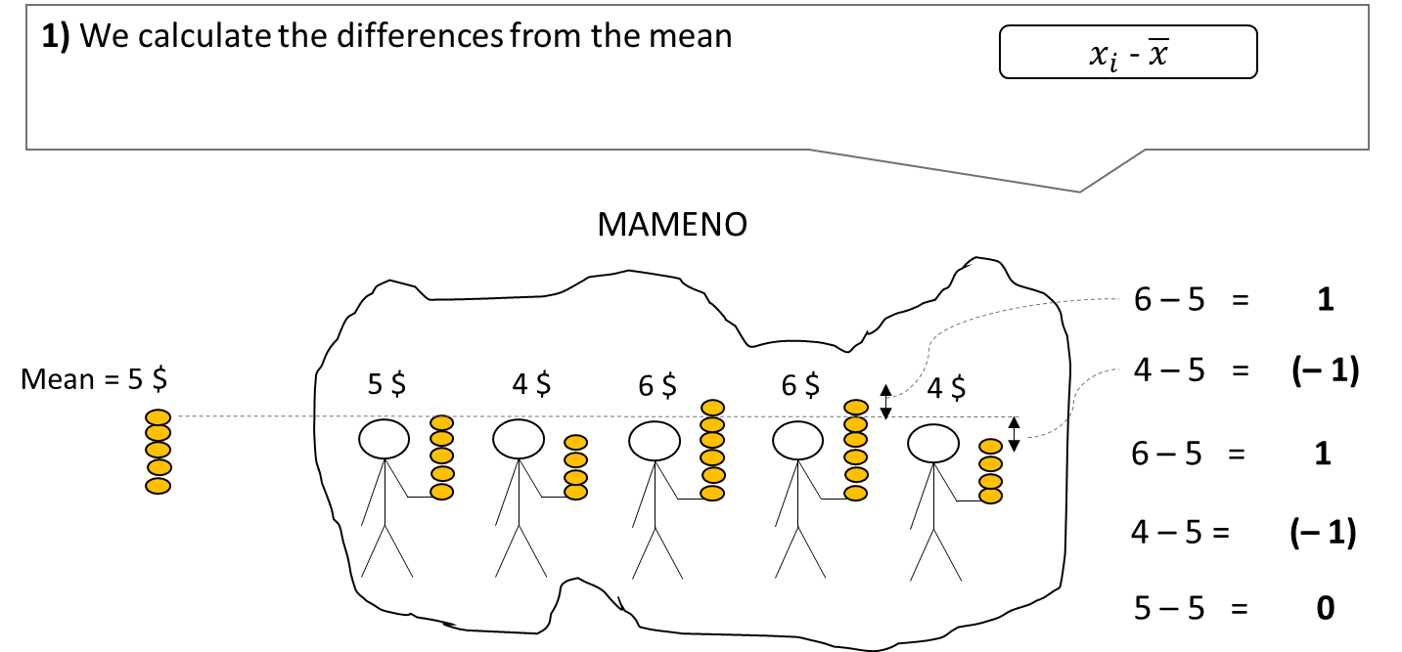

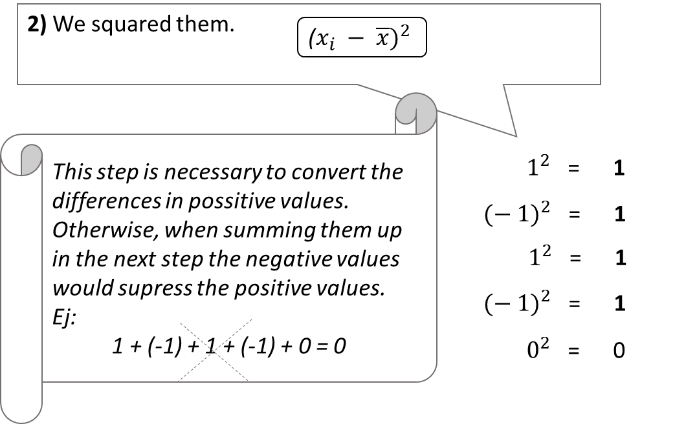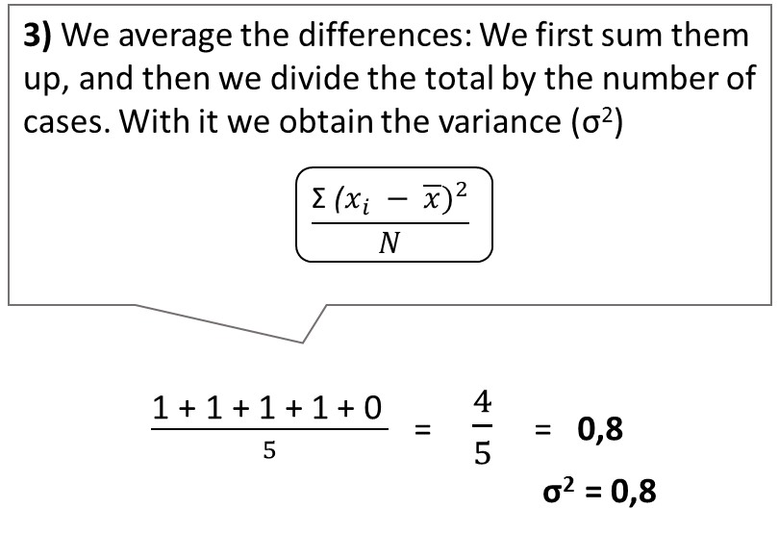

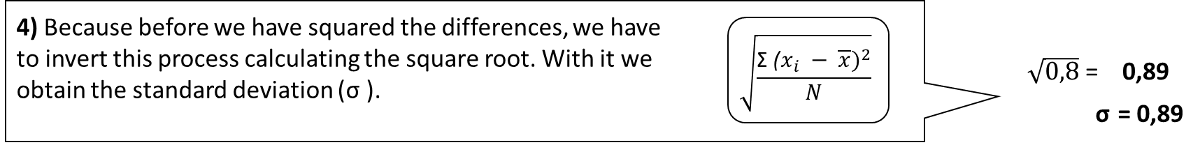

(continue to the next page)

Solution:
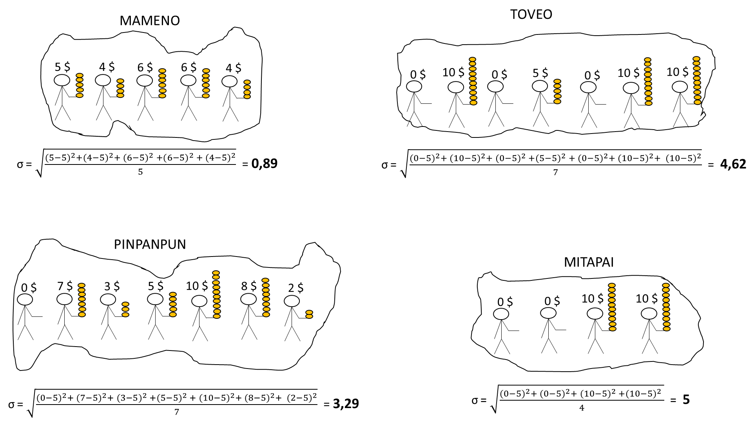

LIMITATIONS OF THE STANDARD DEVIATION:
- Although in general it is quite resistant to extreme
values, it also considers them in its calculation. This is
the reason why, when we find very asymmetric
distributions, where there are very extreme values towards one side of the distribution, the standard deviation can be distorted.

- It is not always appropriate to be used with
ordinal variables. In ordinal variables the differences
between values are uncertain, and the standard
deviation is based on the calculation of these exact
differences.

When we are in any of these situations, we can
use the interquartile range.

ADVANTAGES OF THE STANDARD DEVIATION:
It is a very comprehensive indicator, as it considers the differences of all the cases in the distribution. This allow us to identify the different degrees of inequality of the 4 countries, even when they are very subtle, for example when we compare Mitapai and Toveo.

Only if you have finished studying these contents, in the reverse of the page you can practice developing the procedures for the calculation of the inter-quartile range and standard deviation in Toveo , Pinpanpun, and Mitapai. Do your solutions correspond with the solutions given here?

3. Invention Problem

This image shows the average
income (GDP per capita) of the
countries in 2012. We can see
that, for example, Spain and
Russia have a similar average
income. However, only with the
average income, can we have
an idea of the wealth of the
inhabitants?

Below you can see 4 imaginary countries. Although the average income is the same in all of them, it is easy to see that they differ on how inequality strongly affects the wealth of their inhabitants.
How can we measure inequality?
Try to design a mathematical index that would help us to measure and compare inequality in these 4 countries. You can give multiple answers. There is no one unique valid solution!

4. Practice Problem
Calculate the range, the interquartile range, and the standard deviation for the income distribution in Tristras. Discuss the affordances and limitations of how these three measures allow to observe higher or lower inequality in Tristras versus the four countries you have seen in the previous activity.
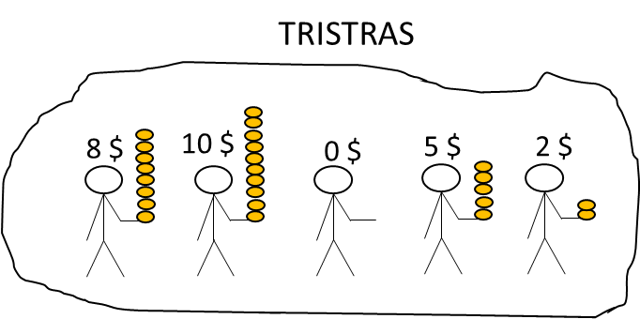

Appendix E: Further description of the Lecture (Step 7)
The power-point to support the lecture can be seen in https://www.dropbox.com/sh/aa6p3hs8esyf5xa/AACTvpVlEbdEtLVfBIbe9j7aa?dl=0. This file includes animations to stagger the contents, comments with proposed explanations to give to students, and indications about the approximative time allocated for each explanation. Also, a general description of these aspects is provided below:
- Introductory explanation of the concept of variability, the different types of variability measures, their complementation with central tendency measures, and the use of all of them depending on the different type of variables. Slides 1-5. Approximate time: 3 minutes.

- Introductory explanation of the standard deviation, when we use it and why. Slides 6-8. Approximate time: 4 minutes.

- The students are given time to calculate the standard deviation for the distributions in the following problem. They can refer back to the explanations in the Worked Example. Slide 9. Approximate time: 5 minutes.
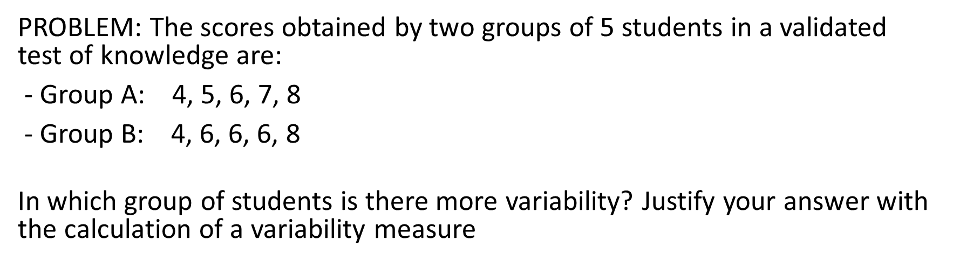
- Feedback on the calculations and interpretation of results in the previous problem. Slides 10-11. Approximate time: 2 minutes.
- Feedback on incorrect or partial calculations of the standard deviation. Slides 12-21. Approximate time: 7 minutes.
- Short explanation of the different symbols used to refer to standard deviation depending on whether we refer to samples or populations. Slide 22. Approximate time: 1 minute.
- Short explanation of the formula used in SPSS or other inferential statistics programs to calculate the standard deviation: the unbiased standard deviation. Slide 23. 1 minute.
- Explanation of the properties of the standard deviation. Slides 24-25. Approximate time: 2 minutes.
- Introductory explanation of the interquartile range: when and why we use it. Slides 26-30. Approximate time: 5 minutes.
- Students are given time to calculate the interquartile range of the distributions in the following problem. They can refer back to the explanations in the Worked Example. Slide 31. Approximate time: 3 minutes.
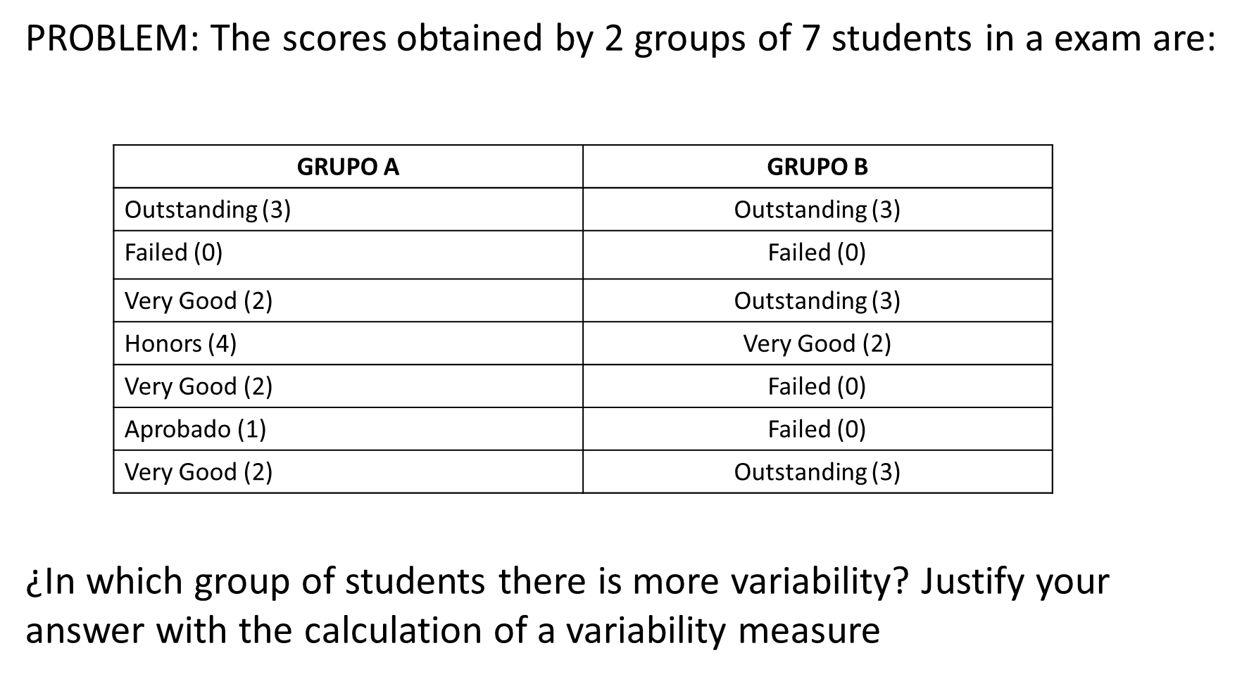
- Feedback on the calculations and interpretation of the interquartile range from the previous problem, including the discussion of the partial solution of the range. Slides 32-33. Approximate time: 2 minutes.
- Explanation of the property of resistance to extreme values and the appropriateness of the interquartile range when we deal with ratio or interval variables in asymmetric distributions. Slide 34. Approximate time: 2 minutes.
- Introductory Explanation to the Coefficient of Variation: How we calculate it, when and why we use it. Slides 35-37. Approximate time: 3 minutes.
- Overview of the contents covered. Slide 38. Approximate time: 1 minute

Appendix F: Curiosity Questionnaire (Step 8)
Identification number:

We are interested in the emotions you experienced when learning this lesson. For each emotion, please indicate the strength by circling the number that best describes the intensity of your emotional response during the learning process.

 | Not at all | Very little | Moderate | Strong | Very Strong
1.Curious | 1 | 2 | 3 | 4 | 5
2. Interested | 1 | 2 | 3 | 4 | 5
3. Inquisitive | 1 | 2 | 3 | 4 | 5

Appendix G: Learning Post-test (Step 9)

Identification number:

Please answer the following questions:

- (a) Calculate the standard deviation (SD) of the following set of marks on a test:
3, 6, 5, 4, 7
- 1 B. $\sqrt{2}$ C. 2 D. $\sqrt{1}$

- The owners of two cinemas, A and B, argue that their respective cinema enjoys a more consistent attendance. They collected the daily attendance of their cinemas for 11 random days. The results of their data collection are shown below:

 |  | Cinema A | Cinema B
Mean, M |  | 72 | 75
Standard Deviation, SD |  | 10 | 14

Which cinema do you think presents a more consistent attendance?
- Cinema A
- Cinema B
- Both enjoy equally consistent attendance.
- None of the above.

- Below we can see the data from 2 distributions. In which distribution there is more variability?
 |  | Distribution A | Distribution B
Median |  | 6 | 8
Interquartile Range |  | 3 | 2

- In distribution A
- In distribution B
- Both have the same variability
- Not enough information to decide

- In calculating the standard deviation, why is it important to divide the sum of squared deviations by n?

- As we can see in the following table, the standard deviation is greater in group A than in group B, while the interquartile range is greater in group B than in group A. How can it be explained?
 | Group A | Group B
Standard Deviation | 5,37 | 2,77
Interquartile Range | 2 | 4

- In the Group A there must be more extreme scores than in Group B.
- In the Group B there must be more extreme scores than in Group A.
- The interquartile range indicates the central tendency, and the standard deviation indicates the variability, and therefore they do not have to coincide.
- It is imposible, both are measures of variability and they have to provide consistent results.

- Consider the following six datasets:
  - (1, 5, 6, 10)
  - (4, 4, 4, 4)
  - (101, 102, 103, 104)
  - (7, 8, 9, 10)
  - (1, 2, 9, 10)
  - (1, 2, 3, 4)

- Which dataset has the smallest SD? _____________________
- Which dataset has the largest SD? _____________________
- Which datasets have the same SD? _____________________

- A data set consisting of five numbers has mean, M = 7, and standard deviation, SD = 4. If each of the five numbers is increased by 2, what are the new mean and SD?
- M = 7, SD = 4
- M = 9, SD = 4
- M = 7, SD = 6
- M = 9, SD = 6

- An equal number of students competed in the 100m sprint and 100m swim finals. The timings (in seconds) of the champions of the 100m sprint and 100m swim are shown below, as are the average timings and the SDs of the finalists in the two competitions.

 | 100m sprint | 100m swim
Champion | 10s | 40s
Average of the Finalists, M | 12s | 45s
SD of the Finalists | 1s | 3s

Assuming all else being equal, between the two champions, who is the better performer?
- The sprint champion
- The swim champion
- Both
- Not enough information to decide

- David’s scores for Mathematics, Physics and Chemistry in the final examinations are given below. His class’s performance for the three subjects is also given below:

 | Mathematics | Physics | Chemistry
David’s Score | 95 | 90 | 85
Class Average, M | 80 | 80 | 80
Class SD | 15 | 5 | 4

- Relative to his class, in which subject did David perform the best? _________
- Relative to his class, in which subject did David perform the worst? _________

Appendix H. Materials to be Provided to Students at the End (Step 10)
A folder with the materials used during the lesson and the feedback for exercises in the pretest and the posttest can be downloaded in the following link:
https://www.dropbox.com/sh/88k9b8qgxngbukq/AABMIIxNc20jGGwhCTVal-F1a?dl=0
Concretely, the folder includes four documents:
- The “Solutions to Central Tendency Exercises” document includes the solutions to the pre-test exercises.
- The “Preparatory Exercises for Variability” document includes in a single document the Invention Problem, the Worked Example, and the Practice Problem.
- The “Variability Lecture Slides” document include the slides used for the lecture, but without the comments about the proposed explanations
- The “Solutions to Variability Exercises” document includes the solutions to the posttest exercises.

Appendix I. Answer Keys for Coding (Step 11)

1. Pretest Answer Key
The score of this pretest can vary from 0 to 8 points. It will be calculated summing the points obtained in each of the questions, as described below.
- The following shows the timing expressed in seconds for a group of 9 students in a 25 meters swimming competition: 12, 14, 16, 14, 18, 16, 13, 14, 18
¿What is the mean, the median, and the mode of the timing of this group?
Mean: 15 → 1 point
Median: 14 → 1 point
Mode: 14 → 1 point

- In the previous distribution, ¿What would the quartile 1 and the quartile 3 be?
Quartile 1: 13.5 → 1 point
Quartile 2: 17 → 1 point

- In a different group of 5 students, the mean for the 25 meters swimming competition is 20 seconds. The incorporation of an additional member to this group changes the group mean to 19 seconds. What is the time of this additional student?
  - 119 seconds
  - 19 seconds
  - 14 seconds → 1 point
  - 15 seconds
  - None of the above

- What is the most appropriate measure of central tendency to address the performance of this group of students? Why?
  - La median, because it is an ordinal variable.
  - The mean, because it is an ordinal variable.
  - The median, because it is an interval variable.
  - The mean, because it is a ratio variable. → 1 point
  - None of the above.

- The heart rate per minute of a group of 20 adults is displayed in the dot diagram below. For example, 3 adults have a rate of 60 beats per minute. Based on this data set, how many individuals from a similar group of 40 adults would be expected to have a heart rate of at least 90 beats per minute?

    - 12 adults → 1 point

    - 6 adults
    - 3 adults
    - 28 adults
    - None of the above

2. Posttest Answer Key
The total score of this posttest can vary from 0 to 12 points, and it will constitute the general learning. This measure can be disaggregated in other learning measures:
- The procedural knowledge score can vary from 0 to 3, and it will be calculated summing up scores in items 1-3.
- The conceptual knowledge score can vary from 0 to 6, and it will be calculated summing up scores in items 4-7.
- The transfer of knowledge score can vary from 0 to 3, and it will be calculated summing up scores in items 8-9.
The assignment of scores for each item is described below.
- (a) Calculate the standard deviation (SD) of the following set of marks on a test:
3, 6, 5, 4, 7
- 1 B. $\sqrt{2}$ → 1 point C. 2 D. $\sqrt{1}$

- The owners of two cinemas, A and B, argue that their respective cinema enjoys a more consistent attendance. They collected the daily attendance of their cinemas for 11 random days. The results of their data collection are shown below:

 |  | Cinema A | Cinema B
Mean, M |  | 72 | 75
Standard Deviation, SD |  | 10 | 14

Which cinema do you think presents a more consistent attendance?
- Cinema A → 1 point
- Cinema B
- Both enjoy equally consistent attendance.
- None of the above.

- Below we can see the data from 2 distributions. In which distribution there is more variability?
 |  | Distribution A | Distribution B
Median |  | 6 | 8
Interquartile Range |  | 3 | 2

- In distribution A → 1 point
- In distribution B
- Both have the same variability
- Not enough information to decide

- In calculating the standard deviation, why is it important to divide the sum of squared deviations by n?

Assign 1 point if mentioned the need to average differences, or made reference to the idea that otherwise the indicator would be contaminated by the number of cases.
Assign 0.5 points if just mentioned a general need for averaging
Assign 0 points if none of the above.
Double coding of this item and evaluation of interrater reliability is recommended

- As we can see in the following table, the standard deviation is greater in group A than in group B, while the interquartile range is greater in group B than in group A. How can it be explained?
 | Group A | Group B
Standard Deviation | 5,37 | 2,77
Interquartile Range | 2 | 4

- In the Group A there must be more extreme scores than in Group B.
- In the Group B there must be more extreme scores than in Group A. → 1 point
- The interquartile range indicates the central tendency, and the standard deviation indicates the variability, and therefore they do not have to coincide.
- It is imposible, both are measures of variability and they have to provide consistent results.

- Consider the following six datasets:
  - (1, 5, 6, 10)
  - (4, 4, 4, 4)
  - (101, 102, 103, 104)
  - (7, 8, 9, 10)
  - (1, 2, 9, 10)
  - (1, 2, 3, 4)

- Which dataset has the smallest SD? B → 1 point
- Which dataset has the largest SD? E → 1 point
- Which datasets have the same SD? C, D, and F → 1 point

- A data set consisting of five numbers has mean, M = 7, and standard deviation, SD = 4. If each of the five numbers is increased by 2, what are the new mean and SD?
- M = 7, SD = 4
- M = 9, SD = 4 → 1 point
- M = 7, SD = 6
- M = 9, SD = 6

- An equal number of students competed in the 100m sprint and 100m swim finals. The timings (in seconds) of the champions of the 100m sprint and 100m swim are shown below, as are the average timings and the SDs of the finalists in the two competitions.

 | 100m sprint | 100m swim
Champion | 10s | 40s
Average of the Finalists, M | 12s | 45s
SD of the Finalists | 1s | 3s

Assuming all else being equal, between the two champions, who is the better performer?
- The sprint champion → 1 point
- The swim champion
- Both
- Not enough information to decide

- David’s scores for Mathematics, Physics and Chemistry in the final examinations are given below. His class’s performance for the three subjects is also given below:

 | Mathematics | Physics | Chemistry
David’s Score | 95 | 90 | 85
Class Average, M | 80 | 80 | 80
Class SD | 15 | 5 | 4

- Relative to his class, in which subject did David perform the best? Physics → 1 point
- Relative to his class, in which subject did David perform the worst? Mathematics → 1 point

