JoVE62125 "Generation of self-assembled vascularized human skin equivalents"

Editorial comments:
Changes to be made by the Author(s):
1. Please take this opportunity to thoroughly proofread the manuscript to ensure that there are no spelling or grammar issues. Please define all abbreviations at first use.
Editing for spelling and grammar has been completed. Abbreviations have been defined at first use and an abbreviations list has been added to supplemental materials.
2. JoVE cannot publish manuscripts containing commercial language. This includes trademark symbols (™), registered symbols (®), and company names before an instrument or reagent. Please remove all commercial language from your manuscript and use generic terms instead. All commercial products should be sufficiently referenced in the Table of Materials and Reagents.
For example: MATLAB; Matrigel; Corning Inc., Corning, NY; Corning Transwell; Sylgard 184, Dow Corning, Midland, MI etc
Commercial language has been addressed throughout the document in every case; some examples are provided below:
-MATLAB: changed to computational software or computational imaging and computational software referenced as MATLAB in materials table.
-Matrigel: changed to general gel term
-Corning : removed from text, referenced in materials table
-Sylgard 184 Dow Corning: removed from text, referenced in materials table
-DRAQ7: changed to far-red fluorescent nuclear dye and referenced in staining table
3. Please revise the text, especially in the protocol, to avoid the use of any personal pronouns (e.g., "we", "you", "our" etc.).
We have carefully gone through the manuscript and removed personal pronouns.
4. Please note that your protocol will be used to generate the script for the video and must contain everything that you would like shown in the video. Please add more details to your protocol steps. Please ensure you answer the “how” question, i.e., how is the step performed? Alternatively, add references to published material specifying how to perform the protocol action. Please add more specific details (e.g., button clicks for software actions, numerical values for settings, etc) to your protocol steps. There should be enough detail in each step to supplement the actions seen in the video so that viewers can easily replicate the protocol.
Lack of detail in the protocol steps has been addressed and we paid special attention to ensuring that we have specified how to do steps. References were added to protocol where applicable.
Added detail to the following steps with specific focus on “how” to complete steps:
1.2
2.1.8
2.3.1
2.3.4
3.1.2
3.1.4
3.4.1
7.3.4
Added references to detail protocol steps (where applicable):
7.1
5. Please highlight only up to 3 pages of the Protocol (including headings and spacing) that identifies the essential steps of the protocol for the video, i.e., the steps that should be visualized to tell the most cohesive story of the Protocol. This is a hard production limit. Remember that non-highlighted Protocol steps will remain in the manuscript, and therefore will still be available to the reader.
We have highlighted only up to 3 pages of the protocol and checked to ensure that highlighted text involves the most essential protocol steps with sufficient working detail. We have edited the highlighted text within the protocol for clarity and have added necessary detail for proper flow of an accompanying script.
6. As we are a methods journal, please add limitations of the technique to the Discussion.
Limitations in the discussion are included in the revised version:
First version: Line 750-756:
“For simplicity and accessibility of the protocol, we utilized the simplest media blends found in previous literature^{11, 71}. Other groups have studied the effects of specific media components on epidermal and dermal health and found that other media additives⁷⁷, such as external free fatty acids/lipids, enhance the stratum corneum of the epidermis and improve skin barrier function. Although our immunofluorescent markers show appropriate differentiation and stratification in the epidermis, depending on the studies being conducted, additional media optimization may be needed.”

Revised Version: Line 846-858:
“For simplicity and accessibility, this protocol utilized the simplest media blends found in previous literature^{11, 80}. Although there are many advantages to using simple media blends, the limitations of this choice are also recognized. Other groups have studied the effects of specific media components on epidermal and dermal health and found that other media additives⁹⁴, such as external free fatty acids/lipids, enhance the stratum corneum of the epidermis and improve skin barrier function. Although our immunofluorescent markers show appropriate differentiation and stratification in the epidermis, depending on the studies being conducted, additional media optimization may be needed. Further, an extensive analysis of the epidermal BM was not conducted when evaluating the VHSEs presented here. The integrity of the BM is an important indication of skin equivalents; various groups have done research on culture duration and its effect on BM markings⁹⁵ as well as analysis of fibroblast presence and added growth factor effects on BM expression¹⁴. It is important to note that analysis of the BM component should be evaluated and may need to be optimized when using this protocol. “

Reviewers' comments:
Reviewer #1:
Minor Concerns:
1) It is a useful protocol for skin engineering. The protocol is very long and the authors may want to compile a list of abbreviation for easy referencing.
We agree with the reviewer’s assessment and have included an abbreviation list as a supplemental document.

2) Language editing is needed. Followed are some examples (not exhaustive).
We acknowledge the necessity for further language editing of the first version of the manuscript and have addressed the edits mentioned and others after carefully reading the document.
Line 21, long-term culture (delete duration)
First Version: line 20:
“The goal of this protocol is to describe the generation and volumetric analysis of vascularized human skin equivalents using accessible and simple techniques for long term culture durations.”

Revised Version: Line 21:
“The goal of this protocol is to describe the generation and volumetric analysis of vascularized human skin equivalents using accessible and simple techniques for long term culture.”
Line 22, rephrase 'customize based on research needs'
First Version: line 22:
“To the extent possible, the rationale for steps are described to allow researchers the ability to customize based on research needs.”
Revised Version: Line 22:
“To the extent possible, the rationale for steps are described to allow researchers the ability to customize based on their research needs.”

Line 59, rephrase 'less intensive model'
Line 60, …skin models), which are composed of ….
First Version: Line 59- 62:
“Of these, one of the less intensive models are human epidermal equivalents (HEE; also referred to as half-thickness skin models) composed of only epidermal keratinocytes on an acellular dermal matrix, but capture epidermal differentiation and stratification seen in vivo.”
Revised Version: Line 59-62:
“Of these, one of the simpler model types is the human epidermal equivalent (HEE; also referred to as half-thickness skin models) which are composed of only epidermal keratinocytes on an acellular dermal matrix, but capture epidermal differentiation and stratification seen in vivo.”
Line 69, ' cell-derived' ?
Line 69, cadaver based ?
First Version: Line 66-70
“Skin equivalents have most often been generated through self-assembly techniques using dermal gels made of collagen type I (either of rat tail or bovine skin origin)^{1, 8}, but similar models have incorporated other matrix components such as fibrin^{9, 10}, commercially available gels, cell-derived¹¹, de-epidermalized membranes¹², cadaver based, and others^{1, 12–16}.
Revised Version: Line 67-71
“Skin equivalents have most often been generated through self-assembly techniques using dermal gels made of collagen type I (either of rat tail or bovine skin origin)^{1, 8}, but similar models have incorporated other matrix components such as fibrin^{9, 10}, fibroblast derived^{11, 12}, cadaveric de-epidermized membranes^{13–16}, commercially available gels and others^{1, 12, 13, 17–19}.”
Line 72 , rephrase
Line 71-73: First version:
“However, these are primarily developed for grafting purposes and are not necessarily suitable as customizable research models.”
Revised Version: Line 72-74
“However, these are primarily developed for therapeutic purposes and cannot be readily customized to specific research questions.”
Line 120, full stop
First Version: Line 119-120
“1.3. All cell centrifugation in this protocol is completed for 5 minutes at 300 x g, but may be decreased for more fragile cell types”
Revised Version: Line 122
“1.3. All cell centrifugation in this protocol is completed for 5 minutes at 300 x g, but may be decreased for more fragile cell types.”
(Added in a missing period)

Line 378, what is the meaning of 'pause point'?
We thank the reviewer for pointing out a need for clarification and have edited the text to explain the reason for placing a pause point in this spot.
First Version: Line 378:
“*Pause point*”

Revised Version: Line 407
“*Pause point* - After fixation and permeabilization, this procedure can be paused since the samples are stable for several weeks if prepared as outlined in step 5.1.5. Alternatively, staining (as described in step 6) can be completed immediately following step 5.”

Reviewer #2:
Manuscript Summary:
A well explained detailed method for creating a multilayer skin construct with vascular element
Major Concerns:
1- The number of endothelial cells is very high in comparison to the epidermal cells. Why did the authors use this particular number? Is there any comparative studies of mixing different cell numbers?
We appreciate the reviewer’s comments regarding cell densities used in the VHSE and have added several sentences to support both the customizable nature of cell density in these constructs and the previous research we based our chosen cell densities upon. To elaborate, we recognize the seemingly large difference of endothelial cell vs. epidermal cell number; however, epidermal cells are creating a monolayer on only the surface of the dermis and because of their stratification nature will differentiate upward and multiply to populate the respective epidermal layers. Endothelial cells are dispersed throughout a three-dimensional matrix of collagen and must populate a whole volume rather than a single plane. We chose the 750,000 cells/ mL of collagen based on preliminary studies of only endothelial cells in collagen and on published work that explored the relationship between collagen densities and vascular network formation [Morgan et al., Biomaterials, 2019]. A sentence regarding this study was added with the appropriate reference in the revised text. The number of fibroblast cells was chosen based off of preliminary experiments of which the goal was to provide fibroblast support in culture while limiting the amount of contraction of the dermis. The keratinocyte cell density of 170,000 cells seeded per dermal component is specific to the 12 well culture insert size and based on previous research from a well established skin equivalent research lab (led by Abdoelwaheb El Ghalbzouri at Leiden University Medical Center in The Netherlands) that often uses around 100,000 cells/cm². In the case of a 12 well culture insert, the growth area of a 12 well size insert membrane is 1.12 cm², so using the scale from literature, the amount to seed onto an insert membrane would be about 110,000 cells; we chose to increase the cell number to 170,000 to ensure epidermal coverage. Other literature values of keratinocytes range from 0.5 x 10⁵ cells/cm² [Commandeur et al., 2011, Experimental Dermatology] to 1 x 10⁵ cells/cm² [El Ghabzouri, 2002, British Journal of Dermatology]. This cell density (170,000 cells/construct at 12 well size) has proven to be appropriate in establishing a properly stratified epidermis after several weeks at air liquid interface. Appropriate edits and citations have been included in our revision to address these important points.

First Version: Line 696-705:
“The cell seeding amounts and media may be adjusted. In the protocol above, the encapsulated cell amounts have been optimized for a 12-well insert at 75,000 fibroblasts and 750,000 endothelial cells per mL of collagen with 170,000 keratinocytes seeded on top of the dermal construct. These cell numbers can be changed, but preliminary experiments should be completed to test contraction of the dermal compartment, which can occur with more dermal cells or more contractile dermal cells. Additionally, the number of days in submersion and the rate of tapering the serum content can also be customized if excessive dermal contraction is occurring. For example, if contraction is noticed during the period of dermal submersion or while keratinocytes are establishing a surface monolayer, moving more quickly through the serum tapering process and raising VHSEs to ALI can aid in preventing additional contraction.”

Revised Version Line 780-801:
“The cell seeding amounts and media may be adjusted. In the protocol above, the encapsulated cell amounts have been optimized for a 12-well insert at 7.5 x 10⁴ fibroblasts and 7.5 x 10⁵ endothelial cells per mL of collagen with 1.7 x 10⁵ keratinocytes seeded on top of the dermal construct. In similar systems, published endothelial cell densities are 1.0 x 10⁶ [cells/mL collagen]⁴⁸; fibroblast concentrations often range from 0.4 x 10⁵ [cells/mL of collagen]^{22, 28, 82} to 1 x 10⁵ [cells/mL of collagen]^{8, 58, 83–85}; and keratinocyte concentrations range from 0.5 x 10⁵ [cells/cm²]⁸⁰ 1 x 10⁵ [cells/cm²]⁸. . Cell densities can be optimized for specific cells and research question. Preliminary experiments should be completed to test epidermal surface coverage and contraction of the dermal compartment (which can occur with more dermal cells, more contractile dermal cells, longer submersion cultures, or softer matrices). Additionally, the number of days in submersion and the rate of tapering the serum content can also be customized if excessive dermal contraction is occurring or a different rate of keratinocyte coverage is required. For example, if contraction is noticed during the period of dermal submersion or while keratinocytes are establishing a surface monolayer, moving more quickly through the serum tapering process and raising VHSEs to ALI can aid in preventing additional contraction. Similarly, if keratinocyte coverage is not ideal, changing the number of days that the VHSE is submerged without serum may help increase epidermal monolayer coverage and mitigate contraction since serum is left out. Changes in cell densities or other suggestions above must be optimized for the specific cultures and research goals.”

2- Handling multilayer skin constructs for fixation, processing and staining is always a challenge. This is an area that needs technical elaboration from the authors.
We thank the reviewer for pointing out the need for clarification on handling skin constructs. This is indeed a challenging area and per this statement we have included several supplemental images and referenced them throughout the protocol that may aid in the handling of VHSEs after generation. Additionally, we have elaborated on techniques of handling throughout steps 5 and 6, as shown in the revisions.
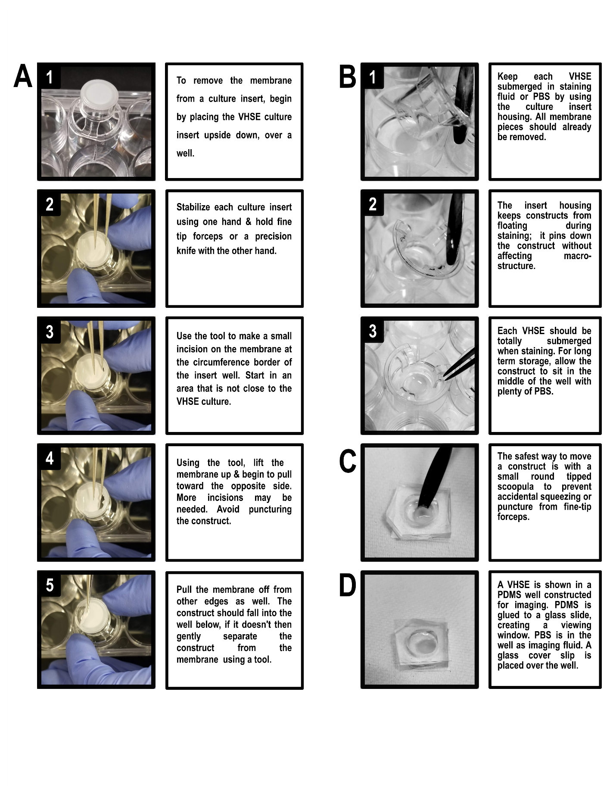
Minor Concerns:
1- I am not sure that the details provided in the preparation of the collagen and glass substrate for the cell culture is really needed as both are commercially available with clear to use instructions.
We thank the reviewer for this insight and have added a clarifying sentence in the revision to address this point. This protocol was written with one of our goals being to provide alternative methods to HSE generation that are not based on commercially available products. To the extent possible, we have provided a protocol that uses accessible and simple techniques, in a comprehensive document to alleviate confusion during VHSE generation. We realize that there are some points in the manuscript that could be made to be more straightforward with commercial products, but in the interest of accessibility, availability, and cost we believe that including these instructions are important.
First Version: Line 90-102:
“Although HSEs are one of the most common organotypic models, there are many technical challenges in generating these constructs including identifying appropriate extracellular matrix and cell densities, media recipes, proper air liquid interface procedures, and post-culture analysis. Further, while HEE and HSE models have published protocols, a detailed protocol incorporating dermal vasculature and volumetric imaging rather than histological analysis does not exist. In this work, we present an accessible protocol for the culture of vascularized human skin equivalents (VHSE) from mainly commercial cell lines. This protocol is written to be readily customizable, allowing for straight-forward adaptation to different cell types and research needs. Further, we describe straightforward volumetric imaging and quantification methods that allow for assessment of the three-dimensional structure of the VHSE. Translating this procedure into a robust and accessible protocol will enable non-specialist researchers to apply these important models in personalized medicine, vascularized tissue engineering, graft development, and drug evaluation.”

Revised Version: Line 91-105:
“Although HSEs are one of the most common organotypic models, there are many technical challenges in generating these constructs including identification of appropriate extracellular matrix and cell densities, media recipes, proper air liquid interface procedures, and post-culture analysis. Further, while HEE and HSE models have published protocols, a detailed protocol incorporating dermal vasculature and volumetric imaging rather than histological analysis does not exist. In this work, we present an accessible protocol for the culture of vascularized human skin equivalents (VHSE) from mainly commercial cell lines. This protocol is written to be readily customizable, allowing for straight-forward adaptation to different cell types and research needs. In the interest of accessibility, availability, and cost, the use of simple products and generation techniques was prioritized over the use of commercially available products. Further, we describe straightforward volumetric imaging and quantification methods that allow for assessment of the three-dimensional structure of the VHSE. Translating this procedure into a robust and accessible protocol enables non-specialist researchers to apply these important models in personalized medicine, vascularized tissue engineering, graft development, and drug evaluation.”
2- There are few linguistic mistakes, especially in the introduction, for a final revision.
We thank reviewer #2 for pointing out general linguistic mistakes. We agree with this assessment and have addressed these mistakes. The introduction and whole manuscript was carefully edited line-by-line for language and clarity by both authors. Many phrases and sentences were improved upon. Several examples (although not exhaustive) are included in these revisions:
First Version: line 20:
“The goal of this protocol is to describe the generation and volumetric analysis of vascularized human skin equivalents using accessible and simple techniques for long term culture durations.”

Revised Version: Line 19:
“The goal of this protocol is to describe the generation and volumetric analysis of vascularized human skin equivalents using accessible and simple techniques for long term culture.”
Line 22, rephrase 'customize based on research needs'
First Version: line 22:
“To the extent possible, the rationale for steps are described to allow researchers the ability to customize based on research needs.”
Revised Version: Line 20:
“To the extent possible, the rationale for steps are described to allow researchers the ability to customize based on their research needs.”

Line 59, rephrase 'less intensive model'
Line 60, …skin models), which are composed of ….
First Version: Line 59- 62:
“Of these, one of the less intensive models are human epidermal equivalents (HEE; also referred to as half-thickness skin models) composed of only epidermal keratinocytes on an acellular dermal matrix, but capture epidermal differentiation and stratification seen in vivo.”
Revised Version: Line 59-62:
“Of these, one of the least intensive model types is the human epidermal equivalent (HEE; also referred to as half-thickness skin models) which are composed of only epidermal keratinocytes on an acellular dermal matrix, but capture epidermal differentiation and stratification seen in vivo.”
Line 69, ' cell-derived' ?
Line 69, cadaver based ?
First Version: Line 66-70
“Skin equivalents have most often been generated through self-assembly techniques using dermal gels made of collagen type I (either of rat tail or bovine skin origin)^{1, 8}, but similar models have incorporated other matrix components such as fibrin^{9, 10}, commercially available gels, cell-derived¹¹, de-epidermalized membranes¹², cadaver based, and others^{1, 12–16}.
Revised Version: Line 67-71
“Skin equivalents have most often been generated through self-assembly techniques using dermal gels made of collagen type I (either of rat tail or bovine skin origin)^{1, 8}, but similar models have incorporated other matrix components such as fibrin^{9, 10}, fibroblast derived^{11, 12}, cadaveric de-epidermized membranes^{13–16}, commercially available gels and others^{1, 12, 13, 17–19}.”

Line 120, full stop
First Version: Line 119-120
“1.3. All cell centrifugation in this protocol is completed for 5 minutes at 300 x g, but may be decreased for more fragile cell types”
Revised Version: Line 122
“1.3. All cell centrifugation in this protocol is completed for 5 minutes at 300 x g, but may be decreased for more fragile cell types.”
(Added in a missing period)

Reviewer #3:
Manuscript Summary:
The authors have developed a method focussing on the integration of endothelial cells in a full-thickness skin equivalent to generate a vascularized 3D skin construct. In addition, they have developed procedures which facilitate the subsequent microscopic/histological analysis of the vascularized skin models. With these protocols the authors pave the way to establish vascularized tissue equivalents and to conduct further analyses in any experienced cell culture/tissue engineering lab in a quite easy and affordable manner.
I appreciate the well-structured protocol sections, the thoroughly described working steps and the richness in detail. This makes it easy to follow the instructions and to properly pursue the single steps in the laboratory. The tables about media compositions, preferred material, and the calculation tables add to the value of this paper.
Major Concerns/General remarks:
Your protocol focusses on the generation of a vascularized skin model. In your results section, and also in your figures, you demonstrate the successful culture of the model and the proper integration of the endothelial cells, based on LSM analyses. However, it would be interested to learn how the vascularized skin model looks like under "standard" fluorescence microscopy conditions after staining with e.g. anti-Col IV antibodies or other endothelium-specific antibodies. For example, is the growing capillary network visible under non-LSM conditions? It would also help to get a better idea of the distribution of the capillaries within the tissues when presenting some histological sections after specific immunofluorescence staining.
This is important for any user when it comes to assessing whether your protocol had been applied correctly and whether the integrated cells had differentiated as expected, even when no LSM technology is available.
Thus, I highly recommed including additional images to visualize the vascularization and to set a benchmark for quality control.

We thank the reviewer for this valuable insight and agree that it is important to be able to assess that the generation of a VHSE has been completed even when no laser scanning microscopy technology is available. Standard widefield fluorescence microscopy can similarly be used to assess VSHE quality while preserving the 3D structural information. We have added a supplemental figure and discussion regarding widefield imaging to provide readers with this important benchmark for quality control as suggested. Histological sectioning is also a powerful technique; however, it can result in a loss of three-dimensional structural information. While comparison of the respective advantages and limitations of histology and confocal microscopy would be an important study, we feel that histological methods are well covered in other literature and beyond the scope of this protocol.
We have added a statement reflecting the accessibility of fluorescent microscopy when LSM is not available and additionally have shown in Supplemental Figure 2 that vascular network is visible via Col IV marker through conventional fluorescent microscopy.

Added statement at the end of the results section: Line 652:
“Widefield fluorescent microscopy is an accessible option if laser scanning microscopy is not available; the vascular network and epidermis can be imaged with widefield fluorescent microscopy (Supplemental Fig. 2). Three-dimensional quantification is possible using widefield imaging of VHSEs rather than laser scanning microscopy, although it may require more filtering and deconvolution of images due to out-of-plane light.”

Supplemental Figure 2:
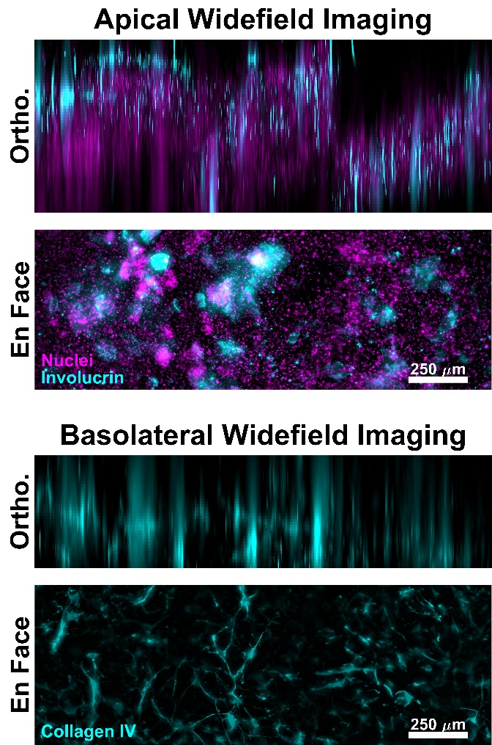

In addition, as your protocol is not intended in the first place to give all details necessary to conduct an LSM analysis with a certain equipment and specific software, I recommend adding a clear statement in this respect. The LSM analyses you have perfomed are only exemplary for any other kind of tissue analyses, whether qualitative or quantitative. The success of your culture method does not depend on the consecutive handling and processing of the tissues. Therefore, the reader must not expect any further details in your protocol.
Starting your results section with a short explanation in the way I have briefly outlined will certainly sharpen the primary scope of your manuscript.

We fully agree with the reviewer’s assessment and recognize that a clarification is necessary to point out the end of VHSE generation vs. optional end point processing and imaging techniques. We have addressed this statement by adding a few remarks throughout the document, including at the beginning of the results section.

Text added to the already existing note: Line 374-376:
“After entirely completing steps 1-4, the generation of a VHSE is complete. Steps 5-end of the protocol are optional processing and imaging techniques that have been optimized for this type of 3D construct.”
Note added before Sub-steps of step 5 (“Fixation and permeabilization of 3D constructs”): Line 378-380:
“Note: Step 5 has been optimized for imaging techniques specific to this 3D construct that are outlined in the remainder of the protocol. The following steps are not necessary for generating a VHSE.”

First version of 1st paragraph of results section: Line 564-572:
“We have presented a protocol for generation of in vitro vascularized human skin equivalents (VHSE) using TERT immortalized keratinocytes (N/TERT-1^{17, 53}), adult human dermal fibroblasts (hDF), and human microvascular endothelial cells (HMEC-1) (summarized in Fig. 1). Additionally, we have shown the customizable nature of this protocol by also demonstrating VHSE generation and stability when using commonly available lung fibroblasts (IMR90) instead of hDF. Volumetric imaging, analysis, and 3D renderings were completed to demonstrate an alternative to the classic histological sectioning analysis methods. These volumetric construct preparation and imaging protocols preserve VHSE structure at both the microscopic and macroscopic levels, allowing for comprehensive 3D analysis.”

Revised version of 1st paragraph of results section Line: 609-620:
“Here is presented a protocol for generation of in vitro vascularized human skin equivalents (VHSE) using telomerase reverse transcriptase (TERT) immortalized keratinocytes (N/TERT-1^{20, 59}), adult human dermal fibroblasts (hDF), and human microvascular endothelial cells (HMEC-1) (summarized in Fig. 1). Additionally, the customizable nature of this protocol is highlighted by also demonstrating VHSE generation and stability when using commonly available lung fibroblasts (IMR90) instead of hDF. Generation of the VHSE is completed in steps 1-4, while steps 5-7 are optional end point processing and imaging techniques that were optimized for these VHSEs. It is important to note that the VHSEs can be processed according to specific research questions and steps 5-7 are not required to generate the construct. Volumetric imaging, analysis, and 3D renderings were completed to demonstrate a volumetric analysis method. These volumetric construct preparation and imaging protocols preserve VHSE structure at both the microscopic and macroscopic levels, allowing for comprehensive 3D analysis.”

Minor Concerns/Specific remarks:
Page 7, line 230: Solidification/gellation can simply be checked when applying a droplet of collagen solution on a coverslip. After the gellation time, only the cover slip can be removed from the incubator, and gellation can be checked. In addition, the gel can be analyzed under the microscope to look for homogenicity and collagen fibre formation. If the droplets already contains the cells, cell distribution after gellation can be easily checked, too, even for the next 24 hours. This prevents unnecessary movements of the cell-containing plates. I recommend including this quality check into your protocol.
We appreciate this suggestion and recognize the importance of this quality check procedure. Text has been added to explain the process of a collagen quality check:
Added text to the Note existing in Line 126: “It is advised to complete a quality check of the collagen stock to ensure proper gelation and homogeneity before beginning dermal component seeding, see troubleshooting in discussion.”

Added text in the already existing collagen gelation troubleshooting section in the discussion:

First Version: Line 692-701:
“Proper collagen gelation is a challenging step in establishing skin culture. Especially when using crude preparations without purification, trace contaminants could influence the gelation process. To help ensure consistency, groups of experiments should be performed with the same collagen stock. Further, the gelation should ideally occur at a pH of 7-7.4, and trace contaminants may shift the pH. Before using any collagen stock, a practice acellular gel should be made up at the desired concentration and pH should be measured prior to gelation by pipetting a small amount onto a pH test strip. Using the same practice solution, gelation should be carried out as described above to verify the collagen gelation occurs as expected.”

Revised Version: Lines 762-778:
“Proper collagen gelation is a challenging step in establishing skin culture. Especially when using crude preparations without purification, trace contaminants could influence the gelation process. To help ensure consistency, groups of experiments should be performed with the same collagen stock that will be used for VHSE generation. Further, the gelation should ideally occur at a pH of 7-7.4, and trace contaminants may shift the pH. Before using any collagen stock, a practice acellular gel should be made up at the desired concentration and pH should be measured prior to gelation. Completing this collagen quality check before beginning dermal component seeding will identify problems with proper gelation and collagen homogeneity prior to setting up a complete experiment. Instead of seeding acellular collagen directly onto a culture insert, seed some collagen onto a pH strip that evaluates the whole pH scale and verify a pH of 7-7.4. Gelation can be evaluated by applying a droplet of collagen gel solution onto a coverslip or tissue culture plastic well plate (a well plate is recommended to simulate the confined sides of a culture insert). After gelation time, collagen should be solid, i.e., it should not flow when the plate is tilted. Under phase contrast microscopy, the collagen should look homogeneous and clear. Occasional bubbles from collagen seeding is normal but large amorphous blobs of opaque collagen within the clear gel indicates a problem-likely due to insufficient mixing, wrong pH, and/or failure to keep the collagen chilled during mixing.”
Page 8, line 269: 30%- that's the only confluency grade that works with your protocol? Generally, with primary human keratinocytes, it is possible to grow them up to 75-80% confluency without any limitations in viability and differentiation potential. Please comment on this! I recommend indicating a range of values which is comaptibel with your approach.
We thank the reviewer for pointing this limitation out. We have corrected the text to clarify that for the N/TERT-1 cell line, 30% confluency before trypsinization is necessary according to the Rheinhart lab who established N/TERT cell lines [Dickson, M.A. et al., Molecular and Cellular Biology, 2000]. The 30% confluency limit is to prevent un-wanted differentiation of keratinocytes in 2D culture, specific to this cell line. For primary cell lines, keratinocytes are routinely culture to a higher level without limitations in viability and differentiation potential. The text has been revised to discuss these points.

First Version: Line 272-273:
“Keratinocytes (N/TERT-1^{20, 55} or other appropriate cells) should be approximately 30% confluent (and should not significantly exceed) before trypsinization and seeding onto VHSEs.”

Revised Version: Line 285-291:
“Keratinocytes (N/TERT-1^{20, 59} or other appropriate cells) should be cultured to their confluency limit before trypsinization and seeding onto VHSEs. For N/TERT-1 cells, confluency should not significantly exceed 30% to prevent un-wanted differentiation of keratinocytes in 2D culture⁵⁹. For other appropriate cell lines, such as primary human epidermal keratinocytes, a confluency limit of 75-80% is generally used⁶⁰.”
Page 8, line 284: This should be done extremely careful in order not to disturb the layer of settled keratincoytes which might not yet adhere tightly to the underlying collagen gel. Please ad a respective warning at this place.
We thank the reviewer for this suggestion and recognize the importance of maintaining integrity of settled keratinocytes. A cautionary statement has been added to clarify step 3.1.3.

First Version: Line 284-285:
“Two hours after seeding the keratinocytes, add 300 µL of HSE media supplemented with 5% FBS to the top chamber of each construct well then place plate back into cell incubator.”

Revised Version: Line 306-310:
“Two hours after seeding the keratinocytes, carefully add 300 µL of HSE media supplemented with 5% FBS to the top chamber of each construct well; slowly pipette media onto side of culture insert. Loading media into the top chamber should be completed very carefully as to not disturb settled keratinocytes that may not have adhered tightly to the underlying collagen gel yet. After loading media, place construct back into incubator.”

Page 9, line 347: How do you prevent gel shrinkage? Or, if the gel shrinks during culture, how do you cope with this effects in terms of adherence to the culture well, floating, fragility? Also, it is well know that fibroblasts in a contracted gel behave differently compared to fibroblasts in a quite soldi matrix with high mechanical stability. In the worst case, fibroblasts are driven into apoptosis in a shrunk gel.
Please, add some more details about this phenomenon, which apparently occurs in your skin model. This will help the experimentor to take approriate measures during culture. This issue can be also placed in another part of the protocol, it is not confined to page and line as indicated.
We agree with the reviewer that gel shrinkage is prevalent in many HSE culture methods, and we have elaborated on this topic to help researchers using this protocol avoid excessive contraction. As the reviewer notes, excessive contraction results in changes to culture geometry, density, and floating.
Typically, we do not experience the construct losing adherence to the culture insert membrane or floating in the well using this protocol. We have only experienced excessive contraction and floating when the collagen stock has not gone through an appropriate quality check and the pH of the collagen stock was compromised. As suggested, we have included a collagen quality check in this protocol. The need for a quality collagen check was added in step 2 and further revision of the quality collagen check was included in the discussion section.
If the gel starts to shrink in culture when a normal collagen stock was used, it has always occurred during the period of dermal maturation and keratinocyte monolayer maturation while the construct is submerged and when the media contains serum. Optimization of submersion period, specifically mentioning contraction, has been expanded based on reviewer suggestion in both Step 3.1 and the Troubleshooting Discussion section. A discussion of faster media tapering and faster ALI induction is also included in the troubleshooting discussion and has been revised to emphasize contraction.
Collagen Quality Check Revisions are as previously noted above.
Further clarification was included in the discussion troubleshooting section. Explicit examples are included in the revised version.
First Version: Lines 696-705:
“The cell seeding amounts and media may be adjusted. In the protocol above, the encapsulated cell amounts have been optimized for a 12-well insert at 75,000 fibroblasts and 750,000 endothelial cells per mL of collagen with 170,000 keratinocytes seeded on top of the dermal construct. These cell numbers can be changed, but preliminary experiments should be completed to test contraction of the dermal compartment, which can occur with more dermal cells or more contractile dermal cells. Additionally, the number of days in submersion and the rate of tapering the serum content can also be customized if excessive dermal contraction is occurring. For example, if contraction is noticed during the period of dermal submersion or while keratinocytes are establishing a surface monolayer, moving more quickly through the serum tapering process and raising VHSEs to ALI can aid in preventing additional contraction.”

Revised Version: Lines 780-801:
“The cell seeding amounts and media may be adjusted. In the protocol above, the encapsulated cell amounts have been optimized for a 12-well insert at 7.5 x 10⁴ fibroblasts and 7.5 x 10⁵ endothelial cells per mL of collagen with 1.7 x 10⁵ keratinocytes seeded on top of the dermal construct. Cell densities have been optimized for this VHSE protocol based on preliminary studies and previous research investigating 3D vascular network generation in various collagen concentrations⁴⁸ and HSE generation^{22, 80, 81}. In similar systems, published endothelial cell densities are 1.0 x 10⁶ cells/mL collagen⁴⁸; fibroblast concentrations often range from 0.4 x 10⁵ cells/mL of collagen^{22, 28, 82} to 1 x 10⁵ cells/mL of collagen^{8, 58, 83–85}; and keratinocyte concentrations range from 0.5 x 10⁵ [cells/cm²]⁸⁰ 1 x 10⁵ [cells/cm²]⁸. Cell densities can be optimized for specific cells and research question. Three-dimensional cultures with contractile cells, such as fibroblasts, can contract leading to viability reduction and culture loss^{86, 87}. Preliminary experiments should be completed to test contraction of the dermal compartment (which can occur with more dermal cells, more contractile dermal cells, longer submersion cultures, or softer matrices) and to test epidermal surface coverage. Additionally, the number of days in submersion and the rate of tapering the serum content can also be customized if excessive dermal contraction is occurring or a different rate of keratinocyte coverage is required. For example, if contraction is noticed during the period of dermal submersion or while keratinocytes are establishing a surface monolayer, moving more quickly through the serum tapering process and raising VHSEs to ALI can aid in preventing additional contraction. Similarly, if keratinocyte coverage is not ideal, changing the number of days that the VHSE is submerged without serum may help increase epidermal monolayer coverage and mitigate contraction since serum is left out. Changes in cell densities or other suggestions above must be optimized for the specific cultures and research goals.”

Text added to note in step 3.1 (Submersion Day 7 (SD7): seed keratinocytes):
First Version: Line 263-268:
“3.1 Submersion Day 7 (SD7): seed keratinocytes
Note: Seed keratinocytes to establish the epidermis on SD7. This time point can be shifted based on the needs of the researcher. Duration of submersion culture without keratinocytes should not exceed 9 days, as longer submersion often leads to increased dermal contraction. Optimize submersion period as needed for specific experiments (see troubleshooting in discussion).”

Revised Version: Line 278-284:
“3.1 Submersion Day 7 (SD7): seed keratinocytes
Note: Seed keratinocytes to establish the epidermis on SD7. This time point can be shifted based on the needs of the researcher. Duration of submersion culture without keratinocytes should not exceed 9 days, as longer submersion often leads to increased dermal contraction. If contraction is occurring before SD7, it is recommended to shorten submersion period to 5 days and seed epidermis on SD5. Optimize submersion period as needed for specific experiments (see troubleshooting in discussion).”

Page 11, line 428: According to 6.2.3. the housing has not been removed since then. Please be more precise at this point.
We thank the reviewer for pointing out this mistake and we have adjusted the protocol for precision.
First Version: Lines 427-431:
“6.2.4 After 48 hours, prepare secondary antibodies and chemical stains in 700 µL of blocking buffer (per well) and add culture insert housing to keep VHSE construct submerged.
6.2.5. Remove primary stain solution and wash with 1X PBS, 3x for 5 minutes before adding the secondary stain solution. Expose for 48 hours in 4 °C refrigeration without agitation or rocking.”
Revised Version: Lines 460-466:
“6.2.4. After 48 hours, prepare secondary antibodies and chemical stains in 700 µL of blocking buffer (per well).

6.2.5. Remove culture insert housing and primary stain solution and wash with 1X PBS, 3x for 5 minutes before adding the secondary stain solution. Add culture insert housing to keep VHSE construct submerged. Expose for 48 hours in 4 °C refrigeration without agitation or rocking.”

Page 12, line 434: "Rehydrate with PBS and place the culture insert housing back into the well to keep it submerged…" This procedure is mentioned a few times in your protocol. Can you please add a picture or a drawing to illustrate this step? The handling of the insert housing and the recommended position of the skin model is difficult to understand without any additional illustration.
We agree with the reviewer’s assessment and have added Supplemental Figure 1 regarding the statement mentioned (keeping the construct submerged), handling the insert housing, and handling the VHSE.
Page 13, line 477: Does this product include both base and crosslinker? Please add the respective information.
We recognize that this step requires further clarification and have edited the text according to the comments received. Additionally, clarification of base/crosslinker purchasing norms have been added to the materials list.
Line 479-480 First Version:
“Prepare PDMS, suggested concentration is [9:1], base: crosslinker. Prepare 30 g of PDMS by adding base then crosslinker (use any clean mixing vessel).”

Revised Version: Line 516-520:
“ 7.1 Two days before imaging: prepare polydimethylsiloxane (PDMS; see materials list)

Prepare PDMS^{48, 63, 64} at a suggested concentration of [9:1], base: crosslinker. Prepare 30 g of PDMS total: 27 g of base component and 3 g of crosslinker. Using a weigh scale, add any clean mixing vessel and tare the scale, then add the base amount (27 g) then add the crosslinker amount (3 g) to achieve a total of 30 g or other desired amount. Always add base then crosslinker. Stir solution vigorously for at least 4 minutes, this will create small bubbles.”
Page 13, line 492: Cutting out of the PDMS sheet? Please add this to the sentence to avoid any misunderstanding.
We recognize the necessity of clarification in this step and have adjusted the text accordingly.
First Version: Line 491-493:
“Punch or cut out a circular well about the same size as the VHSE construct (use steel punch or a handheld precision knife, see materials list). Cut a square patch around the well to create a single PDMS well.
Revised Version: Line 530-532
“Using a steel punch or handheld precision knife, punch or cut out a circular well from the PDMS sheet prepared in 7.1. The well should be around the same size as the VHSE construct. Cut a square patch around the circular well to create a single PDMS well.”

Page 14, line 523: This conformation does work only with an inverse microscope. If using an upright positioned microscope, the set-up must be changed. Please add this piece of information to avoid any misinterpretation.
We agree with the reviewer’s assessment and have added information to address the differences in upright v. inverse microscopy.
First Version: Line 522-523:
“Place construct with the orientation of interest facing down toward the glass. For example, to image the epidermis, make sure the epidermis is facing the glass.”

Revised Version: Line 561-565
“Place construct with the orientation of interest facing toward the objective. For example, to image the epidermis using an inverted microscope, make sure the epidermis is facing down, toward the glass. Alternatively, for an upright microscope, the epidermis should face up. The below imaging procedures are described for an inverted microscope, but could be readily adapted for an upright.”

Page 15, line 579: Col IV is also a component of the basement membrane, thus this structure should be stained, too. Alternatively, Col IV is not expressed properly in collagen gel-based skin equivalents. Please add a comment in your results section.
We appreciate the reviewer’s assessment and have added a statement in the results section and in the limitations discussion section about Col IV expression in the basement membrane of the epidermis, and potential limitations/improvements to acknowledge on basement membrane evaluation.
Added statements in the results section:
First Version: Line 574-579:
“Characterization of the epidermis and dermis show appropriate immunofluorescent markers for human skin in VHSE constructs (Fig. 2 & 3). Cytokeratin 10 (CK10) is an early differentiation keratinocyte marker which usually marks all suprabasal layers in skin equivalents^{14, 28, 59} (Fig. 2). Involucrin and filaggrin are late differentiation markers in keratinocytes and mark the uppermost suprabasal layers in skin equivalents^{15, 28, 59, 60} (Fig. 2). DRAQ7 was used to mark nuclei in both the epidermis and dermis and Col IV marks vasculature of the dermis (Fig. 2, 3, 4).”
Revised Version: Line 622-631:
“Characterization of the epidermis and dermis show appropriate immunofluorescent markers for human skin in VHSE constructs (Fig. 2 & 3). Cytokeratin 10 (CK10) is an early differentiation keratinocyte marker which usually marks all suprabasal layers in skin equivalents^{18, 30, 68} (Fig. 2). Involucrin and filaggrin are late differentiation markers in keratinocytes and mark the uppermost suprabasal layers in skin equivalents^{12, 30, 68, 69} (Fig. 2). A far-red fluorescent nuclear dye (see materials list) was used to mark nuclei in both the epidermis and dermis and Col IV marks vasculature of the dermis (Fig. 2, 3, 4). Epidermal basement membrane (BM) components are not always properly expressed in HSE cultures^{15, 16}; and Col IV staining of the BM is not consistently observed using this protocol. Research focused BM components and structure would benefit from additional media, cell, and imaging optimization¹⁴.”

Added statements in the discussion section

First version: Line 750-756:
“For simplicity and accessibility of the protocol, we utilized the simplest media blends found in previous literature^{11, 71}. Other groups have studied the effects of specific media components on epidermal and dermal health and found that other media additives⁷⁷, such as external free fatty acids/lipids, enhance the stratum corneum of the epidermis and improve skin barrier function. Although our immunofluorescent markers show appropriate differentiation and stratification in the epidermis, depending on the studies being conducted, additional media optimization may be needed.”

Revised Version: Line 846-858:
“For simplicity and accessibility, this protocol utilized the simplest media blends found in previous literature^{11, 80}. Although there are many advantages to using simple media blends, the limitations of this choice are also recognized. Other groups have studied the effects of specific media components on epidermal and dermal health and found that other media additives⁹⁴, such as external free fatty acids/lipids, enhance the stratum corneum of the epidermis and improve skin barrier function. Although our immunofluorescent markers show appropriate differentiation and stratification in the epidermis, depending on the studies being conducted, additional media optimization may be needed. Further, an extensive analysis of the epidermal BM was not conducted when evaluating the VHSEs presented here. The integrity of the BM is an important indication of skin equivalents; various groups have done research on culture duration and its effect on BM markings⁹⁵ as well as analysis of fibroblast presence and added growth factor effects on BM expression¹⁴. It is important to note that analysis of the BM component should be evaluated and may need to be optimized when using this protocol.”

