Supporting Information
TITLE:
Microscopic Visualization of Porous Nanographenes Synthesized Through Combination of Solution and On-surface Chemistry

AUTHORS AND AFFILIATIONS:
Rafal Zuzak,¹ Iago Pozo,² Mads Engelund,³ Manuel Vilas-Varela,² José M. Alonso,² Enrique Guitián,² Dolores Pérez,² Diego Peña,² Szymon Godlewski¹

¹ Centre for Nanometer-Scale Science and Advanced Materials, NANOSAM, Faculty of Physics, Astronomy and Applied Computer Science, Jagiellonian University, Łojasiewicza 11, PL 30-348 Kraków, Poland
² Centro de Investigación en Química Biolóxica e Materiais Moleculares (CiQUS), Departamento de Química Orgánica, Universidade de Santiago de Compostela, 15782-Santiago de Compostela, Spain
³ Espeem S.A.R.L., L-4365 Esch-sur-Alzette, Luxembourg

Corresponding Author:
Szymon Godlewski
szymon.godlewski@uj.edu.pl
Tel: (48)-12-664-46-05

Email Addresses of Co-authors:
Rafał Zuzak (rafal.zuzak@uj.edu.pl)
Iago Pozo (iago.p.m@hotmail.com)
Mads Engelund (mads.engelund@espeem.com)
Manuel Vilas-Varela (manuelvilasvarela@gmail.com)
José M. Alonso (xosemag@yahoo.es)
Enrique Guitián (enrique.guitian@usc.es)
Dolores Pérez (dolores.perez@usc.es)
Diego Peña (diego.pena@usc.es)

KEYWORDS:
on-surface synthesis, scanning tunneling microscopy, atomic force microscopy, nanographenes

Figure S1 shows spectroscopic characterization of docecaphenyl[7]starphene.
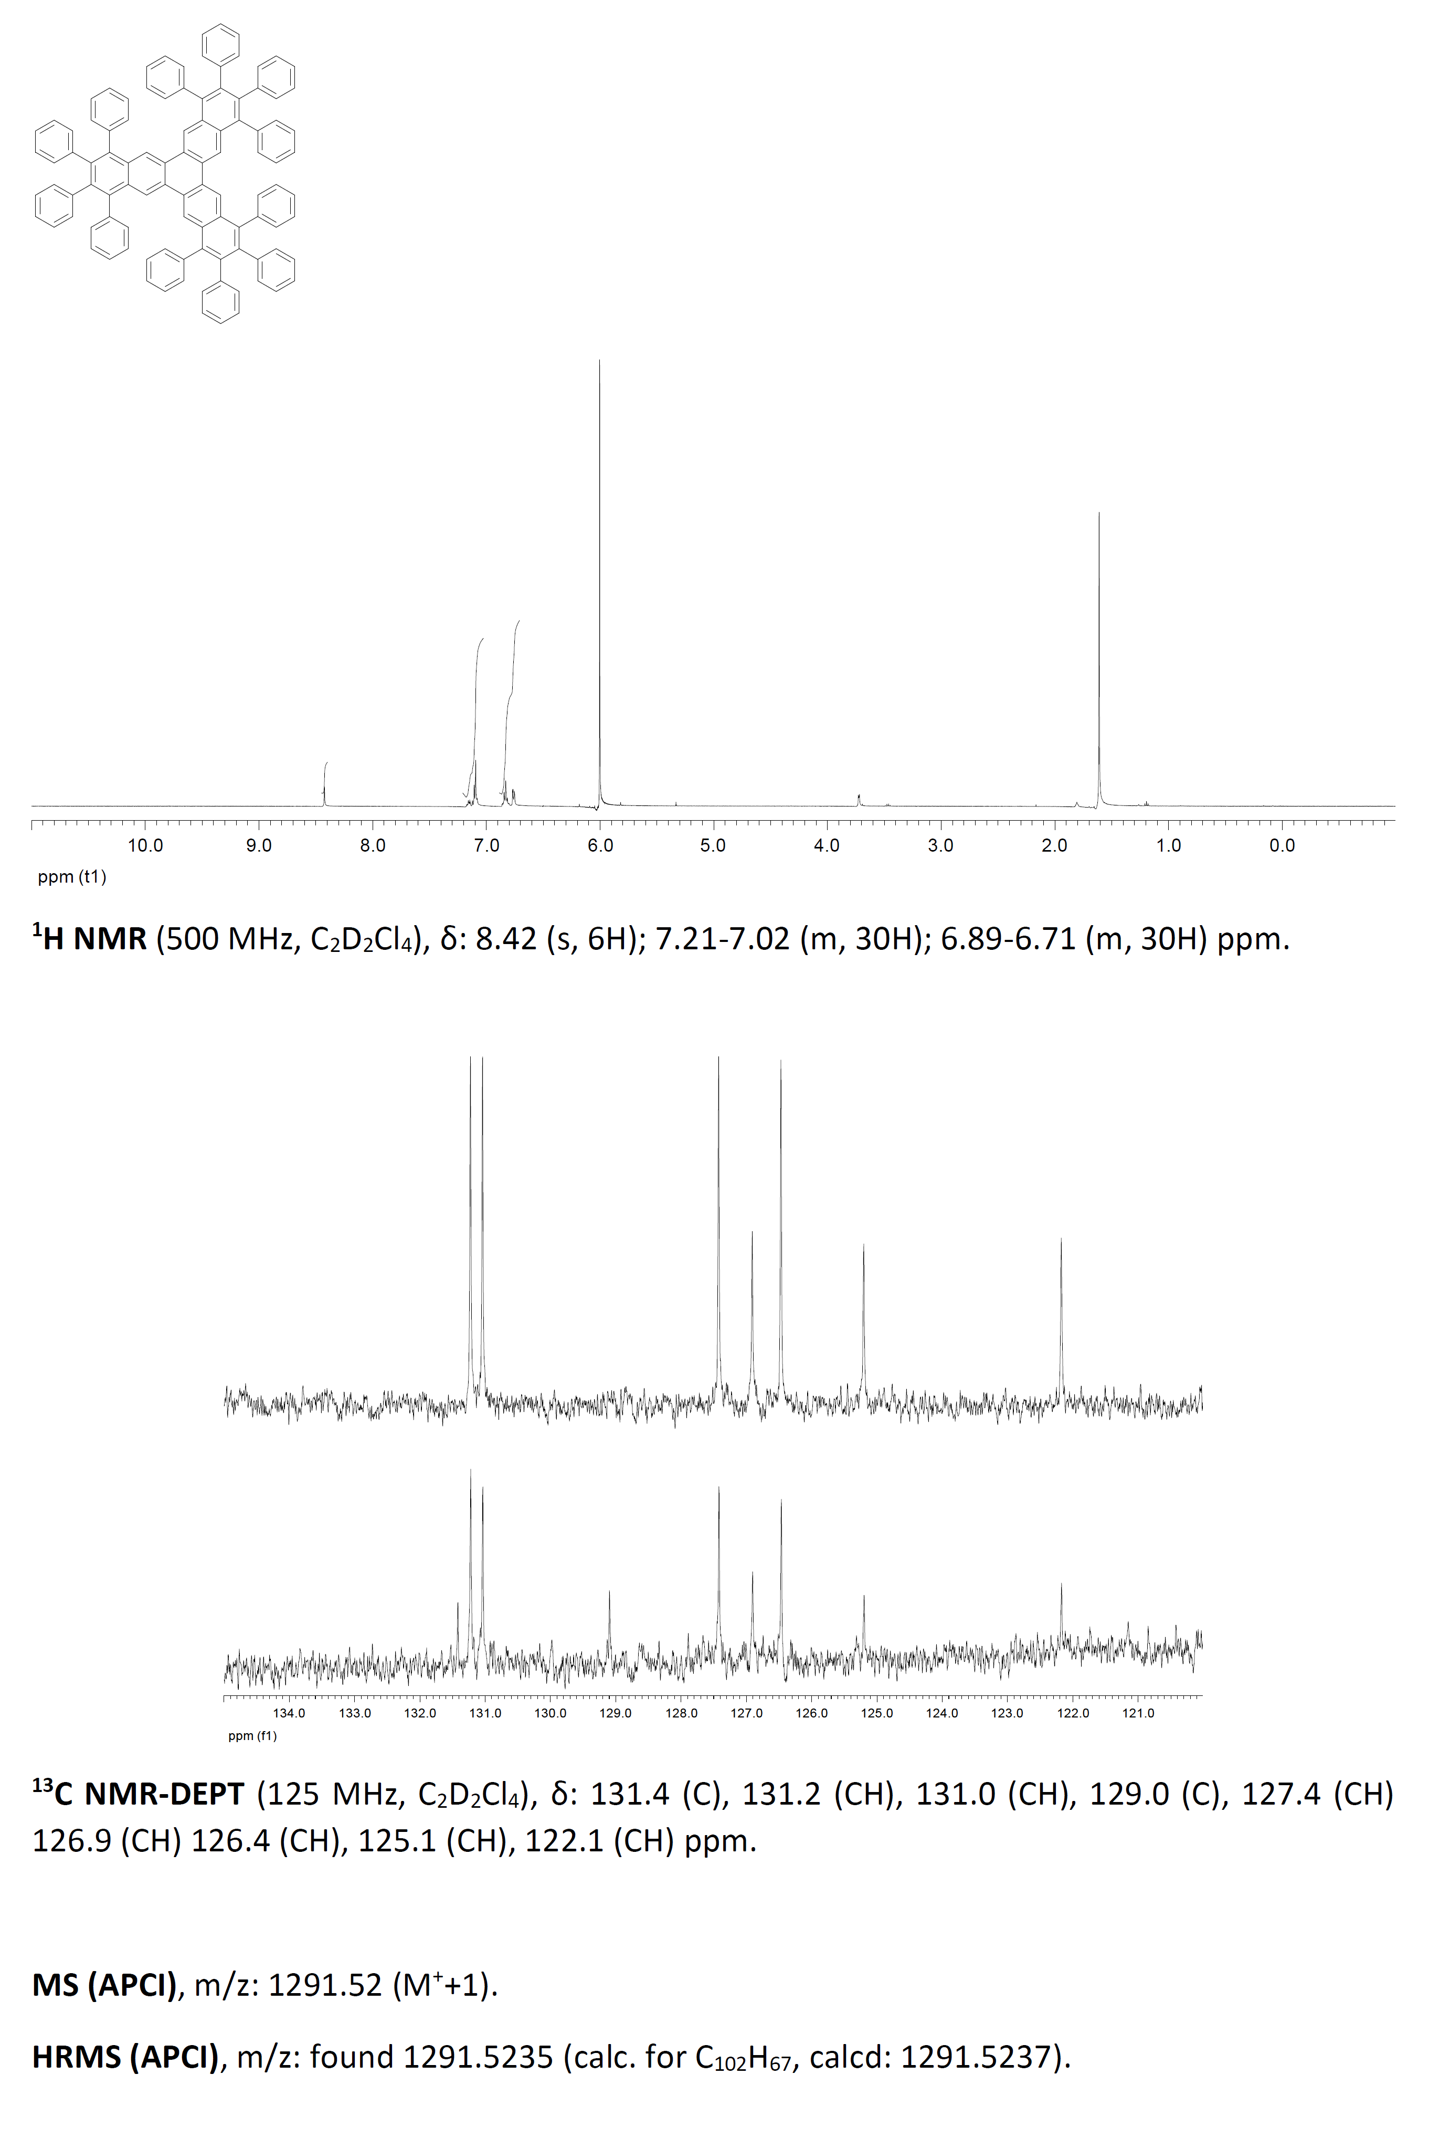
Figure S1. Spectrowscopic characterixzation of docecaphenyl[7]starphene.
Figures S2 and S3 show the reference measurements of the Schockley surface state on Au(111) and the appearance of CO molecules measured with metallic/functionalized tips, respectively.

Figure S2. Au(111) surface, (a) filled state high resolution STM image with clearly discernible herringbone pattern, the inset shows magnified image with mark fcc and hcp areas, -1.0 V, 100 pA, (b) typical single point STS data acquired with well-shaped metallic tip presenting the onset of the Au surface state at approximately -0.5 V.

Figure S3. nc-AFM tip functionalization with a CO molecule, (a) schematic drawing of the process, (b) typical STM image of Au(111) with CO molecules imaged with a CO functionalized tip, the CO molecule is visualized as a dark depression surrounded with a bright halo and a characteristic bright lobe in the center, (c) typical STM image of Au(111) with CO molecules imaged with a metallic tip, the CO molecule is visualized as a dark depression surrounded with a bright halo without the characteristic bright lobe in the center, exemplary CO molecules are highlighted by white dashed circles in (b,c), +0.5 V, 15 pA.

