Dr. Philippe EVON (Research Engineer)
ENSIACET – Laboratoire de Chimie Agro-industrielle (UMR 1010 INRA/INP-ENSIACET)
4, allée Emile MONSO – BP 44362
31030 Toulouse Cedex 4 / France
Tel: (33)(0)5 62 44 60 80 or (33)(0)6 88 09 40 41
e-Mail: Philippe.Evon@ensiacet.fr

Ref.:
Cover letter for the submission of a manuscript in the JoVE journal.

Toulouse,
24th December, 2020.

Dear Guest Editor,
I am submitting for a third review in the JoVE journal the paper untitled “The twin-screw extruder, a continuous and versatile tool for pre-treating lignocellulosic fibers and adding to them an exogenous binder to produce renewable fiberboards”.
This is a contribution to the Methods Collections “Pretreatment of lignocellulosic biomass: established technologies and recent developments” from Dr. Gabriel PAËS.
This contribution deals with the thermo-mechanical pre-treatment of lignocellulosic biomass through twin-screw extrusion before using it, with or without exogenous binder added, as a source of renewable fiberboards.
You will find in the attached files the revised version of the manuscript with the required answers to the Editorial comments. In the manuscript, corrections were made using the track change service of MS Word software, the parts on yellow background being those to be integrated in the script of the video.
The first author and corresponding author chosen for this contribution is still Dr. Philippe EVON, Research Engineer.
We hope that the manuscript quality will be satisfactory for publication in the JoVE journal.
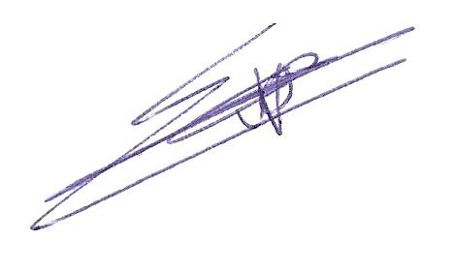
Best regards.
Dr. Philippe EVON.

