Response to reviewers;
We thank the reviewers for their review of our work and feel that the recommended changes have helped to improve the quality of the manuscript. We have addressed each of the reviewers’ concerns as follows and highlighted the corresponding changes within the manuscript in blue.
Editorial comments:
Changes to be made by the Author(s):
1. Please take this opportunity to thoroughly proofread the manuscript to ensure that there are no spelling or grammar issues. Please define all abbreviations at first use.
Response: We have reviewed the manuscript thoroughly to check spelling and grammar. Abbreviations have been defined at first use.
2. For in-text formatting, corresponding reference numbers should appear as numbered superscripts after the appropriate statement(s), but before punctuation.
Response: We have edited the reference numbers as requested.
3. JoVE cannot publish manuscripts containing commercial language. This includes trademark symbols (™), registered symbols (®), and company names before an instrument or reagent. Please remove all commercial language from your manuscript and use generic terms instead. All commercial products should be sufficiently referenced in the Table of Materials and Reagents.
For example: TrypLE; Eppendorf tube; Biorupter; Qiagen; NanoDrop; GE Healthcare Life Sciences cat#RPN203B; Whatman membrane; UV Stratalinker 2400 (Stratagene); Abcam cat#ab27156; Kerafast cat# ENH001; Sigma cat#03978; New England Biolabs cat# M0297; ThermoFisher Scientific cat# EN0541; Invitrogen cat# AM2290;
Response: Commercial language has been removed from the manuscript.
4. Please note that your protocol will be used to generate the script for the video and must contain everything that you would like shown in the video. Please add more details to your protocol steps. Please ensure you answer the “how” question, i.e., how is the step performed? Alternatively, add references to published material specifying how to perform the protocol action. Please add more specific details (e.g. button clicks for software actions, numerical values for settings, etc) to your protocol steps. There should be enough detail in each step to supplement the actions seen in the video so that viewers can easily replicate the protocol.
Response: Additional information has been added throughout the protocol to add details to the protocol steps. We have added additional information to specify how the procedures are performed in sections 1.1, 3.1, 4.1, 4.3, 4.4, 6.4, and 7.7. We have also added table 2 with instructions on troubleshooting.
5. 1.1: Which cells are you culturing? In what medium? Please move the information in the representative results to the beginning of the protocol.
Response: The cells and culture conditions have been added to section 1.1 of the protocol.
We added the following note to 1.1:
NOTE: The steps described below were used for the analysis of primary human skin fibroblasts, although an array of cell types can be assayed. Fibroblasts were grown in basal media containing 10% fetal bovine serum. Alternatively, cell lysis buffer (Table 1) can be added directly to the cell-culture after washing.
6. Please highlight up to 3 pages of the Protocol (including headings and spacing) that identifies the essential steps of the protocol for the video, i.e., the steps that should be visualized to tell the most cohesive story of the Protocol. Remember that non-highlighted Protocol steps will remain in the manuscript, and therefore will still be available to the reader.
Response: The essential steps of the protocol (sections 3 and 4) have been highlighted on pgs. 6 and 7.
7. As we are a methods journal, please add any modifications and troubleshooting of the technique to the Discussion.
Response: Additional troubleshooting information was added to the second paragraph of the discussion section on pg. 11. We have added table 2 with specific instructions on troubleshooting.
We have added the following information into the discussion on pg.11:
Some have reported concerns about the specificity of the S9.6 antibody. As with any reagent, there may be batch to batch variability with the S9.6 antibody. Our protocol includes RNase H, RNase T1 and RNase III to check signal specificity. In addition, we use synthetic oligonucleotides to ensure the specificity of each batch of S9.6 antibody.

8. Please ensure that the references appear as the following: [Lastname, F.I., LastName, F.I., LastName, F.I. Article Title. Source. Volume (Issue), FirstPage–LastPage (YEAR).] For more than 6 authors, list only the first author then et al. Wherever possible, please include volume and issue numbers for all references. Do not abbreviate journal names and capitalize the first letters of each word in the journal name.
Response: References were edited as requested.
9. Please submit each figure individually as a vector image file to ensure high resolution throughout production: (.psd, ai, .eps.). All tables should be uploaded separately to your Editorial Manager account in the form of an .xls or .xlsx file. Figure legends and table captions should be included in the figure and table legends section after the representative results. Please remove embedded figures and tables from the manuscript.
Response: Embedded figures and tables have been removed and submitted in the requested formats.
10. Please sort the Materials Table alphabetically by the name of the material.
Response: The materials table has been ordered alphabetically.

Reviewer #1:
Manuscript Summary:
This is very timely protocol to get a general idea for changes in genomic R loops and is simpler and far less costly than DRIP-seq or related assays. Indeed, it is very useful starting step to assess whether or not to proceed towards more elaborate (and expensive) NGS-based approaches. The authors are experts in this field and their protocol is detailed and well-written so it should be easily understandable even to newcomers. My only request would be the add a note in the Introduction about the size of RNA-DNA hybrids that the S9.6 Ab can detect. The control substrates used in this protocol are 36 nt but I imagine many R loops are much smaller such as those near TSSs that are frequently detected by DRIP assays. Since replication origins also harbor short RNA-DNA hybrids due to RNA priming of DNA polymerases, does the S9.6 Ab detect these too? It is important to know since many origins of replication are very close to or overlapping TSSs and so many of the TSS-associate R loops may be arising from replication origins. It is a general question unrelated to the protocol here, but it would be good to address it since I do not find this being addressed in the literature (although, admittedly, I may have missed this).
Response: We thank the reviewer for their comments, and we have now included a reference (33) in the introduction which reports the detection of RNA-DNA hybrids down to 8bp in length at the bottom of pg. 3.
The specific reference that has been added is:
Phillips, D.D., Garboczi, D.N., Singh, K., Hu, Z., Leppla, S.H., Leysath, C.E. The sub-nanomolar binding of DNA-RNA hybrids by the single chain Fv fragment of antibody S9.6. J Mol Recognit. 26 (8), 376-381 (2013).
Major Concerns:
None
Minor Concerns:
None

Reviewer #2:
Manuscript Summary:
This manuscript describes a method to detect mainly cytoplasmic RNA-DNA hybrids (also known as R-loops) by dot blot in mammalian cells. The manuscript includes a useful protocol to detect R-loops in genomic DNA.
Major Concerns:
This method has been previously described in Wahba et al., eLIfe 2013; Stork et al. eLife 2016 (for example). Hence it seems to me that it is somehow too minimal. It would have been nice to show how R-loops accumulate in cells treated with DNA damaging agents such as campthotecin for instance previously shown to induce R-loops accumulation (Hodroj et al., 2017 EMBO J) and also include some cell fractionation experiments to detect cytoplasmic and nuclear R-loops.
Response: We do not intend to say that we have developed a new method for assessing R-loops. Like many other papers in JOVE, this is a step-by-step guide, and in this case to quantify R-loops without special equipment. We receive requests from researchers and clinical laboratories for this protocol as an initial study of R-loops in their samples. This manuscript is intended for them, and by no means is a substitute of the many excellent papers on R-loops that show dot-blots.
Minor Concerns:
1. In the introduction, more recent reviews describing R-loops resolving enzymes must be included
Response: We have included two references (21 and 22) in the second paragraph of the introduction on pg. 3 which provides a recent review of R-loop resolving enzymes.
The specific references added are:
21. Hyjek, M., Figiel, M., Nowotny, M. RNases H: Structure and mechanism. DNA Repair. 84, 102672 (2019).
22. Pohl, T.J., Zakian, V.A. Pif1 family DNA helicases: A helpmate to RNase H? DNA Repair. 84, 102633 (2019).
2. In the method section, as it is described, it appears that the DNA is spotted on the membrane without the use of a dot-blot apparatus, why? It seems to me that using a dot-blot apparatus makes experiments more reproducible and allows less loss of material.
Response: We thank the reviewer for this recommendation. The blotting we have described works well without a dot-blot apparatus, however the use of such an apparatus can be considered if the reader would prefer. We have edited the manuscript section 3.3 which reads
3.3 Spot 2μL of each sample onto 2 membranes. One for the S9.6 antibody and the other for dsDNA. Alternatively, a dot-blot or slot-blot apparatus which allows the loading of samples with larger volumes can be used.
3. Further, the isolation of genomic DNA includes a sonication step. This procedure may disturb R-loops stability, and might reduce the amount of those R-loops that are not very abundant (as it is the case for nuclear versus cytoplasmic R-loops).
Response: We appreciate the concern the reviewer has regarding sonication. We have performed dot-blot assays with and without sonication, and have observed that there is no reduction in signal intensity with sonication. In samples with increased DNA viscosity, sonication allows for more even distribution of S9.6 and dsDNA signal intensity.
4. When using oligonucleotides it is important to assess their degree of annealing, and better purify the annealed nucleic acids to make sure that what it is spotted represent an homogenous population of nucleic acids species.
Response: We recognize that the purification and validation of a homogenous population of nucleic acids is important. To ensure high-quality oligonucleotide controls, we have provided a detailed protocol in section 6 using oligonucleotide sequences that have been previously reported to serve as appropriate positive and negative controls for S9.6 signal interpretation. We added a note under step 6.4 on pg. 8 for annealing efficiency of oligonucleotides to be checked by non-denaturing gel electrophoresis. It reads:
NOTE: Annealing efficiency should be checked by non-denaturing gel electrophoresis. Duplexes migrate more slowly than the unannealed oligonucleotides (Table 2).

5. Details of how quantification of R-loops shown in Figure 2 are missing and/or unclear. Authors state that these are representative results, but no errors bars are displayed on the graphic.
Response: We thank the reviewer for this request. We have clarified in figure legend 2 on pg. 10 that the steps needed for signal quantification are specified in section 7. It reads:
S9.6 signal was divided by dsDNA signal intensity, then normalized to the mock sample following the steps outlined in section 7.
We have also added information in step 7.7 on pg. 9 to discuss how variation within a sample can be assessed by loading triplicates of the sample for S9.6 and dsDNA analysis. It reads:
7.7 The S9.6 signal intensity for each sample should be divided by the measurement of dsDNA to obtain the S9.6/dsDNA signal ratio. The results should be verified by repeating the experiments (we suggest at least triplicates for both S9.6 and dsDNA signal acquisition). Standard error of the mean can be calculated from the S9.6/dsDNA signal ratios.
The graph in Figure 2 is intended to show the quantitation of the S9.6 signals and loading controls shown in Figure 1, and not averages from replicates therefore no error bars were shown.
Reviewer #3:
Manuscript Summary:
This work provides a detailed easy method to quantify, a three-stranded nucleic acid structure R-loop. The authors have attempted to address a long-lasting challenge in the quantitation of R-loops based on the S9.6 monoclonal antibody. They combined dot-blots with the S9.6 antibody to quantify R-lo. They examined sensitivity and specificity of this dot blot assay with various RNA structure sensitive enzymes RNase H, RNase T1, and RNase III. They made this assay reproducible and easy to perform. This assay will be applied in research and clinical settings to quantify R-loops abundance. I recommend its publication.
Response: We thank the reviewer for their support of our manuscript.

Reviewer #4:
Manuscript Summary:
In this manuscript, Ramirez and colleagues propose a method to quantify RNA:DNA hybrids by dot blotting using the well-characterized monoclonal antibody S9.6. This protocol is not novel, but to my knowledge, there is currently no published method on the subject. It should therefore be very useful to an ever-growing community of scientists interested in these structures. Indeed, R-loops have attracted a lot of attention during the past decade. Although dot blots are frequently used to measure R-loop levels in a population of cells, people also often use immunofluorescence (IF), which generates images with a low signal-to-noise ratio and are often very difficult to quantify in a reliable manner. This protocol could therefore be very important for the community by promoting the use of dot blot instead of IF. Overall, this protocol is straightforward and all the major steps are clearly described. With the addition of video, it could become a reference in the field. However, several important issues need to be addressed to improve the manuscript.
Major Concerns:
1. Several general statements on R-loops in the abstract and the introduction are incorrect or misleading. For instance, the sentence "…recent findings of fewer R-loops in diseased cells made it clear that R-loops have functional roles in a variety of human cells (line 33)" is confusing. A large body of evidence indicates that an excess of R-loops correlates with diseases, but I am not aware of any disease caused by a deficit in R-loops. Unless if the authors can refer to specific references, this statement should be removed. Along the same line, the authors indicate that the physiological roles of R-loops were discovered after their pathological consequences (lines 64-68), which is incorrect. They also refer to different types of R-loops (line 49) but it is unclear to which types they refer to. It would be more useful to mention RNA:DNA hybrids that do not necessarily correspond to R-loops and that could also be detected by the S9.6 antibody. Finally, they incorrectly quote an article from the Chedin lab by stating that "5% or more of RNA can be found in R-loops". What the paper shows is that R-loops may cover up to 5% of single-copy loci in mammalian genomes, which is quite different. I would recommend that a senior author of the manuscript carefully double checks the introduction section and the references before publication.
Response: We thank the reviewer for the opportunity to clarify why discussion of R-loop deficits and disease were included in the manuscript.
In the referenced manuscript Grunseich et al., Mol Cell 2018, the authors show that ALS4 patients with mutation in senataxin have fewer R-loops. This reduction in R-loops was measured by dot-blot (A) and S9.6 immunofluorescence (B) in patient and control fibroblast cells and S9.6 immunohistochemistry staining in patient and control spinal cord tissues (C).
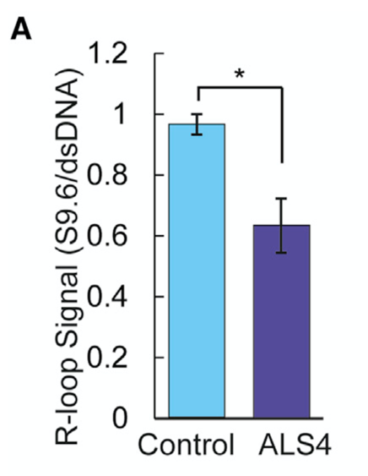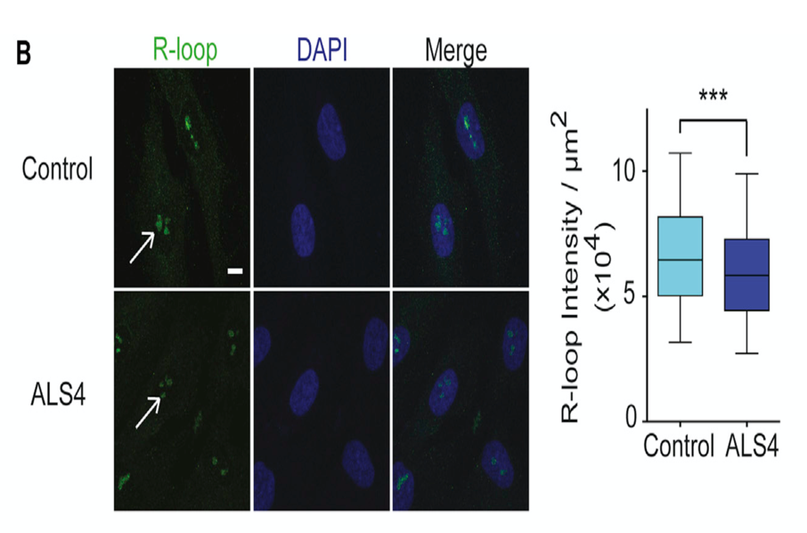
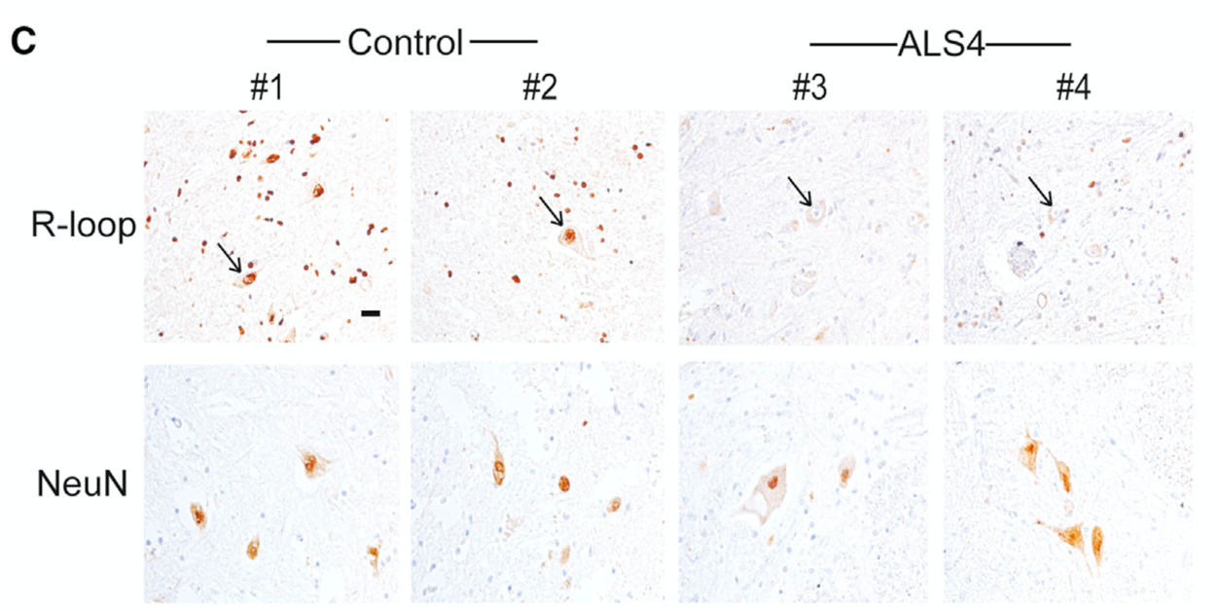
We have edited the second paragraph of the introduction on pg.3 so that the normal physiologic functions of R-loops are introduced first. It now reads:
R-loops play a regulatory role. They regulate gene expression by affecting transcription at promoters^{10,11}, mediating class-switch recombination^{12,} and facilitating CRISPR-based genome editing^{13,14,15}.
The beginning of the introduction on pg.2 was edited to clarify that R-loop formation occurs for many different reasons. It now reads:
R-loop forms when RNA invades a double-stranded DNA to generate an RNA-DNA hybrid and displaces the other DNA-strand. R-loops are found in different stages of the lifecycle of RNA.
We have corrected the referenced information in the Sanz et al. manuscript to indicate that R-loops can be found in 3-5% of the human genome in the first paragraph of the introduction on pgs. 2-3. It now reads:
Given the many opportunities for their formation, R-loops are not rare, and can be found in 3-5% of the human genome⁶, depending on the cell’s transcription status.
2. The authors use sonication to reduce the viscosity of genomic DNA. Since it has been reported by different labs that sonication could destabilize at least a subset of R-loops, it would be important to compare the intensity of the S9.6 signal before and after sonication. If needed, DNA could be fragmented with a cocktail of restriction enzymes, which is the procedure most commonly used in DRIP-seq protocols.
Response: We appreciate the concern regarding sonication. We have performed dot-blot assays with and without sonication, and have observed that there is no reduction in signal intensity. In samples with increased DNA viscosity, sonication allows for more even distribution of S9.6 and dsDNA signal intensity.
3. Line 73: It would be worth mentioning that the earliest versions of DRIP-seq protocols are not quantitative. Most genome-wide approaches provide therefore qualitative and positional information rather than quantitative results, which further justifies the use of dot blot. The authors should also mention IF in this paragraph and recommend the use of dot blot instead of IF because of the many issues with IF mentioned above.
Response: We have added additional language to the third paragraph of the introduction on pg.3 to indicate that early versions of the DRIP-seq protocols did not achieve sequence coverage to allow precise quantification. We have also mentioned the option of immunofluorescence, and the limitations with this technique in this paragraph. It now reads:
Early versions of these sequencing-based methods did not achieve adequate sequence coverage to allow precise quantitation but rapid improvement in sequencing technologies now allows locus-by-locus R-loop analysis. Immunofluorescence techniques have also been used to quantify and localize R-loops^{10,17}. These methods are comprehensive, but they are not practical in many clinical settings or as initial assessments since they require expensive equipment and specialized analysis.
4. Line 79: Many people use slot blot as an alternative to dot blot. The difference between slot blot and dot blot should be discussed.
Response: We thank the reviewer for this comment. The blotting we have described works well without a dot-blot apparatus, however the use of such an apparatus can be considered depending on the preference of the reader. We have edited the manuscript section 3.3 on pg.6 to include mention of a dot-blot apparatus. It now reads:
3.3 Spot 2μL of each sample onto 2 membranes. One for the S9.6 antibody and the other for dsDNA. Alternatively, a dot-blot or slot-blot apparatus which allows the loading of samples with larger volumes can be used.
5. RNase H degrades RNA, rather than cleave it.
Response: We have included a reference from Nowotny et al., Cell 2005 which reports on the cleavage of RNA strands in RNA/DNA hybrids. We recognize that RNase H activity on RNA-DNA hybrids involves both its cleavage and subsequent degradation. We have edited the fourth paragraph of the introduction on pg. 3 to indicate that the enzyme activity involves both cleavage and degradation. It now reads:
Our protocol uses the S9.6 antibody²⁷ to identify RNA-DNA hybrids in R-loops and incorporates RNase H, an endoribonuclease that cleaves and therefore leads to the degradation of the RNA in an RNA-DNA hybrid^{20,28}, to ensure that the detected signals are those of hybrids.
6. The concentration of S9.6 antibody should be indicated, not only the dilution.
Response: Thank you. We have provided the concentration in section 4.2 of the protocol on pg.7. It now reads:
Add the S9.6 antibody to the second membrane (1:1000 [1μg/mL] dilution).
7. The authors treated DNA samples with various RNases at 37°C for only 15 minutes, the kinetic of enzyme digestion can be included to determine whether longer period of RNase treatment might alter the abundance of RNA:DNA hybrids.
Response: The RNases used have been demonstrated to have substrate specificity in previous studies (Wang IX et al., Genome Research 28:1405-1414, 2018, and Hartono et al., J Mol Biol 430:272-284, 2017). We are attaching data below showing stability of S9.6 and dsDNA signals following a time course of RNaseIII treatment.
8. The authors used lysis buffer and low-speed centrifugation to separate nuclear and cytoplasmic fraction before isolating genomic DNA. To exclude a possible contamination of genomic DNA with R-loops from mitochondrial DNA origin, the authors could quantify the relative amount of mitochondrial DNA in total DNA using qPCR.
Response: We thank the reviewer for this comment. We have added language concerning signal specificity to section 1.9 of the protocol on pg. 5. It reads:
NOTE: Fractionation of the nuclear and cytoplasmic compartments of the cells ensures signal specificity. The quality of nuclear and cytoplasmic separation can be evaluated before proceeding (Table 2).

We have provided information in table 2 which provides a method for verifying cell fractionation. This recommendation includes a suggestion to assess for mitochondira contamination in the nuclear fraction by qPCR. It reads:
The quality of nuclear and cytoplasmic separation can be evaluated by adding standard protease inhibitor cocktails to the cell and nuclear lysis buffers (Table 1). The cytoplasmic and nuclear fractions can be evaluated by western blotting analysis to confirm adequate restriction of labeling with cytoplasmic markers (for example, GAPDH or HSP90) in cytoplasmic fractions and labeling with nuclear markers (for example, HDAC1 or Histone H3) in nuclear fractions. The contribution of mitochondrial contamination in the nuclear fraction can be evaluated by qPCR analysis with probes specific for mitochondrial DNA.

9. The use of methylene blue to quantify total DNA is not very convincing. Considering the importance of normalization, I would rather omit this part and only recommend the use of anti-DNA antibodies.
Response: We agree and have removed the methylene blue quantification from the manuscript.
10. The authors should provide additional guidelines on how to ensure that the signal measured is in the linear range of the assay and how many biological replicates should be performed to generate reliable results.
Response: Additional guidance on sample preparation to ensure a linear range of detection has been added to section 3.1 on pg. 6 of the manuscript. Discussion of biological replicates has also been added to this section. It reads:
3.1 Prepare dilutions of nucleic acids to desired concentrations in elution buffer (ie. 50ng/μL, 25ng/μL, or 12.5ng/μL). These samples with a range of concentrations (200, 100, 50, 25, 12.5ng) ensure that there will be signals within the linear range.

Note: Be sure to prepare enough sample for technical and biological replicates, and for the various RNase treatments, see Step 5.

In compliance with data protection regulations, you may request that we remove your personal registration details at any time. (Remove my information/details). Please contact the publication office if you have any questions.

