Dear reviewers,

thank you for taking the time to critically review our work. Your recommendations and impulses are highly appreciated.

Answers to reviewer 1:
1) We elaborated our success rates in the results section. However, extensive detailed success rates are beyond the scope of this paper and have been and will be published elsewhere. Since our protocols are subjected to constant improvement, a definite “overall success rate” cannot be determined clearly. To give the reader an idea of our PDX establishment rates, we added the current numbers of available PDX models. Even this is a little tricky since depending from the qualitative and quantitative measures chosen to call a model “established” or not yet established these numbers would of course vary. An extensive analysis of colorectal PDX establishment, QC data etc. is currently in preparation to be published soon by Matschos et al.
2) We use the biobank for our own preclinical studies but are also willing to cooperate with university and industrial partners. So far, this happened either by exchanging PDX specimen with other groups or by even conducting in vivo experiments as “commissioned work”. A growing number of published manuscripts can be found in Pubmed taking advantage of the HROC collection. However, in order not to overstretch the amount of self-citations, we used only selected work to be cited in the current manuscript.

Answers to reviewer 2:
We aimed to incorporate most of your suggestions for improvements. However, some demands go beyond the scope of this manuscript and would blow up the already extensive protocol and discussion, respectively. Of course, we comprehensively explain which points have been addressed in which ways on a point-to-point basis:
Major concerns:
Clear standard terminology and order:
we checked the complete manuscript for the correct use of terminology taking especially the suggestions of this reviewer into account. Also the correct and logic order of experimental steps has been re-checked.
Media composition and cell culture coating:
we kept these points general on purpose. Over the years, we tried more than 30 different media, even >50, depending on how the addition of certain supplements is counted. This is very similar with the use of coated cell culture plastic. Over the years, we used a variety of different pre-coated plates from different suppliers. Moreover, we tested different in-house coatings. For both points, we would like to refer readers and also this reviewer to previous publications of our group, which have been cited properly.
The statistical comparison of various media compositions on a side-by-side basis is subject of a thesis, data are almost complete and we hope that we can published that also soon. Since some media are provided by industrial cooperation partners, naming specific media without prior statistical analysis as well as approval by the company, could pose a conflict of interest. However, we encourage everyone to test different media for their specific purpose, since there are definitely considerable deviations concerning the “ideal media” for different tumor entities; maybe even for sub-entities.
We always use DMEM/F12 with 10 % FCS as standard medium when a cell line is finally established.
Description of further cell culturing:
A detailed description of the 2D cell line generation procedure is - with all necessary respect to the understandable wish of this reviewer for an easy description to be followed by other labs – by far too complex to be added to this more general procedure of the complete integrated biobanking procedure. It took years to develop and train the cell culture skills to reach the current level of establishment success rate. For some cell lines it took over a year before we could consider it “established”. It is, to be honest, for most of the cases extremely individual. However, we discussed the possibility to describe our 2D cell line establishment procedure by another video publication and it is likely that we will go for this in the near future.
LIMS system used and clinical data:
As wished, we indicated the use of Freezerworks® in our group in 9.4. In our hands this is a very reliable system; it might be worth noting that we use individual N2-resistent barcode stickers for all samples stored. However, since there are plenty of professional solutions available now for biobanking and even more individual solutions how to deal with the samples created in a given lab, this is in our opinion again out of the focus of the current manuscript. Concerning clinical data collected, we have the following statement in the discussion: “… the biobank should be linked to a clinical database comprising patients characteristics (general information, survival, relapse free survival, therapy, secondary neoplasia etc.). Due to legal regulations of privacy protection and lack of such an anonymized data base, our clinical data set is regularly administrated and updated manually by the cooperating physicians.” And would like to again refer to our previous publication by Mullins et al., 2019.
Lack of proof:
In principle, we totally agree with this reviewer that numbers demonstrating the success rates are mandatory. Thus, we included our current total success numbers into the video, the discussion as well as the results part of the manuscript. However, final success rates cannot as easily be delivered since this was, again, not the focus of the present, but even several other manuscripts which are in preparation and will be published soon. Still, the numbers are sufficient to demonstrate the overall success of our strategy presented here.
Molecular validation/comparison to original tumor:
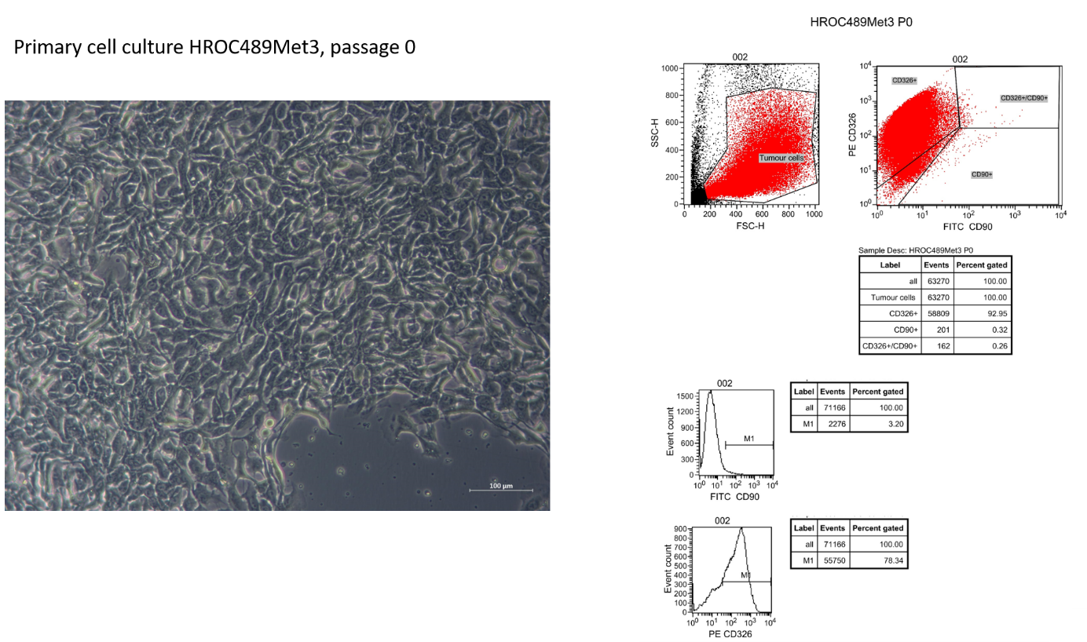
Several of the suggestions have been followed as outlined below. All cell lines are routinely characterized by FACS analysis. We attached a recent FACS analysis of a newly established CRC line as an example. Due to the fact that the overall length of the manuscript is a limiting factor, plus several previous publications exactly describing the general procedure, this information is given just for review purposes.

Concordance between patient and cell line is confirmed by STR-analysis using germ-line, tumor, cell-lines as well as PDX derived genomic DNA – this has also been described in detail in our previous publications. Still, we included one exemplary analysis into the results part.
Concerning the quality of PDX models, we not only confirm PDX- donor concordance by STR analysis but regularly subject FFPE samples of PDX tumors to a critical evaluation by an experienced clinical pathologist. This cooperation highlighted the high morphological congruency (see Linnebacher et al. 2010; PMID: 20615215), but also elucidated the relevant differences between donor tumor and corresponding PDX (Prall et al. 2017; PMID: 29040282). An extended analysis of the mutational profile and molecular phenotypes of the PDX collection is, as mentioned above, in preparation to be published soon by Matschos et al. and would clearly be beyond the scope of the current manuscript.

Minor concerns:
Title:
We agree with this reviewer that beside living cells, also serum and snap-frozen tissues are collected according to our SOPs and that thus, the biobank is of course not exclusively focused on “living” samples. However, we still would like to stick to our – admittedly eye-catching – title since it shall for the most part highlight the difference to “classical” biobanks.
QC of tumor pieces collected:
Again, we totally agree that in an ideal world, the pieces used for biobanking should directly be QC-checked. This is on the other hand obviously not possible. QC measures in place are as follows: a comparison of PDX morphology with primary tumor morphology (results are, as repeatedly mentioned, in preparation), in recent time there is also the possibility to compare whole exome sequencing mutation data between original tumor and cell lines as well as PDX. The latter data are so far promising, but the data collection has to continue for some more months or even years before we consider putting them together for publication.
Section 5.1:
This has been rephrased.
Discussion:
When considering the length of the discussion, we would politely refuse adding more discussion points. The biobanking procedures mentioned by this reviewer are indeed worth being compared to our strategy. However, in our opinion this shall best be done by potential readers.

Answers to reviewer 3:
Since we implemented strict SOPs for biobanking, the “warm ischemia time” rarely exceeds half an hour. If direct transport into the pathology lab is not possible, we store the whole specimen in tissue storage solution (Miltenyibiotec, order-number 130-100-008) overnight at 4 ° C. The transport time between the department of pathology and our lab is 10 minutes, but can be neglected, since the tissue is well cooled. The processing time depends on the sample size, and lies between 15 and 30 minutes. Most important is to keep the tissue well hydrated, especially during the tissue processing.

