Submission ID #: 62028

Scriptwriter Name: Bridget Colvin
Project Page Link: https://www.jove.com/account/file-uploader?src=18918588

Title: Fluorescent Leakage Assay to Investigate Membrane Destabilization by Cell-Penetrating Peptide

Authors and Affiliations: Karidia Konate, Quentin Seisel, Eric Vivès, Prisca Boisguérin, Sébastien Deshayes

PHYMEDEXP, INSERM U1046, CNRS UMR 9214, University of Montpellier

Corresponding Author:

Sébastien Deshayes

sebastien.deshayes@inserm.fr

Co-Authors:
karidia.konate@inserm.fr
quentin.seisel@live.fr
eric.vives@umontpellier.fr
prisca.boisguerin@inserm.fr

Author Questionnaire

1. Microscopy: Does your protocol require the use of a dissecting or stereomicroscope for performing a complex dissection, microinjection technique, or similar? N

2. Software: Does the part of your protocol being filmed demonstrate software usage? Y
Videographer: Film the screen for all SCREEN shots
3. Interview statements: Considering the Covid-19-imposed mask-wearing and social distancing recommendations, which interview statement filming option is the most appropriate for your group? Please select one.

☒ Interviewees wear masks until the videographer steps away (≥6 ft/2 m) and begins filming. The interviewee then removes the mask for line delivery only. When the shot is acquired, the interviewee puts the mask back on. Statements can be filmed outside if weather permits.

4. Filming location: Will the filming need to take place in multiple locations (greater than walking distance)? N

Protocol Length
Number of Shots: 32

Introduction

- Introductory Interview Statements

REQUIRED:
  - Sébastien Deshayes: This fluorescence leakage assay is a simple method for addressing membrane destabilization by biomolecules. Using liposome-encapsulated fluorescent dyes, it can be used to compare different membrane-interacting peptides [1].

    - INTERVIEW: Named talent says the statement above in an interview-style shot, looking slightly off-camera

REQUIRED:

  - Prisca Boisguerin: This method is especially useful to investigate membrane destabilization by cell-penetrating peptides in order to understand their mechanisms of cellular internalization and to assess their involvement in direct membrane translocation [1].

    - INTERVIEW: Named talent says the statement above in an interview-style shot, looking slightly off-camera

REQUIRED:

  - Karidia Konate: Compared to biological membranes, liposomes enable control of the phospholipid composition in order to mimic different lipid bilayers, such as plasma, endosomal, or mitochondrial membranes [1].

    - INTERVIEW: Named talent says the statement above in an interview-style shot, looking slightly off-camera

Protocol
- Large Unilamellar Vesicle (LUV) Preparation
  - To prepare LUVs (L-U-V’s) for their use as cell membrane mimics for a fluorescence leakage assay, use a Hamilton glass syringe to mix phosphatidylcholine, sphingomyelin, and cholesterol at a 4:4:2 molar ratio [1-TXT].
    - WIDE: Talent mixing materials, with material containers visible in frame Videographer: Important step TEXT: See text for all solution preparation details

  - Use a rotary evaporator to evaporate the methanol-chloroform under vacuum [1] for 46-50 minutes at 60 degrees Celsius until a dried lipid film has formed [2].

    - Solution being evaporated
    - Shot of dried lipid film

  - To reconstitute the multilamellar vesicles, resuspend the dried lipid film with 1 milliliter of lipid hydration solution [1] and vortex thoroughly until the dried lipid film has dissolved [2].

    - Talent adding solution to film, with solution container visible in frame
    - Talent vortexing solution TEXT: Small lipid aggregates will negative impact LUV generation

  - After confirming that all of the lipid has been incorporated and that no film is left on the sides of the flask [1], freeze and thaw the vesicles five times for 30 seconds in liquid nitrogen and 2 minutes in a 30-degree water bath per cycle [2].

    - Talent checking flask
    - Talent transferring flask from LN2 to water bath or similar representative shot

  - To prepare lipid extruder, insert two HEPES (heeps) buffer treated filter supports into each PTFE (P-T-F-E) extruder piece within the metal extruder canister [1] and place a 0.1-micron pore HEPES humidified polycarbonate membrane onto the top of one filter support [2].

    - Talent adding filter support(s) to extruder piece(s)
    - Talent placing membrane onto filter support

  - Screw the two metal extruder canisters together [1] and place the assembled extruder into the holder [2].

    - Talent screwing canisters together
    - Talent placing extruder into holder

  - To check the extruder for leaks or other problems, introduce an empty 1-milliliter syringe into the appropriate hole at one extremity of the PTFE extruder piece [1] and another 1-millilier syringe loaded with 1 milliliter of HEPES buffer at the other extremity [2].

    - Talent connecting syringe to hole
    - Talent flushing buffer into extruder

  - Then deliver the multilamellar vesicle sample to the extruder in the same manner and push the sample from one syringe to the other through the polycarbonate membrane at least 21 times to obtain uniform LUVs [1].

    - Talent connecting syringe and Talent flushing syringe Videographer: Important step

- LUV Purification

  - To purify the LUVs, add the freshly extruded LUVs onto a liquid chromatography column [1] and let the vesicles enter the cross-linked dextran gel [2].

    - WIDE: Talent adding LUV to column Videographer: Important step
    - LUV entering column Videographer/Video Editor: can skip if no visual able to be obtained

  - Continuously add HEPES buffer 2 to the column [1] and begin eluting approximately 2 milliliters of HEPES buffer 2. The free yellow ANTS (A-N-T-S) and DPX (D-P-X) solution will migrate more slowly than the liposomes [2-TXT]. After 1 milliliter has been eluted, start collecting the purified LUVs in 1.5-milliliter tubes [3].

    - Talent adding buffer to column
    - Solution being eluted Video Editor: please emphasize yellow solution when mentioned if possible/visible TEXT: ANTS: 8-aminonaphthalene-1, 3, 6-trisulfonic acid; DPX: p-xylene-bispyridinium bromide
    - Eluate being collected

  - When the drops of eluate become opalescent, change the tube to recover the LUV-containing fraction [1]. When the drops are no longer opalescent, elute another 500 microliters in a separate fraction before stopping the elution [2].

    - LAB MEDIA: Shot of opalescent droplets Videographer: Film the screen here
    - Drops becoming non-opalescent/Tube being switched Videographer: Difficult step. NOTE: Use updated pptx for all the screenshots. Updated pptx uploaded on project page (62028_Deshayes_Screenshot.pptx).

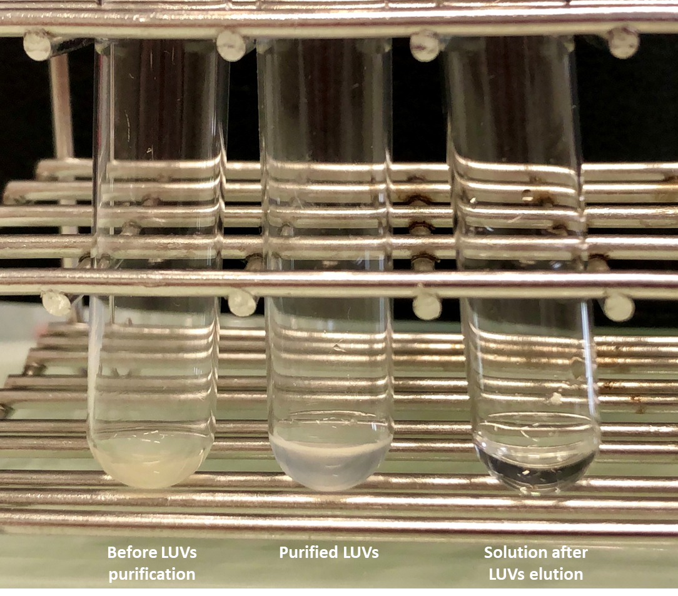

- LUV Size and Homogeneity Characterization

  - To determine the LUV size and polydispersity index, indicate the viscosity of the solvent [1] and the polystyrene semi-micro cuvette to be used in the experiment in the dynamic light scattering system [2] and add 500 microliters of the LUV solution to the cuvette [3].

    - WIDE: Talent indicating viscosity, with monitor visible in frame
    - LAB MEDIA: JOVE_DLS_ScreenCapture.pptx, slide 1. Video Editor: Emphasize the viscosity entry. NOTE: Use updated pptx for all the screenshots. Updated pptx uploaded on project page (62028_Deshayes_Screenshot.pptx).

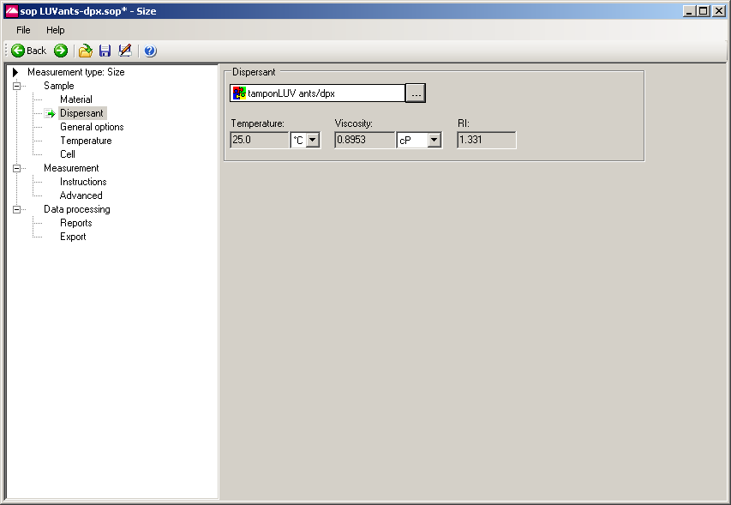

    - Talent loading solution into cuvette

  - Then load the cuvette onto the instrument [1] and measure the size distribution in terms of the mean size of the particle distribution and the homogeneity [2].

    - Talent loading cuvette onto instrument Videographer: Important step
    - LAB MEDIA: JOVE_DLS_ScreenCapture.pptx, slide 2. NOTE: Use updated pptx for all the screenshots. Updated pptx uploaded on project page (62028_Deshayes_Screenshot.pptx).

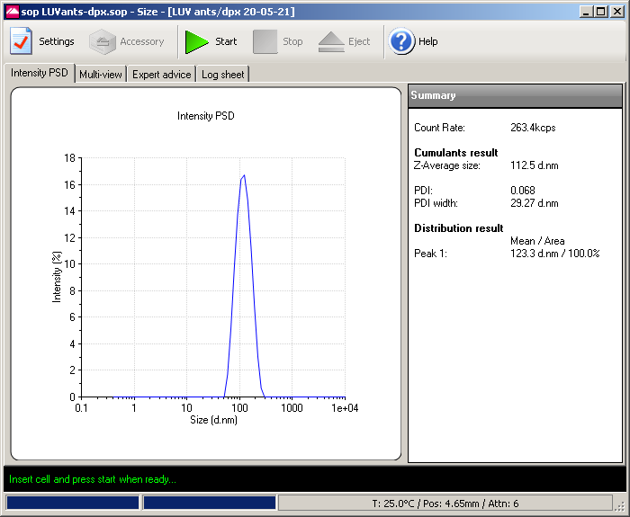

- Fluorescence Leakage Assay

  - To measure the fluorescence leakage, dilute the LUVs in 1 milliliter of HEPES buffer 2 in a quartz fluorescence cuvette to a 100-micromolar final concentration [1] and add a magnetic stirrer to facilitate homogenization of the solution during the experiment [2].

    - WIDE: Talent adding LUV to buffer, with buffer container visible in frame
    - Talent adding stirrer and put the cuvette in the fluorimeter

  - Measure the LUVs alone during the first 100 seconds to assess the background fluorescence [1] before measuring the leakage as an increase in fluorescence intensity upon the addition of aliquots of peptide solution over the next 900 seconds [2-TXT].

    - SCREEN: Leakage being measured in LUV alone during first 100 seconds Videographer: Film the screen here

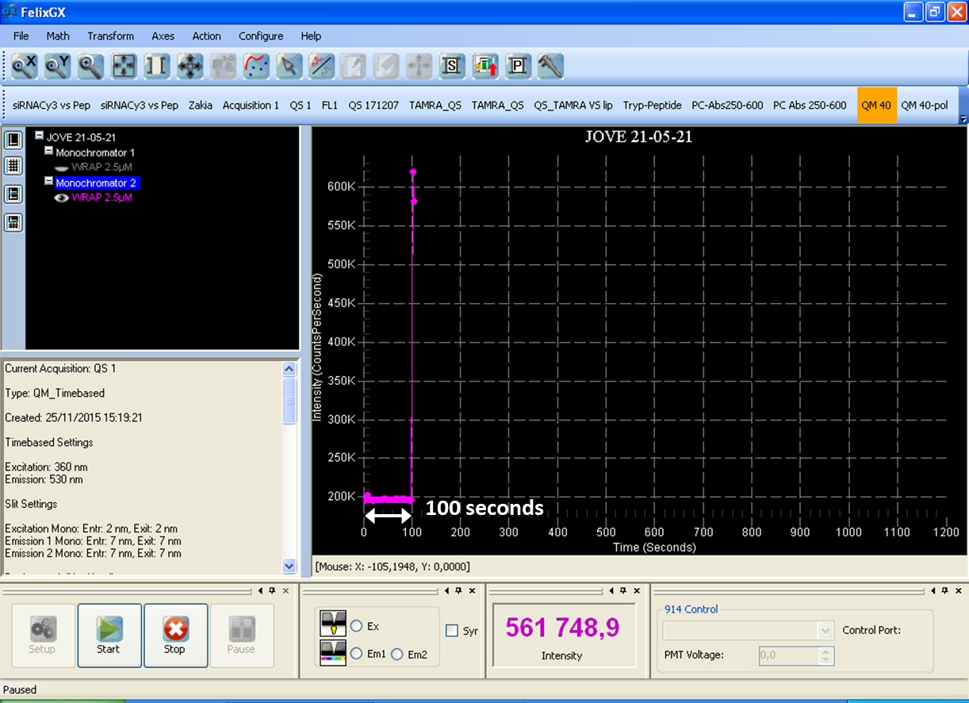

    - SCREEN: Leakage being measured after peptide addition TEXT: Repeat measurement for each concentration from 0.1-2.5 micromolar Videographer: Film the screen here

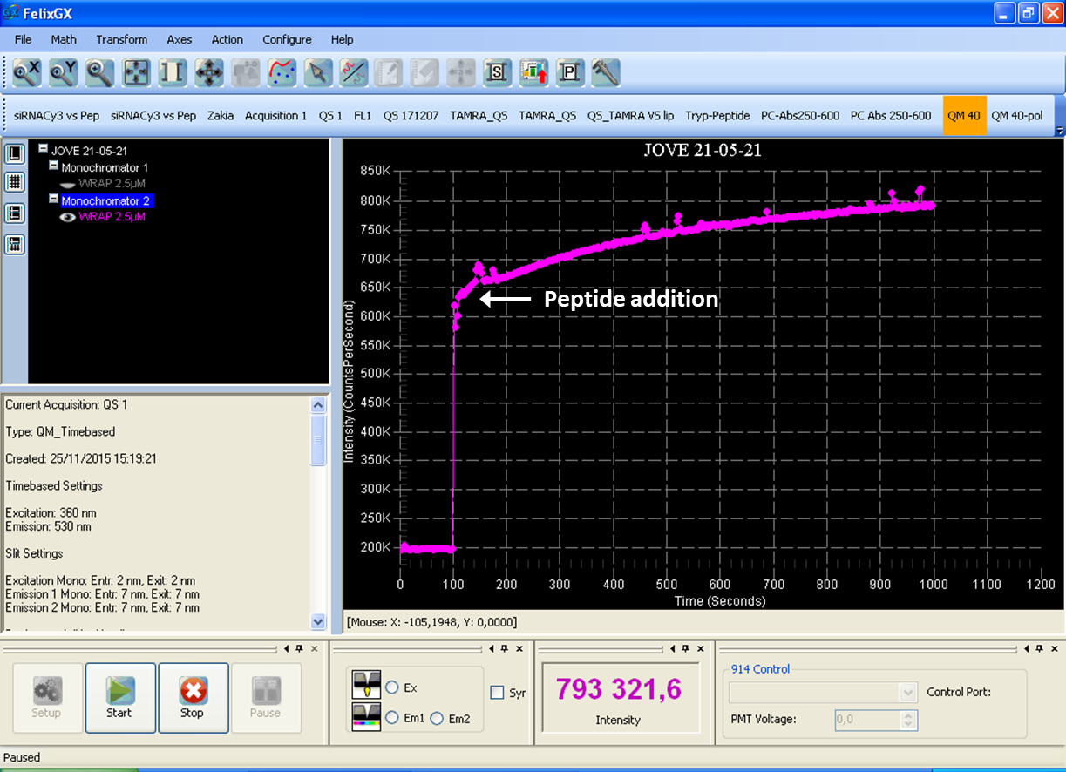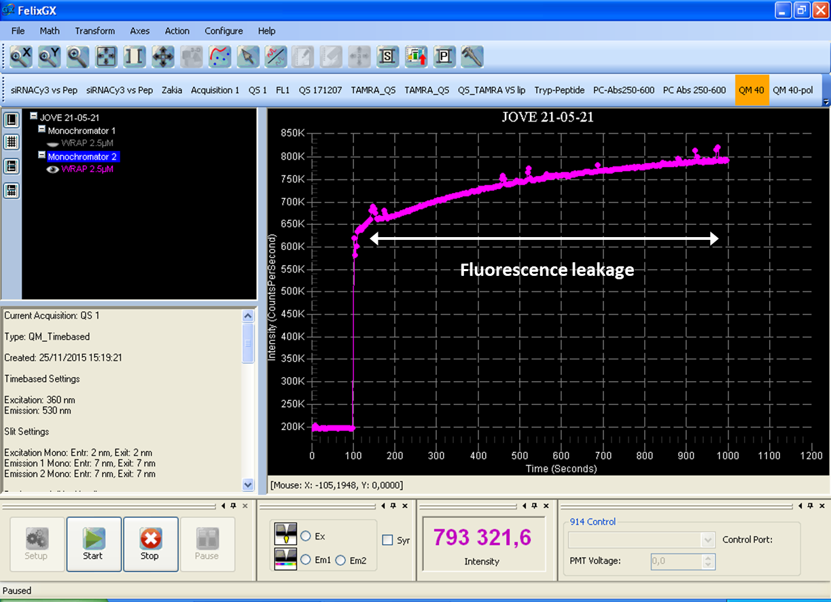

  - To measure 100% fluorescence leakage as a positive control, add 1 microliter of Triton X-100 to the LUVs to solubilize the vesicles [1], resulting in a complete unquenching of the probe during the last 100 seconds of the analysis [2]. Then use the formula to calculate the leakage percentage at each time point [3-TXT].

    - Talent adding Triton X-100, with Triton X-100 container visible in frame Videographer: Important step
    - SCREEN: Leakage being measured after Triton X-100 addition Videographer: Film the screen here

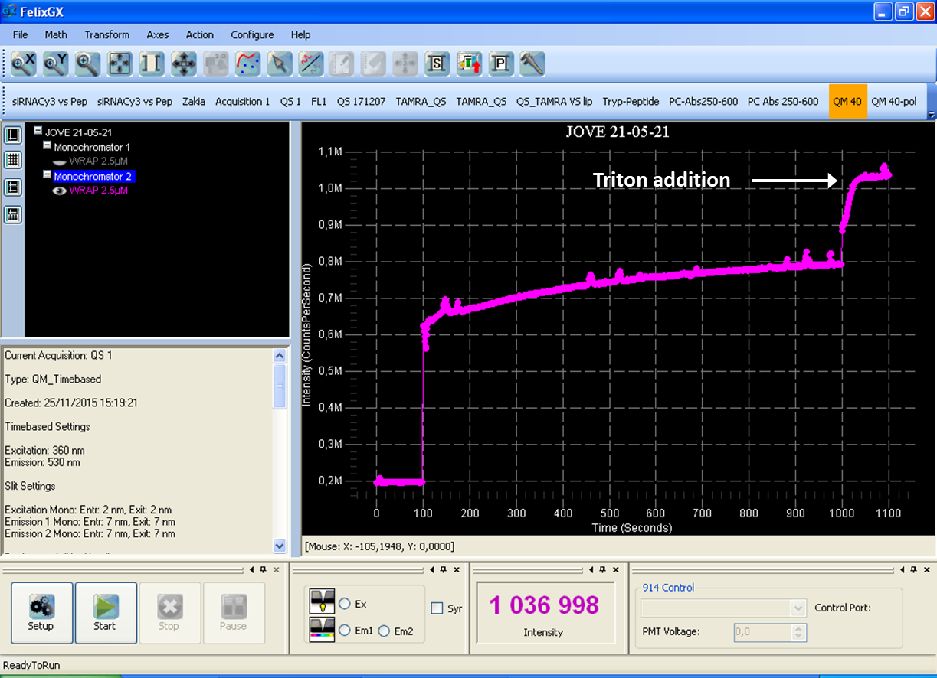

    - BLACK TEXT WHITE BACKGROUND : %Leak_{(t=x)} = (F_{(t=x)} - F_{min})/(F_{max} - F_{min}) x 100

Results
- Results: Representative Fluorescence Leakage Analysis

  - In the absence of peptides, no fluorescence leakage is observed from the LUVs [1]. The addition of WRAP (wrap) onto the LUVs induces a significant increase in fluorescence [2-TXT], revealing an important LUV leakage and ANTS release [3].

    - LAB MEDIA: Figure 2 Video Editor: please emphasize black data line from 0-100 s
    - LAB MEDIA: Figure 2 Video Editor: please emphasize dashed Peptide line TEXT: WRAP: tryptophan- and arginine-rich amphipathic peptide
    - LAB MEDIA: Figure 2 Video Editor: please emphasize data points right at about/after 100 s

  - After 15 minutes, a leakage of approximately 67% is obtained in the presence of 2.5-micromolar tryptophan- and arginine-rich amphipathic peptide [1] compared to the Triton positive control [2].

    - LAB MEDIA: Figure 2 Video Editor: please emphasize black data line and/or add 67.9 text
    - LAB MEDIA: Figure 2 Video Editor: please emphasize black data line after 1000 s

  - In contrast, when tryptophan- and arginine-rich amphipathic peptides is assembled at the same concentration with small interfering RNA to form peptide-based nanoparticles, the leakage is 1.5-fold weaker [1] compared to the free peptide [2].

    - LAB MEDIA: Figure 2 Video Editor: please emphasize grey data line and/or 44.1 text
    - LAB MEDIA: Figure 2 Video Editor: please emphasize grey data line after 1000 s

  - When the conjugated Penetratin-iCAL (eye-cal) peptide is used, no significant fluorescence increase is detected [1], whereas the addition of WRAP-iCAL peptide induces a net leakage characterized by very strong fluorescence signal at the same 2.5 micromolar concentration [2].

    - LAB MEDIA: Figure 3 Video Editor: please emphasize grey data line from 100-1000 s
    - LAB MEDIA: Figure 3 Video Editor: please emphasize black data line from 100-1000 s

  - These results indicate that the fluorescence leakage assay can be used to reveal the ability of some cell-penetrating peptides to perform peptide-membrane interactions [1], leading to a more [2] or less pronounced membrane permeability [3].

    - LAB MEDIA: Figures 2 and 3
    - LAB MEDIA: Figures 2 and 3 Video Editor: please emphasize black data line in both graphs
    - LAB MEDIA: Figures 2 and 3 Video Editor: please emphasize grey data lines in both graphs

Conclusion
- Conclusion Interview Statements
  - Sébastien Deshayes: This method favors a rapid identification of peptide-membrane interactions that lead to membrane destabilization to decipher the internalization mechanism of CPPs or other “membrane-active peptides”, such as fusiogenic or antimicrobial peptides [1].
    - INTERVIEW: Named talent says the statement above in an interview-style shot, looking slightly off-camera
  - Prisca Boisguérin: In the case of peptide-lipid interactions without leakage induction, other approaches, such as tryptophan fluorescence experiments, are required [1].
    - INTERVIEW: Named talent says the statement above in an interview-style shot, looking slightly off-camera
  - Karidia Konate: This fluorescence leakage assay is widely used within the CPP field and can provide important information about direct cell translocation or endosomal escape [1].
    - INTERVIEW: Named talent says the statement above in an interview-style shot, looking slightly off-camera

