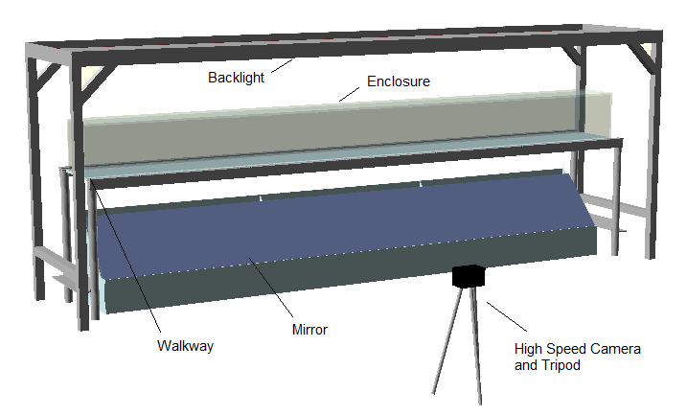
Fig S1 Rat Walker:

Fig S2 Backlight:
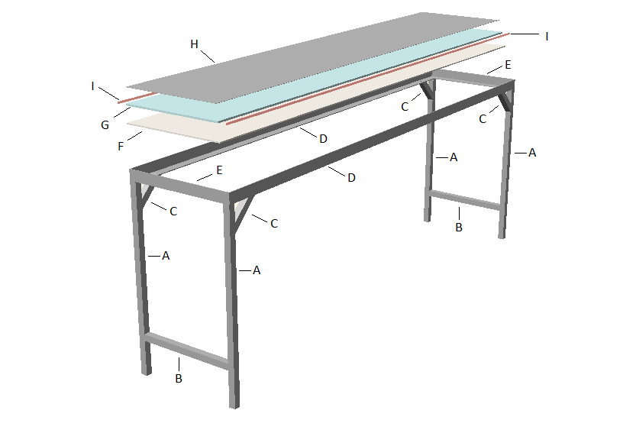

Fig S3 Enclosure:
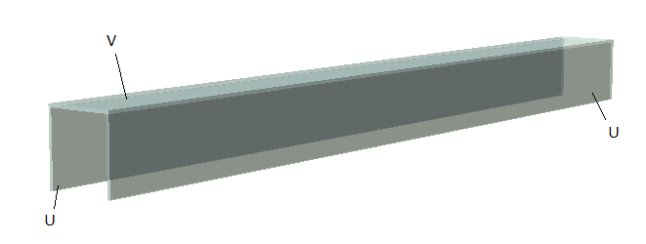

Fig S4 Walkway:
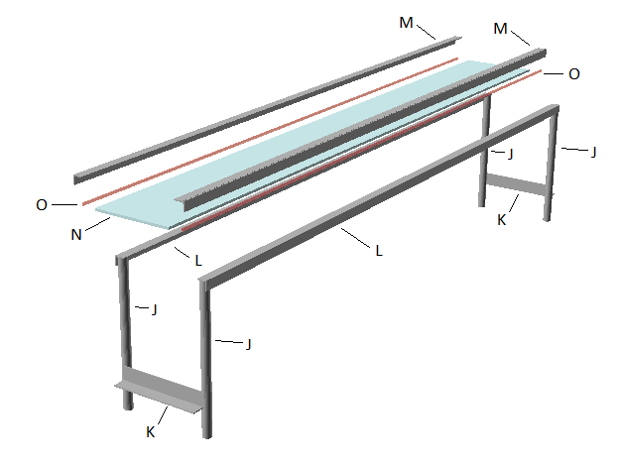

Fig S5 Mirror:
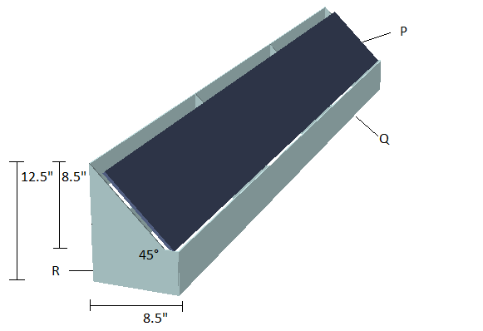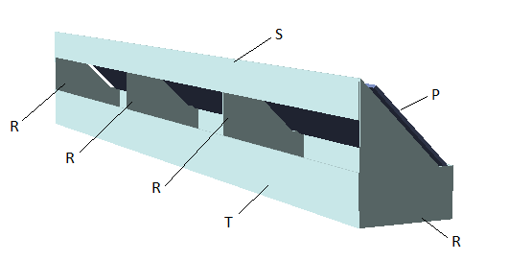

Fig S6 Software Settings
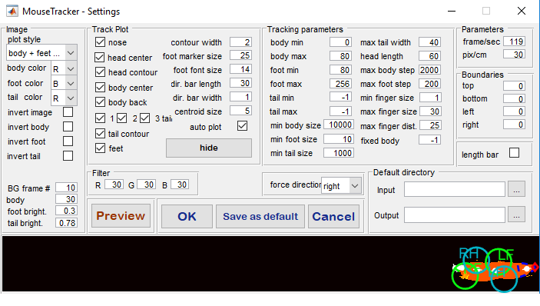

Fig S7 Genotyping
A
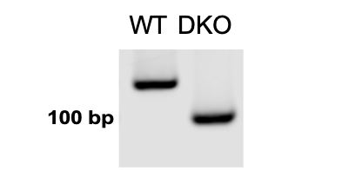
B

Genotyping of DKO rats. A. Representative result of polymerase chain reaction (PCR) to confirm the deletion of 26 bp in the PINK1 in DKO rat model in comparison with WT. B. Sequencing of DKO rats to confirm the deletion of 5 bp.

