December 21, 2020

JoVE (Journal of Visualized Experiments)
RE: JoVE62002R1 “Applying the RatWalker System for Gait Analysis in a Genetic Rat Model of Parkinson’s Disease”

Dear JoVE Editors:

We would like to thank the editor for their careful review and comments regarding this manuscript resubmission. The responses to the editor’s comments are provided below detailing the changes that we have made. We hope these changes make this manuscript suitable for reconsideration and publication.

Thank you for your consideration of our work.

Sincerely,

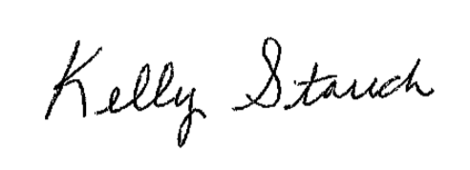

Kelly L. Stauch, PhD, for the authors
Assistant Professor

Editorial comments:
1. There are still some scatter typos throughout the written manuscript. Please copyedit the manuscript.

The manuscript has been carefully edited to correct the typos.
2. Please highlight up to 3 pages of protocol text for inclusion in the protocol section of the video. This is a hard production limit to ensure that videography can occur in a single day.

The protocol text for inclusion in the protocol section of the video has been highlighted in yellow.
3. Additional comments are in the attached manuscript.

3a. Please revise the title for conciseness: Applying the RatWalker System for Gait Analysis in a Genetic Rat Model of Parkinson’s Disease

The title has been revised accordingly.

3b. Please shorten this to 50 words or less. Please do not use references in the Summary or the Abstract.

The Summary has been shortened to less than 50 words. References have been removed from the Summary and the Abstract.

3c. Please do not cite references in the Abstract.

References have been removed from the Abstract.

3d. This is an incomplete sentence.

The incomplete sentence has been revised.

3e. leads?

The wording “does lead” has been changed to “leads”.

3f. Please include an ethics statement.

An ethics statement has been added.

3g. Please move this to the introduction.

The highlighted section has been moved to the introduction.
4. Please upload the supplemental table and figures separately.

The supplemental table and figures have been uploaded separately.

