Editorial comments:
Changes to be made by the Author(s):
1. Please take this opportunity to thoroughly proofread the manuscript to ensure that there are no spelling or grammar issues. Please define all abbreviations at first use.

I followed the editor suggestion and fixed the few spelling errors. However, I want to notice that the manuscript was checked by a professional English Language proofreader and, if needed, I can provide a certificate.
2. JoVE cannot publish manuscripts containing commercial language. This includes trademark symbols (™), registered symbols (®), and company names before an instrument or reagent. Please remove all commercial language from your manuscript and use generic terms instead. All commercial products should be sufficiently referenced in the Table of Materials and Reagents.
For example: N-2 (Thermo Fisher Scientific, Waltham, MA, USA); flask (Nunc); Billiups-Rothenberg, Inc., Del Mar, CA;

I apologize for the mistake; I removed all the commercial language throughout the text.
3. 2.2.1: Please do not highlight any steps describing euthanasia.

I removed the highlighting from the text describing euthanasia.
4. For centrifugation conditions, use format: 400 × g or 1,000 × g.

I changed the format as indicated.
5. Please note that your protocol will be used to generate the script for the video and must contain everything that you would like shown in the video. Please add more details to your protocol steps. Please ensure you answer the “how” question, i.e., how is the step performed? Alternatively, add references to published material specifying how to perform the protocol action. Please add more specific details (e.g. button clicks for software actions, numerical values for settings, etc) to your protocol steps. There should be enough detail in each step to supplement the actions seen in the video so that viewers can easily replicate the protocol.

As indicated, I add more details about the protocol throughout the text and specifically for the software section.
6. 6.1: How do you determine that the oligospheres have reached a diameter of 100-150 µm?

I added a description of a rapid evaluation of the diameter at 4.1, replicated for 6.1.
7. 8.1: What is the final volume of the well contents (as you have stated the concentration of each cytokine in the mix is 20 ng/mL)?

The volume depends on the cell number, since cells are seeded as 10 - 50 cells/µl for spheres formation as explained during neurospheres and oligospheres protocol. I added a note at 8.1.
8. 11.1: Which software is this? If readers/viewers have some other software, what operations should they perform with their software?

The software is specific for the HCS and directly linked at the hardware. I added the name of the software.
9. Please convert 11.11 into a note if there are no actions to be performed.

I updated the software section, better describing also this point.
10. Please highlight up to 3 pages of the Protocol (including headings and spacing) that identifies the essential steps of the protocol for the video, i.e., the steps that should be visualized to tell the most cohesive story of the Protocol. Remember that non-highlighted Protocol steps will remain in the manuscript, and therefore will still be available to the reader.

I have tried to reduce as much as possible to stay in the 3 pages limit.
11. As we are a methods journal, please add to the Discussion to explicitly cover the following in detail in 3-6 paragraphs with citations:
a) Critical steps within the protocol
b) Any limitations of the technique
c) How physiologically relevant the mixture of fetal and adult brain OPCs would be for drug screening and other applications.

As indicated by the Editor and the Reviewers, I updated the Discussion section.
One of the main limitations was already described (less uniformity of the mixed cultures; last paragraph before conclusions) and I clearly added now the fundamental limitation suggested also by the Reviewer 1 (lacking axon myelination). This is now followed by the physiological relevance of the fetal/adult cultures in a translational view.

12. In the reference list, please do not abbreviate any journal names. Do capitalize the first letters of all the words in the journal title.

I updated the bibliography according to the Editor’s instructions
13. Where is Table 1 (list of primary and secondary antibodies)?

I apologize for the missing table, I updated it during the first submission but apparently it did not worked.
Reviewers' comments:

Reviewer #1:
Manuscript Summary:
The author describes a protocol for differentiation of oligodendrocytes from adult or fetal neural progenitor cells. The differentiation protocol is described in an easy to follow way. It is reproducible as presented. The author couples this differentiation protocol with a high content screening design in which the quantification in automatic. There are a few issues with the description of the workflow.

Major Concerns:
1- Though the author discussed the complex cellular environment better mimicking the in vivo, he fails to discuss the culture does not produce myelin and lacks the interaction between neurons and oligodendrocytes. This, of course, does not diminish the importance of the work however an important limitation to be discussed.

I agree with the Reviewer’s suggestion, and I implemented the discussion of the method limitations.

2- Although the author mentions approximately 40% astrocytes in line 388, for adult NSCs it looks more like more than half of the cells are astrocytes. In addition, beta-III-tubulin-positive cells looks like above 10% for the fetal cultures. It may be helpful to give the numbers as a table or to print on the graph.

I agree with the Reviewer’s comment and I add the percentage for each cell type in fetal and adult-derived cultures in the figure.
I also commented this aspect in the text (Results section) and figure legend.

3- The automated quantification is not described in enough detail. First, the software used was not stated. Therefore, all the descriptions are vague as we cannot replicate them.

I apologize for di missing details and I updated the software section as suggested by the Reviewer.

4- Are the images pre-processed? For example, was histogram stretching applied?

All the HCS software-based image processing is now described in the procedure.

5- How are the false positive nuclear rings identified? In figure 2, there are several nuclei that overlap with the marker (looks like MBP but not stated but clearly are not positive for the marker i.e they maybe the nuclei of underlying astrocytes. What are the criteria for calling a ring positive? Is it possible to distinguish between a bright spot that falls into the ring vs a general low but diffuse signal? They both may give about the same average intensity.

I agree with the Reviewer that this is a critical point and must be better clarified.
The positive ring is chosen by the “average intensity” of the lineage-specific marker. To do so, it is important to go through the sample images, during the mini scan section, select the rings of true-positive cells and nuclei randomly overlapping the staining and define the threshold based on this observation. This is now explained in the updated software procedure.
Note that the HCS is a balance between rapid and robust results avoiding the operator bias and a percentage of error occurring by automated analysis. This error is reduced at the minimum by the good cell seeding and good staining.

Minor Concerns:
1- It will be easier to interpret figures if the colors of the markers were stated. For example, MBP (red).

Labeling markers are always stated, I understand that the confusion may derive by the double staining and I modified the pictures giving the specific color for the specific marker.
Reviewer #2:
Manuscript Summary:
Dr. Baldassarro proposes a protocol able to obtain OPCs differentiated from NSCs isolated from SVZ at embryonic and adult stages. The author claim that this protocol should be very useful because of the equilibrium between the content of OPCs (very useful for the study of one of the contingents acting in demyelination) and the presence of a significant amount of astrocytes (40%) which is intended to add a physiological surplus to this experimental paradigm.

Major Concerns:
1-the quality of the images is very low and difficult to be properly evaluated;

As the Reviewer may note, all the images produced by a standard epifluorescence microscope are of a standard good quality (e.g. Figure 1). However, HCS machine takes pictures at 10x objective (for the described protocol) and produces images of the reported quality.

2-description of procedure is sometimes very superficial (ex.: composition of dissociation buffer is just described at the Table without any reference in the text, etc.). It is not conceivable the use of sentences like this one: "The entire protocol takes around 30 days, depending on the age of the animals and the experimental goals" (lines 488-489).

I apologize if some passages sound superficial to the Reviewer. I hope that Reviewer understands that, as he stated, it is a complex procedure with different variables that should be taken in consideration. The example of the protocol timing is complex, since if the user decides to work only on fetal cells or only on adult cells the timing is highly variable, according also to the seeding density. The age of the adult animal, also, may make a variation in time of more than one week with old animals. It is not possible to describe the exact time for each variables combination. However, I added more details about the different variables.

I do not understand the dissociation buffer concern. Non-enzymatic dissociation buffer is a commercial product (please, see the table of the products), while enzymatic dissociation buffer composition is described in detail in section 1 (solution and reagents). Both of them are used in the protocol, the “non-enzymatic” for the fetal tissue (see 2.1, firs sentence; 2.1.6) dissociation and the “enzymatic” for the adult (2.2.8). I do not understand where the Reviewer noted the superficiality of the description.

3-the coexistence of nesting and NG2 co-stainings is suggested by the author (lines 378-382; experiment illustrated in Figure 2) but not at all clearly demonstrated. Many of the problems derived of the lack of co-stainings for the evaluation of GFAP vs nestin/NG2 positive cells, for example. Additional staining (PDGFRalpha) would be very useful to clarify this point. Is the author sure about the lack of predicts in this cultures?

Please, note that throughout the whole comment text, maybe the Reviewer missed the figure order. The figure with the culture characterization with different stainings is figure 1.
Since when plated (-3 DIVs) most of the cells are positive for nestin and for NG2 we suggested this. I agree that, since double staining was not performed, I cannot state the co-existence of the two markers. I now added a clear statement of the goal of the protocol, to describe only the final cultures composition.

As the Reviewer perfectly knows, the differentiating OPCs cultures are NOT defined as black-or-white system (see figure 2 in Silbereis et al., 2010), but markers progressively disappear and appear and, in some stages, they can co-exists (e.g. all the MBP-positive cells are also CNPase-positive) or they can be in the transitions sate (e.g. between NG2- and CNPase-positive cells).

The objective of this protocol is not the study of the shades of these markers and, of course, each user can adopt the protocol to their main differentiation study goal. Moreover, the system was already well characterized in previous studies (Baldassarro et al., Stem Cell Research, 2019) and here I showed also the percentage of PDGFaR-positive cells (Figure 2) that, in cells differentiating from the multipotent NSCs population, identify OPCs.

Here the markers are used to quantify the percentage of cells in a specific population at the end of the differentiation phase.

Ref:
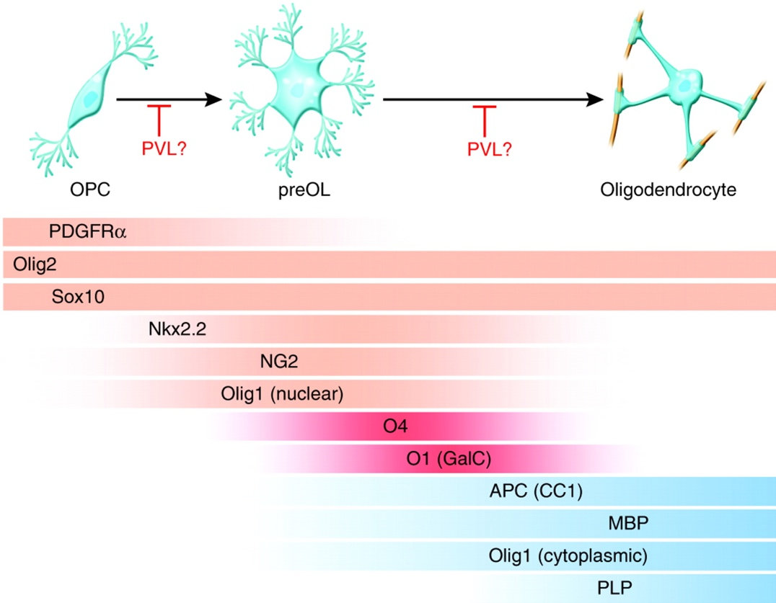
Silbereis JC, Huang EJ, Back SA and Rowitch DH. Towards improved animal models of neonatal white matter injury associated with cerebral palsy. Dis Model Mech, 2010. 3:678-88.

4-there are very general assumptions with no detailed descriptions (ex.: the percentage of astrocytes present in the culture, if there are differences between the cultures derived from embryonic NSCs and from adult ones, the timing differences between both types of cultures). It is not possible that cellular composition and timing for such a complex differentiation process do not vary from cultures derived from embryonic NSCs to the adult ones (in purified OPC primary cultures, the difference would be as much as three times more...!). There are no quantifications (see lines 388-390), not descriptive data (average numbers with SDs/SEMs, statistical analysis): this is intended to be a protocol and data should be very orientating for future users (as examples, see: Duncan et al., 2012; Medina-Rodrigues et al., 2013).

I agree with the Reviewer: that fetal and adult cultures are different. In fact, this is one of the main points of the protocol, to compare two different cultures in the most standardized way.
The first sentence of the Result section is “The first phase of the culture may vary in duration, depending on seeding density and on whether the spheres are of fetal or adult origin” and now I added comment about the longer duration of the adult one.
However, after the cell seeding, the protocol follows the same timing.

The difference in doubling time between neurospheres and oligospheres (two different phases of the culture) is also stated in the text with a dedicated graph (Figure 1B).

In Figure 2 the culture composition of both fetal and adult cultures at the end of the differentiation phase is clearly stated with a dedicated graph (Figure 2C). Now I added also comment about this in the text.

5-It is not very clear why if OPCs are seeded in high density, the culture derive in astrocytic massive production (lines 394-396; experiments illustrated in Figure 3).

Please note that this is always a mixed culture, with astrocytes as the main proliferative cell type, since OPCs are induced to differentiate. In fact, while the OPCs are differentiating and the few neurons are post-mitotic, astrocytes keep replicating and, when in high number, rapidly generate a continuum layer.
I added this as an example of bad situation that can be produced by seeding an high number of cells and I think it can be useful for researcher approaching this in vitro model for the first time.

6-Inflammatory conditions are not described in detail.

I do not understand this point. In the text it is present the cytokine mix composition (1.9 cytokine mix preapration) and the treatment (8. Induction of inflammation-mediated differentiation block).
The choice of those cytokines and the rationale behind their effect it is also justified in the results section (penultimate paragraph).

7-the surprising data of similar survival to inflammatory conditions (experiments illustrated in Figure 5) are not sufficiently discussed (line 406).

Please, note that figure 5 does not refer to inflammatory conditions, but to OGD experiment conducted on fetal OPCs. In these cultures, the survival in strongly challenged by OGD exposure.

8-Introduction and Discussion seem very biased for this reviewer: while in the Introduction the option of organotypic slice cultures is systematically forbidden (and in the Discussion it is just cited -lines 454-456-), almost the entire Discussion just contemplates previous works of the author´s group.

As Reviewer stated, for the author was worth to mention the organotypic cultures. However, they were not “systematically forbidden” but “systematically avoided” in the introduction, since this model do not represent a cellular model comparable to cell lines, primary OPCs and NSCs-derived OPCs. Moreover, for the limited space for this section in a method manuscript it is not possible to discern the whole portrait of non-in vivo models.
Since the journal instructions state to focus the discussion on the protocol (critical steps, limitation, troubleshooting, applications, significance respect alternative methods) and to avoid the replication of existing experiments, and since the representative results are originally presented in the figures, I added all the model characterization references, coming from previous studies, in the discussion. It is useful to understand the potential of the system and, for new users, if it fits the experimental questions.
The discussion has been modified and, as editor requested, shortened.

Minor Concerns:
-Introduction should be completed with relevant bibliography (Dincman et al., 2012; Medina-Rodrigues et al., 2013; others). It is quite surprising that the work of maybe the two more active groups working with adult OPCs (Antel, deCastro) are missed in the manuscript, as well as extremely important data recently obtained by the groups of Williams and Castello-Branco: all these would significantly increase the quality of the manuscript and put proposed protocol in the real perspective to be balanced.

I apologize for the missing updated bibliography. I would only remind that this is not a review, and even the editor requested to shorten the discussion focusing more about the method itself.
I updated the text (in the discussion where contextualization according to other methods is requested) according to the Reviewer’s comment and suggested references, within the limited space requested by the journal.

-It is quite naïve to still refer myelination and remyelination as identical events (lines 463-464): Franklin et al. have clearly discarded this in later work (Franklin & french-Constant, 2017) than the cited...!

I agree with the Reviewer’s comment. In fact, it is already underlined that it was described that myelination and remyelination are different events.
However, it is useful to cite the recapitulation hypothesis to clarify the context. This is, in fact, cited in different recent reviews of other groups describing myelination and remyelination and still a debated and discussed point.

See, for example:

Guo et al., 2020. Medical Hypotheses. Doi: 10.1016/j.mehy.2019.109522
Voskuhl et al., 2020. PNAS. Doi: 10.1073/pnas.1821306116
Laitman et al., 2018. Mult Scler J Exp Transl Clin. doi: 10.1177/2055217318806527
Bove and Green, 2017. Neurotherapeutics. Doi: 10.1007/s13311-017-0577-0

Moreover, the recapitulation hypothesis is still at the base of a big in vitro bias: using fetal/neonatal-derived primary OPCs to test molecules aimed to stimulate remyelination in adulthood. This is a key point at the base of the presented method.

Following the Reviewer’s comment, I better clarified that point in the introduction, and I added the reference.

-bFGF is an old-fashion form to refer to FGF2 (along the entire paper, Table included).

I do not agree with the Reviewe’s comment, since bFGF is still widely used and alternatively to FGF2.
I choose this form since it is also used by the company selling the product.

Please see recent papers on relevant journal using the “bFGF” nomenclature:

Shakya et al., 2020. Scientific Reports. Doi: 10.1038/s41598-020-65572-2
Oyane et al., 2020. Royal Society of Chemistry. Doi: 10.1039/C9RA06906B

-the mixture of ornithine/laminin used is poorly described.

I do not understand this point. The full protocol on how to prepare the coating ornithine/laminin is fully described in section 5 as follow:

“5. Plate coating
5.1 Poly-D,L-ornithine / laminin coating: at least two days before plating the OPCs, add 50 µg/ml poly-D,L-ornithine solution, diluted in PBS, to each well (40 µl/well for 96-well plates) and incubate at RT overnight.
5.2 The following day, remove the liquid and wash three times with distilled sterile water.
5.3 Let the plates dry at RT overnight. The following day, add a laminin solution diluted in PBS (5 µg/ml; 40 µl/well for 96-well plates) and incubate for 2 hours at 37°C.”

I do not understand which detail is missing.

