Protocol Name: Aesthetically Enhanced Silica Aerogel Via Incorporation of Laser Etching and Dyes
Date: 1/3/21
Online Text/PDF Protocol
Please use this table to address changes that need to be made to the online text/PDF document. Both the online text and PDF are generated from the HTML template of your article. Since the PDF is generated from the HTML by our conversion software, it may contain formatting errors. For major structural changes or more than 10 spelling or grammatical mistakes, we will require re-upload of the entire document.
 | Protocol Step | Comment | Requested Change (highlight in bold)
Example | 1.1 | Step says “Centrifuge lysate at 2,000 x g.” | Please correct to “Centrifuge lysate at 4,000 x g.”
1. | Table 1 | In the pdf document, table 1 is split across two pages. | Please format so the table is on one page.
2. | Table 1 | The structure for Rhodamine 6G is incorrect (a corrected version of Table 1 has been uploaded with this file). | Please replace with the correct structure (below):  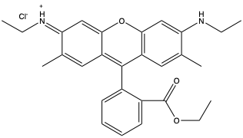
3. | Table 1 | The structure for Fluorescein is of insufficient quality (it was meant to be a placeholder but we didn’t replace it prior to submission -- our apologies)  (a corrected version of Table 1 has been uploaded with this file) | Please replace with the following version:  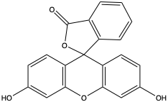
4. | Table 1 | The structure for Rhodamine B is of insufficient quality (it was meant to be a placeholder but we didn’t replace it prior to submission -- our apologies)  (a corrected version of Table 1 has been uploaded with this file) | Please replace with the following version:  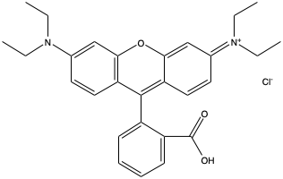
5. | 2.2.3 | Step refers to “a” software. | “Use image processing software to remove…..”
6. | Figure 1 | Change start of caption. | Figure 1: Mold Assembly. Schematics of the (a)...

