Supporting Information

Designed for Molecular Recycling: A lignin-derived semi-aromatic biobased polymer

Dennis Molendijk¹, Koen van Beurden¹, Jack van Schijndel¹

¹Research Group Green Chemistry, Avans University of Applied Science

Figure S1: ¹H NMR spectrum of sinapinic acid

Figure S2: ¹H NMR spectrum of dihydrosinapinic acid

Figure S3: ¹H NMR spectrum of 4-acetoxy-dihydrosinapinic acid

Figure S4: ¹H NMR spectrum of dihydrosinapinic acid, obtained after depolymerization of poly-S
Figure S5: Full cycle DSC thermogram of Poly-S generation 1.0 in the third heating cycle

Figure S6: Full cycle DSC thermogram of Poly-S generation 2.0 in the third heating cycle

Figure S7: Full cycle DSC thermogram of Poly-S generation 3.0 in the third heating cycle

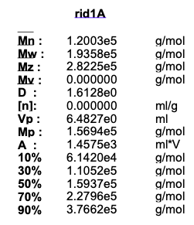
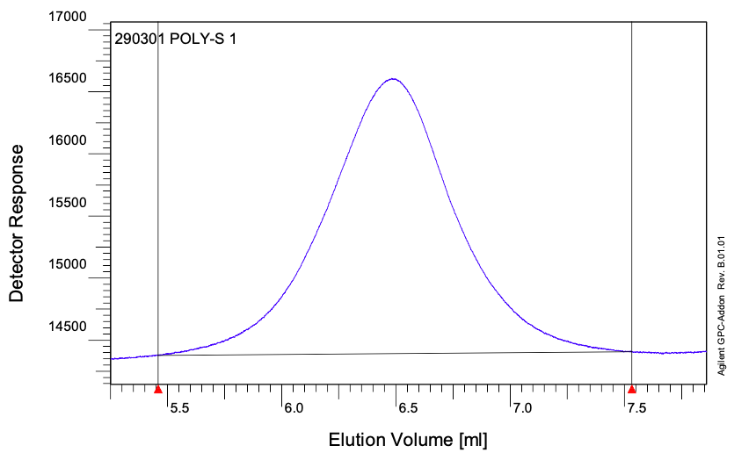
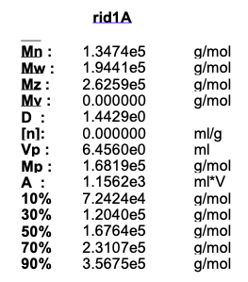
Figure S8: GPC chromatogram of Poly-S generation 1.0 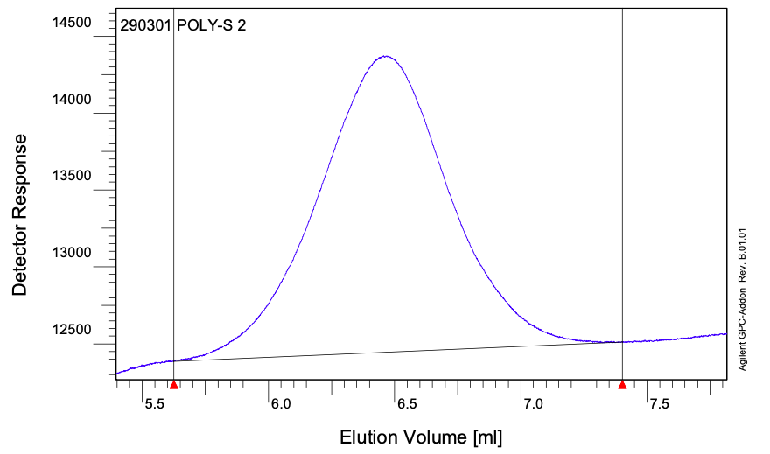
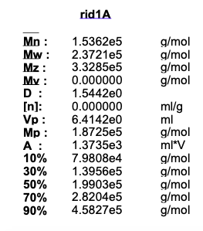
Figure S9: GPC chromatogram of Poly-S generation 2.0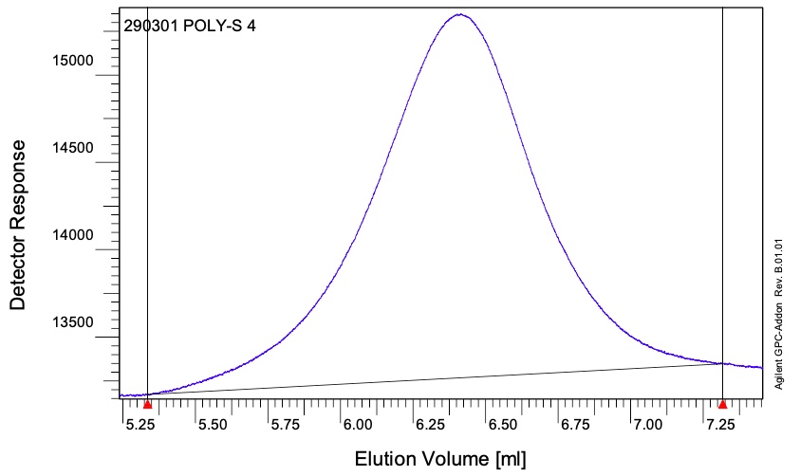
Figure S10: GPC chromatogram of Poly-S generation 3.0
Figure S11: TGA thermogram of Poly-S generation 1.0

Figure S12: HPLC calibration curve of dihydrosinapinic acid

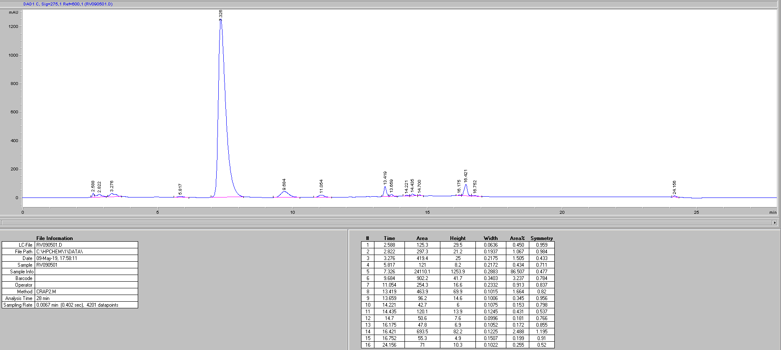
Figure S13: HPLC chromatogram of dihydrosinapinic acid, obtained after depolymerization of poly-S

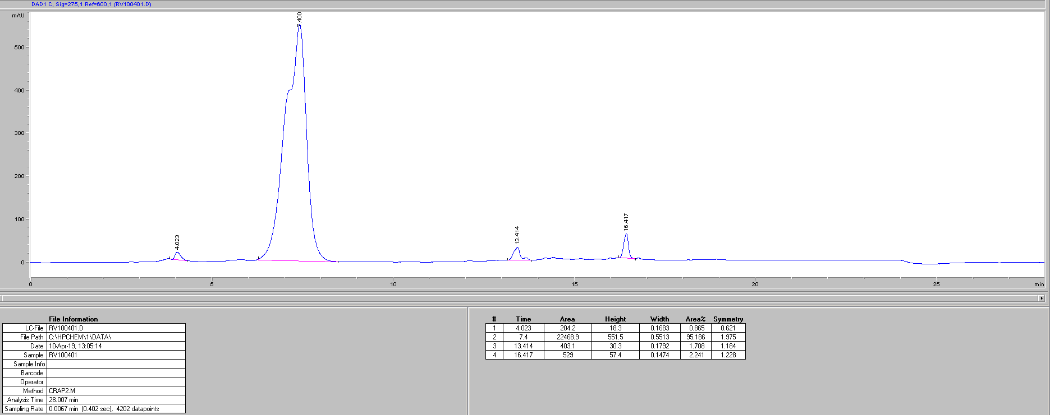
Figure S14: HPLC chromatogram of dihydrosinapinic acid reference

