Response to Review

Editorial comments:
1. Please take this opportunity to thoroughly proofread the manuscript to ensure that there are no spelling or grammar issues. Please define all abbreviations at first use.

Author reply: We appreciate the editor’s comments to improve the quality of the paper. The manuscript was carefully checked and a few grammatical errors were caught and corrected. All abbreviations were defined at first use.
2. For in-text formatting, corresponding reference numbers should appear as numbered superscripts after the appropriate statement(s), but before punctuation.

Author reply: We modified reference numbers format according to the editor’s suggestion.
3. Please adjust the numbering of the Protocol to follow the JoVE Instructions for Authors. For example, 1 should be followed by 1.1 and then 1.1.1 and 1.1.2 if necessary. Please refrain from using bullets or dashes.
O we
Author reply: We changed the numbered list of the Protocol to the required format.
4. Please note that your protocol will be used to generate the script for the video and must contain everything that you would like shown in the video. Please add more details to your protocol steps. Please ensure you answer the “how” question, i.e., how is the step performed? Alternatively, add references to published material specifying how to perform the protocol action. Please add more specific details (e.g. button clicks for software actions, numerical values for settings, etc) to your protocol steps. There should be enough detail in each step to supplement the actions seen in the video so that viewers can easily replicate the protocol.

Author reply: We thank the editor for the suggestions. We have added more specific details to the protocol steps where appropriate. For example, see responses to comments #5 and #6 below. In general, the action descriptions in each numbered step provide adequate information for a rheometer user to execute the protocol. There are instances where we felt increasing the level of specific detail would violate NIST’s neutral position or create confusion for users rheometers from different manufacturers.

We thank the editor for indulging our justification for this position with respect to providing “every” action item in the manuscript. We have strived to accurately describe actions in a way that is rheologically accurate, as well as to eliminate bias toward a particular manufacturer’s software. NIST is an independent measurement laboratory, a government agency that must hold a neutral position to any vendor and manufacturer, and we do not endorse any commercial products and their suppliers. The calibration protocol reported in this paper aims to provide recommendations for best practices to use the OSP technique, avoid procedural mistakes, and minimize experimental error, which is expected to benefit the entire rheology community. Before submission, our manuscript has gone through reviews by our internal Editorial Review Board and Legal team. Upon their guidance, we refrain from writing a “Standard Operating Procedure” style methods paper for a specific rheometer or citing the User Manual or Technical Note by a specific rheometer manufacturer, in accordance with NIST’s position. Nevertheless, we are able to write the Protocol section with step-by-step instructions and detailed tips for those operations, which should be easily followed by rheologists using a different instrument and software. We appreciate the editor’s understanding of our position.

In closing, as the editor pointed out that the numerical values for experimental settings are important, we strongly agree. Those specifics have been included in the protocol steps to allow the readers to replicate the tests. In addition to the short notes provided in the Protocol, we also emphasized several important steps where users should proceed with care, later in the Discussion section. With those detailed descriptions, we expect the entire procedure to be readily comprehensible and adoptable.
5. 2d: How do you tare the normal force and torque?

Author reply: The following text was added to Protocol 1.2.4 (lines 154 to 156) to explain how to tare the normal force and torque.

“This can be achieved by either using the Tare Transducer button in the transducer control panel from the rheometer software or using Tare Torque and Tare Normal on the Instrument tab from the instrument touch screen.”
6. 3: How do you zero the gap between upper and lower geometries?

Author reply: The following text was added to Protocol 1.3 (lines 159 to 161) to describe how to zero the gap between geometries.

“This can be achieved by clicking the Zero Fixture button in the gap control panel from either the rheometer software or from the instrument touch screen.”
7. Note after II-2, how much of the higher viscosity material do you use?

Author reply: It is difficult to precisely control the volume of a high viscosity fluid. We recommend users start with the approximate volume of the geometry, specified by the manufacturer, to load the high viscosity fluid. This is followed by using the wetting line of the bob to adjust the final volume in the geometry. The following changes were made to the Note after Protocol 2.2 (lines 174 to 183).

“NOTE: For loading a low viscosity test material (e.g., less than 5 Pa s), use an adjustable volume pipette (Figure 2a). The minimum volume to fill the geometry can be found in the Geometry information under the Experiment panel in the rheometer software. Approximate volumes needed for the currently available OSP geometries, viz., 0.5 mm and 1.0 mm annular gap width, are 32 ml and 36 ml, respectively. For loading a higher viscosity test material (e.g., higher than 5 Pa s), use a spatula or a positive-displacement pipette (Figure 2b). Since precise volume control for a highly viscous liquid is difficult, fine adjustment based on the fluid volume is not recommended for loading a high viscosity liquid. In any case, it is expected to slightly underfill rather than overfill in this step. Follow the next step to ensure precise loading of material.”
8. Note after II-3c, how do you determine if the temperature effect on the material property is fully recoverable?

Author reply: We thank the editor for the question. The calibration protocol was performed using Newtonian fluids that exhibit a temperature dependent viscosity. As long as the temperature is controlled to within the range specified for the viscosity standard, the fluid viscosity is reproducible, and the fluid is not expected to degrade within the operating temperature of the instrument. There is no need to discuss temperature-dependent properties of other test materials in the paper. The following text was removed from Note after Protocol 2.3.3.

“This approach can be used to load other test materials as long as the temperature effect on the material property is fully recoverable.”
9. First note in III, please cite references for the routine calibrations and checks.

Author reply: In compliance with NIST’s guidance, we must refrain from citing the User Manual or Technical Note by a specific manufacturer. Please see the response to your comment #4 above. We added the following sentence to the Note after Protocol 3 (lines 238 to 240) to direct the readers to the proper reference.

“The readers should refer to the User Manual of the rheometer manufacturer for the procedures of performing routine calibrations or checks.”
10. After revising the protocol (renumbering and adding some details), please highlight up to 3 pages of the Protocol (including headings and spacing) that identifies the essential steps of the protocol for the video, i.e., the steps that should be visualized to tell the most cohesive story of the Protocol. Remember that non-highlighted Protocol steps will remain in the manuscript, and therefore will still be available to the reader.

Author reply: We have made those changes.
11. Please remove the embedded figures and tables from the manuscript. All figures should be uploaded separately to your Editorial Manager account. Each figure must be accompanied by a title and a description after the Representative Results of the manuscript text. All tables should be uploaded separately to your Editorial Manager account in the form of an .xls or .xlsx file. Each table must be accompanied by a title and a description after the Representative Results of the manuscript text.

Author reply: We have made those changes.
12. As we are a methods journal, please add limitations of the technique to the Discussion.

Author reply: We thank the editor for this suggestion. The limitations of the technique were initially discussed in the last paragraph of the Discussion, and were modified for clarification (lines 599 to 615).

“We strongly recommend that users determine the end-effect correction factors for their own instrument and geometry, because the actual corrections are material-dependent and will vary among instruments and geometries. The protocol presented in this work is critical to support the growing interest from academic and industrial users that want to apply this technique. Suitable end-effect factors should be applied to obtain accurate results, otherwise the errors are appreciable.

The present calibration procedures are carried out for Newtonian fluids, which suggest that the corrections for non-Newtonian fluids could be even larger due to a more complicated flow field within the OSP geometry. As the measurement reliability for non-Newtonian fluids by OSP remains a general concern among the rheology community, future studies will focus on the quantification of end effects and other detrimental effects on the experimental error for non-Newtonian fluids. Understanding the correction related to Newtonian fluid viscosity measurements and the flow field non-idealities within the complicated OSP geometry is the first step for the application of the OSP technique. The protocol presented in this paper paves the way for future investigation on non-Newtonian fluids in order to avoid artifacts and experimental error bias for OSP research.”
13. Please sort the Materials Table alphabetically by the name of the material.

Author reply: The Materials Table was revised.
Reviewers' comments:
Reviewer #1:
Manuscript Summary:
Experimental errors due to sample preparation, calibration, or geometry uses are critical in rheology measurements. The authors report detailed orthogonal superposition rheology technique that will contribute insights to the field. The manuscript was well written and can be published as is, or with minor revisions as noted:
1. Page 8, lines 264- 268: It is not necessary at 25 C, 15 minutes, or that shear rate range. The authors are suggested to comment on the temperature, time, and shear rate setup based on the measuring samples.

Author reply: We first thank the reviewer for the positive feedback and helpful suggestions to improve the completeness of the paper. The following text was added to better explain the temperature and equilibration time recommendations (lines 290 to 294).

“NOTE: The calibration measurements are performed at the temperature at which the certified viscosity of the standard liquid is reported, i.e., 25 °C. The readers may use a different test temperature suitable for their Newtonian standard liquids. An equilibration time or soak time, i.e., 15 min, is recommended to ensure that the environmental control device, geometries, and sample reach thermal equilibrium.”

For the shear rate range, we would like to bring it to the reviewer’s attention that those aspects were initially discussed in the third paragraph of the Discussion in the previous version of the manuscript:

“The measurement range (i.e., shear rate and angular frequency) (Figure 5 and Figure 6) used for this liquid is based on the instrument limitations (Table 1) and other measurement artifacts, for example, the instrument and fluid inertia. We have reported the appropriate shear rate and orthogonal frequency ranges for Newtonian standards with viscosities ranging from 0.01 Pa s to 331 Pa s in previous work¹⁸. Briefly, for the steady shear, the applicable shear rate range is constrained by the transducer torque limits. For the orthogonal shear, the suitable frequency window is subjected to the axial force range, gap width, and fluid properties. Specifically, measurements should be conducted within the gap loading limit that arises from shear wave propagation in viscoelastic fluids¹⁹. Understanding the measurement limitations and artifacts are important to avoid any misinterpretation of experimental data²⁰.”

We also added a Note after Protocol 3.2.3 for better clarification (lines 302 to 305).

“NOTE: The shear rate range used here is based on the instrument torque sensitivity limits (Table 1) and the measuring liquid. For example, for a higher viscosity liquid (e.g., 300 Pa s), a lower shear rate range of 10⁻⁴ s⁻¹ to 1 s⁻¹ may be used, and vice versa.”
2. Page 8, line 291: Similarly, selection of angular frequency range should be discussed. Is there any reason to select 0.1- 40 rad/s? Also, please specify the measurement is from 40 to 0.1 rad/s or from 0.1 to 40 rad/s?

Author reply: We thank the reviewer for the questions. The selection of angular frequency range was initially discussed in the Discussion in the previous version of the manuscript. Please see the response to the previous comment #1 above. In addition, the following text was added to Protocol 3.3.5 for clarification (lines 331 to 333).

“NOTE: The angular frequency range used here is a recommended range for OSP operation based on the instrument axial frequency sensitivity limits (Table 1) and the consideration of gap loading conditions¹⁸. See the Discussion section for more details.”
3. Page 14, line 460 (Figure 3): It is difficult to observe the contact line. Should you mark or use a dotted line for the observation?

Author reply: We thank the reviewer for this observation. The figure was modified to highlight the contact line.

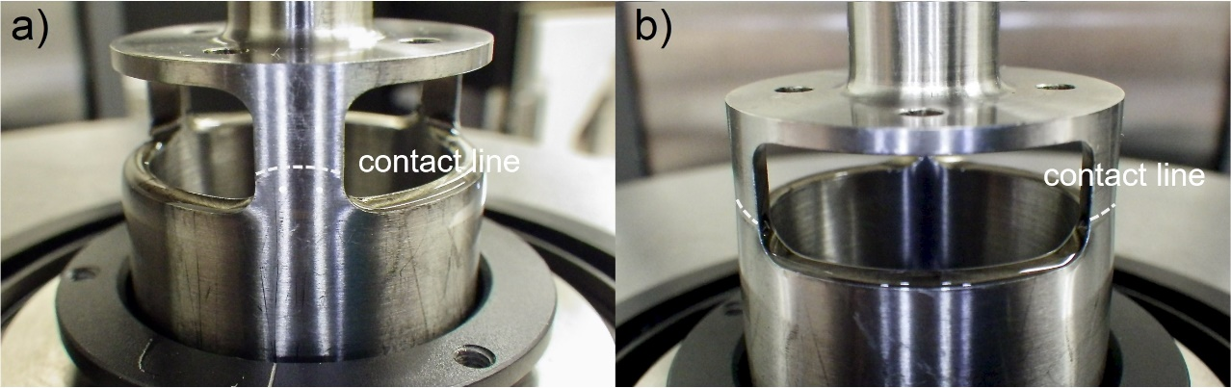
Figure 3: Visual inspection of the wetted fluid contact line on the bob after lifting the bob out of the double wall cup. (a) Front view showing the contact line slightly above the upper bob end. (b) Side view showing the lower rim of the upper openings on the bob is properly wetted. The white dashed lines indicate the wetted fluid contact line on the bob. Please click here to view a larger version of this figure.
4. Some additional comments on the sample types and temperature range capacity for the measurements are suggested.

Author reply: We thank the reviewer for the suggestions. The following text was added to address the measurement fluid types (Newtonian vs non-Newtonian) in the Discussion (lines 606 to 608). The temperature range capacity of the environmental control device is included in Table 1.

“The present calibration procedures are carried out for Newtonian fluids, which suggest that the corrections for non-Newtonian fluids could be even larger due to a more complicated flow field within the OSP geometry.”

Reviewer #2:
Manuscript Summary:
This work describes a protocol for the calibration of the geometry-correction factors for orthogonal superposition (OSP) rheology for Newtonian fluids. Orthogonal superposition is a technique that is of significant interest for rheological measurement because it can provide easily interpretable data of fluids far from their mechanical equilibrium point, i.e. when material properties often have non-linear dependencies. The technique has had notable but relatively limited usage since its initial development, but is gradually becoming more widely adopted, especially with the advent of a commercially available system.
From my own experience working with this system, the protocol described here is well presented and would be very helpful in generating reproducible, high quality rheological data. I recommend acceptance of this work to JoVE. Below are several points that the authors may wish to consider that I believe could further clarify and improve the manuscript's impact.
Major Concerns:
My only significant concern regarding this protocol is the limitation to Newtonian fluids. Measurement of Newtonian fluids is not generally an area in which a typical researcher would apply the OSP technique and it is not necessarily the case that calibrating the OSP for a Newtonian standard would provide the correct geometric corrections for a non-Newtonian fluid. However, the authors correctly state in their last paragraph that understanding and measuring the Newtonian correction is the necessary first step in proper application of this technique. Furthermore, the setup and loading steps would likely be identical for any sample—including non-Newtonian ones—and thus still have significant value. The authors might wish to point out these aspects earlier in the manuscript.

Author reply: We first thank the reviewer for the positive feedback and helpful suggestions to improve the quality and impact of the paper. We completely agree with reviewer, and we recognize the value of the OSP technique to study non-Newtonian fluids. The procedures delineated in this paper on sample loading and experimental setup for OSP experiments should be easily adoptable and translated for non-Newtonian fluids measurements. Therefore, it is worthwhile to highlight these points earlier in the manuscript. The following text was added to the last paragraph of the Introduction (lines 96 to 98).

“The procedures delineated in this paper on OSP geometry setup, sample loading, and OSP test settings should be easily adoptable and translated for non-Newtonian fluids measurements.”
Minor Concerns:
- In the abstract and introduction, the authors mention "non-linear flow", which I believe refers to flows that result in material properties with non-linear dependencies. Though a typical rheometer-user would likely understand what is meant by a "non-linear flow", it would be helpful to more precisely define this term and how OSP achieves it.

Author reply: We thank the reviewer for this comment. The reviewer’s point is correct. We have revised the following text in the Introduction for better clarification (lines 54 to 64).

“Unlocking this structure-property loop via non-linear viscoelastic behavior of complex fluids in response to flow and deformation remains a challenging task for experimental rheologists.

Orthogonal superposition (OSP) rheology³ is a robust technique to address this measurement challenge. In this technique, a small amplitude oscillatory shear flow is superimposed orthogonally to a unidirectional primary steady-shear flow, which enables the simultaneous measurement of a viscoelastic relaxation spectrum under the imposed primary shear flow. To be more specific, the small oscillatory shear perturbation can be analyzed using theories in linear viscoelasticity⁴, while the non-linear flow condition is achieved by the primary steady-shear flow. As the two flow fields are orthogonal and thus not coupled, the perturbation spectra can be directly related to the variation of the microstructure under the primary non-linear flow⁵.”
- Similarly, references are made to the "pumping flow" problem in the introduction, but I think a user who is new to OSP would not be familiar with the term. Instead I recommend considering something like, "unintended secondary flows"?

Author reply: We thank the reviewer for the suggestion. The following text was modified to define the pumping flow effect (lines 72 to 74).

“Those early custom-built devices suffer from many drawbacks such as alignment issues, the pumping flow effect (due to the axial movement of the bob to provide orthogonal oscillation), and limits to instrument sensitivity.”
- In part 1 of the protocol, it would be helpful to include an image of the short PRT. In 2c, for consistency, the "spring-loaded PRT" should be referred to rather than a thermometer.

Author reply: We thank the reviewer for the helpful suggestions. The image of the short PRT has been included in the new Figure 1b. The text “thermometer” was changed to “spring-loaded PRT” to reflect the correct description (line 140).

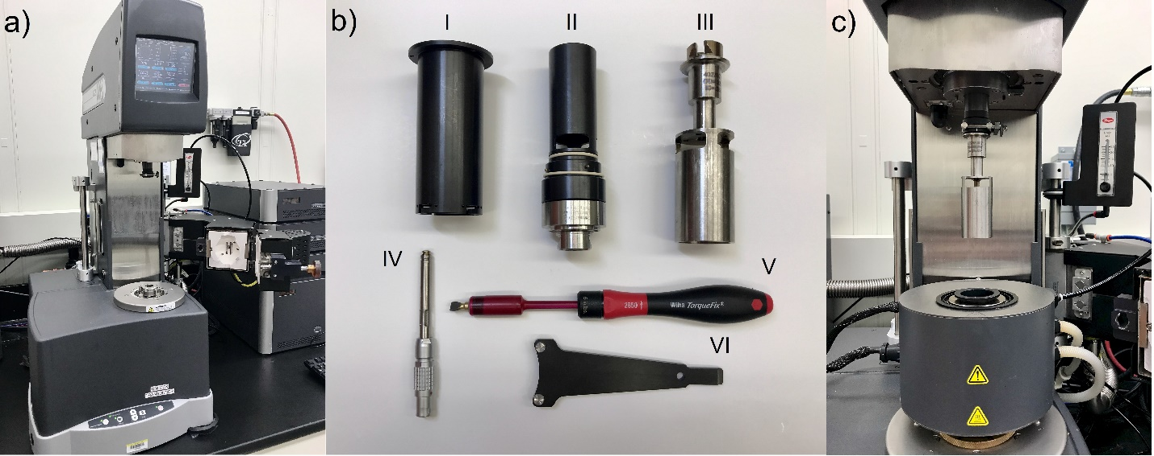
Figure 1: Pictures of the rheometer, the OSP geometry, and the Advanced Peltier System (APS). (a) ARES-G2 test station. (b) Components of the orthogonal double wall concentric cylinder geometry: the outer cylinder (I), inner cylinder (II), and the inner cylinder (III); the PRT (IV), the torque screwdriver (V), and the spanner wrench (VI). See Table of Materials for the part number. The PRT, torque screwdriver, and spanner wrench are included in the APS kit. (c) The rheometer setup after the installation of the environmental control device and the orthogonal double wall concentric cylinder geometry for experiments. Please click here to view a larger version of this figure.
- I recommend that after 2c, an additional step or note be added to confirm that signal from the PRT is being received. Though I'm unsure if it was a quirk of our particular installation, it was common for the rheometer to not recognize that the PRT was connected.

Author reply: We thank the reviewer for the consideration. The following text was added to the Note after Protocol 1.2.3 (lines 147 to 151).

“Verify that the temperature signal is received from the lower PRT. The rheometer should automatically recognize the temperature sensor by default; if not, select the lower PRT as the Temperature Control Sensor source in the temperature control options from the rheometer software.”
- In part 2, a positive-displacement pipette could also be suggested for handling very viscous materials.

Author reply: We thank the reviewer for the suggestion. We have modified the Note after Protocol 2.2 (lines 178 to 180).

“For loading a higher viscosity test material (e.g., higher than 5 Pa s), use a spatula or a positive-displacement pipette (Figure 2b).”
- In part 2, step 3, It would be helpful to quote some observed/recommended wait times for the highly viscous liquids. Are the few minutes specified in a) and the 15 minutes in c) for highly viscous materials or even for low viscosity ones?

Author reply: We thank the reviewer for the questions. The following text was added to Protocol 2.3.3 to describe the observed wait times (lines 220 to 222).

“The wait time depends on the viscosity of the standard material. For example, for a 1 Pa s liquid, a wait time of 15 min is sufficient; whereas for a 100 Pa s liquid, a much longer wait time (4 hours) is needed.”
- In line 183, there should be a hyphen between "yield" and "stress" in yield-stress fluid

Author reply: We thank the reviewer for the meticulous suggestion. The suggested change was made.
- The authors appropriately cite their own related work for discussion on the analysis of sources of error, however I think it would helpful to experimentalists carrying out this protocol to provide some intuitive explanation for why they might expect the end-effect corrections to be greater than or less than unity. Along these same lines, a range of expected or observed values of the end-effect factor would be helpful as a quick check that the calibration was performed correctly.

Author reply: We thank the reviewer for the helpful suggestions. The following text was added to address those aspects in the Discussion (lines 586 to 601).

“…In both directions, without correction, the measured viscosity overestimates the actual viscosity, as indicated by a greater than unity value for the end-effect factor (1.17) and a less than unity value (0.79) of the orthogonal end-effect factor (Table 2)…

…The overestimation of primary viscosity is due to a higher average shear rate in the double gap; and the overestimation of the orthogonal viscosity is attributed to the pressure forces on the bob ends in addition to the higher shear rate in the double gap…

… We strongly recommend that users determine the end-effect correction factors for their own instrument and geometry, because the actual corrections are material-dependent and will vary among instruments and geometries.”

