Institut für
Pharmakologie und Toxikologie
Prof. Dr. med. Niels Voigt
Professor für Molekulare Pharmakologie
Robert-Koch-Straße 40,
37075 Göttingen
Tel: +49 551 / 39-65174
Fax: +49 551 / 39-65169
niels.voigt@med.uni-goettingen.de
www.molecular-pharmacology.de

Universitätsmedizin Göttingen, 37099 Göttingen
September 18, 2020
Sebastian Clauß, MD
Guest Editor
&
Vineeta Bajaj
Review Editor

Journal of Visualized Experiments
Re: JoVE61890R1 - Single-cell optical action potential measurement in human induced pluripotent stem cell-derived cardiomyocytes

Dear Dr. Clauß and Dr. Bajaj,
I respectfully submit the revised version of our above-indicated manuscript, which has been edited in response to your editorial correspondence and the reviewer comments of 4.09.2020. We have addressed all comments and modified the introduction and discussion significantly in response to the suggestions from the reviewers.

These changes will provide more valuable and accessible information to the potential reader about the advantages and limitations of this optical technique. We have also provided more context regarding the relevance of this protocol today in the “age” of pluripotent stem cell derived constructs.

We thank the reviewers for their suggestions which have helped us to improve the protocol, and we also thank you for detailed editorial guidance. We hope that you and the reviewers find the revised paper acceptable for publication in the Journal of Visualized Experiments.

Sincerely,
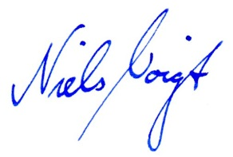
Niels Voigt, MD

