JoVE submission JoVE61879

“Fabrication of 3D Cardiac Microtissue Arrays Using Human iPSC-Derived Cardiomyocytes, Cardiac Fibroblasts, and Endothelial Cells”

Response to Editorial and Reviewer comments:
We are grateful to the Editor and the Reviewers for reviewing our work and providing insightful feedback. We are thankful to the 4 reviewers who have now endorsed our protocol. We have revised our manuscript based on comments from the additional 3 reviewers that were newly assigned. All changes to the manuscript are highlighted in blue for tracking.

Editorial Comments:
1. Please address specific comments marked in the manuscript.
We have now addressed all specific comments marked in the manuscript.
2. Please address all reviewers' comments.
We have now addressed all 7 reviewers comments.
3. Please ensure that the highlight is no less than 1 page and no more than 3 pages including headings and spacings. Notes cannot be filmed.
We have now highlighted additional portions of the protocol for filming.

Reviewer #5:
Minor Concerns:
1: In figure 4, cardiac microtissues were immunostained with different markers to show cell composition. How many days of cardiac microtissues after fabrication did you use here? Could you provide a 3-D view of this z-stack images? Does the time of culture after fabrication affect the composition of this 3D cardiac sphere?
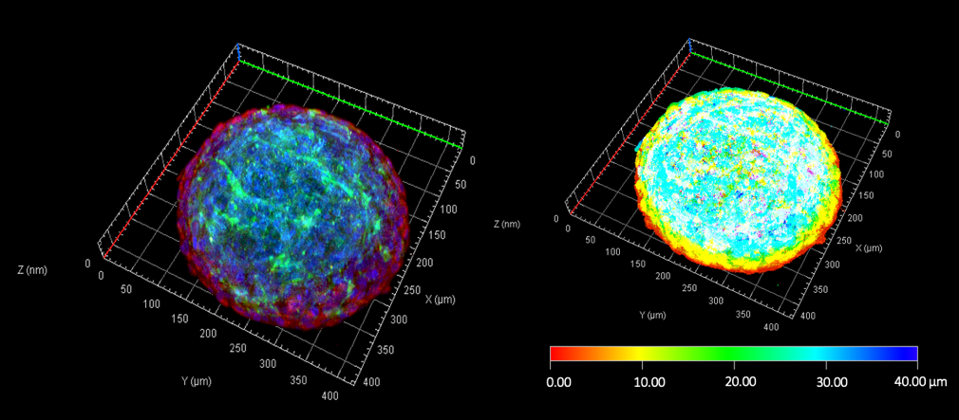
We thank the reviewer for the comment. The cardiac microtissues in this protocol have been cultured for 10 days. We have now included a 3D view of the z-stack images in the response to reviewers. Figure 1 shows a 3D reconstruction of the Z-stack images taken across ~80 µm from top to bottom with and interval of 8 µm. We are currently in the process of enumerating the cell composition as a function of time and treatment, and thus we have not included this in the protocol. For the scope of this protocol, we have detailed an optimized digestion of the microtissues that will enable users to quantify the cell proportions systematically using flow cytometry.
Figure 1: (left) A Z-stack 3D visualization of cardiac microtissue; (right) A pseudocolor field of depth view of cardiac microtissue with a step-size interval of 8µm from top to bottom.
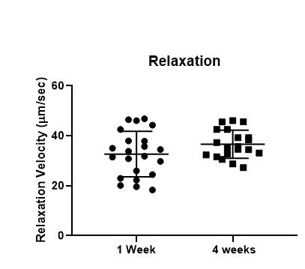
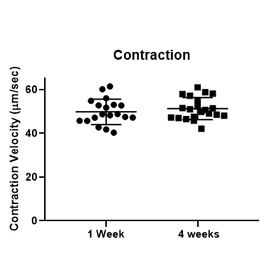
2: Figure 5 shows the contraction map of cardiac microtissues 1 week after fabrication. How long could cardiac microtissues show regular contraction and relaxation? Is there any relationship between the contraction capability and the time of culture after fabrication?
Figure 2: (A) Maximum Contraction and (B) Relaxation velocities of untreated cardiac microtissues remain comparable between week 1 and week 4 in culture; n=20/group.
We thank the reviewer for their question. The cardiac microtissues can be maintained for up to 1 month in culture. We have now included week 1 and week 4 contractility data (n=20) as Figure 5C in the protocol (Figure 2 in Response to Reviewers) to demonstrate that the contraction and relaxation velocity remain comparable for up to 4 weeks in culture.

3: This manuscript described that cell-cell signaling arising from supporting cell types such as ECs and CFs was faithful recapitulated in this 3D self-assembled cardiac microtissue. I think it is better to show the cell junctions between CMs and CMs or CMs and CFs by immunostaining in figure 4 to provide a strong evidence.
We thank the reviewer for this comment and suggestion. For clarification, in the introduction of the current protocol, we have described the utility of the model in dissecting effects due to cell-cell interactions. In this protocol, we do not claim the establishment of specific cell-cell junctions. To clarify this, we have now added the following line in the discussion: Lines 678-680: “In order to maintain structural integrity of the cardiac microtissues, we have not probed for proteins involved in specific cell-cell interactions and their maintenance over the culture period.”

Reviewer #6:
Minor Concerns:
Are the cardiac fibroblasts activated or non-activated in this culture method? Please show experimental evidence, e.g., by alpha smooth muscle actin staining.
We thank the reviewer for this comment. The method described in the protocol utilizes cardiac fibroblasts generated from human iPSCs that are quiescent and express all cardiac fibroblasts markers (COL-I, DDR2, VIM, and POSTN), as we have demonstrated in recent publications (Reference 13 and 14). In this protocol, we aim to demonstrate the feasibility of generating cardiac microtissues with phenotypically well characterized cells. However, we acknowledge that these cell types could undergo several fates dependent on the perturbation. Therefore, we recommend the users to run appropriate controls to validate cell fate related changes such as fibroblast activation. To clarify this, we have now included the following line in the discussion:
“Higher purity in the cellular phenotype will also ensure detection of changes in cellular trajectory due to different treatments.”

Figure 2: FACS panels - the middle panel did not show in one version of the pdf. Best to check at proof stage.
Thank you for the comment. In the newly compiled figures, we can confirm the middle panel now appears correctly, and will be mindful of this comment as we review any final proofs.

Figure 3: Panel D - add 'cell density' to x-axis
We thank the reviewer for this correction. “Cell Density” is now added to the x-axis.
Reviewer #7:
Major Concerns:
In Figure 5, the velocity vector profiles measured from the cluster appear to have three peaks. It is unclear how the software used has parametrized these peaks - are the first two considered as contraction and the third one as relaxation? I assume this to be due to the temporal difference of contraction onset and propagation in different parts of the cluster. Thus, the selected approach of measuring contraction for the whole cluster without directional information does not appear to characterize the contraction mechanics in a way that is comparable between different clusters.
We thank the reviewer for this comment. It is correct that the first and second peak-split is the contraction and the third one is relaxation. Once the cardiac microtissue is fully formed, they do not beat as separate clusters within a single microtissue. However, as the reviewer alluded to, occasional acentric contraction does result in split peak. During analyses, this does not affect the annotation of the contraction and relaxation peaks as the “Min. Peak Distance” is pre-defined. To avoid further confusion and for clarity, the contraction profile and associated microtissue micrographs are now replaced with a more representative example.

Minor Concerns:
Discussion, line 598: the percentage should be 70% iPSC-CMs instead of 75% as per the reported Giacomelli et al. protocol.
We thank the reviewer for pointing out this error. We have now changed the percentage from 75 to 70 on line 613 of the revised protocol.

Discussion, lines 668-671. The authors are right in pointing out that contractility analysis does not detect effects of passive tension or loading. However, I would point out that micropillars and flexible posts also influence the contraction of the cluster, as the cells adhere to the micropost tips - an environment is not typical to the cells in vivo.
We thank the reviewer for this suggestion. We have now included the discussion as follows:

Line 692-696 “It must be noted that the contractility analyses may not detect passive tension or loading effects due to suspended form of the microtissues, in contrast to microtissues formed between flexible posts of pre-defined stiffness. However, in both cases, it is important to note that the contraction profiles of engineered cardiac muscle tissues do not achieve contraction forces generated at an organ-level.”

Figure 1: The text, text boxes and images are poorly aligned, and the font size is inconsistent. Please revise.
We thank the reviewer for this comment. We have now corrected the formatting inconsistencies in Figure 1.

Figure 2: Although not key to reading the sorting graph, the axes of the three plots should have either consistent axis ticks or values.
We thank the reviewer for this comment and apologize for the inconsistency. Cell numbers gated for each cell type is different. Therefore, for consistency we have now replaced the scatter plots denoting the total cell count on the Y-axis.

Figure 4: Please make sure the DAPI text box does not cover the text above or the immunostaining image, and that the scale bar is not coloured.
Thank you for the comment. We now confirm the DAPI label and the scale bar appear correctly prior to PDF conversion. This will be further verified at the proof stage.

Figure 5 caption: Please be more specific in indicating the measured distribution of values of the contraction heatmap. At what point during the contraction is the velocity distribution measured? Related to protocol 8 stage 8.
We thank the reviewer for this comment. We would like to clarify that the contraction heatmap is a mean of the motion detected on X and Y axes. We have now revised protocol 8 and stage 8 as follows:
“The function “Map Time Ave.” can be used to generate a mean contraction heatmap based on motion detected on X and Y axes.”

Figure 5B: Make sure to use consistent terms to indicate that the values in table are velocities and use the same abbreviation for second as in 5A.
We thank the reviewer for bringing this to our attention. We have now used consistent terms in Figure 5 to describe the velocity measurements.

