June 26, 2021

Dear Zhao,
Thank you for your letter. I have known that your under-reviewed protocol “Characterization of Bacteria in Ovarian Tissues and Functional Prediction of These Bacteria” has some figures reprinted from the article “The differential distribution of bacteria between cancerous and noncancerous ovarian tissues in situ”. We permitted the reprint.

Sincerely,

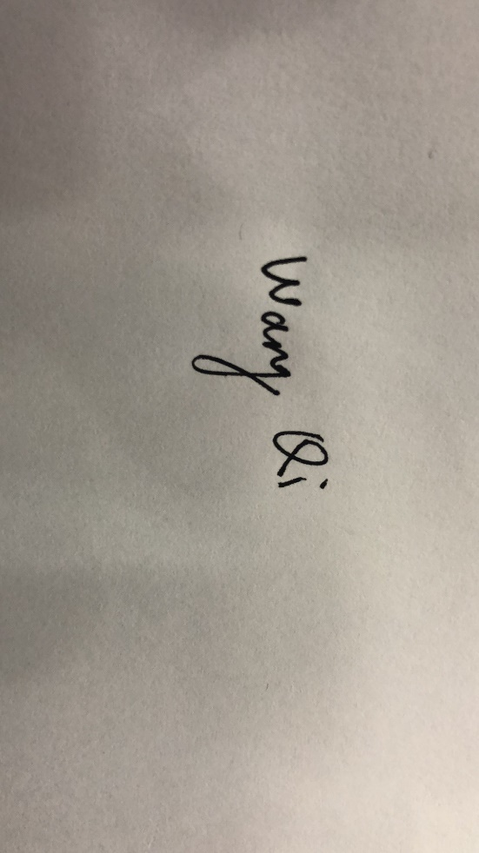
Qiling Li

