

09/08/2020

Dear Dr. Nguyen,

Thank you very much for sending us the editorial and reviewers’ comments. We are pleased that the reviewers raised mostly minor concerns. Based on their suggestions, we have, 1) updated the technical details about the SRS system setup and laser safety, 2) mentioned this protocol describes only one of several SRS system configurations, 3) elaborated more on the different lipid storage types in C. elegans and on the recent advances with capabilities to detect these. We have addressed all the comments in our point-by-point response attached below. Please let us know if you would have any questions and/or would need any further information.

With best wishes,

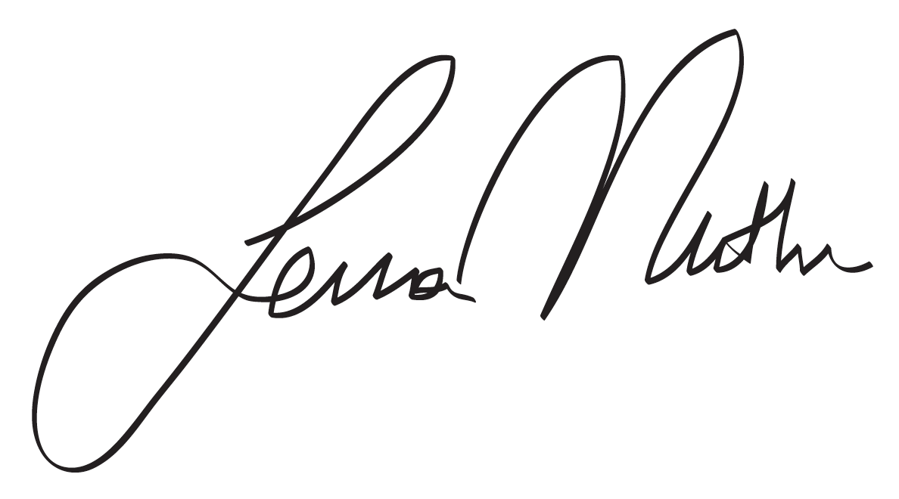
A. Sena Mutlu, Ph.D.
Postdoctoral Fellow
Huffington Center on Aging
Baylor College of Medicine
POINT-BY-POINT RESPONSE

Editorial comments:
Changes to be made by the Author(s):
1. Please take this opportunity to thoroughly proofread the manuscript to ensure that there are no spelling or grammar issues.

We have thoroughly proofread the manuscript for spelling and grammar errors.
2. The Protocol should contain only action items that direct the reader to do something. Please move the discussion about the protocol to the Discussion.

We changed the protocol steps and notes to ensure they are only action items.
3. Please note that anesthetization cannot be filmed in the protocol.

We will only show the step where the worms are picked into the anaesthetizing agent droplet on the coverslip using a dissecting microscope. The worms will not be seen in the video. Please let us know if we still need to remove this step from the highlights for the video.

Reviewers' comments:

Reviewer #1:
Manuscript Summary:
SRS microscopy has become a very useful tool for biomedical research. In this manuscript, the authors present the working principles and the detailed setup of the SRS microscope, and also provide methods for its use in quantifying lipid storage at distinct developmental timepoints of wild-type and insulin signaling deficient mutant C. elegans. Generally, it is a very good protocol for those who are interested in building their own SRS microscope or using SRS microscope to study lipid metabolism in C. elegans.
We appreciate the reviewer finding our protocol a good resource for those who are interested in utilizing SRS microscope in their research.
Major Concerns:
None.
Minor Concerns:
1. It should be noted somewhere in the manuscript that the protocol presented here is just one of the protocols that can be followed to build a SRS microscope.

We thank the reviewer for this suggestion to mention that this protocol should be used with an SRS microscope system that utilizes a picosecond laser with pump integrated optical parametric oscillator. We have now added additional information in Protocol 1 that there could be technical differences with each SRS system setup (lines 151-153 and lines 201-2015).
2. As described in the APE website, the wavelength of picoEmerald should be around 1030nm instead of 1064nm, and the modulation frequency of EOM should be 10MHz or 20MHz instead of 8MHz. Please double check these parameters.

We thank the reviewer for bringing this important point to our attention. The APE company has upgraded the picoEmerald one-box laser system. Therefore, specifications can vary due to different production date. The older version of picoEmerald, used in this protocol, has a Stokes beam of 1064 nm, but the new version has a Stokes beam of 1032 nm. Moreover, the modulation frequency of EOM used in this protocol is customized to 8 MHz, but the default modulation frequency for the new version picoEmerald is 10 or 20 MHz. We have added this information as a note after protocol step 1.2.2 (lines 201-205).
3. I'm not sure why there are many paragraphs highlighted in yellow color in the manuscipt.
As per the author guidelines of JoVE, we used the yellow highlighting to indicate the essential parts of the protocol to be filmed.
Reviewer #2:
Manuscript Summary:
The authors describe the use of stimulated Raman scattering to assess lipid storage in C. elegans.
Major Concerns:
The way the authors describe C. elegans' fat in this manuscript is a little bit misleading. Not all the C. elegans' fat is the same. For example, the yolky fat, analogous to human low-density lipoprotein fat, is destined to the progeny but not utilized by the parent worms. The production of yolk (vitellogenesis) is also a critical modulator that regulates the reproduction and aging in C. elegans, but the regulation pathways could be different from obesity-related metabolic disorders [Current Biology 28, 2544-2556 (2018); Front. Physiol. 10:1067.doi: 10.3389/fphys.2019.01067 (2019)]. However, both histochemical lipid staining and single-frequency SRS/CARS cannot tell the difference between the fats for progeny (yolk) and for somatic maintenance [Nat. Chem. Biol. doi.org/10.1038/s41589-020-0565-2 (2020) ]. The authors should mention this limitation. The authors should also point out the complexity of these fats but not simply try to draw parallels between all the C. elegans' fat content (particularly the intestinal fat) and adiposity in mammals.

We thank the reviewer for bringing these publications to our attention. We are sorry that the reviewer found our description about C. elegans fat storage misleading. Studying the difference between lipid storage types, including the intestine and the hypodermis, is quite exciting, however it is out of the scope of this protocol. In this protocol, our goal is to explain how C. elegans samples are used for quantifying total intestinal lipid storage by SRS imaging. To prevent any further misunderstanding, we now state this goal specifically in Protocol 2 (line 257-258). In the Discussion section, we also included an explanation about the changes in daf-2 mutants’ intestinal lipid storage levels that are likely due to a combination factors, including the overall lipid synthesis and utilization, as well as the changes in yolk production and accumulation (lines 450-453). Additionally, we mentioned that advances in hyperspectral SRS/CARS will enable us to investigate the distinct types of lipid storage particles in different tissues (lines 477-481).
Minor Concerns:
The laser power, pump = 200mW, Stokes=400mW, seems too high. What is the exactly power of both beam on the focus plane? Typically, <20mW on the sample works well enough to obtain sufficient coherent Raman signal. The power should be even less because the author's laser system has high peak power due to the low repetition rate.
We thank the reviewer for this comment. We have measured the beam power on the focus plane and it is ~50 mW for the pump beam and ~56 mW for the Stokes beam. We have added these measurements as a note in Protocol 1, after step 1.3.4 (lines 231-235).
Reviewer #3:
Manuscript Summary:
The reviewed article presents Stimulated Raman Scattering Microscopy as a method to quantify lipids in a label-free manner and in vivo in Caenorhabditis elegans. Results of the experiment were previously published. The designed experiment is well-selected to demonstrate applicability of SRS microscopy for fast and reliable quantification of lipids in vivo in a model organism (particularly attractive for this kind of analysis due to its transparency and ease of genotyping). I find the topic clearly interesting and well-chosen to popularize SRS that is yet a niche method despite its great potential in biological sciences.
The article is well written, therefore I have only minor remarks (below).
We appreciate the reviewer finding our protocol “interesting and well-chosen”.
Minor Concerns:
Introduction:
The introduction contains all necessary information that a reader needs to understand the purpose of the experiment, limitations of other techniques for reliable lipid quantification and imaging, and basics of both Raman and SRS microscopy.
"The molecular vibration will experience an enhanced transition (…)" I would rather say: "The molecule will experience an enhanced transition (…)".

We thank the reviewer for this comment and have made the suggested change (line 116).
Protocol:
The protocol is clear and detailed.
1.1.1 Could the authors explain the term "scanner import"?

We thank the reviewer for this feedback. We now changed the term to “IR laser input port” (line 157).
1.1.2. "Firstly, set the pump beam at 800 nm, which can be visually inspected" Is the beam visible at 800 nm?
No information about necessary precautions due to use of laser beams are included (protective eyewear?).

We thank the reviewer for these suggestions. It is correct that the picosecond 800 nm pump beam is invisible for alignment. For alignment purposes, we need to tune the laser wavelength down to 750 nm and lower down the laser power to 50 mW for safety and visual inspection of the optical path. We now changed this in the main text (line 165). Once the wavelength is switched to 816.7nm, the pump beam path can be checked using an IR sensor card or IR viewer (line 225-226). Moreover, we have added more details on laser safety in Protocol 1, after step 1.1.1 (lines 160-163).
3.2.2. Are the differences in the measured area taken into account?
When quantifying the C. elegans intestinal lipid levels in SRS microscopy images, we select the first 3-4 pairs of anterior intestinal cells in each worm and measure the average pixel intensity. Although the intestinal area selected in each worm can be different in size, total pixel intensity will be averaged to the area. Since the lipid droplets are homogenously distributed in C. elegans intestinal cells, the average SRS signal intensity is a reliable measure for lipid levels. We thank the reviewer for this comment and we have added this explanation to image analysis section, step 3.2.6 (lines 367-370).
Representative results:
I suggest to develop/simplify this part to make it more understandable for readers without the biological background.

We thank the reviewer for this feedback and we have simplified the results section.
Discussion:
Discussion summarizes well advantages of SRS and its perspectives in biosciences.

We thank the reviewer for the feedbacks that improved our manuscript.

