Reviewers' comments:
Reviewer #1:
Manuscript Summary:
Here in this protocol paper, the authors describe an interesting method for (1) harvesting and culturing sensory neurons from the ganglionic cell layer of the rat retina, and (2) plating them on top of a mono-layer of immortalized human OEG cell line to assess and quantify the regenerative role of the OEG cells. The method is well described, is easy to understand, easy to follow, and also potentially easy to adapt to evaluate regenerative potential of any other cells that can be grown as a monolayer in 2D culture. The biggest advantage is that the neurons gathered here are fully differentiated, adult cells; this means that they should not be able amplify or grow on their own without explicit aid from the co-cultured cell in the mono-layer.
Major Concerns:
My only major concern is that the description in step 3 (lines 178-204) needs more specific descriptive details at multiple places.
- After cutting the whiskers (in step 3.4), the authors state "Pick the optic nerve with forceps and, with a scalpel, make an incision across the eye". Do they mean to keep the eyeball in the orbital fossa and insert the forceps behind the eye to grip the optic nerve, or to take the eyeball out first and then proceed? Some details should be added between these steps to clarify the dissection process a little more.
We thank the reviewer for this suggestion. We have specified to grip the optic nerve to pull out the eyeball enough to be able to do the procedure, instead of “pick”, that can be misinterpreted with taking the eyeball completely out.
- In step 3.8, the instruction is to cut the retina into small pieces with scalpel. Here, the authors should specify how big or small these pieces should be. Is the size significant? As they discuss in line 318, the tissue dissociation is an important step - one can then conclude that the size of the retinal cut-ups might have a significant bearing on the overall yield of the neurons.
Thank you for the comment. We have now added to text that pieces have to be of an approximate size < 1 mm.
- In this same step, the authors may also want to describe if the removal of retinal pigment epithelial layer needs to be performed, and if so, how thoroughly should it be performed.
Thank you to the reviewer for the comment. When using this method (as it will be shown in the video) the whole retina comes out and is isolated from the rest of the eyes’ layers. We have now added to the text: “…pull out the retina (orange-like tissue), while the remaining layers of the eye stay inside (including the pigment epithelial layer).”

- In step 3.16 (line 200), it should be specified that the entire content of ME-10 should be replaced by NB-B27, instead of stating "aspire ME-10 medium from the OEG 24 well cell dish"
These are the main examples. However, I encourage the authors to give more specific details at other places as well, if deemed appropriate.
We now specify to completely remove the ME-10 medium and to replace it with the NB-B27 medium.
Minor Concerns:
- In line 51 in the abstract, the word "neurogenerative" is not appropriate, since the OEGs do not generate neurons, but rather they help the axons regrow. Hence, I recommend it should be amended to "neuroREgenerative"or "reparative" capacity.
Thank you to the reviewer for warning us of the writing mistake. We have now corrected the word to “neuroregenerative”.
- In step 5.1 and 5.2 (lines 238-245) the authors describe the method for quantification of axon regrowth by measuring (1) % of cell bodies with axons, and (2) mean axonal length at a single timepoint of 96 hours after co-culture.
I think if the authors can provide a timeline of sorts here, for example, at 2 hours (enough to allow the cells to settle in the new culture conditions), 2 days (48 hours) and 4 days (96 hours) after plating the co-culture, the results can elucidate the regenerative potential of the test cell population more clearly. I understand that this may require additional lab work, which is why, I request the authors to at least address this point in their discussion. For the validity of the described protocol, this point is not critically important (hence, I have put this as a minor concern).
Thank you to the reviewer for his/her interesting considerations with respect to the time course of the experiment. To assess the capacity of different glial populations to foster adult neurons axonal regeneration, we have determined that 96h is the time interval that best suits our aim, because: 1) it is the longest time to maintain the culture without disturbing the OEG monolayer; 2) it is the time needed for neurons to grow axons long enough to reveal differences between the regenerative capacities of different OEG populations or other non-regenerative cells, i.e. fibroblasts (see references 12-18,32,33). It would certainly be interesting to determine the time course of the regeneration process, as it could provide information about the differential regenerative properties of the different glial populations, at shorter times of the co-culture. In our hands, for regenerative glia, the time course between 72-96 hours is quite similar for all the cell lines, although axons are shorter at 72 hours (unpublished data). Also, 96 hours of co-culture, permits to study OEG-dependent mechanisms of adult axonal regeneration (see references 12,14).
We have now added these considerations to the discussion.

- In lines 290-291, the statement "Experiments were performed in triplicate with duplicated samples for each experimental condition" is confusing. Did the authors do 3 technical replicates AND 2 biological replicates (meaning N = 6) or just 3 technical replicates with the same sample for each replicate? Please rephrase to clarify this. Also clearly state the N value here.
We thank the reviewer for highlighting this ambiguity. We have modified the sentence to clarify the type of replicates that were made, so it now states: “Experiments were performed in triplicate, from three different rats (N=3), retinal tissue pooled from both eyes, with duplicates for each experimental condition (each glia population tested)”.
- In the line 326-327, the authors raised a very good point "Therefore, the experimenter must take serial pictures in the chosen areas, to measure the real axonal lengths". I recommend that the authors clarify here, with regards to "the minimum of 30 fields" mentioned in line 289. If the user takes 2 serial pictures at each random point, does the reader then only do 15 random points in this way (15x2 = 30)? Or do the authors recommend that the user should image 30 random Regions of interest (ROI), where each ROI may contain serial pictures of completely imaged axons?
We understand the need to clarify this point. As the reviewer says, we choose random points; if there is in an axon in the chosen field, we take the necessary pictures to follow the axon. In total we take 30 pictures corresponding to, approximately, 10 random regions of interest.
We clarify this point in the manuscript in Step 5 of the Protocol, Figure 3 legend and in the Discussion.

Reviewer #2:
Manuscript Summary:
In this manuscript the authors present an in vitro model system to assay and measure OEG neurogenerative capacity after neural injury. For this, retinas, extracted from adult rats and retinal ganglion neurons (RGN) are cocultured onto the reversibly immortalized human OEG (ihOEG) monolayer. Axonal and somatodendritic markers in RGNs are analyzed after 96 hrs by immunofluorescence and the number of RGNs with axon and the mean axonal length/neuron are quantified. This protocol evaluates the OEG neuroregenerative properties in adult tissue when compared to other existing protocols which rely on embryonic or postnatal neurons with intrinsic plasticity. Axonal regeneration has been quantified as percentage of neurons with axon, respect to total population of RGNs and axonal regeneration index is calculated as mean axonal length per neuron. The authors mention that this protocol is useful for assessing the neuroregenerative potential of ihOEG of different origins. Though the study is presented with some minor modification from previously existing protocols, the authors could introduce readily available reversibly immortalized adult human OEG cells in the protocol. That adds some novelty to this in vitro model system.

Major Concerns:
A major concern is, after co-culture experiment no differential labelling has been done to show that the RGNs are grown on the OEG layer. It could have been good if the authors can explain which are the other contexts in which this protocol can be used as a model of adult axonal regeneration as this is just a short period demonstration of 96 hours.
Thank you to reviewer 2 for the suggestion. We consider that we have a differential labelling because, the markers that are shown, are neuronal markers and they are not present in glial cells. The reviewer may refer to the fact that we do not present a co-labelling, showing glia and neurons in the same pictures. Normally, we just focus in RGN markers to study neuronal regeneration, assessing the existence of a monolayer by contrast of phase microscopy during all the experiment. Below these lines, we have included a picture in which we have increased the intensity and contrast of the images, for the reviewer to be able to perceive the monolayer below the RGN, as the SMI31 marker also labels the nuclei in the sample.

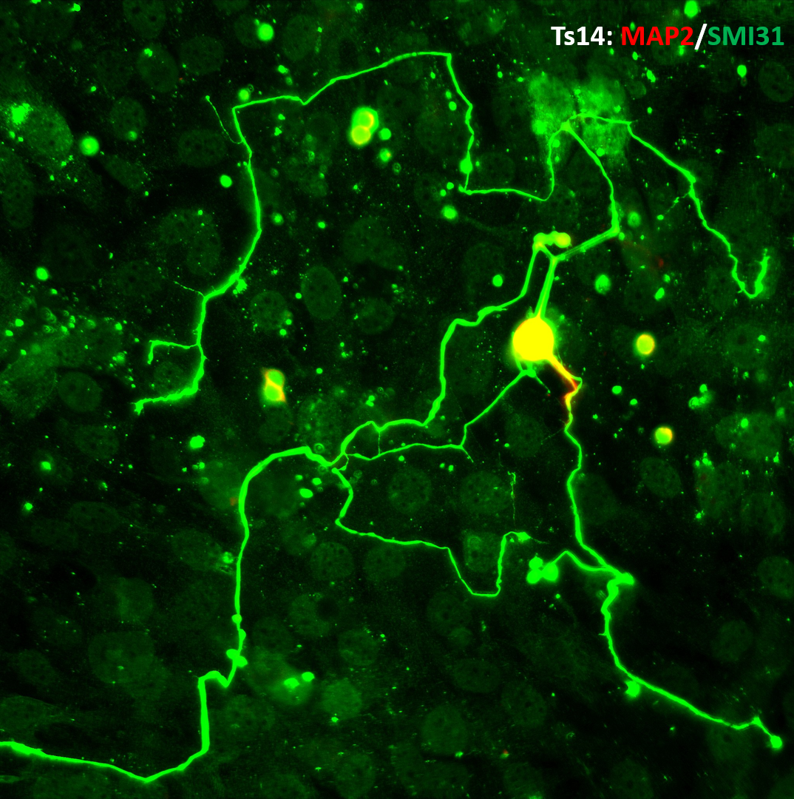

To measure the regenerative property of a cell line, the timing of 96h stablished in this protocol is enough for neurons to be able to regenerate axons, if they are in the correct environment. Nevertheless, the time window could be set up to a shorter or longer period if needed, but 96 hours is ideal to permit regeneration of long axons, without disturbing the OEG monolayer.
As for the contexts of the assay of the neuro-regenerative capacity of OEG, regeneration only occurs in the presence of a monolayer of a regenerative OEG population, not taking place over PLL or over a fibroblast monolayer (please check our references in the manuscript 12-18, 32 and 33).
We added a paragraph in the discussion considering these facts.

Other specific concerns are listed below.
1. Line 122, The approximate quantity of cells to be plated can be mentioned (eg: 3x106 cells/ml).
We understand the suggestion of the reviewer. The number of cells to be plated depends on the size of the cell line, as we mention in lines 316-317, and in the confluence of the cells when they were frozen. Normally, a confluent p-60 has a mean cell number of 7 x 10⁵ for Ts14 and 2,5 x 10⁶ for Ts12 cell lines.
2. Line 127, the approximate time for each passage can be mentioned though it depends on cell growth.
As reviewer 2 says, each cell line growth rate is different. That is why we assume that the specification of amplifying the cells when they are at 90% confluence, is informative enough for the reader to know when to proceed to the passage of cells. Nevertheless, we have now specified the time for each passage for our lines Ts14 and Ts12 (every 2-3 days).
3. Line 203, A cell strainer with appropriate pore size can be used in this step to remove undigested clumps and debris as those will interfere further culture.
Thank you for this suggestion, but we have verified that it is not necessary the use of the cell strainer if the retina is well processed. Also, the passage of the cell suspension through vial 4 (ovomucoid component of the papain kit) and its posterior centrifugation, avoids the interference of debris with further cell culture.
4. Line 203, it is important to mention, where exactly have to plate the resuspended cells. is this the coculture stage? please clarify
We have now specified this step in the protocol, stating that we add 100 µL of retinal cell suspension, per well of the m24 plate, onto PLL-treated or OEG monolayers-coverslips.
5. Line 213, Is it 0.1% Trypsin? please correct appropriately.
The blocking solution is composed by 0.1% Triton X-100 (to generate pores in the cell membrane) and 1% FBS (to block unspecific attachment of antibodies) in PBS. Trypsin is used to detach the cells.
6. If Ts14 stimulates the outgrowth of axons in RGN, the rate of regeneration can be assessed by keeping Day 1, axons as a control. The axonal regeneration in 24 hr,48hr,72hr and 96 hr can be recorded to confirm that the results are actual axonal regeneration and not the pre-existing axons.
To measure the regenerative property of Ts14 cell line, the timing of 96h stablished in this protocol is enough for neurons to be able to regenerate axons, if they are in the correct environment. Nevertheless, a shorter or longer time window could be set up if needed, but 96 hours is ideal to permit regeneration of long axons, without disturbing the OEG monolayer.
Misquantification of pre-existing axons is ruled out by means of the PLL negative control. At 96 h, RGN over PLL practically do not extend axons, compared to RGN over an OEG cell layer. Even more, the presence of pre-existing axons would be difficult after the process of retinae extraction and papain digestion.
We have now added these considerations to the discussion.
7. Will the papain treatment simulate neuronal injury? Please add a statement about this.
We thank the reviewer for raising this possible concern. When the retina is extracted from the eye, the RGNs are axotomized and, consequently, injured. The papain is used to disaggregate the retina tissue and then obtain the RGN population. In fact, it is a soft treatment.
8. line 204, is there a medium change necessary as the directly plated digested tissue pellet will contain lot of cell debris which negatively affect the survival of the attached cells? This step is usually part all the tissue digestion protocols for cell culture.
The kit eliminates the debris, specifically the vial 4 centrifugation (steps 3.14 and 3.15) and accordingly, the retinal cell suspension is clean and ready to be directly plated in the corresponding wells.
9. How it will be ruled out that the retinal digest contain only RGN, clarify
When the retinal extraction is performed, the retinal tissue is easily recognizable because of its orange-like color). Thus, the remaining layers stay inside the eye after cutting it and extracting lens and vitreous humor. Although other neuronal cell types (amacrine, horizontal or bipolar neurons) may be present in the retinal digest, regenerative RGN are easily distinguished by their characteristic morphology.
10. Figures and Figure legends are not numbered and titled properly, please make appropriate changes
After revision, we have not seen any mistakes in the figures or figure legends.
11. Only Ts14 OEG identity not Ts12 is assessed by immunostaining, explain
The aim of Ts14 characterization in this paper is to show the readers the characteristic OEG markers. Ts12 and Ts14 cell line’s identities are already published by our group (references 17 and 18 in the manuscript) so we do not consider it is necessary to assess the identity of both lines in this work.
12. Why no nuclear staining has done for neuronal cells to make sure they are cells itself, explain
Antibody 514 positive cells are neuron cells because this marker labels the somatodendritic compartment, (see Figure 3). Precisely we use this labelling to identify and count neurons, and then we use SMI31 to detect their axons.

Minor Concerns:
It is desirable to change the title as "Coculture of axotomized rat retinal ganglion neurons with olfactory ensheathing glia, as an invitro model of adult axonal regeneration"
We thank the reviewer for the suggestion. We have now specified in vitro in the title.

Reviewer #3:
Manuscript Summary:
The Methods Article by Portela-Lomba and co-authors presents an in vitro model to assess olfactory ensheathing glia (OEG) neuro-regenerative capacity, which is based on a co-culture of axotomized adult retinal ganglion neurons (RGN) on OEG monolayer and subsequent study of axonal growth. This manuscript described the protocol in which the immortalized human OEG (ihOEG) was cultured as a monolayer, and retinal ganglion neurons (RGN) were co-cultured on the OEG monolayer. While the manuscript is well-written, the following points should be considered to improve the accuracy of the protocol.
Major Concerns:
1. In the Summary and Abstract, and other sections, the authors stated that this model could measure OEG neuro-generative capacity after neural injury. However, this protocol were not involved in the neural injury. Actually, the author only measured the neural growth on the OEG monolayer.
We thank the reviewer for raising this possible misunderstanding. Nevertheless, when the retina is extracted from the eye, the RGNs are axotomized and, consequently, injured. In our negative control PLL we demonstrate that adult RGN cannot regenerate by itself, and it is the OEG monolayer which provides the appropriate environment for RGN to be able to extend axons.
2. The authors only showed the identity of ihOEG cell line Ts14 in Figure 2. The identity of ihOEG cell line Ts12 should also be provided.
As answered previously to reviewer 2, the aim of Ts14 characterization in this paper is to show the readers the characteristic OEG markers. Ts12 and Ts14 cell line’s identities are already published by our group (references 17 and 18 in the manuscript) so we do not consider it is necessary to assess the identity of both lines in this work.

3. The step-by-step labels of the procedure are imperfect and should be re-labeled. e.g., Line 188 and 189, Step 3.1.1 and Step 3.1.2 are not found. So, the '1. On the day of the assay, prepare the following media:' might be labeled as 3.1, and the '1.1 A p60 cell culture dish with 5mL of cold EBSS' might be 3.1.1.
We have followed the Instructions for Authors from the journal editors. The protocol must be a numbered list: step 1 followed by 1.1, followed by 1.1.1, etc. Each step should include 1−2 actions and contain 2−3 sentences. Use subheadings and substeps for clarity if there are discrete stages in the protocol.
Below we provide a screen capture of a recent JOVE paper showing the protocol structure, accepted by the journal editors (Fujiki R, Lee JY, Jurgens JA, Whitman MC, Engle EC. Isolation and Culture of Oculomotor, Trochlear, and Spinal Motor Neurons from Prenatal Islmn:GFP Transgenic Mice. J Vis Exp. 2019;(153):10.3791/60440. doi:10.3791/60440):
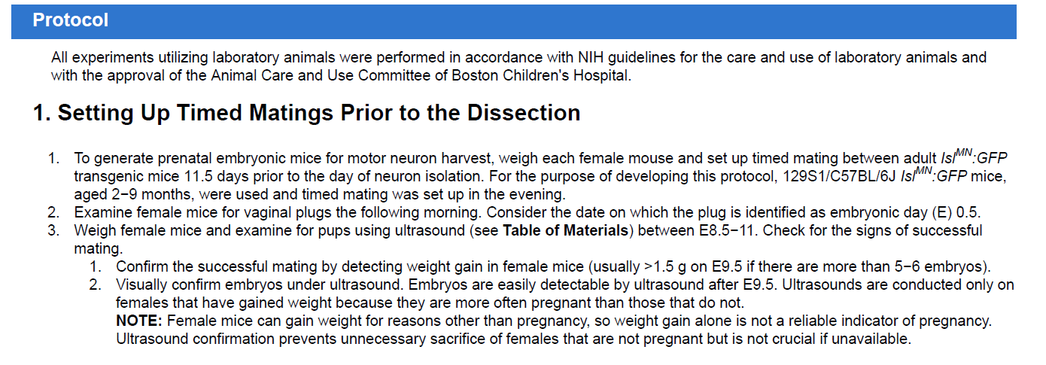
Minor Concerns:
1. Overall, this manuscript needs English expression and grammar checked. e.g., Line 76 growth signals might be "growth factors", dish might be plate or vice versa. In addition, Line 151, 80.000 Ts14 cells should be 80,000 Ts14 cells; Line 171, mix 2,7 mL vial 1 might be mix 2.7 mL vial 1; and so on.
We have now changed the words “growth signals” in line 76 to growth factors. Regarding to the synonyms plate and dish, both are correct and usable.
We have now unified the format of the decimal signs.
2. The Legal Unit of Measurement should be unified. e.g., minutes and min, hours and h; 200 g and 200 x g; ml and mL, and so on.
We have now unified the format of the Units of Measurement.

