USDA National Wildlife Research Center Y-maze materials and dimensions – Here, the basic design and construction of the apparatus used in diurnal Protocol section 1 of the manuscript has been outlined.

- Maze bottom, sides, and top

  - The bottom or base of the maze is made of four 1.22 m x 2.44 m panels of fiber cement siding in two layers of two panels each. The panels are placed together along the long edge, such that they form a 2.44 m square. The top layer of panels is oriented perpendicular to the bottom layer for added support. Holes drilled in the top layer allow carriage bolts to be passed up through the top for attachment of the maze (locations determined when the top and sides are assembled on the base). When the carriage bolts are in place, the two layers of panels are secured together using masonry screws.

  - The sides of the Y-maze are made using cellular white polyvinyl chloride (PVC) trim board (1.9 cm x 13.9 cm). The smooth side faces the interior of the maze environment and the wood-textured side faces out. For stability during maze assembly and to secure the sides to the cement siding base, aluminum angle (2.5 cm x 2.5 cm x 0.16 cm thick) is attached using stainless steel screws to the outside edge of the board along the full length with the angle facing out. Where the angle meets the Y-maze base, two holes are drilled at opposite ends of the board to allow carriage bolts from the base to pass through. Another piece of aluminum angle (1.9 cm x 1.9 cm x 0.16 cm thick) is attached along the full length of the outside top edge of the side with the angle facing in. A 0.7 cm gap is left between the angle and PVC board creating a slot to allow the maze top to be inserted. The arm ends of the main passageway sides are mitered at 45° to allow a flush fit with the arm sides. Where the ends of the sides meet with the holding and capture boxes, a small piece of aluminum angle (3.2 cm x 3.2 cm x 0.16 cm thick) is attached, allowing the boxes to be secured to the maze. Holes drilled in the angle allow the use of thumb screws to attach the boxes.

  - The top of the Y-maze is a clear acrylic sheet (0.56 cm x 48 cm), inserted into the slots at the top of the Y-maze sides. Two pieces are used to cover the main passageway from the box end to the V-end and one piece each for the arms. The piece at the end of the main passageway is cut to match the V-shape of the maze and the arm pieces are cut at an angle to meet with straight edges of the main passageway piece. When assembled, all top pieces fit flush together forming a completely enclosed top. Holes drilled through the aluminum angle, acrylic top, and PVC sides approximately every 35 cm allow the top pieces to be secured during trials using simple flat top nails (inserted into the aligned holes).

- Internal partitions are used within the main passageway of the Y-maze to control space use by scent-laying animals and thereby restrict scent deposition to defined areas of the maze.

  - For trials where a single scent trail is deposited by a scent-laying animal, a 46 cm L x 13.7 cm H x 0.8 cm thick PVC board partition is used to completely block the passageway of the control/untreated arm. The ends of the partition are beveled so that the interior face of the partition meets flush to the interior sides of the maze. For stability, a 30 cm long x 3.8 cm x 9 cm H untreated wood board is attached to the rear face of the partition using stainless steel screws. A 90° 2.5 cm steel corner brace attached to the bottom edge of the wood board in the center allows the partition to be secured with a deck screw to the base of the maze during trials. A pre-drilled hole made in the base and marked conspicuously (using black or red wax pencil) makes attachment easier, as the location of the hole will be faintly visible through the scenting layer.

  - For trials where two scent trails are deposited by different animals, a system of partitions is used to block alternating arms of the maze and exclude each animal from alternating halves of the main passageway (see Supplemental Figure 1).
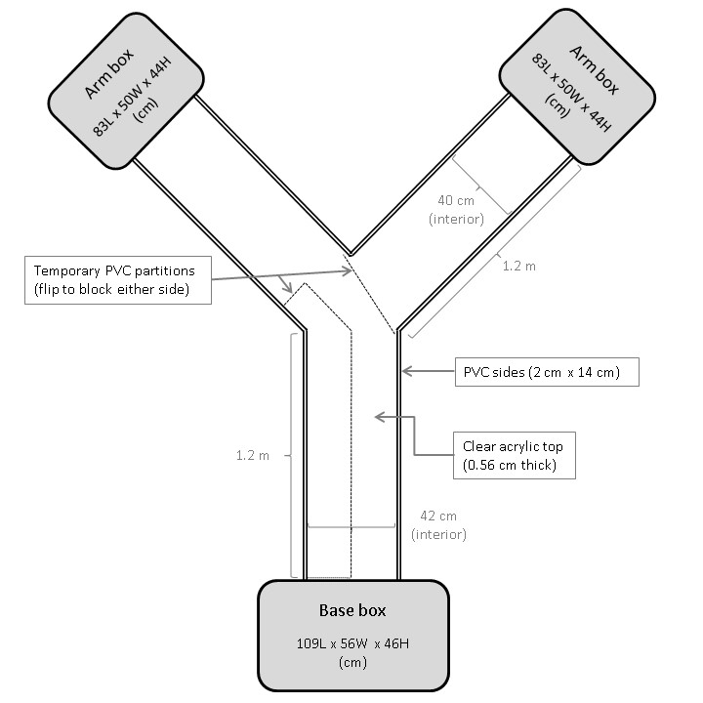
Supplemental Figure 1. Dimensions and layout of Y-maze at USDA NWRC.

    - The partition described in 2.1 is used to block the unused arm of the maze.

    - A 120 cm L x 13.7 cm H x 1.9 cm thick PVC board partition is used to bisect the length of the main passageway. The arm end of the partition is cut to a 45° point. For stability, aluminum angle (2.5 cm x 2.5 cm x 0.16 cm thick) is attached to both sides of the base of the board along the full length. At the distant ends of the partition, holes are drilled into the aluminum angle at the base; one hole at each end on each side (4 total). Using these holes, the partition is secured to the base using deck screws (again holes in the base predrilled and conspicuously marked).

    - An L-shaped partition is used to enclose the arm end of the main passageway, on the side opposite the blocked arm. This partition is constructed of two pieces of 13.7 cm H bx 1.9 cm thick PVC board, such that the long side is 30 cm L and the short side 11 cm L. The pieces are permanently joined by a butt joint using stainless steel screws. A rebated butt joint cut into the end of the long side allows the partition to overlap the 45° point of the main passageway partition. A small bevel cut into the outside tip of the butt joint makes for a flush 45° union. A small 90° 2.5 cm steel corner brace attached to the inside of the L partition allows it to be secured to the base using a deck screw. Attaching one bracket to the top side and one to the bottom side allows the L-partition to be flipped for use on either side of the main passageway.

- Base and arm boxes

  - A box secured to the base end of the Y-maze holds the scenting or test animal prior to its release into the apparatus. Boxes secured at the terminal ends of the Y-maze arms facilitate capture of the animal at the end of the trial.

  - Base and arm boxes are grey plastic storage containers modified to include openings that match the ends of the Y-maze, with removable doors.

    - Openings cut into a bottom side of each box are reinforced with externally mounted pieces of PVC trim board (1.9 cm x 18.4 cm) with similar openings cut to match. Two layers of thinner PVC trim boards (0.8 cm x 18.4 cm) are attached to the outside of the first trim board and matching openings are cut. The top of the middle board is mostly cut away to create a slot in which a removable 0.56 cm thick clear acrylic door can be inserted. The opening assembly is secured to the box using stainless steel screws with a backing of aluminum strap for reinforcement. All seams are sealed with clear acrylic caulk. To secure the door while the animals are in the boxes, a thumb screw is secured through a hole in the top of the acrylic door into a threaded insert screw. Two threaded insert screws installed on each side of the opening (matching openings in the aluminum angle on the sides of the maze) allow the boxes to be secured to the maze using thumb screws.

    - Holes drilled through the top lid and top edge of each box, approximately 25 cm apart, allow the top to be secured using small plastic cable ties. With the lid in place, cable ties are passed through the holes and around the box edge and tightened.

    - Seven holes (2.5 cm diameter) along the top edge of both long sides of each base box provide ventilation. An additional row of six 1.2 cm holes in the upper middle sides of the base box provides extra ventilation.

    - The dimensions of the base box are 108.6 cm L x 55.9 cm W x 45.7 cm H. The base box has two clear acrylic doors, one full size and one half-size. The half-size door is used to block one half of the opening to the main passageway during two-scented trials.

    - The dimensions of the arm boxes are 82.9 cm L x 50.2 cm W x 43.8 cm H.

- Enclosure for maze

  - If Y-maze trials are conducted outdoors under ambient conditions, additional shelter is required to provide a safe and comfortable environment free of distraction from outside influences. Additional security (secondary and/or tertiary layers of caging) is also suggested and may be required when working with non-native study animals.

  - Place the entire Y-maze apparatus within a secondary cage enclosure (6.1 m L x 3.0 m W x 1.8 m H) covered with wire mesh on the roof and sides. A walk-through door provides access. Secure green, heavy-duty shade cloth to the top and upper sides of the enclosure to provide shade and a visual barrier.

  - A 6.1 m L x 3.7 m W white canopy (12 ft. x 20 ft. 2 in. 8-leg canopy) erected over the secondary cage enclosure provides additional shelter from the sun and rain.

