JoVE 61138 Villemain – Video comments

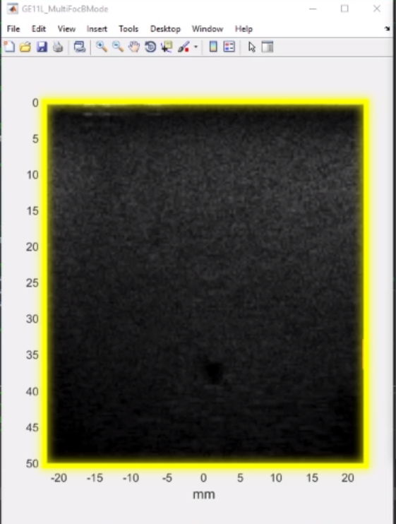
02:39 – “The fluid will appear darker” This statements asks the experimenter to focus on the dark disk at the bottom of the ultrasound image (here shown in a red circle). The yellow highlight is a bit confusing as it emphasizes the whole ultrasound image (and not only the fluid-filled portion).

03:13 – “to reshape the 3D space times space times time IQ matrix” this should be rephrased as follow “to reshape the 3D IQ matrix”. Otherwise the scientific message is compromised.
03:19 – similarly, “into a 2D space times time Casoratti matrix” should be modified: “into a 2D Casoratti matrix”
05:03 – Please add a small banner with the reference of the original article for this image: “Adapted from Baranger et al, Adaptive Spatiotemporal SVD Clutter Filtering for Ultrafast Doppler Imaging Using Similarity of Spatial Singular Vectors. IEEE Trans. Med. Imaging. 37, 1574–1586 (2018).”
All the reproduction rights were obtained from the editor.

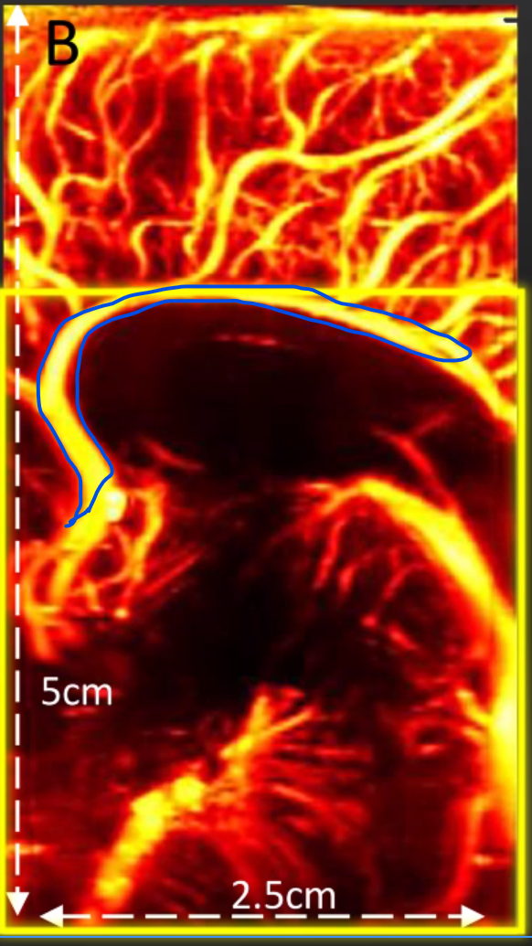
05:13 – “To the major pericallosal arteries”. The yellow highlight encompasses more vessels that the pericallosal artery . That could be confusing. Below, I coarsely drew the contour of the pericallosal artery in bue.

05:18 - Please add a small banner with the reference of the original article for this image: “Adapted from Maresca et al, Noninvasive Imaging of the Coronary Vasculature Using Ultrafast Ultrasound. JACC Cardiovasc. Imaging. 11, 798–808 (2018).”
All the reproduction rights were obtained from the editor.

