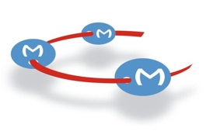


September 8th, 2020

Dear Editor,
It is with pleasure that we would like to re-submit the revised version of our manuscript entitled, “Lymphatic and Blood Network Analysis During Obesity” for review in “JOVE”. We generated and included new data in Figure 1 and addressed all the reviewers questions and concerns. We believe that the method reported here is of interest for the scientific community.

Sincerely yours,

Stoyan Ivanov

