Benjamin Werth
Senior Science Editor
JoVe

Claudia Lengerke, MD

Universitätsspital Basel
Departement für Biomedizin
Hebelstr. 20
CH-4031 Basel

Tel.: +41 61 2652381
Email: claudia.lengerke@unibas.ch

June 30th, 2020



Dear Mr. Werth
Herewith, we would like to submit our revised manuscript „ ABSENCE OF IMMUNE ACTIVATING NKG2D LIGANDS AS A TOOL TO IDENTIFY LEUKEMIC STEM CELLS” for publication as a video article in JoVe.

Please note that we have made significant changes according to the Reviewers’ and Editors’ suggestions. Furthermore, we have added two more co-authors that were involved during the revision phase. However, we were not able to include them in the system, but they should for sure be included. Please, also note the equal contribution of 2 co-authors for this new manuscript.

Thank you very much for your consideration.

Sincerely,

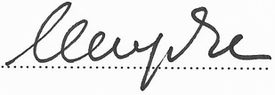

Claudia Lengerke

