Giuseppe Valacchi, PhD
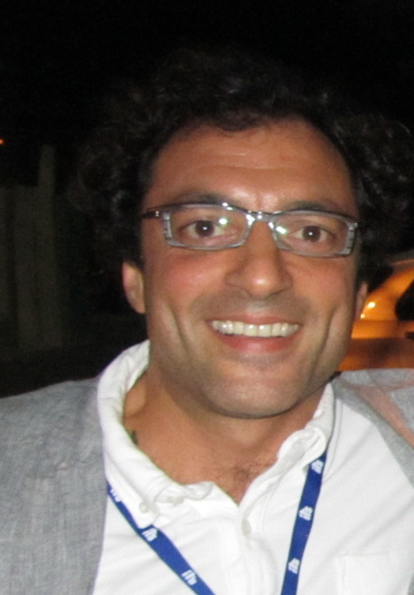
Giuseppe Valacchi obtained his B.S. with Laude in physiology, MS in physiopathology and his PhD degree in Cell Physiology and Neuroimmuno-physiology at the University of Siena. During his training he has worked as “exchange PhD student" in the “Department of Molecular and Cell Biology at the University of California at Berkeley" where he started out some studies on the effect of environmental oxidative stress such as O3 and UV on skin physiology. After his PhD graduation, he continued working as Post Doc at the University of Berkeley until December 2000. Between 2000 and 2004 he was appointed first as Post Doc in the “Department of Internal Medicine" and then in the "Department of Nutrition" at the University of California at Davis (UCD). In 2005 he become Faculty and member of the Academic Federation in the Department of Internal Medicine (UCD). At the end of 2006 he was awarded with the “progetto rientro dei cervelli”, granted by the Italian Ministry of Health and returned to Italy at the University of Siena as Assistant Professor until 2011. Since 2011 he is appointed as Associate Professor in Physiology at the University of Ferrara. From 2008 is also Adjunt Prof. at Kyung Hee University, Seoul, South Korea and starting from August 2016 he is Associate Professor in Regenerative Medicine at North Caroline State University. His research has been focused in understanding the cellular, and molecular mechanisms that define the tissues physio-pathological responses to altered redox homeostasis. He is a member of the SFRR Europe Council and he is author of more than 235 peer reviewed internationals papers, 15 book chapters, one book. He has been invited speaker to more than 100 international conferences and organizer/Chair to over 50 international meetings. He has won several awards among them the Entelligence Award from Actelion, OCC Young Investigator Award, Science and Education Award and recently the Exposome grant. In 2018 he was awarded with the “Doctorate Honoris Causa” in Biochemistry and Pharmacy from the University of Buenos Aires for his work in the redox biology field. He is the Associate Editor of several international journals among which is Mediators of Inflammation, Frontiers in Cellular Biochemistry, World Research Journal of Biochemistry, Journal of Complementary and Traditional Medicine, Biomed Research International (Dermatology Subjects), Oxidative Medicine and Cellular Longevity; in addition he is member of the Editorial Board of several journals such as Genes and Nutrition, Open Biochemistry Journal, Archives in Biophysics and Biochemistry, Clinical Immunology Endocrine & Metabolic Drugs, Frontiers in Inflammation Pharmacology, Clinical Anti-Inflammatory & Anti-Allergy Drugs, BioFactors, Cosmetics.
H Index 51
I10-index 157.

