Reviewer comments
Reviewer #1:
Manuscript Summary:
The manuscript explains a descriptive analysis of the impact of touchscreen device on the human performance and musculoskeletal structure of the hand. It presents significant findings on the type of layout to be used by illustrating the differences among 4 types of keyboard. The protocol established line ups with the intended aims and objectives of the study.
Major Concerns:
There are no major concerns
Minor Concerns:
# Comments 1:
Gap in the literature should be stated and the significance of this study should be emphasized. Figure 1 should be explained within the manuscript at lines 102-103. Figure 2 cannot be on P.4 line 116 and P.6 line 180. One of them should be preferred.

* Response 1:
Thanks for your kind suggestions. Figure 1 and Figure 2 have been corrected as follows:
1.

PROTOCOL:
The study was conducted in accordance with the ethical principle and was approved by the Ethics Committee of Tsinghua University. Figure 1 shows the process of evaluating the keyboard design of smartphones.

[Place Figure 1 here]

2.
1.2 Dependent variables
1.2.1 Physical data were composed of hand length, the length of input finger, and the circumference of input finger which was measured by a tape measure as shown in Figure 2.

[Place Figure 2 here]

1.2.2 Physiological data consist of galvanic skin response (measured by the portable wireless physiological detector), heart rate (measured by the portable wireless physiological detector), electromyographic activity (measured by Electromyography), etc.

Gap in the literature has been added and the significance of this study has been re-written as follows:
- In the section of Summary
The presented protocol integrates various evaluation methods and demonstrates a summarized method and Python scripts for evaluating the keyboard design on smartphones. Pairs matched by English characters is proposed as the input material and the transition time between two keys is used as the dependent variable. The representative results show whether the curved QWERTY keyboard design with size-adjustable buttons could optimize the input efficiency and experience on smartphones for one-handed usage when compared with the traditional QWERTY keyboard.

- In the section of Abstract
……There is sufficient existing literature on evaluating virtual keyboards, however, little of them systematically summarized and took reflection on the evaluation methods and processes. Therefore, this protocol fills in the gap and presented a process and method of the systematic evaluation of keyboard design with code for analysis and visualization that are available, need no additional or expensive equipment required, and are easy to conduct and operate. In addition, the protocol also helps to get potential reasons for the disadvantages of the design and enlighten the optimization of designs. In conclusion, this protocol with the open-source resources not only could be an in-class demonstrative experiment to inspire the novice to start their studies but also contributes to improving the user experience and the revenue of input method editor companies.

And, based on the above, some words and sentences about the significance were re-written throughout the manuscript.

Reviewer #2:
Manuscript Summary:
The authors are presenting a "protocol" for assessing keyboard layouts on virtual keyboards (touch keyboards) with a specific focus on curved keyboards.
Major Concerns:
# Comment 1:
The text input literature is large and also the part addressing virtual keyboards. There are some established conventions for how to conduct experimental assessments of text entry experiments. As such I do not see that this protocol adds to anything new that has not already been covered by others.

* Response 1:
Thanks for your comments. To be sure, there are currently many studies that use text input to evaluate virtual keyboard design. During the evaluation process, the subjects mainly input sentences from the phrase set proposed by Mackenzie and Soukoreff (2003). Traditionally, researchers collected and analyzed their Word Per Minute, Word Error Rate (objective variables), and some different subjective feedbacks. The main contributions and innovations of this paper are as follows:

- There is much existing literature on virtual keyboards but little of them summarizes the evaluation methods and processes. This article will systematically sort out the evaluation methods and materials commonly used by the previous studies. Also, this protocol could help novice researcher to select the appropriate method and indicators for their own experiments rather than being confused with such various methods and indicators.

- WPM commonly used in existing research is a descriptive indicator. According to our accepted paper "Usability Evaluation of Smartphone Keyboard Design from an Approach of Structural Equation Model" (coming online) by HCII 2020, WPM is not a appropriate evaluation indicator. During the collection process, it is affected by many confounding factors, such as cognitive factors. Therefore, we proposed Pairs (matching 26 letters in pairs; a total of 676 pairs) as the new text input material. All words and abbreviations (including LX, QL, which are not words, but abbreviations for companies or names) are composed of multiple pairs. Then, we added the transition time between two keys as the new objective variable to help researchers better explore the reaction time and input behavior of the participants during the transition of fingers. Its results can also better help designers optimize the virtual keyboard.

Based on the above, we found that the description of our contribution was unclear and we have re-written as follows:

- In the section of Summary
The presented protocol integrates various evaluation methods and demonstrates a summarized method and Python scripts for evaluating the keyboard design on smartphones. Pairs matched by English characters is proposed as the input material and the transition time between two keys is used as the dependent variable. The representative results show whether the curved QWERTY keyboard design with size-adjustable buttons could optimize the input efficiency and experience on smartphones for one-handed usage when compared with the traditional QWERTY keyboard.
- In the section of Abstract
……There is sufficient existing literature on evaluating virtual keyboards, however, little of them systematically summarized and took reflection on the evaluation methods and processes. Therefore, this protocol fills in the gap and presented a process and method of the systematic evaluation of keyboard design with code for analysis and visualization that are available, need no additional or expensive equipment required, and are easy to conduct and operate. In addition, the protocol also helps to get potential reasons for the disadvantages of the design and enlighten the optimization of designs. In conclusion, this protocol with the open-source resources not only could be an in-class demonstrative experiment to inspire the novice to start their studies but also contributes to improving the user experience and the revenue of input method editor companies.

And, based on the above, some words and sentences about the significance were re-written throughout the manuscript.

# Comment 2:
The protocol seems very specific to the curved keyboards which is a bit odd, and not so useful for other types of experiments. The authors have also failed to relate to the other work on "curved" or "tilted" keyboard design. There are quite a lot of such works (especially in the ergonomics literature).

* Response 2:
Thanks for your comment. This protocol aims at all experiments on smartphones to evaluate the keyboard design. Curved keyboard study was conducted based on the protocol, and we have nearly collected all variables (without the optional) mentioned by the protocol to fully present the protocol while existing studies might just select several indicators which were much appropriate for their research goals. This manuscript did not try to in-depth explore the usability of curved design, therefore, after the general protocol, we have not discussed the related works on “curved” and “tilted” keyboard design in the section of representative results, and we just simply showed the results and draw a conclusion. In addition, the exemplar python scripts are also available for other keyboard evaluation experiments on smartphones by just changing some parameters and functions.

However, our description about the protocol may confused readers that this protocol is specific to curved keyboard evaluation, therefore, the content of the protocol has been refined and added more evaluation methods as follows:

- In the section of Protocol
  - Dependent variables
……
1.2.2 Physiological data consist of galvanic skin response (measured by the portable wireless physiological detector), heart rate (measured by the portable wireless physiological detector), electromyographic activity (measured by the surface Electromyography), etc.
……
1.2.4 Body-movement data contain hand gesture and body (finger) movement. They could be collected by the motion capture system ³⁵.

2. Procedure
……
2.3 Disinfect all devices and clean the body parts of the participant that will touch the devices.

2.3.1 Ask participants to wash their hands and clean the screen of smartphones so that sensors of smartphones can be more sensitive.

2.3.2 Wear portable wireless physiological detectors or motion capture system for participants. Wear the portable wireless physiological detection wristband on the non-dominant hand of participants to record galvanic skin response and heart rate with the noise interference avoided. Place passive markers of the motion capture system on the fingernails, the proximal phalanx of the finger, cervical vertebrae (C3-C5), and arm, to collect the precise body and finger movement. Stick wireless electrodes to the skin of two arms and two forearms to detect the electromyographic activity. (Optional step)

2.3.3 Calibrate all the devices used in the experiment.

- In the section of Representative Results
The representative study is mainly following the mentioned protocol. The study adopts a 2 (Keyboard layout: Curved QWERTY vs. Traditional QWERTY) × 2 (Button size: large, 6.3 mm × 9 mm vs. small, 4.9 mm × 7 mm) within-subject design to evaluate whether the curved QWERTY could improve the input efficiency and comfort when compared with the traditional QWERTY in different sizes of buttons by the character pair input task through our self-developed software (Figure 3). This study has not adopted the expensive physiological detector equipment or motion capture system, and the data analysis did not contain the modeling or simulation.

- In the section of Discussion
Limitation (lines 615-618):
……Besides, other expensive devices or equipment adopted by previous studies have not been included in the representative results, such as the portable wireless physiological detector or motion capture system and researchers should choose their specific experimental devices based on their research problem and hypothesis……

Based on the above, some words and sentences about the significance were re-written throughout the manuscript. Also, Figure 1 (the evaluation process) was changed as follows:
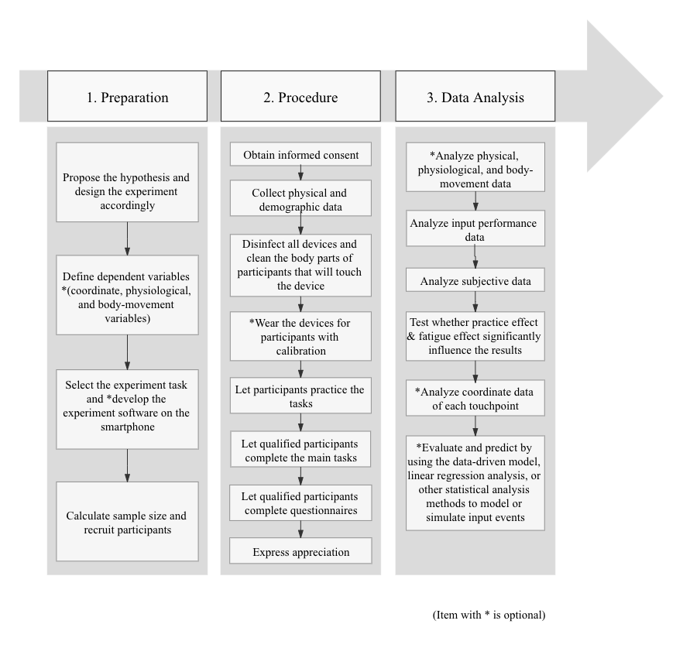
# Comment 3:
The statistical analysis part of the protocol lacks reflection on the appropriateness of the statistical tests used. The authors simply rely on parametric tests, while in some situations the assumptions for these tests are not satisfied and non-parametric substitutes are needed. Others would argue that the hypothesis testing paradigm is old fashioned (the followers of the New Statistics, or Bayesian enthusiasts).

* Response 3:
Thanks for your kind suggestions. To be sure, the statistical analysis part of the protocol should pay much attention to both parametric tests and non-parametric tests. Although this protocol concentrates on evaluation, and hypothesis testing is commonly used, modeling and other statistical analysis methods could also enlighten the evaluation by their indexes or indicators. In the section of data analysis, we have added some new methods, such as modeling and simulation (do not appear in representative results). In the limitation, we hope that researchers could explore more evaluation analysis method. Thanks a lot!

- In the section of Data Analysis
- Data analysis
  - Hypothesis testing by appropriate parametric or non-parametric tests
    - Analyze the physical, physiological, body-movement data to test whether the difference between participants would significantly influence the results and inexpressive input experience of users. (Optional step)
    - Analyze the input performance of participants to test the input efficiency on the keyboard.
    - Analyze subjective data to test the perceived usability and subjective feedback of the keyboard.
    - Figure out whether the practice effect and fatigue effect significantly influences the result. For each condition, trials are divided into two parts according to the timestamp, i.e., the first half part and the second half part. Specifically, under each condition, examine the difference of input performance between the first half part and the second half part to test whether it exists the practice effect or fatigue effect.
    - Analyze the area of the fitted ellipse of touchpoints on each button as well as the offset from its center to the target center of each button. (Optional step)
      - All the touchpoints of each button were collected by our self-developed software, and they roughly accord with the bivariate Gaussian distribution. The 95% confidence interval of each button in both x- and y-directions is derived through the coordinate data of each touchpoint in pixel, and the 95% confidence ellipses over a 1:1 outline of the button for each keyboard is fitted through Python scripts on pixel coordinate (see coding file 2).
      - Fitted ellipses (95% CI) and their areas demonstrate the dispersion of touchpoints on each button. In each button, the offset of fitted ellipse calculated by Python scripts is defined as the center point of the fitted ellipse to the target point of the button, and it could be represented from x- and y-directions, i.e., in X-axis and Y-axis (see coding file 3).
  - Modeling and simulation
    - Use the data-driven model as a function of keyboard location and orientation to predict the finger movement by Python scripts. All movements of fingers are divided into 8 directions ³⁸ (the top to the bottom, the bottom to the top, the left to the right, the right to the left, the left-top to the right-bottom, the right-bottom to the left-top, the left-bottom to the right-top, the right-top to the left-bottom). For each direction, the average transition time between two keys is calculated to represent the effectiveness of finger movement which is used to evaluate the keyboard design. (Optional step)
    - Use linear regression analysis to build an enhanced Fitts' Law (or its extended version, FFitts Law) model to predict the transition time between two keys by using an integrated cognitive architecture ³⁹ by Python scripts. The enhanced Fitts' Law model could provide a better prediction and evaluation on keyboard design based on its analyses on the location and effective width of keys, as well as the distance of two keys. (Optional step)

- In the section of Discussion
Limitation (lines 618-620)
……Finally, followers of the New Statistics or Bayesian enthusiasts could try to adopt more statistical methods to analyze and evaluate the keyboard design.

