Dear Author(s),
This document is divided into sections in which you can add your comments to the video and voiceover. Please be aware that our policy is to do a single complimentary revision, so it is critical that all participants in this project offer their comments collectively. In addition, please make sure that your comments are easily interpreted and transparent.
Have fun!
Protocol Name: Isolation and Analysis of Plasma Lipoproteins by Ultracentrifugation
Date: March 8, 2021

Authors and Affiliations
Please fill in any missing author information not included in the video.
Order | Author | Affiliation

Video Comments
Please fill in any comments you wish to make using the table below using the example as a guide. If you need more space to write, please do so below the table. DO NOT ADD CORRECTIONS TO THE NARRATION HERE. PLEASE DO THIS IN THE AUDIO COMMENTS SECTION.
 | Time code | Comment | Requested Change
1. | 0.01 | All authors’ first and last names have been combined together without space. | The first names should be separated from the last names.
2. | 0:10 | Jianglin Fan, Wuyi University should be changed. | Change to Jianglin Fan, University of Yamanashi
3. | 4:20 | Onscreen figure (shot list 3.5.2)  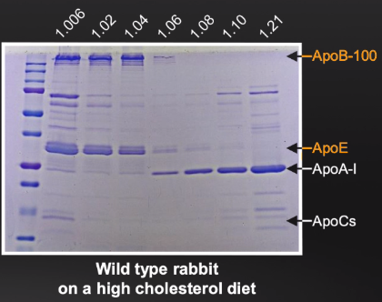 | Figure should be highlighted as shown below  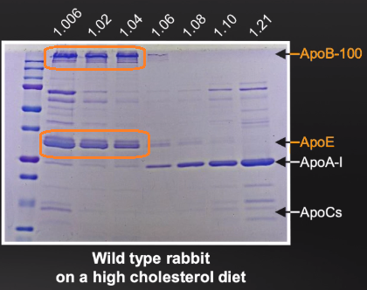
4. | 4:50 | Onscreen figure (shot list 3.7.1)  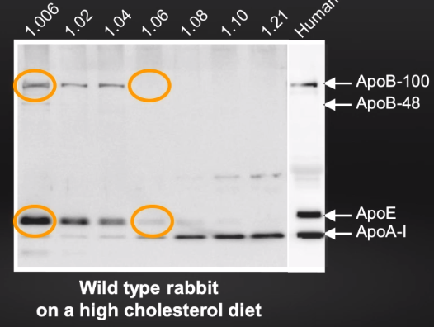 | Figure should be highlighted as shown below  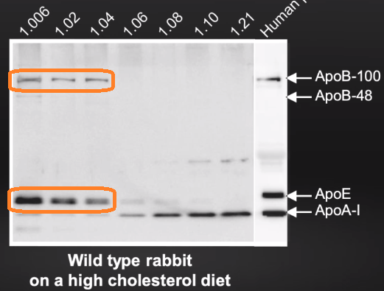
5. | 5:00 | Onscreen figure (shot list 3.7.2)  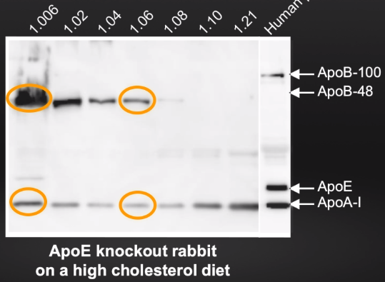 | Figure should be highlighted as shown below  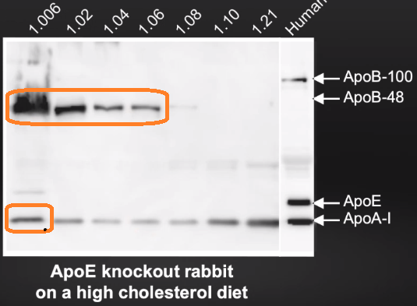
6. | 5:15 | Onscreen figure (shot list 3.8.2)  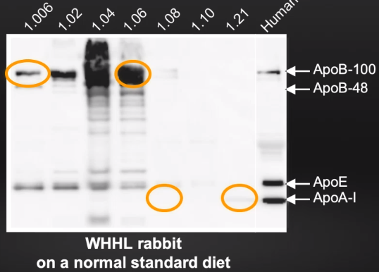 | Figure should be highlighted as shown below  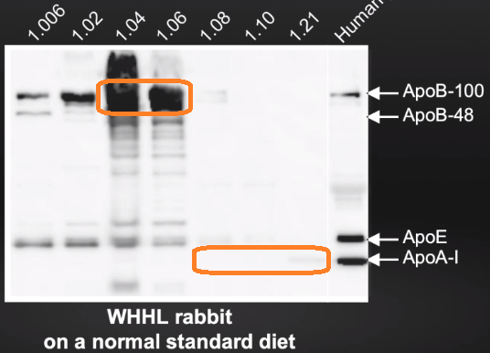
7. | 5:37 | Manabu Niimi, Wuyi University should be changed. | Change to Manabu Niimi, University of Yamanashi

Audio Comments
This section is used to specify the changes that need to be made to the narration. Please follow the example below as a guide to list your changes. If there is a pronunciation change, please provide a phonetic pronunciation key or a web link.

 | Time code | Comment | Step(s) in Shotlist | Rewritten Text or Corrected Pronunciation (highlight in bold)
1. | 3:40 | Original Script Text:  “57% of plasma PL is contained in HDLs” | 3.3.3 | Rewritten Script Text:  “57% of plasma PL is contained in HDL-3”

